To schedule time on the XRD and update the schedule on the web……..

Go to G:\LABWORKS\xrdsched

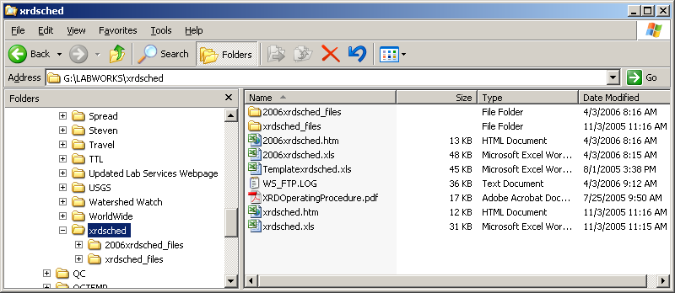

Double click on the 2006xrdsched.xls file to open the schedule in excel.

Fill in the users name and time to be scheduled in the appropriate spot.

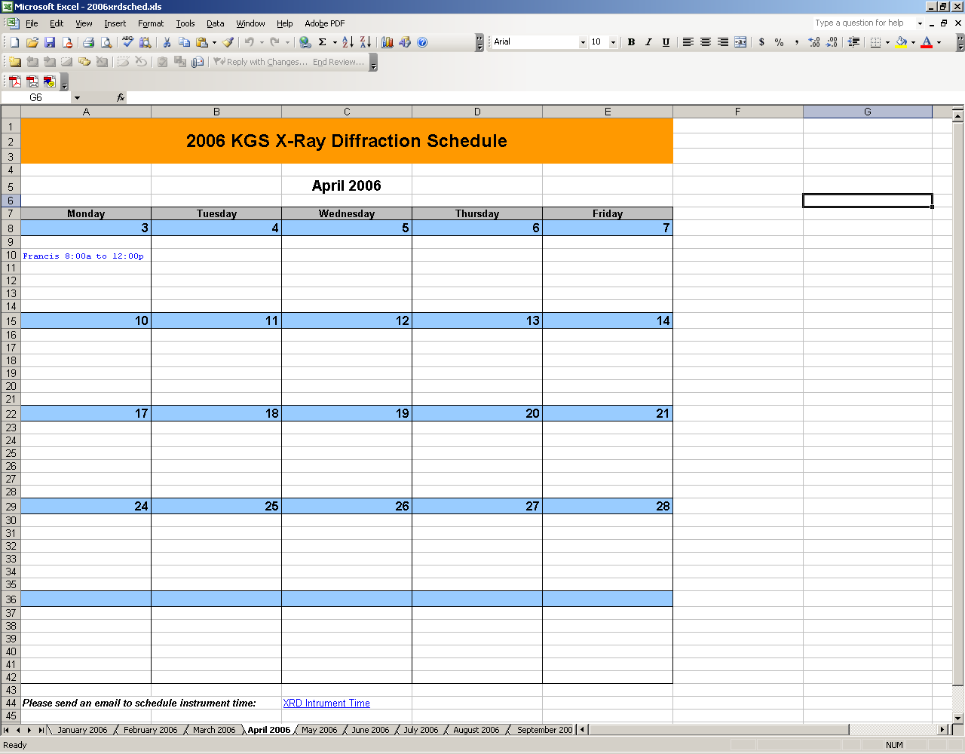

We need to save the file twice…..
- click on save to save the updated excel spreadsheet as the original name (2006xrdsched.xls).
- Do a file, save as and in the save as type drop down menu, choose Web Page (*.htm, *.html), and click save.
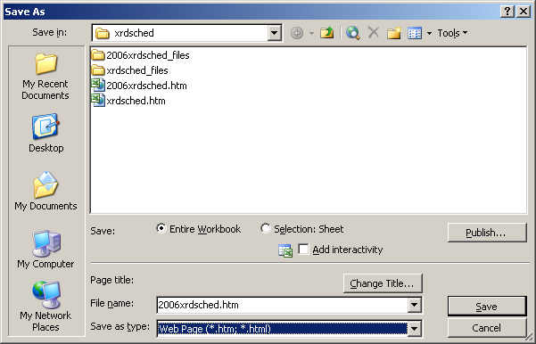

Exit.

Next we need to transfer the files and web page to the server. We use a program called WS-FTP95.exe to do this.

Go to the labshare drive on “kgs0” G:

Open the WS-FTP folder.

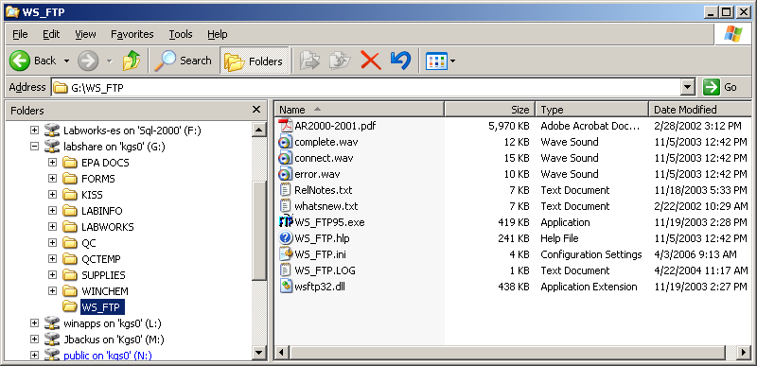

Open the WS_FTP95.exe program:

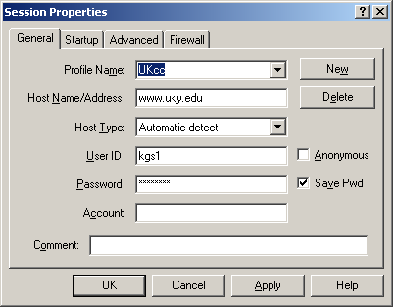

Click OK, and this box pops up. You will here a tone and see 226 Transfer Complete when done.

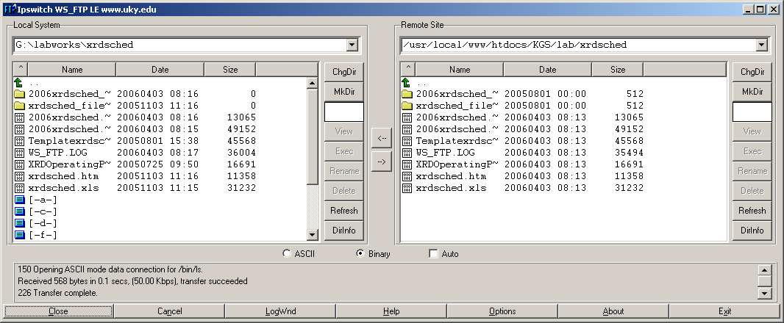

Next, highlight the two files and the folder associated with 2006xrdsched…..
- 2006xrdsched_files
- 2006xrdsched.htm
- 2006xrdsched.xls
- you can also choose WS_FTP.LOG, but is not necessary

Then click the RIGHT facing arrow in the center of the box to transfer the files to the server.
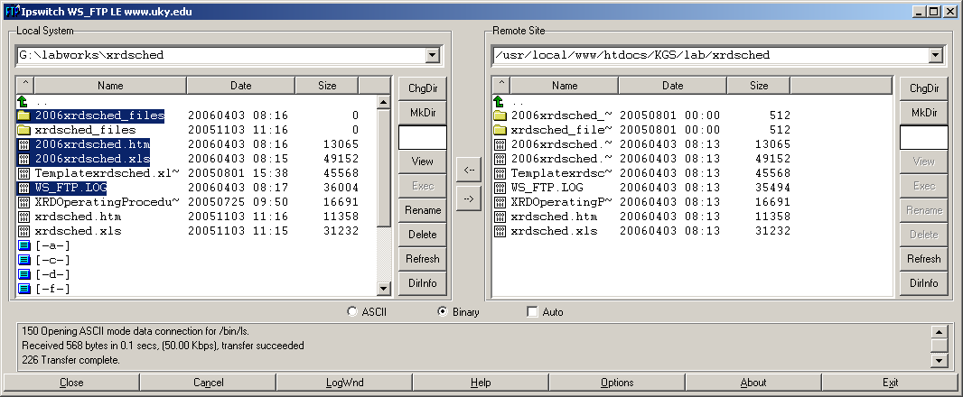

Click yes to verify that you want these files transferred.

NOTE:
If a box appears stating a newer version of a file already exits, do you want to transfer anyway, choose the Yes To All box.

When the transfer is complete, a tone will sound and you will see:
226 Transfer complete in the dialog box.

Click Exit.

