Business Office
Email: CHS-Business-Orders@uky.edu
Link: https://www.uky.edu/chs/ofa/online-order-forms

How To Process a Payment Works Application

All orders should flow through the Division’s Staff Support

- Log into myUK.
- Click the Enterprise Services tab.
- Click the sub heading “PaymentWorks” tab. A screen will open and click the “Vendor Master Updates”.
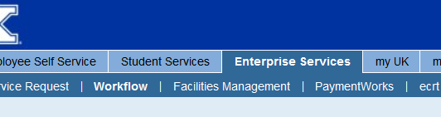
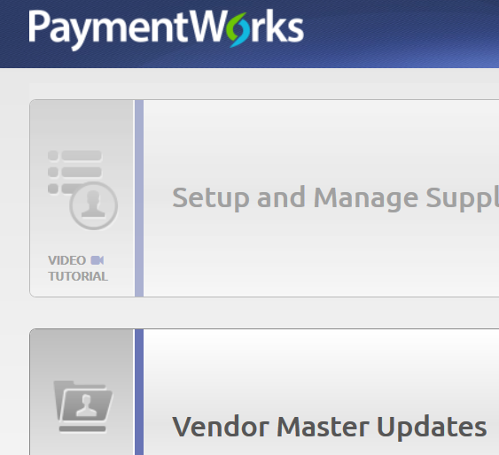

- On the left hand side at the bottom, click the “Send Invitation” button.
- Enter the Company/Individual Name
- Enter the Contact Email
- Enter the Contact Email again to verify
- When prompted “is this a UK employee” cancel if yes, scroll down and continue if no.
- A suggestion for the Personalized Message – “Please take about 30 minutes to complete this free registration to be paid by check from the University of Kentucky _______ Program or Research Project.”
- Click “Send”
- Follow up with an email to the new vendor explaining that this is a free service and required for payment by check.
- Let the vendor know that they can follow up with Payment Works directly if they encounter issues with the process by email to support@paymentworks.com.
- Tell the vendor that the process will take about 30 minutes to complete.
- They will be creating a log in and password so once they have registered with Payment Works, they can log in and update their address and submit to UK for it to be updated.
- For tax purposes, most of our vendors are individuals and click the first radio button as “yes.”
- They will need their Social Security number or Federal Id number available when they begin this process.
- We ask that the vendor continue the registration process until they receive an email with this screen.
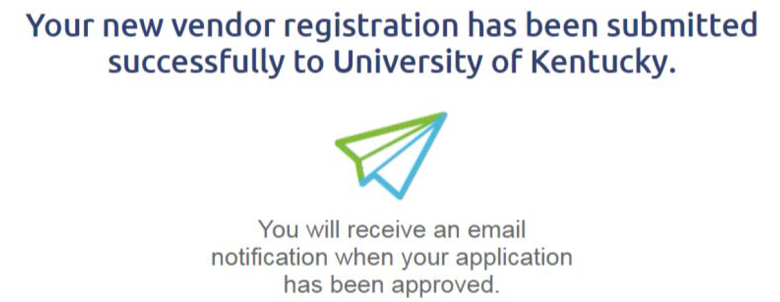

- Please remember to log back in to myUK and look at the system for updates on the process. If you are working on this for your analyst, let her know when this is approved or completed with a vendor number.

- Attached documents from Purchasing with more information on Payment Works.
- Frequently asked questions:

- Quick Reference Card

