SECTION 230900S03 - AUTOMATIC TEMPERATURE CONTROLS

PART 1 - GENERAL

RELATED DOCUMENTS:

Drawings and general provisions of the Contract, including General and Supplementary Conditions, General Mechanical Provisions and General Requirements, Division 1 Specification Sections apply to the work specified in this section.

DESCRIPTION OF WORK:

Furnish a BACnet system compatible with existing University systems. All building controllers, application controllers, and all input/output devices shall communicate using the protocols and network standards as defined by ANSI/ASHRAE Standard 135-2001, BACnet. This system shall communicate with the University of Kentucky Facility Management’s existing BACnet head-end software using BACnet/IP at the tier 1 level and BACnet/MSTP at the tier 2 level. No gateways shall be used for communication to controllers installed under section. BACnet/MSTP or BACnet/IP shall be used for all other tiers of communication. No servers shall be used for communication to controllers installed under this section. If servers are required, all hardware and operating systems must be approved by the Facilities Management Controls Engineering Manager and/or the Facilities Management Information Technology Manager.

All Building Automation Devices should be located behind the University firewall, but outside of the Medical Center Firewall and on the environmental VLAN.

Provide all necessary hardware and software to meet the system’s functional specifications. Provide Protocol Implementation Conformance Statement (PICS) for Windows-based control software and every controller in system, including unitary controllers. These must be in compliance with Front End systems PICS and BIBBS and attached Tridium PICS and BIBBS. Provide all hardware and software to backup, restore, troubleshoot and install system. Software, backups, unitary, and ASC files shall be delivered to UEM (Utilities & Energy Management) for archiving purposes.

It is the contractor’s responsibility to insure that the University of Kentucky Facilities Management’s head-end system’s licensed device/point count is increased to accommodate the number of devices and/or points that are added to fulfill the contractor’s obligation to meet the requirements of the project.

Prepare individual hardware layouts, interconnection drawings and software configuration from project design data.

Design, provide, and install all equipment cabinets, panels, data communication network cables needed, and all associated hardware.

Provide and install all interconnecting cables between supplied cabinets, application controllers, and input/output devices.

Provide complete manufacturer’s specifications for all items that are supplied. Include vendor name of every item supplied.

Provide supervisory specialists and technicians at the job site to assist in all phases of system installation, startup, and commissioning.

Provide a comprehensive operator, administrator and technician training program as described herein.

Provide as-built documentation, programming software for use site wide, electronic copies of all diagrams, and all other associated project operational documentation (such as technical manuals on approved media, the sum total of which accurately represents the final system.

Furnish, install, and fit-up in complete working order, with all accessories required, the automatic temperature control and monitoring systems shown on the Drawings and specified herein. The systems shall be properly connected, piped and wired in a manner conforming to the laws, ordinances and codes now in force in the Commonwealth of Kentucky.

The controls and all listed I/O points from this project shall communicate with the University of Kentucky Facilities Management’s existing BACnet software head-end station using BACnet/IP. All BACnet points shall be exposed to the University of Kentucky Facilities Management’s head-end station. Graphics will be installed by UEM on the head-end system. All point and device names shall comply with the University Facilities Management standards and shall be approved before and included in the shop drawings submittal. Cooperate with the Owner (UEM) to ensure that all specified points and alarms communicate and operate on the head-end system. All point and device names shall comply with the University Facilities Management standards (format listed below, consult Utilities and Energy Management (UEM) for the correct abbreviations) and shall be included in the shop drawings submittal for review and approval. Point naming conventions and formats are listed further in this specification in the Direct Digital Controls Equipment section. Refer to University Standard 230553S02 for the AHU Naming Convention.

Related to the alarms, the contractor is to set up the alarm parameters specified by the system sequences of operations without enabling the alarms. Contractor is to provide a list of points containing alarm extensions to Owner (UEM). UEM will be responsible for doing the alarm names, alarm texts and enabling the alarm points provided on the list.

All work must be coordinated and scheduled with the UEM Controls group prior to any work being done on site.

Thermostats: Each terminal unit requires a thermostat for operation, unless specifically indicated on the Drawings to be slaved to another unit. Slaved terminal units shall be controlled to match the CFM and discharge air temperature of the master unit. Thermostat locations have been identified on the Drawings to the extent possible, but all such locations may not be shown. Provide the required thermostats whether or not shown on the Drawings. For those thermostats not shown on the Drawings, work out an acceptable location with the Architect/Engineer. Thermostats are to be provided with no doors.

Provide DDC controls for the air terminal units. Provide electronic operators controlled and monitored by direct digital control systems which shall include, but not be limited to, air handling systems, pumps, terminal units, etc.

The control equipment shall be complete and shall include, but not be limited to, all necessary valves, damper operators, pipe, fittings, etc.

Electronic Control System installer must physically demonstrate to Owner and Owner's representatives (UEM) via software simulations that the proposed building automation system and control sequences will function as outlined in the contract documents prior to field implementation.

Provide VFD’s as specified in other sections.

The control and monitoring system for this project shall be made up using standard materials, equipment and components regularly manufactured for systems of this type. The system shall be complete in every respect and shall be a functioning system.

Electrical power wiring and interlock wiring for all controls, signal devices, equipment, alarms, etc., shall be in accordance with diagrams and instructions from the supplier of the systems. All power and control wiring, conduit and wiring connections required for the complete installation, including wiring to smoke dampers and combination fire/smoke dampers and their motors, shall be provided by this Contractor in accordance with Electrical specification requirements. Controls shall be on emergency power.

Refer to other Mechanical Division sections for installation of instrument wells, valve bodies, and dampers in mechanical systems; not work of this section.

QUALITY ASSURANCE:

Manufacturer: Subject to compliance with requirements, manufacturers offering controls that may be incorporated into the work at Tier 1 BACnet/IP include the following:

Vykon
Johnson Controls
Alerton

Subject to compliance with requirements, manufacturers offering controls that may be incorporated into the work at Tier 2 BACnet/MSTP include the following:

Honeywell
Johnson Controls
Alerton
Distech

Acceptable controls manufacturers shall include any controls manufacturers which utilize a BACnet protocol in accordance with the specification. If the bidding manufacturer is not listed above, documentation for approval as an equal must be submitted 10 days prior to the bid opening date to allow for evaluation by the university.

Installing Contractor: Installing controls contractors must comply with the following requirements:

The installing systems integration contractor has been in the business of installing BACnet controls for the last 5 years minimum. In addition, the installing systems integration contractor needs to demonstrate with documentation that they have provided the controls in a minimum of (3) hospital or university renovation projects of similar size and scope where they utilized a BACnet system.

The systems integration contractor must have on staff the following number of key personnel as a minimum, each with a minimum of 5 years of related BACnet controls installation experience: Project Manager - 2, Controls Applications Engineer - 2, Programmer - 2, Installation Supervisor - 2, Controls Technician - 5.

Prefer contractor staff to include Niagara Tridium AX/N4 certified technicians.

Contractor to have experience with successful integrations of controls with Niagara Tridium systems.

Contractor to have a minimum of 3 years of installation history with the brand of controls being bid.

Contractor must have a help desk operation or staff available for phone contact 24/7 for providing technical support to university staff. Call forward and emergency service numbers are not acceptable during normal business hours.

Codes and Standards:

Electrical Standards: Provide electrical components of pneumatic control systems which have been UL-listed and labeled, and comply with NEMA standards.

NFPA Compliance: Comply with NFPA 90A "Standard for the installation of Air Conditioning and Ventilating Systems" where applicable for controls and control sequences.

Kentucky Building Code: Comply with requirements where applicable for controls.

Provide products of the temperature control system with the following agency approvals:

UL-916; Energy Management Systems
UL-873; Temperature Indication and Regulating Equipment
UL-864; Subcategories UUKL, OUXX, UDTZ; Fire Signaling and Smoke Control Systems
CSA; Canadian Standards Association
FCC, Part 15, Subpart J., Class A Computing Devices

All products shall be labeled with the appropriate approval markings. System installation shall comply with NFPA, NEMA, NEC, Local and National Codes.

SUBMITTALS:

Product Data: Submit manufacturer's technical product data for each control device furnished, indicating dimensions, capacities, performance and electrical characteristics, and material finishes, also include installation and start-up instructions.

A. Shop Drawings, Product Data, and Samples

1. Each submittal shall have a cover sheet with the following information provided: submittal ID number; date; project name, address, and title; BAS Contractor name, address and phone number; BAS Contractor project manager, quality control manager, and project engineer names and phone numbers.
2. Each submittal shall include the following information.
a. BAS riser diagram showing all DDC controllers, network repeaters, and network wiring.
b. One-line schematics and system flow diagrams showing the location of all control devices.
c. Points list for each DDC controller, including: Tag, Point Type, System Name, Object Name, Expanded ID, Display Units, Controller Type, Address, Cable Destination, Module Type, Terminal ID, Panel, Slot Number, Reference Drawing, and Cable Number. The initial shop drawing submittal for review needs to include all point names meeting the naming convention outlined in this specification for UEM approval at the shop drawing phase prior to the contractor beginning any programming.
d. Vendor’s own written description for each sequence of operations, to include the following:
- Sequences shall reference input/output and software parameters by name and description.
- The sequences of operations provided in the submittal by the BAS Contractor shall represent the detailed analysis needed to create actual programming code from the design documents.
- Points shall be referenced by name, including all software points such as programmable setpoints, range limits, time delays, and so forth.
- The sequence of operations shall cover normal operation and operation under the various alarm conditions applicable to that system.
e. Detailed Bill of Material list for each panel, identifying: quantity, part number, description, and associated options.
f. Control Damper Schedules. This spreadsheet type schedule shall include a separate line for each damper and a column for each of the damper attributes, including: Code Number, Fail Position, Damper Type, Damper Operator, Blade Type, Bearing Type, Seals, Duct Size, Damper Size, Mounting, and Actuator Type.
g. Control Valve Schedules. This spreadsheet type schedule shall include a separate line for each valve and a column for each of the valve attributes, including: Code Number, Configuration, Fail Position, Pipe Size, Valve Size, Body Configuration, Close off Pressure, Capacity, Valve CV, Calc CV, Design Pressure, Actual Pressure, and Actuator Type.
h. Cataloged cut sheets of all equipment used. This includes, but is not limited to, the following: DDC panels, peripherals, sensors, actuators, dampers, and so forth.
i. Range and scale information for all transmitters and sensors. This sheet shall clearly indicate one device and any applicable options. Where more than one device to be used is on a single sheet, submit two sheets, individually marked.
j. Hardware data sheets for all local access panels.
k. Software manuals for all applications programs to be provided as a part of the programming devices, and so forth for evaluation for compliance with the performance requirements of this Specification.
l. The controls contractor shall include their BACnet PICS and BIBB statements (as described in ASHRAE 135-2001) for each device.
3. BAS Contractor shall not order material or begin fabrication or field installation until receiving authorization to proceed in the form of an approved submittal. BAS Contractor shall be solely responsible for the removal and replacement of any item not approved by submittal at no cost to the Owner.
4. Submittal shall have approved point names.

Maintenance Data: Submit maintenance instructions and spare parts lists for each type of control device. Include that type data, product and shop drawings in maintenance manual.

Operation and Maintenance Instructions:

This contractor shall prepare an electronic Operations Manual entitled "Automatic Temperature Control and Monitoring Systems Operation and Maintenance Data." Manual shall be PDF files with separate PDFs for each of the items noted below.

Each manual shall contain the following information:

Name and address of Consulting Engineer, Contractor, and index of equipment, including vendor (name and address).

Complete brochures, descriptive data and parts list, etc., on each piece of equipment, including all approved shop drawings.

Complete maintenance and operating instructions, prepared by the manufacturer, on each major piece of equipment, including preventative maintenance instructions.

Complete shop drawing submittal on temperature and monitoring controls including control diagrams updated to reflect "as-built" conditions.

All wiring and component schematics necessary for Owner (UEM) to troubleshoot, repair and expand the system.

All manuals shall be submitted to the Engineer prior to final inspection of the building.

Provide a laminated copy mounted in a sleeve on the outside of the panels for the controls sequences pertinent to equipment supplied by that specific controls panel.

Controls Program Backup: At the end of the project, the contractor is to supply digital back-up copies of all final complete operating controls programs. These shall be delivered to UEM for archiving purposes.

DELIVERY, STORAGE AND HANDLING:

Provide factory shipping cartons for each piece of equipment and control device. Maintain cartons while shipping, storage and handling as required to prevent equipment damage and to eliminate dirt and moisture from equipment. Store equipment and materials inside and protect from weather.

PART 2 - PRODUCTS

DIRECT DIGITAL CONTROL SYSTEM

General: This specification defines the minimum hardware and performance requirements for a computer-based building automation system to be furnished and installed.

SCOPE OF WORK:

System Requirements:

Contractor shall provide all equipment, engineering and technical specialist time to check the installation required for a complete and functioning system. The contractor shall furnish and install all interconnecting system components. Components to include, but not be limited to: power line conditioners, field panels, sensors, motor starter interfaces, and any other hardware items not mentioned above but required to provide the Owner with a complete workable system.

Any feature or item necessary for complete operation, trouble-shooting, and maintenance of the system in accordance with the requirements of this specification shall be incorporated, even though that feature or item may not be specifically described herein. This shall include hardware and software.

All materials and equipment used shall be standard components, regularly manufactured for this and/or other systems and not custom designed especially for this project. All systems and components shall be thoroughly tested and proven in actual use.

Input/Output Summary:

The system as specified shall monitor, control and calculate all of the points and functions as listed in the Input/Output Summary.

System Start-Up and Acceptance:

Upon completion of the installation, the BAS Contractor shall start-up the system and perform all necessary testing and debugging operations. An acceptance test in the presence of the Owner's representative shall be performed. The vendor shall check all sensors that exhibit any problems or faulty reading. When the system performance is deemed satisfactory in whole by UEM, the system parts will be accepted for beneficial use and placed under warranty. The BAS Contractor is to be available for system commissioning at the end of the installation when requested by the Engineer and/or Owner. The contractor is to also be available for seasonal commissioning for the other seasons beyond the initial commissioning.

This Contractor shall work with the Owner (UEM), who is developing the graphics, to ensure that all points report, function and alarm as required on the BACnet head-end system. The Contractor will also work with the Project Manager or CNS/MCIS to obtain all necessary IP’s and Ethernet drops needed for BACnet panel. The Owner (UEM) will assign all BACnet/IP instance numbers and all BACnet/MSTP network numbers for use by the Contractor. All BACnet/IP devices will report directly to the head-end system.

UEM will be performing their own complete point by point evaluation as part of this project, independently of the commissioning activity. This will occur during the warranty period of the project.

Facilities Management’s Instruction:

The BAS Contractor shall provide two copies of an electronic version of the operator's manual describing all operating and routine procedures to be used with the system. This user's manual should contain subjects such as: standard operation, error message explanations, software usage, commands, system troubleshooting, etc. The Contractor shall also provide wiring schematics for all system components.

EDIT THE NUMBER OF REQUIRED HOURS FOR SMALL PROJECTS. OTHERWISE THIS COULD ADD SIGNIFICANT COST.

The BAS Contractor shall instruct the Owner's designated representatives in these procedures during the start-up and test period. The duration of the instruction period shall be no less than four (4) hours during two 2 hour sessions. (Number of hours may be adjusted to a max of 40 dependent upon the size and scope of project. For larger projects, training vouchers for instructional training at the manufacturer’s facilities may be requested in lieu of on-site training.) These instructions are to be conducted during normal working hours at the Owner's convenience and are to be prearranged with the Owner. The owner can request this training any time within the one year warranty period and may request any number of classes adding up to the total number of hours. The contractor shall provide an hourly unit price for additional on-site training.

The instructions shall consist of both hands-on at the job site and classroom training at a classroom location on the University of Kentucky campus coordinated with the Project Manager and UEM.

Upon completion, the attendees shall be able to operate the system and implement system changes including start-up, boot load, add point to the data base, enter messages, and down line load field units.

Prior to the scheduling of the sessions, an agenda outlining the training topics must be submitted for approval. Agenda items shall include, but not be limited to, the following topics:

- Explanation of control sequences. Include which sensors are used and how output device operates.
- Explanation of control drawings and manuals, including symbols, abbreviations, and overall organization.
- Walk-through of project to identify controller locations and general routing of network cabling.
- Review of operation and maintenance of hardware devices including air compressor, air dryers, controllers, instruments, and sensors. Include schedule for routine maintenance.
- Programming Application Specific Controllers
        - Backing up and Restoring Application Specific Programming
        - Adding/Deleting/Editing points on Application Specific controllers
        - Troubleshooting Application Specific controllers (inputs/outputs/logic/master – slave relationships/bus issues)
- Programming Building Specific Controllers
        - Backing up and Restoring Building Specific Controllers Programming
        - Adding/Deleting/Editing points on Building Specific Controllers controllers
        - Troubleshooting Building Specific Controllers controllers (inputs/outputs/logic/network issues)
- How to use tools and cables

Warranty:

The system including all hardware and software components shall be warranted for a period of one year when the system performance is deemed satisfactory in whole by UEM. The system parts will be accepted for beneficial use and placed under warranty at that time. A Certificate of Occupancy does not initiate the control system warranty. Any defects in materials and workmanship arising during this warranty period shall be corrected without cost to the Owner.

All applicable software as detailed in this specification shall be updated by the BAS Contractor free of charge during the warranty period. This will ensure that all system software will be the most up-to-date software available from the BAS Contractor.

DIRECT DIGITAL CONTROL (DDC) EQUIPMENT

System Software

All software required for monitoring, modifying, configuring and backup for the system shall be embedded in the controller and accessible via VT terminal, hyper-terminal or the web. This software shall allow any computer with access (and security) to the University’s network to perform the work described above using a web browser or provided software. No software upgrades should be required unless provided at no additional cost to the customer. The software version used for installation of any new devices must either be at the current software version used on the University Facilities Management campus at the current JAVA version or the new software at the most current JAVA version must be installed on all devices and the current system prior to the installation of the new devices. All software is to also operate on the latest version of Microsoft Windows operating system. All configuration and programming tools required for the upgraded version must be provided at the time of installation.

Provide a USB, standard RS-232 9 pin female, Bluetooth, RJ11, RJ12 or RJ45 connection for on-site access.

BACnet Conformance

Building Controller shall as a minimum support MS/TP and Ethernet BACnet LAN types. It shall communicate directly via these BACnet LANs as a BACnet device and shall support simultaneous routing functions between all supported LAN types. Global controller shall be a BACnet conformance class 3 device and support all BACnet services necessary to provide the following BACnet functional groups:

- Clock Functional Group
- Files Functional Group
- Reinitialize Functional Group
- Device Communications Functional Group
- Event Initiation Functional Group

Please refer to end of this section for a complete list of the services that must be directly supported to provide each of the functional groups listed above. All proprietary services, if used in the system, shall be thoroughly documented and provided as part of the submittal data.

Standard BACnet object types supported shall include as a minimum: Analog Value, Binary Value, Calendar, Device, File, Group, Notification Class, Program and Schedule object types. Alarms should also be setup on this system with limits. All proprietary object types, if used in the system, shall be thoroughly documented and provided as part of the submittal data.

The Building Controller shall comply with Annex J of the BACnet specification for IP connections. This device shall use Ethernet to connect to the IP internetwork. It must support interoperability on the campus area network and function as a BACnet Broadcast Management Device (BBMD) and/or a BACnet router.

Building Controller (B-BC)

General

Building Controller (B-BC) shall be minimum 16 bit microcomputer based, utilizing a multi-tasking, multi-user operating system.

The B-BC controllers shall permit the simultaneous operation of all control, communication facilities management and operator interface software, as programmed by the Contractor or User. Modification of the on-board B-BC controller database shall be performed on-line using the built-in software. Systems which require the B-BC to be removed from service while DDC control sequences are modified shall not be acceptable.

B-BC controllers shall utilize true floating point arithmetic capabilities.

All B-BC controllers shall have open licensing to connect to existing UK UEM Tridium BACnet BAS.

Databases and Memory Back-Up

All programming defining the functions to be performed by the B-BC, including but not limited to application programs and point database within each B-BC, shall be protected from loss due to power failure for a minimum of 72 hours. All database and backup shall be provided to the UK UEM Controls group.

Service Ports

B-BC controllers shall be equipped with a minimum of one operator service port for the connection of a laptop computer. The service port shall be either a built-in standard RS-232 data terminal port, USB port, CAT5 cable or RJ11/12 connection.

Connection of a service device, to a service port, shall not cause the B-BC controller to lose communications with its peers or other networked device controllers.

Display and Readout Capability

The B-BC controller shall additionally provide diagnostic LED indication of device transmit and receive data communications for all communication port and peripheral ports, normal operation, abnormal operation and control relay operation indication.

Manual/Auto Control and Notification

The B-BC controller shall provide commanded override capability from the built-in operator interface. Such overrides shall be annunciated to the head-end station. Such overrides shall be valid as long as power is applied to the controller.

Adjustments

Every control panel shall provide adjustments for the functions specified. In general, adjustments shall be provided for all setpoints used by controllers within each control panel. In addition, adjustments shall be provided for throttling ranges, mixed air damper minimum positions, or other items as specified. Adjustments shall be integral to each individual B-BC. The built-in operator interfaces shall allow the easy execution of the adjustment through named identifiers within the B-BC. From a single B-BC user interface, any other B-BC shall be accessible and full adjustment capabilities shall be provided.

B-BC Naming Convention

B-BC devices shall be named using the following naming convention:

B-BC devices shall be named using the following format:
BuildingName_BuildingNumber_Floor_RoomNumber_B-BC Device Type OR
BuidlingNumber_BuildingName_Floor_RoomNumber_B-BC Device Type

All B-AAC points shall be named using the following format:
Building_Floor_RoomNumber_Device Type_Equipment ShortName_Function

Examples:

A B-BC device located in the Pavilion HA mechanical room HA4001 would be named as follows:

PAVHA_0293_04_HA4001_JACE

An exhaust fan status point for a fan in Pavilion HA mechanical room HA3001 fed directly from the above panel would be named as follows:

PAVHA_03_HA3001_HVA_EF1_STAT

For function short names and building short names and numbers, contact the University Controls Engineering Department.

Advanced Application Controller (B-AAC)

General

Controls shall be microprocessor based, Advanced Application Controllers (B-AAC’s). B-AAC’s shall be provided for Air Handling Units, packaged Rooftops, primary and secondary pumping loop systems and other applications as shown on the drawings. B-AAC’s shall be based on a minimum 16 bit microprocessor working from software program memory which is physically located in the B-AAC. The application control program shall be resident within the same enclosure as the input/output circuitry which translates the sensor signals. All input/output signal conversion shall be performed through a minimum of a 10 bit A to D converter. All input points shall be universal in nature allowing their individual function definition to be assigned through the application software. All unused input points must be available as universally definable at the discretion of the owner. If the input points are not fully universal in nature, unused points must be equal in quantity between Analog Inputs and Digital Inputs.

All B-AAC controllers shall have open licensing to connect to existing UK UEM Tridium BACnet BAS.

Contractor shall provide a minimum of one B-AAC controller per air handling or mechanical system as shown on the drawings.

The BAS contractor shall provide and field install all B-AAC’s specified under this section. Mechanical equipment manufacturers desiring to provide B-AAC’ type controls as factory mounted equipment, shall provide a separate bid for their products less all controls, actuators, valve assemblies and sensors, which are specified to be provided by the BAS/Temperature control contractor.

All input/output signals shall be directly hardwired to the B-AAC. Troubleshooting of input/output signals shall be easily executed with a volt-ohm meter (VOM). As a result of this intent, it is specified that power line carrier systems, or other systems which command multiple outputs over a single pair of wires, shall not be utilized.

B-AAC’s shall be in continuous direct communication with the network which forms the facility wide Building Automation System. The B-AAC’s shall communicate with the B-BC at a minimum baud rate of 9,600 baud.

Non-Volatile Memory

All control sequences programmed into the B-BC shall be stored in non-volatile memory, which is not dependent upon the presence of a battery, to be retained. Power failures shall not cause the GDC memory to be lost, nor shall there be any need for batteries to be recharged or replaced to maintain the integrity of the controller database. The B-BC shall allow for the creation of unique application control sequences. Systems that only allow selection of sequences from a library or table are not acceptable.

All control sequences shall be fully programmable at the B-AAC, allowing for the creation and editing of an application control sequence, while at the unit.

The B-AAC shall be provided with an interface port (standard RS232 data terminal port or USB port) for a laptop computer. The interface port shall allow the laptop to have full functionality as described above. From the interface port or network terminal, the laptop shall be able to directly access any B-AAC or B-ASC in the network.

The B-AAC shall provide an input/output point trending utility that is capable of accumulating 48 analog point samples and 10 digital point samples, per Input/Output point. Each sample shall be taken on a user defined interval, ranging from 1 second to 255 hours per sample. The digital readings shall be on a change of state occurrence for the digital points. All samples shall be recorded with the engineering units for the value, along with a time and date identifier for each sample taken. The samples shall be protected against loss due to power interruptions through a battery or capacitor backup method for a minimum of 30 days.

Systems unable to provide the above capability shall provide for the individual Input/Output point trending at the B-BC. Specifics as to how each B-AAC point will be trended, at the B-BC, shall be provided in the submittal documents. Included in the explanation shall be the sample intervals, the memory allocation in the B-BC and the number of B-AAC’s per B-BC that can be expected.

The B-AAC shall provide LED indication of transmit/receive communications performance, as well as for the proper/improper operation of the controller itself.

The B-AAC shall be provided with a battery backed time clock that is capable of maintaining the time of day and calendar for up to thirty days, upon loss of power to the B-AAC, without loss of setting. The battery for the time clock shall be replaceable by the customer. The B-AAC shall be provided with integral time schedules; as a minimum, two seven day schedules with eight on/off periods per day shall be provided. Holiday override of weekly schedules shall be provided for pre-scheduling of holidays, for the year in advance.

Controller Location

To simplify controls and mechanical service troubleshooting, the B-AAC shall be capable of being mounted directly in or on the controls compartment of the air handling system. The B-AAC shall be housed in a NEMA 1 enclosure to accommodate direct mounting on the equipment to be controlled. The B-AAC shall be constructed in a modular orientation such that service of the failed components can be done quickly and easily. The modular construction should limit the quantities of printed circuit boards to a maximum of two. All logic, control system, power supply and input/output circuitry shall be contained on a single plug-in circuit board. When required to replace a printed circuit board, it shall not be necessary to disconnect any field wiring. This shall allow all controls maintenance and troubleshooting to be made while at the air handling unit. The B-AAC shall be directly wired to sensory devices, staging relays or modulating valves for heating and cooling.

Every controller and control panel shall be labeled with a lamacoid plate permanently secured to the device. Sticky tape or glued labels are not acceptable. The labeling shall describe the device and include related information such as MAC address, IP address, BACnet Instance numbers, etc.

All power feeds shall be clearly identified and shall include panel number, breaker and electrical panel location if not in the same room.

For compatibility to the environment of the air handling unit, B-AAC’s shall have wide ambient ratings. B-AAC’s shall be rated for service from -40 DegF (Degrees Fahrenheit) to 140 DegF.

Contractor shall submit description of location of B-AAC’s on all mechanical and air handling equipment.

B-AAC Naming Convention

B-AAC devices shall be named using the following naming convention:

B-AAC devices shall be named using the following format:
Building_Floor_RoomNumber_B-AAC Device Type_Equipment Short Name

All B-AAC points shall be named using the following format:
Function

Examples:

An Air Handler controller in the Pavilion HA mechanical room HA4001 for AHU7 would be named as follows:

PAVHA_04_HA4001_HVA_AHU7

The mixed air temperature point for the above system would be named as follows:

MAT

Therefore, when this point is learned, the entire point name will be:

PAVHA_04_HA4001_HVA_AHU7_MAT

For function short names and building short names and numbers, contact the University Controls Engineering Department.

Application Specific Controller (B-ASC)

General

Controls shall be microprocessor based Application Specific Controller (B-ASC). B-ASC’s shall be provided for Unit Ventilators, Fan Coils, Heat Pumps and other applications as shown on the drawings. B-ASC’s shall be based on a minimum 16 bit microprocessor working from software program memory which is physically located in the B-ASC. The application control program shall be resident within the same enclosure as the input/output circuitry which translates the sensor signals. All input/output signal conversion shall be performed through a minimum of a 10 bit A to D converter.

Contractor shall provide a minimum of one B-ASC controller per unitary system as shown on the drawings.

The BAS contractor shall provide and install all B-ASC’s specified under this section.

All input/output signals shall be directly hardwired to the B-ASC. Troubleshooting of input/output signals shall be easily executed with a volt-ohm meter (VOM). As a result of this intent, it is specified that power line carrier systems, or other systems which command multiple outputs over a single pair of wires, shall not be utilized.

B-ASC’s shall be in continuous, direct communication with the network which forms the facility wide building automation system. The B-ASC’s shall communicate with the B-BC at a baud rate of no less than 38,400 baud.

Non-Volatile Memory

All control sequences programmed into the B-ASC shall be stored in non-volatile memory, which is not dependent upon the presence of a battery, to be retained. Power failures shall not cause the B-ASC memory to be lost, nor shall there be any need for batteries to be recharged or replaced to maintain the integrity of the controller database. The B-ASC shall allow for the creation of unique application control sequences.

The B-ASC shall be provided with the ability to interface with a laptop computer. The interface port shall be provided at the wall sensor or within the unitary equipment. Connection to the wall sensor must be a standard RJ-45 or USB port.

The B-ASC shall provide an input/output point trending utility that is capable of accumulating 48 analog point samples and 10 digital point samples per Input/Output point. Each sample shall be taken on a user defined interval, ranging from 1 second to 255 hours per sample. The digital readings shall be on a change of state occurrence for the digital points. All samples shall be recorded with the engineering units for the value, along with a time and date identifier for each sample taken.

Systems unable to provide the above capability shall provide for the individual input/output point trending at the B-BC. Specifics as to how each B-ASC point will be trended, at the B-BC, shall be provided in the submittal documents. Included in the explanation shall be the sample intervals, the memory allocation in the B-BC and the number of B-ASC’s per B-BC that can be expected.

Controller Location

To simplify controls and mechanical service troubleshooting, the B-ASC shall be mounted directly in the controls compartment of the unitary system. The B-ASC shall be provided with a sheet metal or polymeric enclosure that is constructed of material allowing for the direct mounting within the primary air stream, as defined by UL-465. The direct mounting shall allow all controls maintenance and troubleshooting to be made while at the unitary equipment. The B-ASC shall be directly wired to sensory devices, staging relays or modulating valves for heating and cooling.

For compatibility to the environment of the unitary equipment, B-ASC shall have wide ambient ratings. B-ASC’s shall be rated for service from 32 DegF (Degrees Fahrenheit) to 140 DegF.

Contractor shall submit description of location of B-ASC’s on all mechanical and unitary equipment.

B-ASC Naming Convention

B-ASC devices shall be named using the following naming convention:

B-ASC devices shall be named using the following format:
Building_Floor_RoomNumber_B-ASC Device Type

All B-ASC points shall be named using the following format:
Function

Examples:

A VAV controller in the Pavilion HA room HA498 would be named as follows:

PAVHA_04_HA498_VAV

The discharge air temperature point for the above room would be named as follows:

DAT

Therefore, when this point is learned, the entire point name will be:

PAVHA_04_HA498_VAV_DAT

For function short names and building short names and numbers, contact the University Controls Engineering Department.

CONTROL PANELS

Panelboard shall contain all instruments and accessories. Provide each item of equipment with an engraved nameplate. Panelboard shall be wall-mounted or stand-mounted and shall be completely enclosed.

As far as is practical, the control components for each system shall be grouped. Provide each group of components with identification.

The entire panelboard shall be pre-wired and brought to a main terminal strip. All relays, switches, etc., shall be installed, furnished and wired on panelboard. Clearly mark each terminal strip as to which wire from which component is to be connected.

Fabricate panels of 0.06-inch- (1.5-mm-) thick, furniture-quality steel or extruded-aluminum alloy, totally enclosed, with hinged doors and keyed lock, with manufacturer's standard shop-painted finish and color.

Panel-Mounted Equipment: Temperature and humidity controllers, relays, and automatic switches; except safety devices. Mount devices with adjustments accessible through front of panel.

Door-Mounted Equipment: Flush-mount (on hinged door) manual switches, including damper-positioning switches, changeover switches, thermometers, and gages.

Graphics: Color-coded graphic, laminated-plastic displays on doors, schematically showing system being controlled, with protective, clear plastic sheet bonded to entire door.

SENSORS

Electronic Sensors used in air ducts or liquid lines shall utilize non-adjustable RTD or thermostat sensing elements with + or -0.36ºF, accuracy and stability of at least + or -0.05ºF per year. All sensors used in liquid line shall be provided with separable stainless steel immersion wells. Averaging sensors shall be a minimum of five (5) feet in length, and shall be installed in such a manner so as to sense representative sample of the medium being controlled.

Equipment Operation Sensors: As follows:

Status Inputs for Fans: Differential-pressure switch with adjustable range set to 175 percent of rated fan static pressure. A hawkeye sensor should also be provided so that the owner knows if belts are lost or fans are running backwards.

Status Inputs for Electric Motors: Current-sensing relay with current transformers, adjustable and set to 175 percent of rated motor current.

Digital-to-Pneumatic Transducers: Convert plus or minus 12-V dc pulse-width-modulation outputs (preference is 4-20mA or 0-10 Volts), or continuous proportional current or voltage to 0 to 20 psi (0 to 138 kPa).

Damper Position Indication: Potentiometer mounted in enclosure with adjustable crank-arm assembly connected to damper to transmit 0 to 100 percent damper travel.

SENSOR INPUT AND OUTPUT DEVICES:

The following sensors and devices, or their equivalents, shall be considered acceptable. Other sensors and devices required for this specification are outlined in their respective subsystem.

Analog sensing elements for remote indication shall be independent of local pneumatic sensors used for local control loops.

System Accuracy: The system shall maintain an end-to-end accuracy for one year from sensor to operator’s console display for the application specified.

STANDARD Temperature Sensors

TYPE Electronic

APPLICATION BAS, HVAC, BTU, Boiler Control

STANDARD 100 or 1000 ohm platinum wire wound RTD
element
Standard J (3 wire) configuration
European curve, Alpha = .00385
Ohms/Ohm/deg.C., meets DIN SID 43760
Wire in conduit

MECHANICAL 1/4" stainless steel sheath

SPACE TEMPERATURE Sensor housing to be similar in appearance to existing thermostats except that thermometers are not required. Similarity to be Owner's decision. Locate on an outside wall if possible.

DUCT TEMPERATURE Standard lengths -- 5.5", 11.5" and 17.5"

Other lengths with owner's written approval.

Locate in central area of airstream at minimum of 18” from
reheat coil.

1/2" NPT mounting thread and flange and conduit connection.

Glass encapsulated element unless otherwise approved.

THERMOWELL Drilled brass or stainless steel or brass fitting with stainless steel sheath built-up well with Owner approval.

Glass encapsulated element unless otherwise approved.

3/4" process connection with drilled wells.

1/2" NPT process connection on built-up wells.

Insertion into measured medium - 1" + 1/2" diameter of pipe.

Cast iron connector head - 1/2" NPT process connection and conduit connection.

Rated thermowell pressure = 250 psi.

ELEMENT ACCURACY must meet .1% DIN and the DIN 43760 standard.

OVERALL ACCURACY + 1 deg.F. General duct, space and thermowell temperatures.
+ .75 deg.F. for thermowell ele. on 4" or larger pipes.
+ .5 deg.F. for thermowell ele. on 8" or larger pipes.

OVERALL RANGE -20% to l20% of possible operating conditions.

GENERAL NOTE If wires from RTD probe to DGP are to be more than 200 feet long, provide extra large cast iron connector head (nominal size 2-11/16 x 1/4) or junction box to accommodate a resistance to 4-20 mA convertor transmitter.

STANDARD Pressure Sensor

TYPE Electronic with LVDT element.

APPLICATION 4-20 mA Output (2 wire)
Wire in conduit
Input voltage 10-35 volts DC
Loop resistance greater than or equal to 500 ohms

MECHANICAL Linear variable differential transformer
(LVDT) element
Allowable Standard Ranges 0- 30 PSI
0-100 PSI
0-200 PSI
Other ranges with Owner written approval
1/2" NPT input thread and conduit connection.
Provide differential inputs unless otherwise approved.
Provide an air filter on unused differential ports.
Provide with a NEMA 4 watertight enclosure unless otherwise approved.
Min. rate pressure - l50% FS proof and 450 PSI static.

OVERALL ACCURACY + 0.5% F.S. including Linearity, hysteresis and repeatability.

ACCURACY NOTE: If pressure transducer is used to calculate flow with a pilot tube, then the accuracy of the pressure sensor should be dictated by the overall accuracy requirement of the system and would probably require a high accuracy sensor.

This section covers all new transducers provided. All new transducers provided shall be of the following type:

INPUT OUTPUT

l. Temperature (deg.F.) 4-20 mA, 2 wire
Temperature (deg.F.) 100 ohm platinum wire RTD

2. Pressure 4-20 mA, 2 wire

3. Flow Instantaneous 4-20 mA, 2 wire

4. Flow Integrated Pulse 10 PPS Max A25
msec open (min.) 40 msec
closed (min.)

5. KW Instantaneous 4-20 mA, 2 wire

6. KWH - Integrated Pulse – 10 PPS Max A25
msec open (min.) 40 msec
closed (min.)

Digital inputs from devices with isolated, dry type contacts (no grounds, no voltage) of either normally open (N.O.) or normally closed (N.C.) configuration. Live contact inputs, those that have voltage present, shall be provided with isolating devices to meet dry contact requirement.

THERMOSTATS:

Room Thermostats: Provide room thermostats that work in conjunction with the B-AAC and B-ASC terminal unit controllers. Thermostats shall have visible thermometers, setpoint indication and exposed setpoint adjustment in all areas except public spaces. Thermostats are to have push buttons on the front face for adjusting the temperature setpoints. Thermostats are to have no doors.

In cases where a single room sensor is to be shared by multiple controllers the slave box reheat control valves and dampers shall be individually controlled to track the discharge temperature of the master unit. The Master shall be identified locally and on the FMS.

An RJ-11 type connection to serial port shall allow a local portable operator or programmer’s terminal to access all program blocks and attributes for complete programmability.

Room Thermostat Accessories: As follows:

Insulating Bases: For all thermostat installations.

Thermostat Guards: Locking transparent-plastic mounted on separate base.

Adjusting Key: As required for device.

Aspirating Boxes: Where indicated for thermostats requiring flush installation.

DAMPERS:

Provide automatic control dampers as indicated, with damper frames not less than 13-gage galvanized steel. Provide mounting holes for enclosed duct mounting. Provide damper blades not less than formed 16-gage galvanized steel, with maximum blade width of 8".

Secure blades to 1/2" diameter zinc-plated axles using zinc-plated hardware. Seal off against spring stainless steel blade bearings. Provide blade bearings of nylon and provide thrust bearings at each end of every blade. Construct blade linkage hardware of zinc-plated steel and brass. Submit leakage and flow characteristics plus size schedule for controlled dampers.

Do not exceed maximum 48"x48" damper size. For sizes larger then this maximum in either dimension, use multiple dampers with a separate operator for each damper. Do not link separate dampers together.

Operating Temperature Range: From -20 degrees to 200 degrees F. (-29 degrees to 93 degrees C.). The occupant shall have an operation local range of 68 degrees and 74 degrees on rooms with Occupancy sensors.

For standard applications as indicated, provide parallel or opposed blade design (as selected by manufacturer's sizing techniques) with inflatable steel blade edging, or replaceable rubber seals, rated for leakage less than 10 CFM/sq.ft. of damper area, at differential pressure of 4" w.g. when damper is being held by torque of 50 inch-pounds.

Smoke Dampers: Provide smoke and combination fire/smoke dampers in accordance with applicable requirements of Specification Section "Ductwork Accessories".

ACTUATORS:

Electric Valve and Damper Motors: Size each motor to operate dampers or valves with sufficient reserve power to provide smooth modulating action or 2-position action as specified.

For reheat coils in branch ductwork and heating coils for air terminal units and fan terminal units, provide non-spring return, fully proportional, floating valve actuators.

For all other applications, provide permanent split-capacitor or shaded pole type motors with gear trains completely oil-immersed and sealed. Equip spring-return motors, with integral spiral-spring mechanism. Furnish entire spring mechanism in housings designed for easy removal for service or adjustment of limit switches, auxiliary switches, or feedback potentiometer.

Equip motors for outdoor locations and for outside air intakes with "O ring" gaskets designed to make motors completely weatherproof, and equip with internal heaters to permit normal operation at -40 degrees F. (-40 degrees C.)

Provide separate motor for each outside air, return air and exhaust air damper. Do not link dampers with different functions together on one damper motor.

Provide separate motor for each damper when overall damper size exceeds 48" in either dimension. Do not link different dampers together on one damper motor.

Binary backed-up motors are not acceptable.

MISCELLANEOUS:

Wells for Pipe Mounted Sensor: Wells shall have minimum working pressure of 150 WOG psig. Wells shall be brass or stainless steel.

Lightning Protection: All electric/electronic equipment supplied must be internally or externally lightning/transient surge voltage protected on all external power feeder and input/output connections which are subject to surge voltage transients. Provide high speed clamping elements which meet IEEE. STD. 472 (SWC) on all digital or analog date channels.

Pressure Instruments:

Differential Pressure and Pressure Sensors: Sensors shall have 4-20 mA output proportional signal with provisions for field checking. Sensors shall withstand up to 150% of rated pressure, without damaging device. Accuracy shall be within 2% of full scale.

Pressure Switches: Pressure switches shall have repetitive accuracy of +2% of range and withstand up to 150% of rated pressure. Sensors shall be diaphragm or bourdon tube design. Switch operation shall be adjustable over operating pressure range. Switch shall have application rated Form C, snap-acting, self-wiping contact of platinum alloy, silver alloy or gold plating.

Current Sensing Relays: Relays shall monitor status of motor loads. Switch shall have self-wiping, snap-acting Form C contacts rated for application. Setpoint of contact operation shall be field adjustable.

Low Voltage Wiring: Control wiring for analog functions shall be 18 AWG minimum with 600 volt insulation, twisted and shielded, 2 or 3 wire to match analog function hardware.

SELECT PARAGRAPH ABOVE IF ALL WIRING IS REQUIRED TO BE IN CONDUIT. SELECT PARAGRAPH BELOW IF WIRING IS NOT REQUIRED TO BE IN CONDUIT.

Low Voltage Wiring: Wiring for electric or electronic circuits less than 25 volts shall be cabling manufactured for express use in air plenums. The plenum cable shall be 24 gauge or larger as required, tinned copper, Teflon insulated, twisted pairs, shielded or unshielded, as required, a color coded, overall tape wrap, with transparent Teflon jacket, 150V., NEC725, Class 2 classified for use in air plenum non-conduit signaling application.

Manual Override Switches: In case of failure of the DDC system, provide override switches to operate fans, pumps, air handling units, cooling tower, heat exchangers, etc., manually in local interface control panel. Also for temperature and pressure control provide switches to allow supply temperatures, water temperatures, supply air pressure and fans to be manually regulated. All switches shall be located in locked panel to prevent unauthorized use of the manual override switches.

PART 3 - EXECUTION

INSPECTION:

Examine areas and conditions under which control systems are to be installed. Do not proceed with work until unsatisfactory conditions have been corrected in manner acceptable to Installer.

INSTALLATION OF AUTOMATIC TEMPERATURE CONTROLS

General: Install systems and materials in accordance with manufacturer's instructions, roughing-in drawings and details shown on the Drawings.

CONTROL WIRING:

Contact the project manager for all required Ethernet connections for this project.

Install control wiring, without splices between terminal points, color-coded. Install in neat workmanlike manner, securely fastened. Install in accordance with National Electrical Code. Install wiring in electrical conduit in all areas. All controls conduit shall be green in color.

Conceal conduit, except in mechanical rooms and areas where other conduit and piping are exposed.

Install all control wiring with color-coded wire in ¾” minimum size conduit. Wire gauge to be in accordance with National Electrical Code.

KEEP PARAGRAPH ABOVE AND DELETE PARAGRAPH BELOW IF ALL CONTROL WIRING MUST BE RUN IN CONDUIT (STATE AND UK PROJECTS)

Connect electrical components to wiring systems and to ground as indicated and instructed by manufacturer. Tighten connectors and terminals, including screws and bolts, according to equipment manufacturer's published torque-tightening values for equipment connectors. Where manufacturer's torqueing requirements are not indicated, tighten connectors and terminals according to tightening requirements specified in UL 486A.

POWER WIRING:

Provide power wiring and conduit to air terminal units (if required) and to smoke dampers and combination fire/smoke dampers and their damper motors.

Furnish and install power cabling and conduit for temperature controls panels and equipment from emergency power panels. Each temperature control panel shall be connected to a separate circuit. Conduits shall connect to panels at the locations directed by the Contractor under Division 26. Final connection in the power panels shall be by Temperature Control Contractor in coordination with Division 26 Contractor.

MISCELLANEOUS:

Software Programming: All software programs shall be programmed by this Contractor.

Installation of Mechanical Devices: Refer to Mechanical Division sections for installation of valve bodies, control wells and dampers; not work of this section.

ADJUSTMENT AND SERVICE:

After completion of the installation, the automatic temperature control manufacturer shall regulate and adjust all thermostats, control valves, motors, and other equipment provided under his contract and shall place them in complete operating condition, subject to approval by the Engineer and Owner.

This shall include but not be limited to “tuning” of all control systems. Systems shall be tuned for decaying wave response and minimal overshoot of setpoint. Contractor is to not leave any system in an Auto Tune mode.

Room temperature controls shall have one temperature setpoint with less than a 0.5˚F between calculated heating and cooling temperatures.

This Contractor shall work with Balancing Contractor to provide verification of CFM reading from the DDC terminal unit controllers.

Final adjustment shall be performed by specially trained personnel in direct employ of manufacturer of primary temperature control system.

After completion of installation, perform the following:

Installation.
Check proper installation and connection of each control device.
Verify electric power.
Verify each sensor and actuator connection to field computer.

Field Computer Operation.
Point Test.
- check of wiring of each sensor and actuator end-to-end
- verify calibration of each sensor.
- verify manual operation of each actuator.

Local loop control.
- bring each local loop under control.
- check response to upset, change in setpoint.
- check full and partial load operation.

Supervisory functions.
- verify time clock schedules.
- verify reset control.

Verify communication with each field device.
- perform end-to-end sensor and actuator checks.
- verify that the database is correct.

Test other software.
Trend Logging.
Report Generation.
Remote Access.
System Documentation.

Verify proper operation of every control point in the presence of the Engineer. Include point-by-point checkout.

The control manufacturer shall provide a period of free service extending through one complete heating season and one complete cooling season, after acceptance of the control system, and shall report the condition of the control equipment to the Owner and the Architect.

PART 4 - SEQUENCE OF OPERATION:

(The consultant is responsible for providing the appropriate Sequences of Operation required by the project. Following are some guidelines for use in the development of the drawings and specifications as they relate to University projects.)

AIR HANDLING UNITS (AHU)

For all AHUs, the following is a minimum points list that is required for each unit:
Supply discharge temperature
Return temperature
Mixed Air temperature
Preheat temperature
OA temperature
Damper positions – OA, RA, MA
Pressures – Discharge Static, 2/3 Static, Return Static
Fan Commands & Statuses of all fans – Supply, Return and Exhaust
Heating & Cooling Coil Valve Commands
All VFD information – Fans and Pumps
Pump Commands and Status
CFM readings – Discharge, Return, Outside Air
Humidifier Commands and Humidity points
Setpoints for temperature and pressures
Filter pressure differentials

Related to freezestat operation for all AHUs, the following sequence needs to be added to each sequence: Upon tripping of the freezestat, the heating control valve is to modulate to maintain a heating plenum space temperature of 3 degrees F (adj) less than the specific unit DAT setpoint. Example: For unit with 55 DAT setpoint, plenum temperature is to control to 52 degrees.

All AHUs shall be programmed to restart on their own without any software lockout reset required.

Reference University Standard 230553S02 for the AHU naming convention.

CHILLED WATER SYSTEMS

For buildings and installations that require a chilled water system decoupled loop, refer to University Standard 236000S01.

ROOM TERMINAL HVAC

For all rooms, provide the following points as a minimum:
VAV supply and/or return damper position
Heating valve position
CFM reading
Room DAT
Room temperature
Room temperature setpoint
Radiant Heat valve position (if applicable)

For any space that may be unoccupied during periods of operation, consideration needs to be given in the design of the space to the University Energy Guidelines.

HYDRONIC WATER SYSTEMS

All hydronic water systems shall be developed using an outside air temperature reset schedule developed for each particular building.

BACnet Protocol Implementation Conformance Statement:
The controls contractor shall include their BACnet PICS and BIBB statements (as described in ASHRAE 135-2001) for their BACnet Interface with their shop drawings. The interface shall comply with the following as a minimum.

Vendor Name: Tridium, Inc.
Product Family: Niagara Framework, including N4 Web Supervisor, JACE 6XX at Release 3.8, JACE 8xxx at release 4.6 or greater using the most current version of JAVA or HTML 5. All control work associated with this project must be fully compatible with this version of Tridium such that all alarms, points, etc. communicate and clear alarms seamlessly with the existing system.
Description: This product family provides bi-directional communication between the Tridium Niagara Framework and a BACnet system operating at BACnet Conformance Class 3, over Ethernet media.

BACnet Protocols are documented in Appendices A, B & C.

REQUIRED SUBMITTALS:

The following chart is supplied for the benefit of the Owner, Architect, Engineer and contractor to assure a complete submission of required information. It is a reference listing of documents required by the Specifications under this Section. Refer to Specifications Section - General Provisions for the general requirements of submittals.

ITEM | SHOP dRAWING | M&o MANUAL | PARTS LIST | WRITTEN DESCRIPTION
Control equipment | x | x | x
Control systems | x
Control sequence |  |  |  | x
“As-builts” drawings | x | x | x
Frequency drives | x | x | x
Air terminal units | x | x | x
I/O Summary Charts | x

Print and Save Excel I/O Summary Sheet in Spec Directory (Add general IO Point list)

Appendix A – Vykon Niagara Compatibility Statement (NiCS)

Appendix B – Tridium Niagara 3.8 BACnet PICS

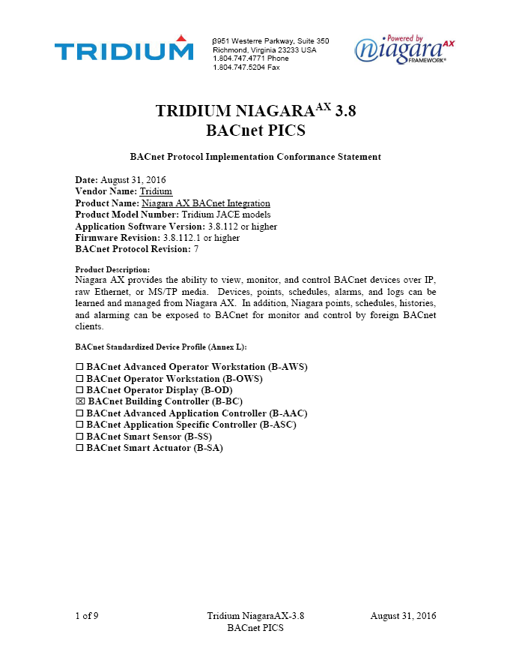
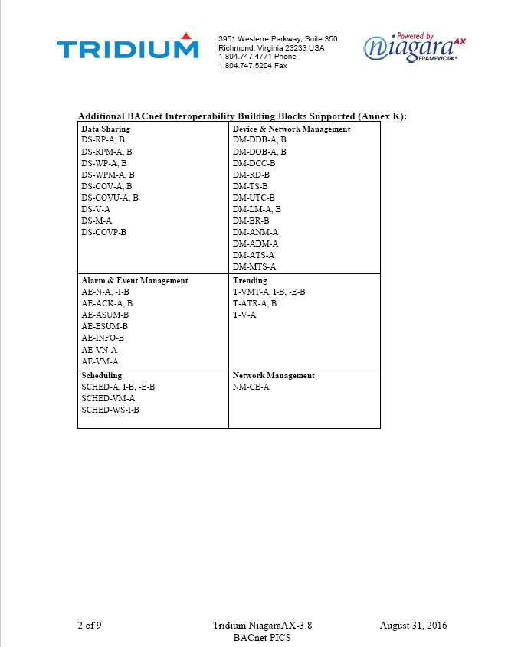
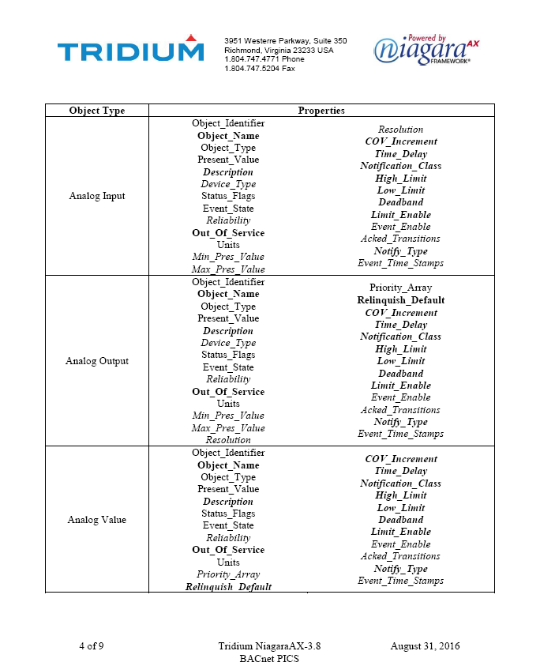

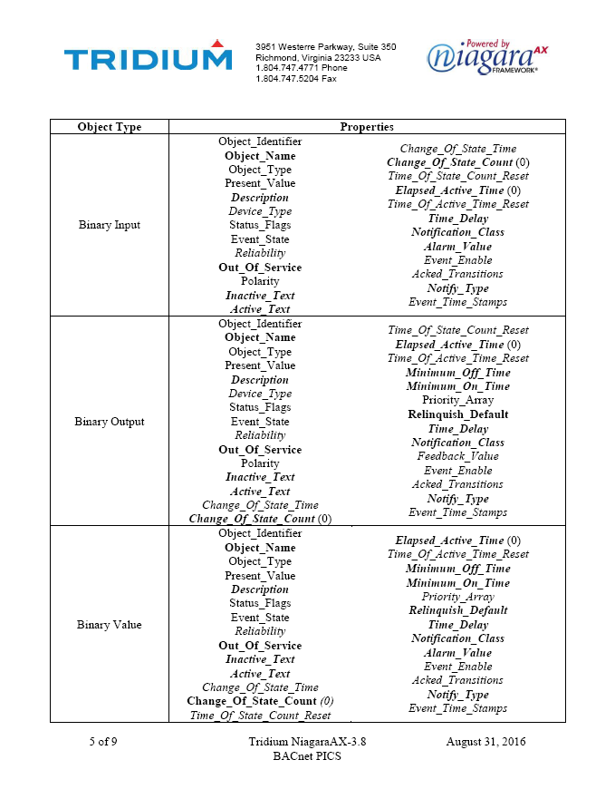
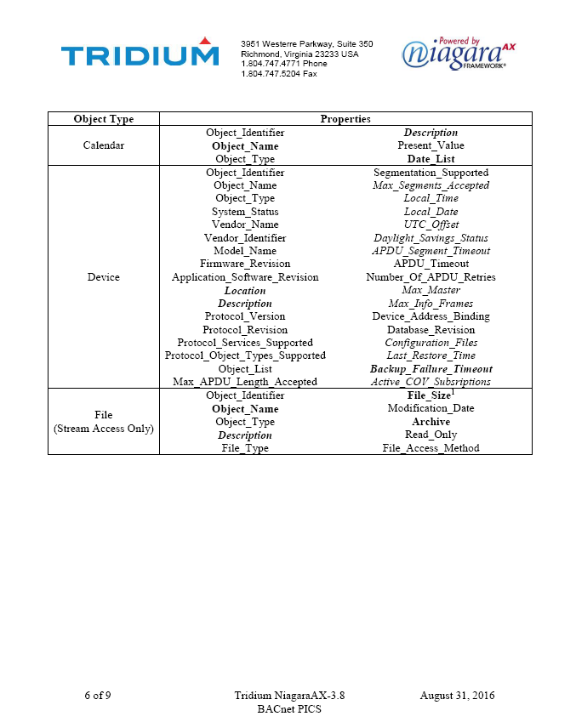

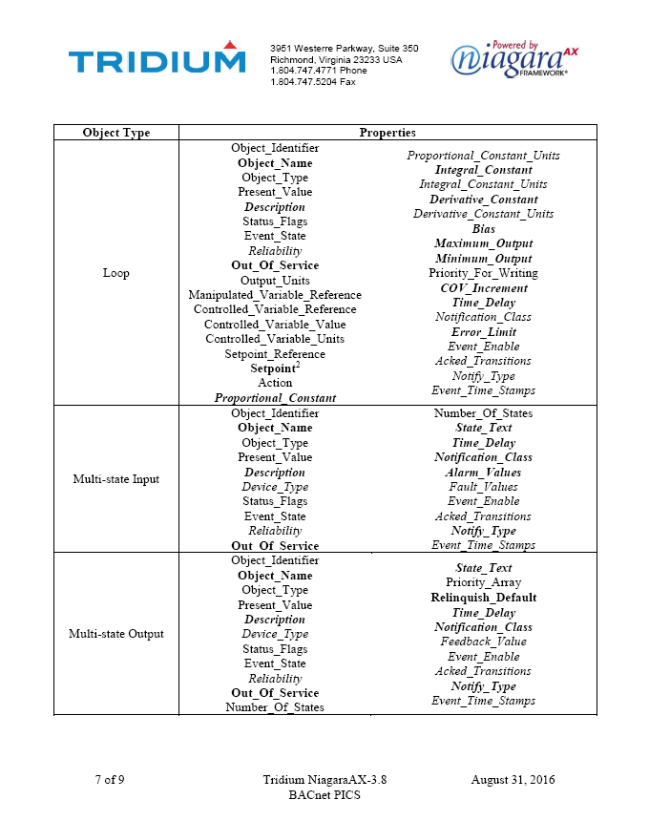

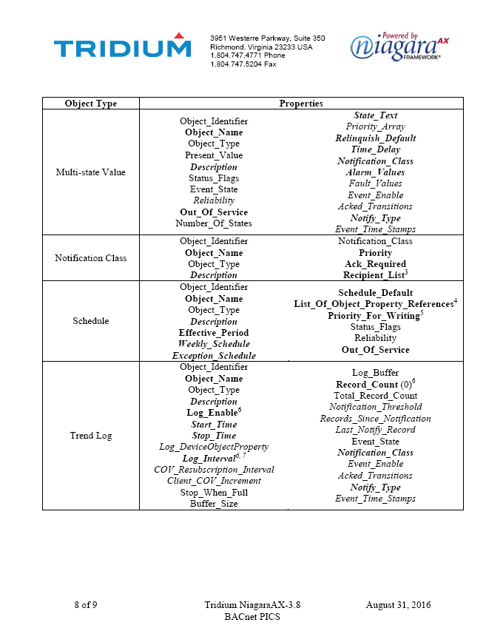

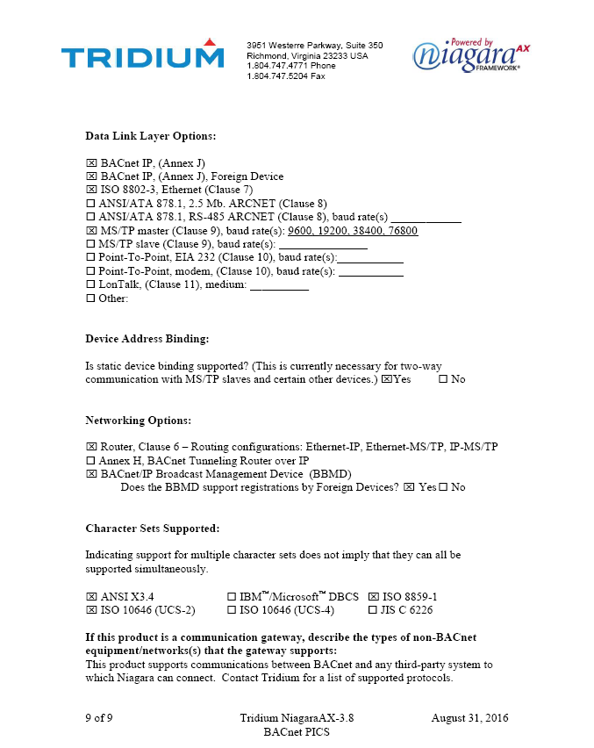

Appendix C – BACnet Testing Laboratories Product Listing

