280000 | Security System Standard
This section includes guidelines and requirements for the design and construction of access control and video surveillance systems. Unless specifically noted, all standards apply to both the healthcare campus and the education campus.
The standards are a resource for the designer of record. The requirements are to be reviewed by the design team and incorporated into the contract documents. The standards themselves will not be included in the contract documents. It is the responsibility of the design team to incorporate them throughout the drawings and specifications.
The standard is not intended to encompass all components required in a complete security system design, but to indicate the university’s requirements where they exist. Exceptions to these standards may be considered on a case-by-case basis for extraordinary projects. All deviations must be approved by the Capital Projects Project Manager and UK Police Department.
Designers are encouraged to present the university with new or different systems, equipment, or materials when they may provide a better or more valuable product.

Table of Contents
PAGE
1.0 System Description
1.0 System Overview 03
1.1 System Description 05
1.2 VMS Network Architecture 06
1.3 SMS Network Architecture 07
2.0 Products 08
2.1 Network Appliance: 08
2.2 Access Card Technology 08
2.3 Card Readers 08
2.4 Access Control Hardware 09
2.5 Door Hardware 10
2.6 Existing Door Key Locks 10
2.7 Emergency Notification Tower 10
2.8 Camera Pole 11
2.9 Interior Notification 11
2.10 Cameras 12
2.11 WIFI IP Enabled Access Control Locks 13
2.12 Power Supplies 13
2.13 Biometric Readers (Eye Scanners) 14
2.14 Interior Lockdown 15
3.0 Implementation 15
3.1 New Construction 16
3.2 Renovation 17
3.3 Implementation Product Information 17
3.4 Integrators / Contractors 21
3.5 Design and Review Services 23
4.0 Project Deliverables 23
4.1 Appendix 24/25

1.0 System Overview
All components of the Main Campus and UK HealthCare Security System are deemed University Life Safety Applications under the exclusive jurisdiction of UKPD.
The Main Campus and UK HealthCare security system is operating as an enterprise system with UK-approved components (Hardware and Software) through Lenel OnGuard PRO SMS and Salient Systems VMS security systems. These UK-approved standardized components must be identified to UK Purchasing prior to bidding. The UK-approved standardized components include ID credentials, VMS Software and Servers, Cameras, Access Control Components, Access Control Software Servers, and Door Hardware, Talk-A-Phones, Interior Notification, and all related programming.
Security Management System (SMS) shall provide ability to:
1. Unlock electrified door locks upon authentication of submitted credential to local card readers.
2. Monitor door alarms and remotely unlock.
3. Lock doors on an automated schedule from central system.
4. Unlock doors as required by code via fire alarm relays.
5. Annunciate intrusion alarms from remote sensors.
6. Unlock individual doors manually via operator interface.
7. Lock doors from Central Operations Center.
Video Management Systems (VMS) shall provide the ability, but not limited to:
- Manage and control all security video cameras.

- Manage and control all video stream recordings and storage.

- Manage and control access to stored video, per user and user groups.

- Manage and control video file retention policies.

- Manage and control video file chain of custody.

- Control and route all live viewing and replay of video streams.

- Control video stream bandwidth and video stream compression.

Definitions:
- Standardized Campus ID:
A standardized campus ID allows the University to integrate SMS with existing systems on Campus that require credentials. ID credentials are multi-function including: University Owned 13.56 MHz Corporate 1000 iClass, 13.56 MHz Seos, bar code, and magnetic strip, with photograph and badge information. ID’s can only be procured through the Wildcard and HealthCare ID offices managed by UKPD.
- Police Department Operation Center:
UK Police Headquarters
UK HealthCare Pavilion A
The 90 EOC
- Video Management System (VMS): Allows motion and other event-based monitoring and situational awareness through IP security cameras centrally managed from UKPD Operations Centers.

- Recording Servers: UK designated/configured servers licensed through Salient Systems located in coordination with UK Information Technology Services (ITS).

- Security Management System (SMS): Access control system used to secure facilities. The SMS systems provide the University with the ability to limit ingress to buildings but offering free egress from all buildings and immediately lock buildings when necessary from its Communications Center.
- Exterior/Interior Notification: Early warning devices used to broadcast and signal campus safety information. Interior Notification works in conjunction with Fire Alarm Voice Evacuation and Clear and Amber Strobe units. Exterior Notification works with Talk-A-Phones with Blue Light Strobes and four (4) outdoor public address speakers and an emergency phone per unit. These systems work together to alert campus to shelter in place as well as weather and emergency information. The UK InformaCast system works as the source for these messages. In response to a crisis, the UK Police Department can provide immediate notifications to alert persons on campus through a combination of warning speakers, voice calls, emails, and text messages.
- Emergency Power: All Security System components will be on emergency generator power where available. If generator power is not available VMS components that are connected to UK network switches will be on UPS backup power to allow for
twenty (20) minutes of full back up. SMS components on the Lenel OnGuard Access Control system shall have battery backup located in or near the controller panels. Where emergency generator power is available, all security components shall have battery backup power sufficient to protect them during power transfers.
1.1 System Description
Both the VMS and SMS systems are enterprise-level open standards-based, non-proprietary, networked platforms that integrate security video and access control. Currently, these systems are not fully integrated but are capable of integration.
The VMS and SMS systems are currently configured in a centralized network structure. Servers are hosted in coordination with UK ITS. Video recordings are stored centrally.
UKPD requires all video files to be stored for no fewer or greater than thirty (30) days. All inquiries regarding video files shall be address through the Chief of Police or his/her designee. UKPD controls and administers the chain of custody for all video files.
Though the systems can be administered through remote clients, primary administration occurs from UKPD Operations Centers. This includes UKPD Police Communications at UKPD Headquarters, the Emergency Operations Center in the 90, UKPD Mobile Command Center, and at UK HealthCare Pavilion A Security Post 8.
1.2 VMS Network Architecture

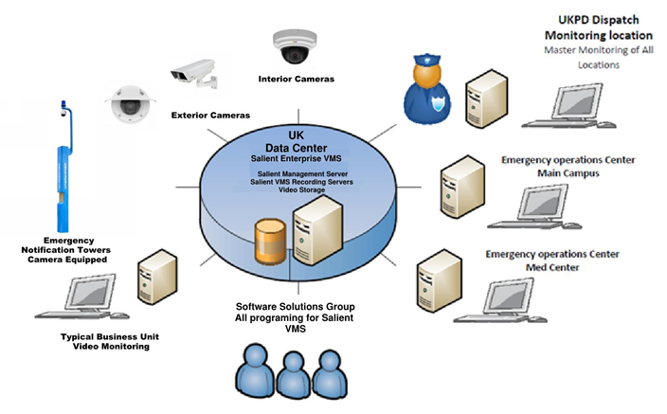

  - SMS Network Architecture

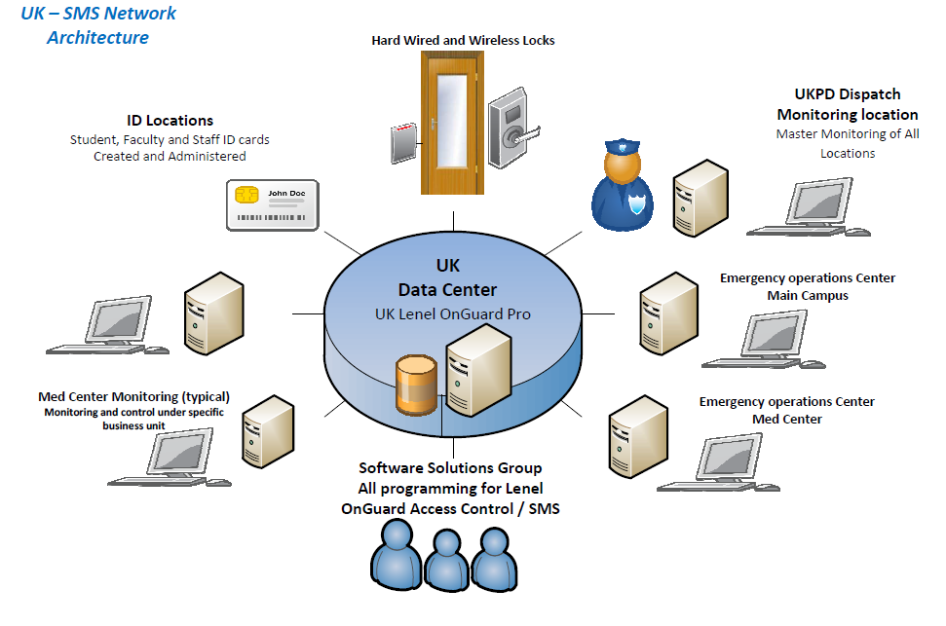

2.0 Products
2.1 Network Centralized Servers:
General Information:
Servers are housed in a virtual server environment in coordination with UK ITS.
- SMS requires servers for the administration and control of access control panels across UK.
- VMS requires a management server in addition to recording servers. The number of recording servers is based on the number of video streams or channels that are being recorded. System administrators monitor server health and capacity, adding additional servers and resources as new video streams or cameras are added to the system.
2.2 Access Card Technology
General Information:
- The Lenel OnGuard Pro system supports the following access card formats:
- HID Seos (13.56 MHz)
- HID Mobile Access Seos (2.4 GHz Bluetooth)
3. HID iClass Corporate 1000 - (University of Kentucky format)
Technical Requirements:
- The ID Badge may only be procured through UK Wildcard and Healthcare ID offices.

- Wildcard includes photo, 13.56 MHz iClass, 13.56 MHz Seos, Mag Stripe, and barcode.

- The Wildcard is also available as a mobile credential through a partnership with HID. This is a 2.4 GHz Bluetooth technology for use with phone devices. This is the preferred credential for UK academic and administrative spaces.

2.3 Card Readers
General Information:
- Current card readers are the HID Signo Line. These readers support credentials equipped with 13.56 MHz iClass Cooperate 1000, 13.56 MHz Seos, mobile devices equipped devices with HID Mobile Access 2.4 GHz Bluetooth.
- HID Signo card readers are available in two configurations, slim mullion-mount, and standard wall-mounted.

- Unless otherwise specified, reader covers shall be furnished in “black” color, classic design.

- Contain LED indicator that displays valid and invalid card.

- Be designed for ambient operating environment.

- Be powered remotely using centralized power supplies.

Manufacturer: HID
Mullion Mount: 20TKS-TO-000375 - RDR, R15, ICLASS, SE E, LF OFF, HF
LEG/SIO/SEOS/MA/MIFARE SIO DISABLED, WIEG, TERM,
BLK, LED BLUE, FLSH GRN, BZR ON, OPT TAMP, OPEN
COLL, CSN SUPPR, IPM OFF, MOBILE-ENABLED-FMT
Wall-mount: 40TKS-T0-000375 - RDR, 40TKS, ICLASS, SE E, LF OFF, HF
LEG/SIO/SEOS/MA/MIFARE SIO DISABLED, WIEG, TERM,
BLK, LED BLUE, FLSH GRN, BZR ON, OPT TAMP, OPEN
COLL, CSN SUPPR, IPM OFF, MOBILE-ENABLED-FMT
2.4 Access Control Hardware
General Information:
The Lenel OnGuard Pro System supports all Lenel Mercury Controller Panels.
SYSTEM CONTROLLER
Model Number: LNL-X2220.
Controllers shall be installed in Life Safety power supply enclosure. See section 2.12 Power Supplies.
MULTI-DOOR DOOR CONTROLLER
Model Number: LNL‐1320.
Controller shall accommodate minimum two card readers and associated inputs/outputs.

MULTI-INPUT / OUTPUT CONTROLLER
Model Number: LNL‐1100 / LNL‐1200.
LNL-1100 controller shall accommodate 16 programmable inputs: and 2
programmable relay outputs.
LNL-1200 controller shall accommodate 16 programable outputs and 2 inputs.
Technical Requirements:
- Access Control components must the most current models with the latest firmware approved and in use by UKPD.
2.5 Door Hardware
Refer to UK Standard – Division 08
All Door Hardware will be equipped with End of Line Resistors if not included with lock
hardware. The Lenel OnGuard Pro system features End Line Device Tamper
Monitoring.
2.6 Existing Door Key Locks
General Information:
When Access Control is added to existing campus buildings, any access-controlled door
with key locking capability shall have Door Position Switch Monitoring (DPS) installed. After door position monitoring or access control is added, all key cores will be removed unless approved by the UK Police Department.
Technical Requirements:
Key cores will remain at ADA doors, doors to mechanical rooms, doors with water shut off valves, UK HealthCare doors, and other UK Police-approved doors for only as the Emergency Access point on all buildings with SMS. Keys will no longer allow access to the building or rooms un-monitored.
2.7 Emergency Notification Tower
General Information:
The unit is highly vandal-resistant, free-standing, steel emergency phone tower-mount, with built-in combination LED Blue Light, illuminated faceplate, an integrated extension arm for mounting a dome camera and Emergency Notification System (ENS) capability. The tower houses an ADA-compliant communication device. The Tower runs daily self-diagnostics, testing lights, phone, amps, and UPS units and send reports to administration.

Technical Requirements:
Talk-A-Phone units must include the following parts or the most current configured with
the most current firmware and software in use on campus and approved by UKPD.
Talk-A-Phone Model: WEBS-MT/R OP 4
Including:
VOIP-600EWEBS-BACKUP 24hr backup power
WEBS-CONTACT WEBS Contact MNS Software Paging & Diagnostics Package
CAMERA for ARM: Refer to Section 2.10 CAMERAS for model number.
2.8 Camera Pole
General Information:
Exterior cameras are mounted on top of a decorative, free-standing aluminum poles accommodating a variety of different manufacturers’ network cameras.
Technical Requirements:
Campus camera poles are a 14-foot Holophane Charlestown CH14F4 Black aluminum
fluted pole or equal on central campus. South campus is a Moog VideoLarm P1800 or
equal. Refer to UK Specification section 16530S01 265600S01 EXTERIOR LIGHTING for more information. Specification can be found on the University’s capital projects standards website.

South campus area is defined as the area South of Woodland Ave., Hilltop Ave. and University Drive to Huguelet Ave over to Rose Street. The complex at Woodland and Hilltop, Johnson, Donovan, Haggin, Lewis Hall, University Flats, UK HealthCare Chandler/Pavilion A and related facilities, UK Agriculture Buildings, and all parcels south of these buildings are included in this area. All other areas are considered central campus. Pole base must match the bases of existing poles in the area of installation.
Poles must be installed to match the pattern of the existing pole in the area of installation.
2.9 Interior Notification
General Information:
Currently Interior Notification consists of utilizing InformaCast broadcasting thru Simplex Fire Alarm Panel 4100 or compatible voice evacuation system. All installations will be in accordance with the most current NFPA standards.
Technical Requirements:
The Interface unit to the Fire Alarm Voice Evacuation System must support
InformaCast - IP Notification by Singlewire Software and must be Cisco compliant.
2.10 Cameras
General Information:
Cameras shall deliver high quality; color video over an IP, UTP structured cable system using H.264/H.265 compression. IP cameras are centrally managed from the University of Kentucky Police Department (UKPD) Operations Centers. The VMS utilizes analytics to identify potential situations on campus and preserving evidence for authorities to review.
Technical Requirements:
- Cameras must be ONVIF compliant.
- Cameras are IP-native.
- Cameras utilize Power-over-Ethernet (PoE) for device power.
- Cameras are designed to provide video streams at the minimum HDTV 720p (1280 x 720) resolution at 30 frames per second using at a minimum H.264 / H.265 compression.
- Cameras are equipped with Day/Night functionality, Wide Dynamic Range (WDR), color video to ½ lux, black and white below ½ lux and feature remote back focus capabilities.
- Cameras have housing and mount color to match surrounding architectural colors.
- Cameras must be of the manufacturer’s official product line, designed for commercial/industrial 24/7/365 use.
- Cameras are based upon standard components and proven technology using open and published protocols.
- Cameras are ceiling/wall mountable dome-type.
- Exterior cameras shall be wall mountable dome-type.
- Exterior pole mounted cameras shall be single image or multi-image dome style enclosures.
  - All cameras shall be approved for use with Salient Security Systems, shall have camera side motion detection, that is supported and compatible with Salient Security, and approved by UKPD. Approved manufacturers:
Interior cameras:
  - Single Image:
AXIS P3265-V or Hanwha Techwin XND-L6080V
  - Dual Image
Hanwha PNM-7002
  - Three Image
Hanwha PNM-8082
  - Quad Image
Hanwha PNM-9002VQ
Exterior Camera:
Hanwha Techwin XNV-6080
Elevator cameras: Axis M3057-PLVE or Hanwha Techwin XNF-8010RW.
Talk-A-Phone or Pole mounted camera: Hanwha Techwin PNM-9002VQ

2.11 WIFI/IP Enabled Access Control Locks:
General Information:
(MAY ONLY BE USED ON INTERIOR DOORS and ONLY WITH ADVANCED UKPD APPROVAL)
IP Enabled IEEE 802.11 b/g (2.4 GHz) WiFi Access Control Integrated Card Reader Lock, BHMA certified extra heavy duty, lever type lock. Lockset with integrated ® 13.56 MHz contactless Signo series card reader, request-to-exit, latch bolt and deadbolt monitoring, and door position signaling in one complete unit. Emergency override access capability with optional mechanical key cylinder retraction of lock latch bolt without necessary electronic activation, this function is allowed only at ADA doors and Life Safety doors as directed by the UK Police Department.
Technical Requirements:
Wi-Fi IP Enabled locks must support 802.11 wireless network and not employ any other wireless bands and or additional equipment. Wireless locks are only to be used with approval of UKPD on Interior doors.
2.12 Power Supplies:
General Information:
Powers supplies for components of the SMS shall be rated and certified for use with
the components that they will be powering.
Technical Requirements:
- Power supplies are required to support Card Reader(s), Door Controller(s), Electrified Door Hardware, Sensor(s) and other components for fully operational turnkey system. Each component connected to power supplies shall be independently fused with rated fuses to match the manufacturer requirements for each specific device.

- All power supplies are to be hard cabled to their AC power source, via conduit.

- All power supply cabinets shall be connected to emergency power circuits.

- All power supply cabinets must be equipped with key lock and cabinet tamper switches.
2.13 Biometric Readers (Eye Scanners):
General Information:
Eye Scanners are used at door openings in conjunction with card readers. Eye
Scanners are installed at 54” AFF typically with a card reader installed directly below at 48” AFF. In low security areas with the approval of UKPD, the scanner maybe used as a primary security point of authentication along with the card reader. In high security areas, the Eye Scanner is to be used as a challenge device.Both functions must be approved by UKPD in the design phase. UKPD is the administrator of the EyeLock user database and its integration with Lenel OnGuard. Users must enroll their eye scan with the designated authority at a designated enrollment location. Eye scanners shall be powered via POE and RS485 from centralized power supplies. This ensures continuous operation during network or power issues.
Manufacturer: EyeLock
Indoor Wall-mount Model: nano IXT
Scanner(s) shall:
    - Be mounted at 54” AFF typically.
b. Be mounted above card reader.
c. Always be installed in conjunction with a Card Reader
Outdoor Wall Mounted Model: nano EXT
a. Refer to project documents for mounting details.
2.14 Interior Lockdown
General Information:
Upon activation of an emergency lockdown button an input signal will be sent to the Mercury controller initiating an alarm event in the SMS. This alarm event will automatically trigger an output on the same Mercury panel to lock the doors in an assigned area (classroom, lab, etc.) This action will allow free egress out of the locked area but will not allow ingress to the same area. During this alarm event only, designated responders will be able to override the locked doors to gain access. The doors will remain in this locked state until returned to normal operation by UKPD Police Command Center.
Panic Button Hold-Up Switch
Lockdown switch for use in rooms, offices, or classrooms with lecterns or instructor desks. Coordinate exact mounting locations with UKPD and end user prior to install. Provide and install end-of-line resistors at each button location for status monitoring of button.
Manufacturer: Honeywell 270R
Single Push Button Wall Mounted Switch with Protective Cover
Lockdown switch for use in all room types where the lockdown button needs to be wall mounted. Custom signage to be coordinated with UKPD and building occupant. The unit must have protective cover to prevent accidental activation.
Manufacturer: STI Stopper Station, with Bopper Stopper SS2325LD-EN or approved equal.
3.0 Implementation:
There are various methods for implementation, the most common would be for UK Facilities or CPMD to utilize public bidding or open solicitations for purchase and installation.
No legacy systems or disparate security systems are allowed to remain as part of any construction project. Security shall be included in all new and renovation construction projects. Any deviations from these requirements must be received in writing from UK CPM in special circumstances only. UKPD must be included in the design process for any work involving door openings. UKPD must review and approve all projects during the design phase.
3.1 New Construction
General Information
All new construction projects shall include electronic access control on any space that requires a locking feature. In addition, the following apply to all new construction projects.
- Access control and camera coverage at all perimeter doors.
- Exterior camera coverage of the perimeter of the building.
- Lock-down feature shall be installed in all spaces defined as classrooms, labs, academic auditoriums, and lecture halls.
- Camera coverage of high-occupancy or congregation areas.
- Interior notification integration with fire alarm voice evac system.
New construction shall not allow the use of non-UK Standard Access Control or Video Systems.
All Security System components will be on emergency power. POE devices connected to UKITS switches are protected during power transfer from normal to emergency power by local Communication’s closet UPS units. Access control power supplies shall be equipped with battery backup as well to protect during transfers.
All card access doors will have a door position switch (DPS).
UKPD must approve all design phases for construction projects.
UKPD shall be included in the submittal, change order, and RFI process review during construction prior to installation.
UKPD shall oversee start-up, testing and commissioning of all installations.
All SMS Lenel OnGuard Pro installations require work to be done by Silver Certified Technicians.
All components associated with Main Campus and UK HealthCare Security VMS System will provide a Three (3) Year Warranty.
Components associated with Main Campus and UK HealthCare SMS will provide three
(3) year warranty.
Security minimums must be followed for all projects and may not be considered at any time for Value Engineering.
All access control enclosures and control panels must be installed in EIDF closets. Access control equipment may not be placed in IDF or MDF spaces.
3.2 Renovation
General Information
All Renovation projects shall replace or eliminate all existing Legacy Access Control and Video Systems with Lenel OnGuard SMS and Salient Systems VMS.
All Security System components will be on emergency power utilizing a UPS for transfer to generator power.
Unless otherwise approved by UKPD, all doors shall be equipped with access control.
All spaces defined as classrooms shall be equipped with access control and lockdown capabilities.
UKPD must approve all design phases (inclusive of layout and equipment) for all renovation construction projects.
UKPD shall be consulted in final decision in award of VMS and SMS projects.
UKPD must be included in the submittal, change order, and RFI process during construction prior to installation.
UKPD must oversee start-up, testing and commissioning of all installations.
All SMS Lenel OnGuard must be completed by Silver Certified Technicians as a minimum.
All components associated with Main Campus and UK Healthcare Security VMS System will provide a Three (3) Year Warranty.
Components associated with Main Campus and UK HealthCare SMS will provide three (3) year warranty.
All access control enclosures and control panels must be installed in EIDF closets. Access control equipment may not be placed in IDF or MDF spaces.
3.3 Implementation Product Information:
VMS Recording Servers:
- Recording servers are centrally located and maintained by UK ITS.

- New camera installation shall be coordinated with UKPD and Securitas Technology to ensure capacity for recording is added when needed.

- Camera information shall be provided to UKPD and Securitas Technology for adding cameras to the system and programming. See Programming Sheet in the Appendix of this document.
Door Hardware: Refer to Division 08 Standard for complete details.
- All access control shall be hardwired installations unless approved in advance by UKPD.

- All security components Division 28 and Division 08 Door Hardware are required to be specified thru a single contractor, in a single trade package. One contractor will be the single point of contact for all ESS matters for the project. This contractor shall submit a list of any subcontractors at the time of bid and provide all required certifications at that time with no exceptions. Bids will not be acceptable without proper certifications.

- All Exterior Doors are required to implement the Campus Central Lock-Down feature utilizing hardwired installation.

- All exterior doors are required to have the door position feature.

- Traditional manual key override installations are required at all ADA exterior Doors and all Life Safety interior doors. Any additional key override installations require UKPD prior approval during design.

- All academic auditoriums, lecture hall and large classrooms are required to implement the campus lockdown feature with local activation buttons.

- The use of POE and Wireless locks requires UKPD approval during design. If Wireless locks are used, then Wi-Fi coverage and strength testing must be performed under peak load condition simulated during design and actual prior to acceptance.

- Currently the only POE and Wireless locks approved by UKPD are manufactured by ASSA Abloy.

- All door hardware and Lenel Mercury panel firmware shall be consistent with the UKPD approved current for campus operations.
Camera
- Camera installations are requested at all exterior door locations. Cameras are mounted on the exterior of the facility with a view that encompasses the ingress and egress of the persons utilizing the entryway and the position of the door.

- All camera modeled views depicted in construction documents shall be matched during installation, coordinated and confirmed by UKPD. Typical camera installation includes low light, wide angle, fixed position, multi-head, and License Plate Reader (LPR).

- The design of all camera installations shall include the planned analytics to be installed during the construction.

- The design, placement, and orientation of cameras shall ensure complete coverage, avoid blind spots, and obstructions, provide overlapping layout and camera physical safeguards.

- Following installation, all cameras will be adjusted to UKPD and stakeholder preferred view.

- All cameras submitted must be certified compatible with or obtain approval from Salient Systems and be approved by UKPD prior to bidding.

- All cameras shall be located to minimize vandalism.

Exterior Emergency Notification Tower (Talk-a-Phone or TAP)
Exterior emergency notification towers are equipped with a VOIP emergency call phone, four (4) speakers to relay emergency broadcast messages, and a camera that monitors
the area located around the Tower. The emergency phone is a single button push-to-dial speakerphone that dials UKPD Police Operations Center. The local broadcast speakers are connected to the UK Alert system via UK’s Informacast system to broadcast any messages addressed to the unit. The tower is also equipped with a local microphone located behind a locked access panel that can be used by authorized personnel to make local announcements. The tower’s camera is located at the top of the unit and is connected to the UK VMS and is available for monitoring in UKPD Police Operations Center. A blue light is located on the top of the unit. The light is illuminated at all times and when the phone is in use it changes to a flashing pattern.
- TAPs shall be provided with all new building construction projects based on the location in reference to the UKPD Talk-a-Phone Master plan.
- TAPs will be sited consistent with the UKPD overall campus plan utilizing a standard Audio Level within a 300 foot - foot diameter pattern.
- TAP units consist of blue strobe, cameras, Emergency Broadcast Speakers and Emergency Call Station with direct ring down to UKPD Police Communications.
- TAPs are activated thru the UK InformaCast system.
- On new construction projects, the TAP unit will be powered by emergency life safety generator from the project building.
- The TAP will require Data and Power from the proposed new building or the nearest existing building. Data and power will be provided to the TAP units in underground conduits. Data will be provided from the nearest UKITS Communications closet and power will be provided from the nearest electrical distribution panel.
- TAPs are required to be the most current UKPD approved models with the accompanying approved firmware.
- Talk-A-Phone Model: WEBS-MT/R OP 4 Including:
1. VOIP-600 IP Phone
2. WEBS-BACKUP 24hr backup power
3. WEBS-CONTACT WEBS Contact MNS Software Paging &
Diagnostics Package
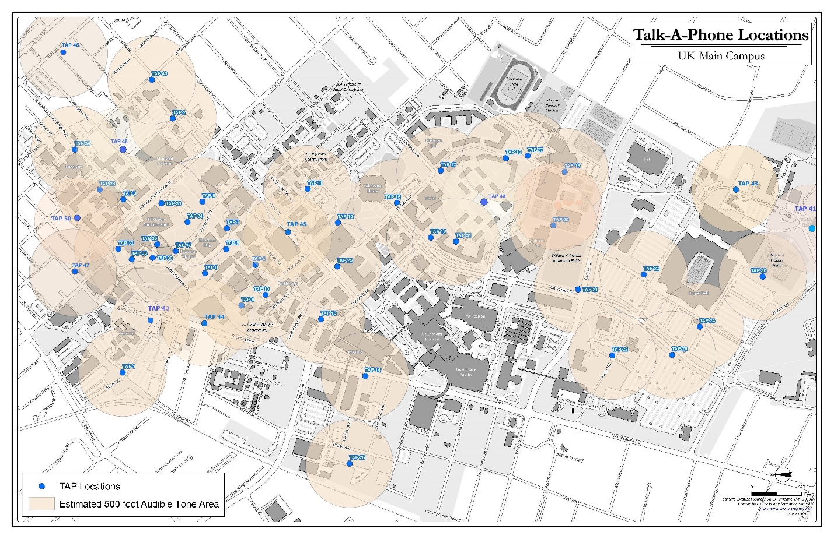
Interior Notification
a. Interior Notification will utilize the Simplex (Or Equal) Fire Alarm Panel with
Voice Evacuation broadcast component. All Audio-Visual devices will be dual
head units depicting Fire Evacuation (Clear Strobe) or Shelter in Place (Amber
Strobe) thru information provided by the Campus InformaCast system.
b. Speakers contained within the ceiling grid are an acceptable alternative to
additional audio-visual devices.
c. The performance standards for Interior Notification shall be no less than the Fire
Alarm Standards.
d. Interior Notification shall comply with NFPA requirements.
3.4 Integrators / Contractors
- The University of Kentucky Police Department prefers that all projects, both New Construction and Renovations, have all work under both Electronic Security Division 28 and Door Hardware Division 08 scoped as one trade package under one Integrator / Contractor. All subcontractors included shall be named by trade work at the time of Bid.
- Selected Integrator shall meet all certification requirements set forth in this document.
- Lenel SMS work must be completed by authorized Lenel Silver Certified installer in current standing with Lenel Corp. Installer is authorized to install panels, components and terminate. Installer is not allowed to perform any system programming as University of Kentucky restricts all programming to the VAR of Record. Contractor will budget hours and allocate funding based on size of project to assist during testing and programing with the VAR of Record.
Contractor is required to contract with the University of Kentucky Lenel VAR of Record for Lenel Licensing and Central System programing and turn up services. Contractor is responsible for providing VAR of Record Reader counts, Controller Panel counts and locations as well as counts of any special components such as Biometric Readers or Elevators that will require special programing. This information is required to provide proper quotes for licensing and programming. Contractor will include these VAR of Record services and Fees in their project Bid. A project spreadsheet is included with the document as an appendix that shall be used to provide this information to VAR of Record. Project Bid is to be all inclusive for a complete working SMS system.
- The current Lenel VAR of Record for the University of Kentucky is:
Securitas Technology
Contact: Vicky Daugherty or Anthony Hollingworth
1440 Kemper Meadow Drive
Cincinnati, OH 45240
912-246-9466 Direct 859-544-3425 Direct
vicky.daugherty@securitas.com anthony.hollingsworth@securitas.com
Salient Systems VMS work shall be completed by certified companies and personnel. Proper certification documentation shall be submitted at time of bid.

- Contractor is required to contract with the University of Kentucky Salient VAR of Record for Salient Systems Licensing and Central System programming and turn up services. Contractor is responsible for providing VAR camera counts and locations as well as counts of any special components such as analytics. This information is required to provide proper quotes for licensing and programming. Contractor will include these VAR of Record services and Fees in their project Bid. A project spread sheet is included with the document as an appendix that shall be used to provide this information to VAR of Record. Project Bid is to be all inclusive for a complete working VMS system.

- The current Salient VAR of Record for the University of Kentucky is:

Securitas Technology
Contact: Vicky Daugherty or Anthony Hollingsworth
1440 Kemper Meadow Drive
Cincinnati, OH 45240
912-246-9466 Direct 859-544-3425 Direct
vicky.daugherty@securitas.com anthony.hollingsworth@securitas.com

- Integrators/Contractors are required to also abide by all UK ITS Division 27 requirements in regard to all DATA cabling and pathways.

4.0 Project Deliverables
A Capital Construction project typically exceeds $1,000,000.00 in Total Scope of Work.
However, as shown in the Security Systems Procurement Drawing ALL contract types
are available to CPMD Project Manager’s to use and implement security installations
TYPICAL METHOD:
It is envisioned that all CPMD projects in excess of $1,000,000 will obtain their Security components from a designer contracting and advertising for a Security Integrator.
Securitas Technology, the current SMS/VMS unit price contractor, would certify the installed components and do all system programming based on information provided by the installing integrator. At that point Stanley Security would add those components to the campus security platforms.
Securitas Technology will provide the security integrator an assignable allowance to be included in the project costs to perform the programming services for both SMS and VMS platforms.
RENOVATIONS:
If the design contract is primarily renovation, at a minimum perimeter access control and video monitoring of exterior openings are required. Any project involving the addition, deletion, or upgrade of doors shall be submitted to UKPD for review and approval. In some cases, an in-depth security review must be conducted by UKPD or its designated representative.

4.1 Appendix
SMS VAR of Recording Programming Worksheet
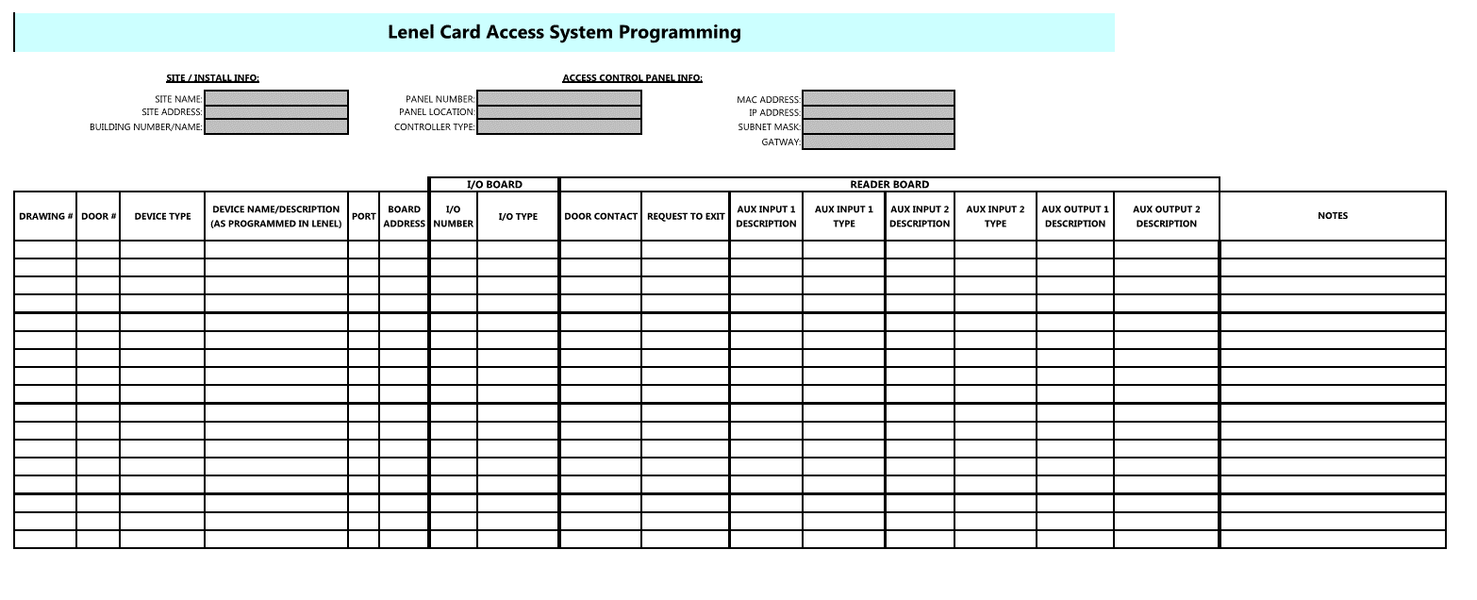

VMS VAR of Recording Programming Worksheet
