Fixed Bollards
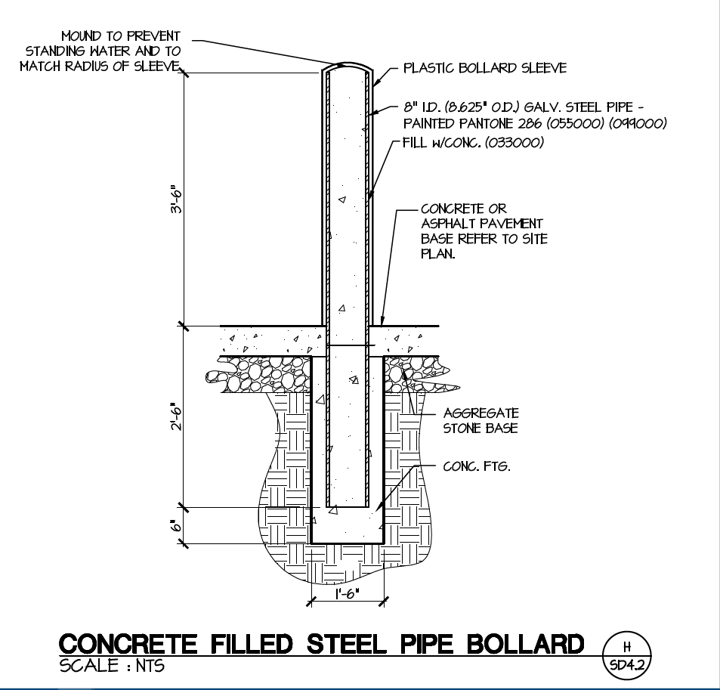

Pipe Bollard Covers
- LDPE or HDPE pipe bollard cover with rounded top, ¼” thick with integral color and adhesive/tape system to anchor cover to bollard. Reflective tape is to be provided but not installed unless requested by the Owner after installation is complete.
- Size: Sleeve sizes are to be coordinated with pipe bollard sizes and field verified prior to ordering.
- Color: Color selections to be tailored to suit the project.
- Basis of Design: Design concept and the drawings indicate the size, profiles, dimensional requirements and aesthetics of the following:
  - Ideal Shield 1/4:” Bollard Cover – Detroit, Michigan 1-866-825-8659
- Additional Stock – Provide two (2) covers of each selected color for additional Owner stock to be used for future replacement. Include adhesive/tape anchor system

Removable Bollards
Notes for operation of the removable bollards:

- Bollards shall be 8” stainless steel, removable, internally locking CalPipe bollards (SSR08040).
- Embedment sleeve caps are to be lockable, removable and keyed to match bollard locks. Bollards are to have domed tops.
- Each bollard is to have two (2) lift handles added, 180 degrees apart. Handles are to be installed so that they run parallel to the flow of pedestrian traffic when locked in place.
- One additional embedment sleeve (ESR080), is to be provided (if applicable) and installed at location shown to allow same bollard positioning with lift handles parallel to the flow of pedestrian traffic when locked into position. Additional embedment sleeve is to come with lockable, removable lid keyed to match bollard locks.
Product website for the removable bollard
http://www.calpipebollards.com/products/internal-locking-removable-bollards.html

