Newport Aquarium has the coolest Summer Overnight in town- Register Today! Learn More

This summer, explore hidden treasures at the most unique overnight adventure in town. Every overnight includes exclusive Aquarium access, animal-themed games and activities- plus, you'll sleep surrounded by amazing sea life!
Learn More

Party with Penguins Overnight Adventure
See our famous cold & warm weather penguins at this overnight event on June 18th!
Learn More

Dream with Denver Overnight Adventure
Learn about our famous Loggerhead Sea Turtle Denver, his journey of survival and sleep over on July 10th.
Learn More

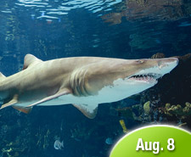 | Sharks After Dark Overnight Adventure  Sink your teeth into some great shark facts and sleep safely as they swim above on August 8th.  Learn More
Overnight Info | About Us | Upcoming Events

Copyright © 2014 Newport Aquarium
| Privacy Policy | Contact Us |
This email was sent by: Newport Aquarium
One Aquarium Way | Newport | KY | 41071 | USA
We are open 365 days a year, 10a.m. to 6p.m.

