Student Sustainability Council Meeting Minutes
22, August 2016

16:14 – Meeting begins with the reading of the preamble
16:15 – Meeting agenda is given an overview, and a general overview of how to meeting process works is given by Ellen
16:16 – Discussion on Fall 2016 meeting times begins
16:18 – Voting on meeting times begins
-Proposed meeting time, First & third Wednesday of each month on Wednesday 6-8pm
Vote: Yes: 14 No: 0
16:18 – Discussion on Suzette Walling proposal begins (Design Week: Retrofitting the Retro) (10 minutes)
16:28 – Motion to extend discussion by 5 minutes (Lauren, Jennifer 2nd)
16:31 – Motion to Vote on Design Week proposal (Lauren, Jennifer 2nd)
Vote: Yes: 14 No: 0
16:32 – Proper voting procedures are discussed
16:36 – Discussion on UK Police department proposal begins (Electric Motorcycles Sustainability Initiative) (10 minutes)
16:45 – Motion to Vote on UK Police Department Proposal (Electric Motorcycles Sustainability Initiative)
Vote: Yes:0 No: 14
16:47 – Discussion on Proxy SSC Constitution Amendment begins
16:59 – Motion to amend amendment (Ellen Gabe 2nd)
Amendment: the submitter of the proxy must also submit a reference letter about the individual they are nominating. This amendment will be in section one subsection d of the amendment
Vote: Yes: 14 No: 0

16:59 – Motion to Vote on Amendment as amended (Mitch, Ellen 2nd)
Vote: Yes: 14 No: 0
17:02 – Motion to end meeting (Mitch, Amanda 2nd)

Name | Beginning | Ending
Bryant, Gray | P | P
Cook, Rachel | P | P
Danatzer, Juliana | P | P
French, Preston
Green, Ellen | P | P
Hanna, Rob | P | P
Hassinger, Tara
Lark, Ryan | P | P
Meyer, Sadie
Mullins, Mitch | P | P
Penava, Elizabeth
Penn, Jerrod | P | P
Smith, Gabe | P | P
Sunderlin, Rachel | P | P
Taylor, Jennifer | P | P
Tedder, Shane (Advisor) | P | P
Thomas, Lauren | P | P
Troupe, Ben | P | P
Varney, William | P | P
Williams, Amanda | P | P

University of Kentucky Student Sustainability Council
2016-2017 Grant Application

- Name: Suzette Walling
- Email: s.walling@uky.edu
- UK Affiliation: Tracy Farmer Institute for Sustainability & the Environment, Built Environment Working Group
- Proposed Project Title: Design Week: Retrofitting the Retro
- If applicable, please provide the sponsoring or overseeing organization. (e.g. the Office of Sustainability, Wildcat Wheels, the Dept. of Ag. Economics, etc.):Tracy Farmer Institute for Sustainability & the Environment
- Total Amount Requested from the Council: $3,866
- Would you like to make a presentation to the Council before your proposal is reviewed? Yes. We have also asked 2 students Shawna Van Zee (interiors) and Morgan Dunay to share their insights from their experience.

- Please mark the primary and secondary focus areas of your project with a 1 and 2, respectively.

  - Recycling: • Climate Change:
  - Transportation: • Local Environment:2
  - Agriculture/Gardening: • Behavioral Change: 1 • Water: • Species Diversity/Conservation:
  - Renewable Energy/ • Other (Please Describe):
Energy Conservation:

- Please name any other project leaders:

Name Ryan Hargrove
Title/Department: Faculty, Landscape Architecture (LA)
Project Role: co-Lead
Email: ryan.hargrove@uky.edu
Name: Carolina Segura
Title/Department: Faculty, LA
Project Role: co-Lead
Email: carolina.segura@uky.edu
Name: Rebekah Radtke
Title/Department: Faculty, School of the Interiors (ID)
Project Role: co-Lead
Email: rebekahradtke@gmail.com
Name: Doug Appler
Title/Department: Faculty, Historic Preservation (HP)
Project Role: co-Lead
Email: douglas.appler@uky.edu
Please note that any project leaders listed will be excused for closed discussion of their project proposal.

10. Please describe the project, its goals, and how it contributes to UK student knowledge, attitudes & culture, or practices of the 3 pillars of sustainability (i.e. economic, environmental and social), including potential long term effects.

The 2016 Design Week is building upon the success of the 2015 Design Week: In Motion which provided students with real-world experiences of data collection, assessment and analysis, and presentation. Through the In Motion project, the Built Environment Team has strengthened connections with city partners and planners who are interested in collaborating on a project entitled Retrofitting the Retro. The project will look at ways to connect and revitalize suburban strip centers by retrofitting vacant parking lots (heat islands) and transform them into vital and aesthetic neighborhood centers. The pilot project will target the Southland area where existing infrastructure and layout often create unsafe and unappealing conditions for pedestrians. This creates disconnectedness and discourages walking between store locations. The goal of the retrofit is to create public space that will enhance physical and social connections and draw patrons to the center, which addresses all 3 tiers of sustainability.
Similar to last year, students from LA, HP, and ID will be placed in interdisciplinary teams and conduct surveys of the defined project area. Teams, guided by faculty and other experts in the field of urban planning and data visualization, will then work to assess their data, map it, and develop ways to visualize the data for their final presentation.
To complement their experience, we are proposing to take participating students to Nashville TN to meet with city planners, developers, and commercial architect and design firms engaged in various renovation projects around the Nashville area. Students will learn about the project history, challenges, and outcomes and tour selected areas. This experience will provide the framework for developing their own assessments and critiques for their project in Lexington.
Long term: Results from Design Week data collection will be used in studio classes in the fall 2016 to develop a design plan. Working from this design, students will build a model or prototype for installation at the retail center in spring 2016. The prototype will be refined following a data assessment for a full-scale demonstration project which will be developed by studio classes in fall 2017.
We are requesting funds to assist with Design Week to help cover the cost of the bus trip (charter bus service).

- Name any anticipated project affiliates and describe the extent of their support, including any financial, matching or in-kind support. Specific details are encouraged.

TFISE = $3000; Landscape Architecture = $500; School of the Interiors = $500. These funds will cover the cost of meals and other associated travel expenses associated with the trip meals and supplies needed to support the week-long series of activities, as well as invited speaker travel and honorarium associated with Design Week.

Other associated support includes departmental support for faculty travel (meals) estimated at $300.

The LFUCG Division of Planning is identified as a collaborator by investing funds ($10,000), connecting with retail owners, and partnering with Habitat for Humanity (in-kind contributions of materials and supplies) to help provide for the implementation phase of the project in the development of the initial prototype in Spring 2017.

- Please mark the primary target population of your project with a 1.

- UK (general):  - Undergraduates:1 • Graduates: | - Community:  - Faculty:  - Other (Please Describe):

In 250 words or less, please answer the following questions.

- Describe the intended University of Kentucky audiences and potential number of people impacted including any potential diverse segments such as student or community organizations and supporting evidence (e.g. expected or historical event/speaker attendance). The primary audience consists of students from Landscape Architecture, Historic Preservation, and School of the Interiors. Based on last year’s participation and enrollment, we anticipate that 70-80 students will participate in the initial Design Week project.

- Are there any students involved in the proposed project? If so, do they benefit from professional or technical skills, outputs, or experiences such as presentations, posters, or reports?

Yes. Students will be conducting the data collection and developing initial design elements as part of Design Week.
Goals for student development:
  - Qualitative (observations) and quantitative (measurements) data collection and analysis skills • Data Visualization
  - Critical thinking skills/problem solving
  - Presentation skills
  - Team building and cooperation
  - Community engagement

From Design Week data, studio students will develop prototypes, refine designs, and potentially develop a full-scale model.

- Please describe any previous history and to what extent you, other project leaders, or the sponsoring organization may have with the UK Student Sustainability Council. TFISE has initiated projects with SSC funds to develop a rain garden and living learning lab, utilized funds for a Water Week workshop, and was funded for the Beyond Design Week studio presentations.

- Please outline a timeline and milestones to ensure project efficacy prior to and after project implementation.

Design Week
September 19: Design Week kick-off – briefing and goals
September 21: Trip to Nashville
September 23: Team reports; Lecture on data gathering, analysis, mapping, and visualization
September 23-25: Data collection at suburban center (ex. surface temperature, traffic volume, parking density and utilization, pedestrian mobility, etc.)
September 26: Framing the problem/developing problem statements
September 28: Refinement
September 30: Team final presentations

Beyond Design Week:
Fall 2016, Studio competitions and presentation to community stakeholders
Spring 2017: pilot prototype
Summer 2017: data analysis
Fall 2017: Potential build

- Does the success of your project require prior approval of other UK or non-UK entities (e.g. IRB or venue approval, etc.)? If so, please provide supporting documentation. No

- Please demonstrate how the Student Sustainability Council will be credited or advertised in your project (this can include promotional material). Would a project leader be available for a radio interview? All promotional materials and products generated in Design Week will acknowledge the SSC as a funding source and include the SSC logo. Yes, a project lead can be available for an interview.

- Using the following format, please provide a line item budget for the total amount request and what percent of the project is being sponsored by SSC funding. Provide information sources or reasoning for the budget estimates.

Description | $ Total Cost | $ Request from SSC | Source of remaining funds
Bus Charter (2, 55 passenger – quote attached) | 4,166.00 | $3,866 | Carryover from 2015*
Bus – parking, wifi | 70.00 | 0.00 | TFISE/LA/ID
Driver fee and hotel | 450.00 | 0.00 | TFISE/LA/ID
Student Travel – meals and snacks | 1400.00 | 0.00 | TFISE/LA/ID
Faculty travel (meals) | 50.00 | 0.00 | TFISE/LA/ID
Workshop meals and refreshments (2 days) | 360.00 | 0.00 | TFISE/LA/ID
Data Collection Supplies | 100.00 | 0.00 | TFISE/LA/ID
Refreshments – final presentation | 400.00 | 0.00 | TFISE/LA/ID
Invited Speaker (travel and honorarium) | 1,000.00 | 0.00 | TFISE/LA/ID
*there was a remaining balance from the 2015 Design Week of $300 that we are requesting to apply towards this request. Note that the bus drivers must be accommodated in a hotel the night prior to travel due to the early departure and length of the trip.

- Are you willing to accept a general reduction in your budget? yes
- Are you willing to accept line item changes in your budget? yes
- You may include additional attachments to supplement the application such as promotional material, resumes, letters of collaborative funding, etc. Attachments: the cover of the draft proposal for the LFUCG project and the cost estimate for bus service.

Submit project proposals and/or questions on proposal processes to ukstudentsustainabilitycouncil@gmail.com with ‘SSC Proposal’ as the subject line.
If successfully funded, a councilmember will be assigned to your project. Failure to communicate with this person can result in a total or partial loss of funding. Any changes in the use of approved funding must be resubmitted and re-approved by the Council. Unused funds are automatically returned to the SSC.
Project proposals will be considered on a rolling basis and must be received 1 week prior a scheduled meeting in order to be considered for the agenda. If SSC and applicant are able to confirm that project, if funded, would be in compliance with University Business Procedures. The fall 2016 meeting schedule is listed below:
Meeting date | Proposal due date
August 23, 2016 - September TBD  October TBD  November TBD  December TBD | Proposals due by August 17, 2016

Attachment1: LFUCG draft proposal for the project the students will be involved in as part of Design Week.
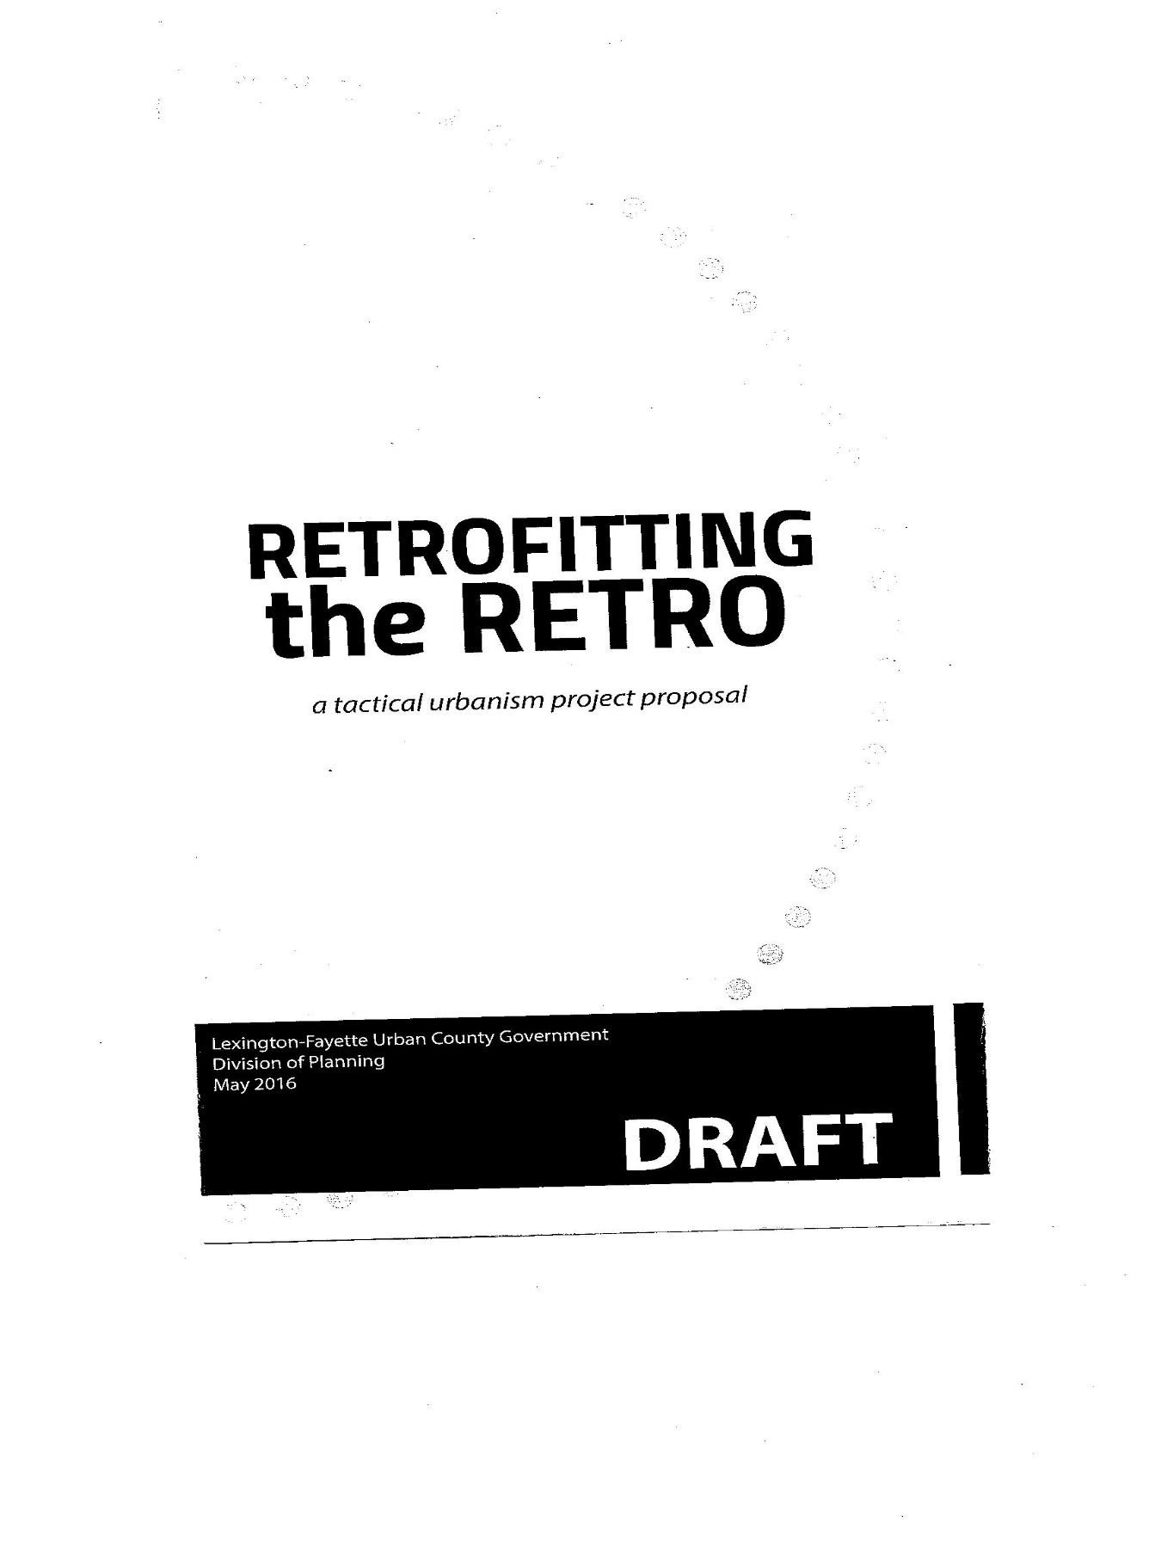
Attachment 2: Quote for Charter Bus
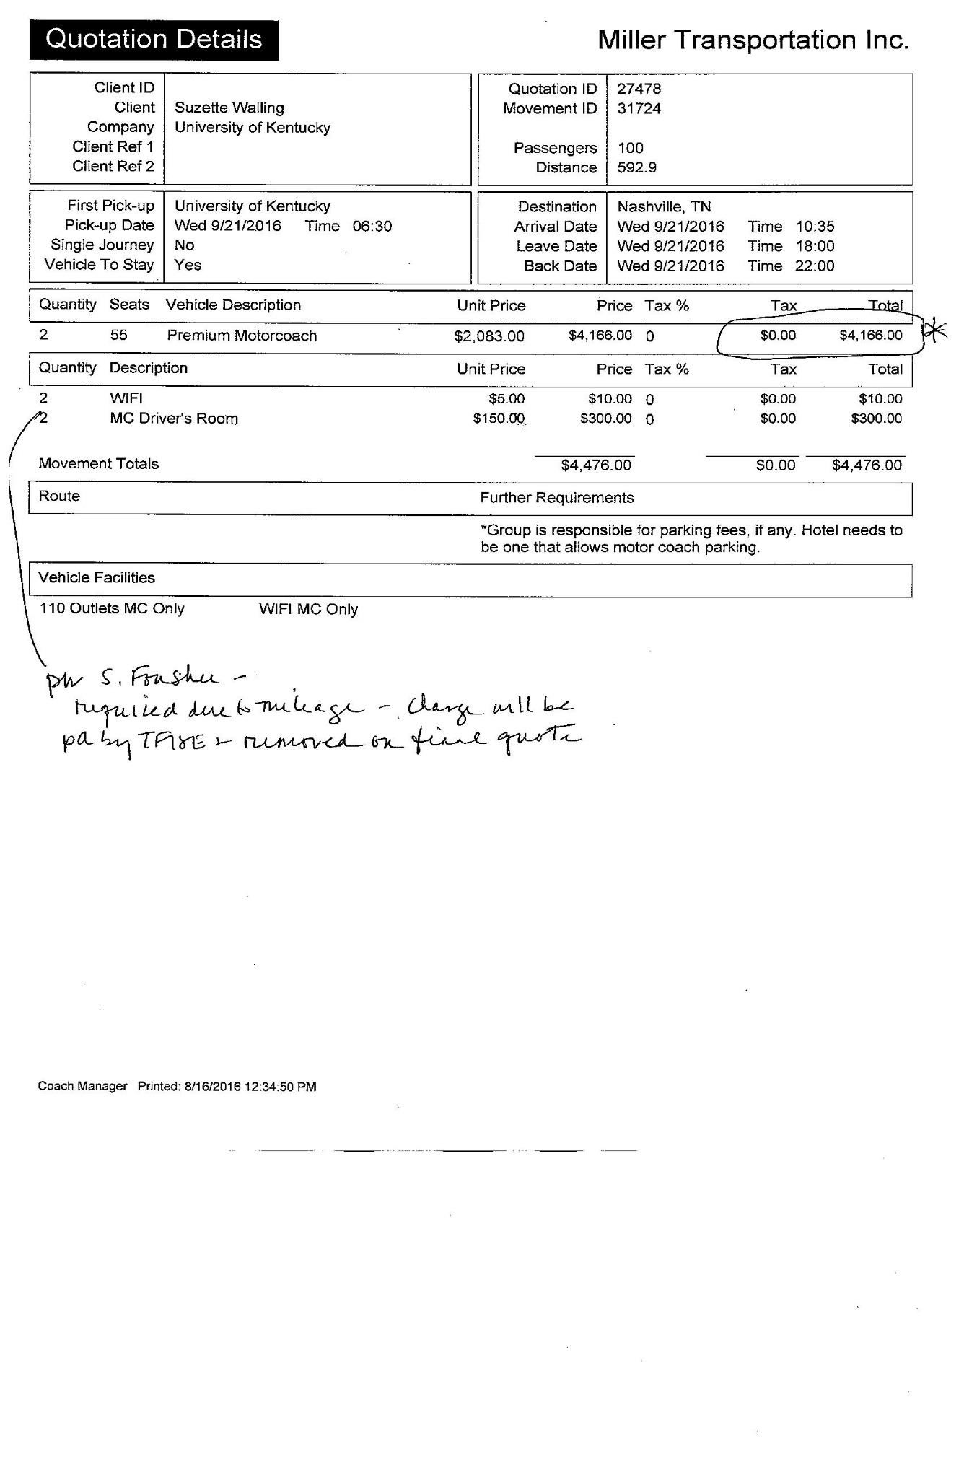
University of Kentucky Student Sustainability Council
2016-2017 Grant Application

- Name: Amy Boatman
- Email: amy.boatman@uky.edu
- UK Affiliation: UK Police
- Proposed Project Title: Electric Motorcycles Sustainability Initiative
- If applicable, please provide the sponsoring or overseeing organization. (e.g. the Office of Sustainability, Wildcat Wheels, the Dept. of Ag. Economics, etc.): UK Police
- Total Amount Requested from the Council: $54,063.82
- Would you like to make a presentation to the Council before your proposal is reviewed?
I am willing to come share our plans.
- Please mark the primary and secondary focus areas of your project with a 1 and 2, respectively.

- Recycling:
- Transportation: 1
- Agriculture/Gardening:
- Water:
- Renewable Energy/
Energy Conservation: 2

- Climate Change:
- Local Environment:
- Behavioral Change:
- Species Diversity/Conservation:
- Other (Please Describe):

- Please name any other project leaders:

Name | Nathan Brown
Title & Department | Major of Administration, UK Police
Project Role | Administrator
Email | cnbrow0@uky.edu
Name
Title & Department
Project Role
Email
Please note that any project leaders listed will be excused for closed discussion of their project proposal.

- Please describe the project, its goals, and how it contributes to UK student knowledge, attitudes & culture, or practices of the 3 pillars of sustainability (i.e. economic, environmental and social), including potential long term effects.
The project is to obtain electric motorcycles to utilize for everyday patrol. The goals are to better serve the needs of the campus community by being able to get to calls faster and being more open and approachable. This project will be a great addition to the police fleet and will help in cutting costs. Right now our main form of transportation is a Dodge Charger and there are several issues and maintenance costs involved in keeping them running. The Charger has more of an impact on the environment and limits our ability to get places quickly. Our goal with this project is to set an example for the campus community in our efforts to reduce emissions while finding ways to change the culture and perception of police. From an overall sustainability standpoint, the minimal maintenance of our motorcycles also contributes less to the waste stream – no oil changes, no fuel or air filters to replace, etc. The goal is to use the solar panel charging system to cut down on our emissions and be a leading supporter of sustainability within the campus community.
Finally, the bike will operate approximately 100 miles on a charge. It takes about five to seven hours to fully charge using a standard three-pronged cord. A full charge costs about $1.28. The equivalent fuel economy for city driving is 409 miles per gallon, according to the manufacturer's specifications.

- Name any anticipated project affiliates and describe the extent of their support, including any financial, matching or in-kind support. Specific details are encouraged.

UK Police has offered to match funding up to 50%.

- Please mark the primary target population of your project with a 1.

- UK (general): 1
- Undergraduates:
- Graduates:
- Community:
- Faculty:
- Other (Please Describe):

In 250 words or less, please answer the following questions.

- Describe the intended University of Kentucky audiences and potential number of people impacted including any potential diverse segments such as student or community organizations and supporting evidence (e.g. expected or historical event/speaker attendance).
The campus community as a whole will be impacted by the purchase of electric motorcycles. When referring to a previous initiative Chief stated, “Besides the benefits associated with saving energy, the community will find the police officers more approachable because of the curiosity in finding out more about the new concept, resulting in more interaction with the public,” stated Joe Monroe, University of Kentucky Police Chief. “The units will ultimately pay for themselves in the first year due to the fuel savings and reduced maintenance costs associated with a normal patrol vehicle.”

- Are there any students involved in the proposed project? If so, do they benefit from professional or technical skills, outputs, or experiences such as presentations, posters, or reports?
There are not any students involved in the proposed project at this time.

- Please describe any previous history and to what extent you, other project leaders, or the sponsoring organization may have with the UK Student Sustainability Council.
I do not know of any previous history we have except working with PPD with our campus community connections.

- Please outline a timeline and milestones to ensure project efficacy prior to and after project implementation.
It would take approximately six weeks to get the motorcycles available and then a few more weeks would be needed to outfit the motorcycle with a radio and a stripe package/paint. We are hoping it won’t take more than a few weeks to get the solar panels installed, but that will depend on ordering parts and making sure the building is ready to go.

- Does the success of your project require prior approval of other UK or non-UK entities (e.g. IRB or venue approval, etc.)? If so, please provide supporting documentation.
Approval for this project has been approved by Chief Joe Monroe and Major Nathan Brown.

- Please demonstrate how the Student Sustainability Council will be credited or advertised in your project (this can include promotional material). Would a project leader be available for a radio interview?
The Student Sustainability Council will be recognized for their assistance in this project through different articles and ongoing communication with the public. As the police department looks to be a forerunner in the sustainability initiatives at the University of Kentucky we would be willing to advertise and give interviews as requested.

- Using the following format, please provide a line item budget for the total amount request and what percent of the project is being sponsored by SSC funding. Provide information sources or reasoning for the budget estimates.

Description | $ Total Cost | $ Request from SSC | Source of remaining funds
Zero Police Motorcycle | 22,031.91 | 22,031.91 | UK Police
Zero Police Motorcycle | 22,031.91 | 22,031.91 | UK Police
Solar Power | 10,000 | 10,000 | UK Police

- Are you willing to accept a general reduction in your budget?
No
- Are you willing to accept line item changes in your budget?
No
- You may include additional attachments to supplement the application such as promotional material, resumes, letters of collaborative funding, etc.
Attached: Zero Motorcycle Quote and Solar Energy Solutions Quote
Submit project proposals and/or questions on proposal processes to ukstudentsustainabilitycouncil@gmail.com with ‘SSC Proposal’ as the subject line.
If successfully funded, a councilmember will be assigned to your project. Failure to communicate with this person can result in a total or partial loss of funding. Any changes in the use of approved funding must be resubmitted and re-approved by the Council. Unused funds are automatically returned to the SSC.
Project proposals will be considered on a rolling basis and must be received 1 week prior a scheduled meeting in order to be considered for the agenda. If SSC and applicant are able to confirm that project, if funded, would be in compliance with University Business Procedures. The Fall 2016 meeting schedule is listed below:
Meeting date Proposal due date
August 23, 2016 - Proposals due by August 17, 2016
September TBD
October TBD
November TBD
December TBD

