INSTRUCTIONS FOR RUNNING ENDOWMENT REPORTS IN BW WEB REPORTING

- On the SAP Launch Pad, select “BW Web Reporting.”

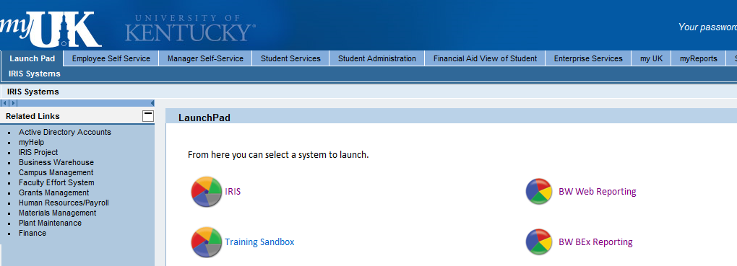

- Select “Financial Accounting.”

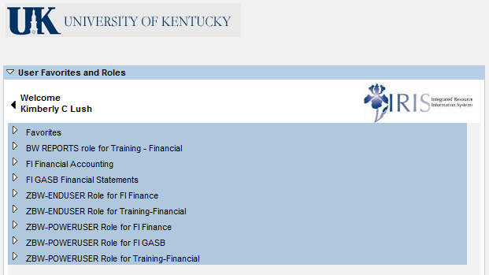
- Select “Endowment Reporting.”

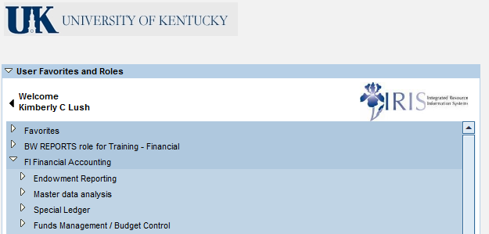

- Select one of the seven endowment reports you would like to view.
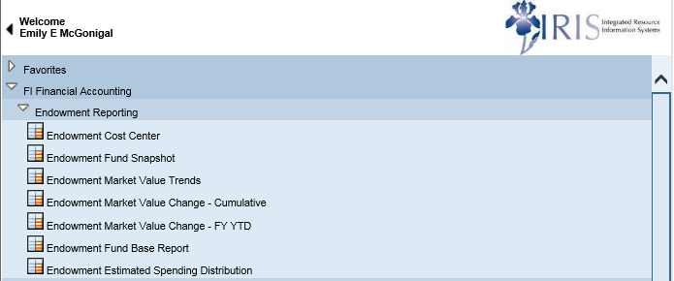

- All of the reports have the same screen for entering variables. All reports require the “Fiscal Period / Year” to be entered in the first field AND the last field.
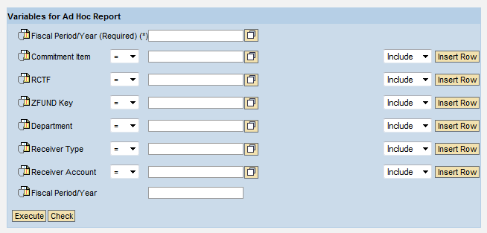
- There are several different variable fields for reporting. Two common searches are by “Department” and by “ZFUND Key” (fund number). Below are snapshots of the variable screen for those two types of searches.
Searching by “ZFUND Key”:
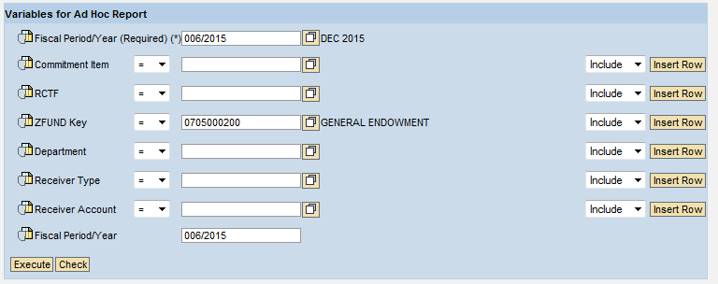
Searching by “Department”:
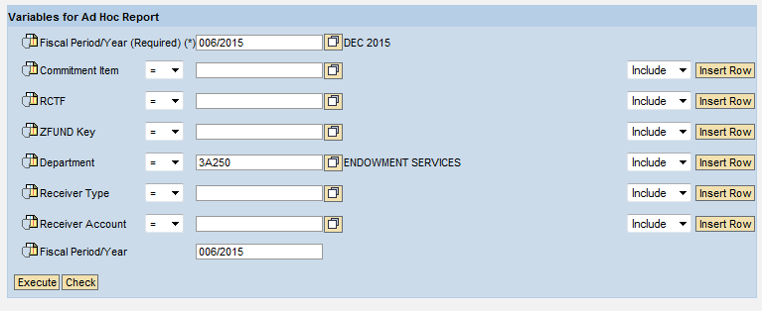
- After entering the search variables, click on “Execute” to run the report.

Below is a list of the seven endowment reports with brief descriptions of each.
- “Endowment Cost Center”: This report displays budget and actual information for cost centers associated with endowment funds. Since December is the base period for budget estimates and determining underwater status, the market value for the preceding December is included.

- “Endowment Fund Snapshot”: This report displays basic fund and cost center data.

- “Endowment Market Value Trends”: This report displays endowment market value, contributed value and underwater status trends.

- “Endowment Market Change - Cumulative”: This report displays changes in the market value since inception of the fund.

- “Endowment Market Change – FY YTD”: This report displays changes in the market value within a fiscal year.

- “Endowment Fund Base Report”: This report displays all variables for an endowment.

- “Endowment Estimated Spending Distribution”: This report displays current fiscal year estimated annual spending distribution for an endowment.

