Monitoring Reports: A Guide for Monitoring Progress in ecrt
To navigate to the reports page, click reports at the top of the homepage, as indicated by the purple arrow.
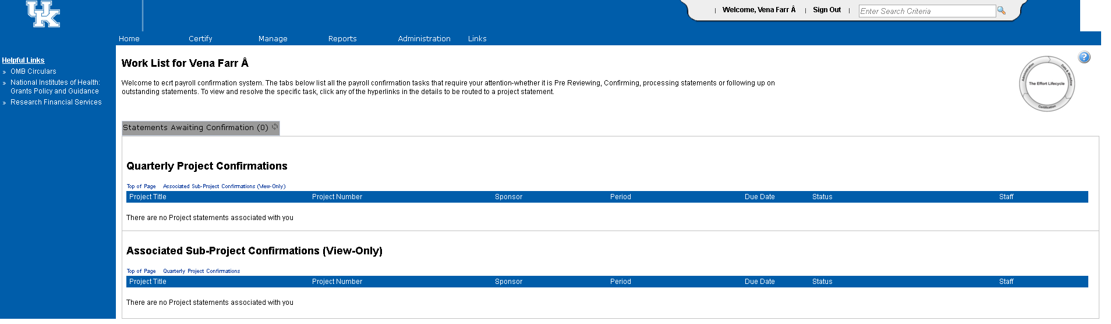
Department Account Report
- From the reports page, select “Management” from the category options. Then select “Department Account Report” under the “Reports” section.
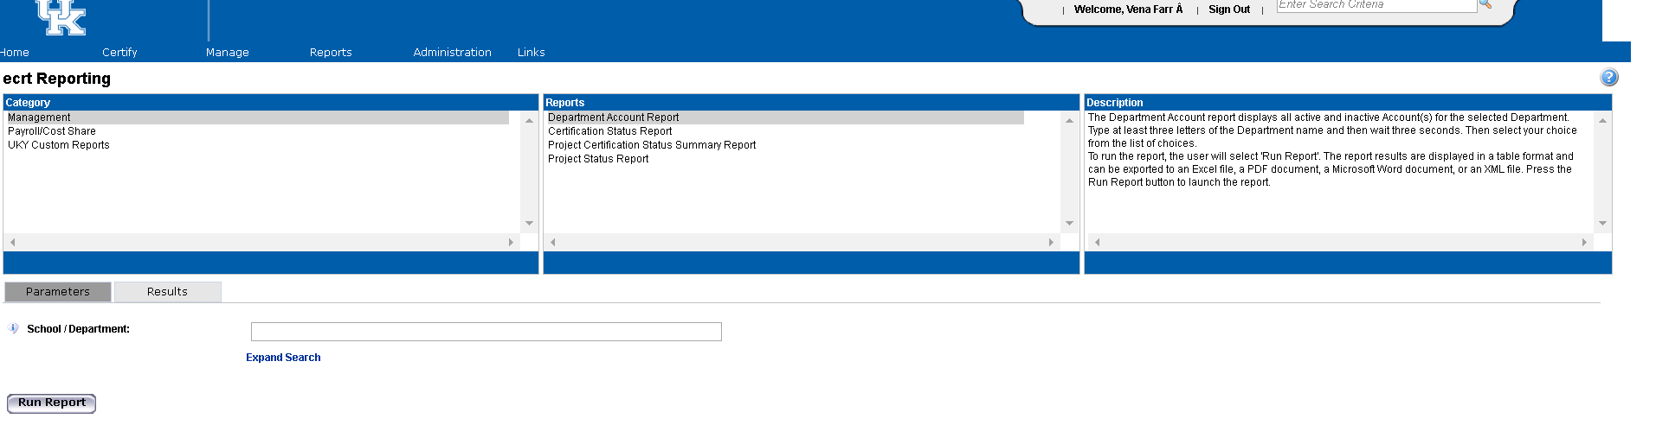

- In the parameters, type in the name of the department that needs to be reviewed.
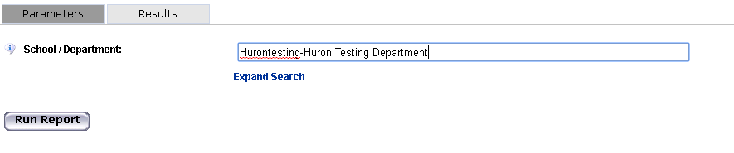
- Click “Run Report.”
- The results will display a comprehensive list of all of the accounts (cost centers and WBS elements) that are associated with this department.
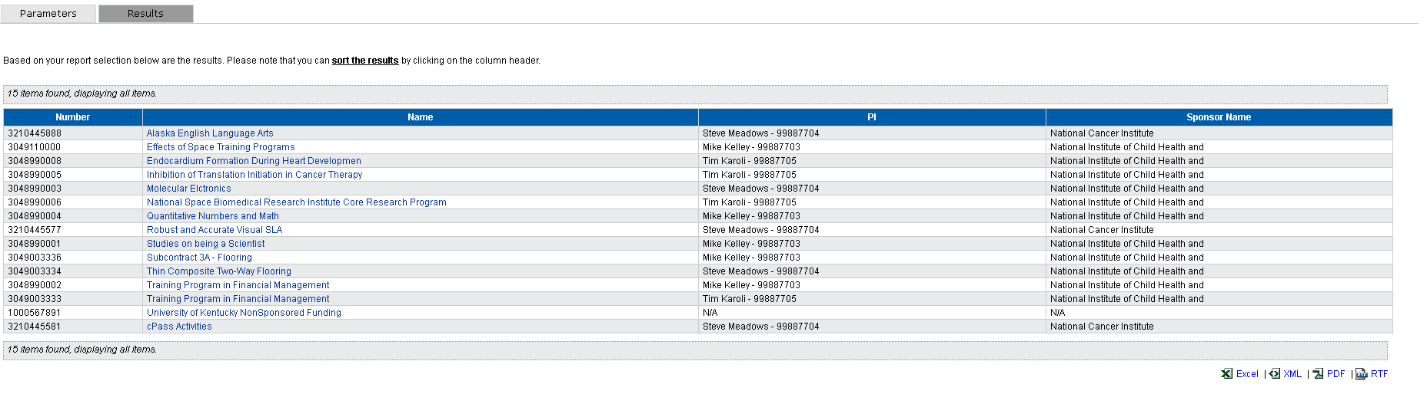
- Check for any missing or new accounts to make sure that all accounts that need to be monitored are included. Notice that from the bottom of the results, this report is available to be exported into Excel or Adobe PDF, by selecting the links at the bottom indicated by the yellow arrow.

Project Certification Status Summary Report
- From the Reports page, select Management under the categories. In the “Reports” section, select “Project Certification Status Summary Report.”
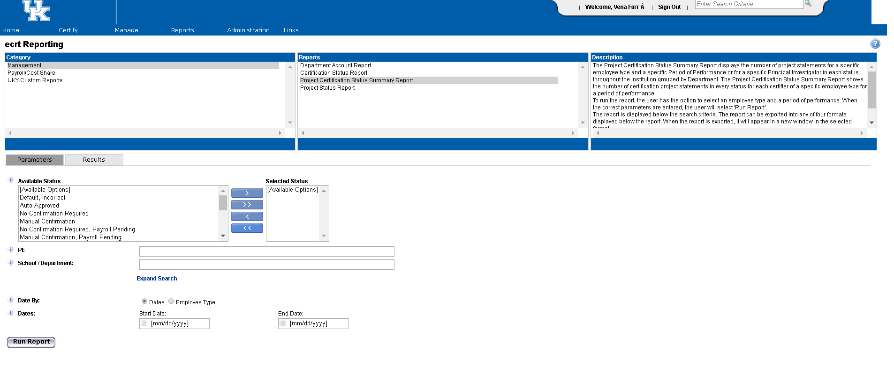
- In the parameters section, select the statuses to review and move them using the blue arrows between the “Available Status” and “Selected Status” boxes. All statuses may be selected by using the double arrow button.
- This report must have either a PI selected or a School/Department. Enter that information in the appropriate field. Note: To see everything from the college level and below, put in the highest level from the hierarchy, for example College of Medicine, College of Agriculture, College of Law, etc.
- Using the radio buttons, select either “Dates” to run by a date range (to look at multiple quarters) or select “Employee Type” and then choose Kentucky for “Employee Type” and then select the quarter to view.
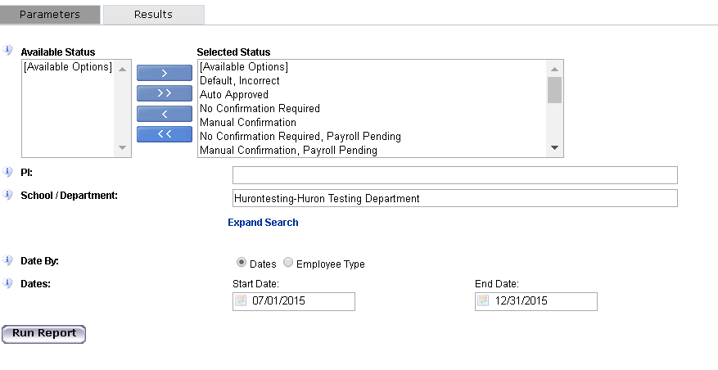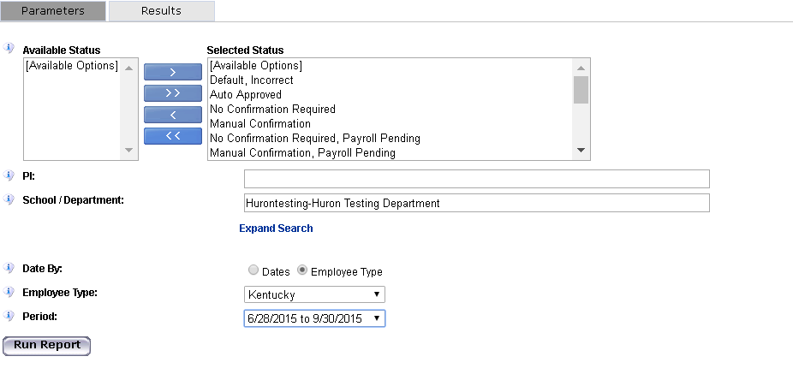
- Click “Run Report” to display results.
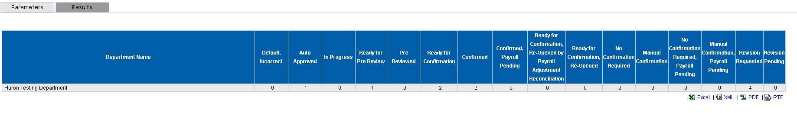
- Results are a summary of how many statements are in each status for the departments that are selected. If this report is generated for results at a college level, there will be rows for each department. This is a very high level report to be able to see the number of project statements and where they are in the workflow process.
- This report is exportable to Excel or PDF by selecting the links from the bottom of the results page, as indicated by the yellow arrow.

Project Status Report
- From the Reports page, under “Category” select “Management” and then under the “Reports” section Select “Project Status Report.”
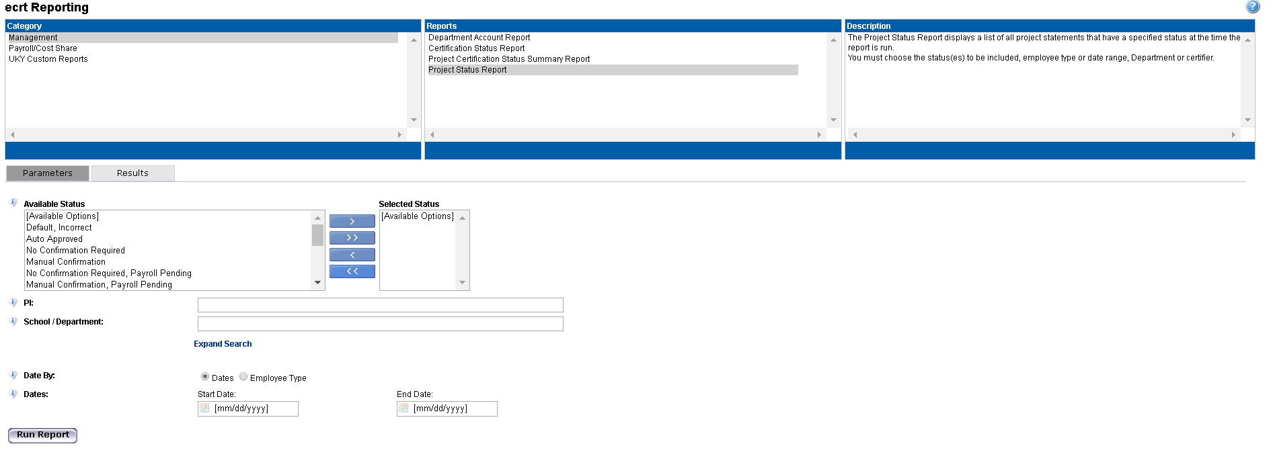
- In the parameters section, select the statuses to review and move them using the blue arrows between the “Available Status” and “Selected Status” boxes. All statuses may be selected by using the double arrow button.
- This report must have either a PI selected or a School/Department. Enter that information in the appropriate field. Note: To see everything from the college level and below, put in the highest level from the hierarchy, for example College of Medicine, College of Agriculture, College of Law, etc.
- Using the radio buttons, select either “Dates” to run by a date range (to look at multiple quarters) or select “Employee Type” and then choose Kentucky for “Employee Type” and then select the quarter to view.
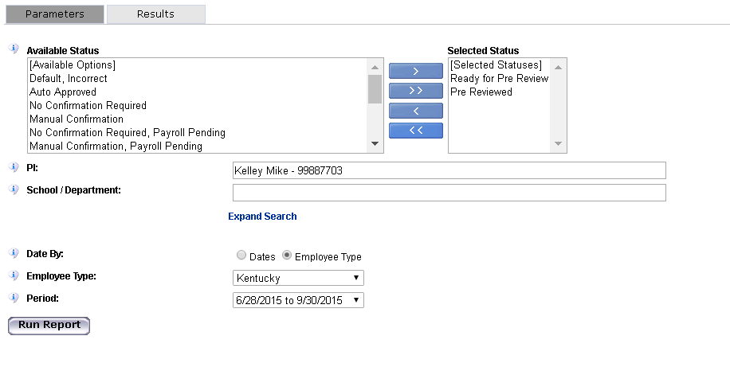
- Once you have the parameters set, click “Run Report.”
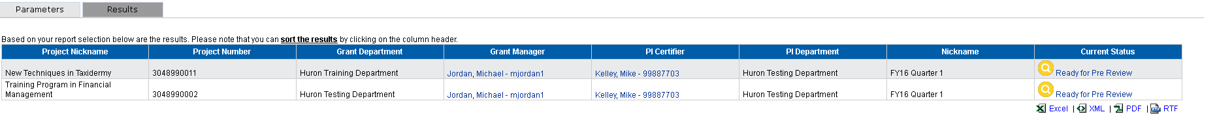
- The report generates a list of statements in the statuses that you selected. You can click on the “Current Status” hyperlink for any statement on the report to be routed to the project statement page. This report can also be exported to Excel or PDF to save for later.

All Grants with ECs and GMs
- From the reports page, under “Category” you will select “UKY Custom Reports” and select “All Grants with ECs and GMs” from the reports section.
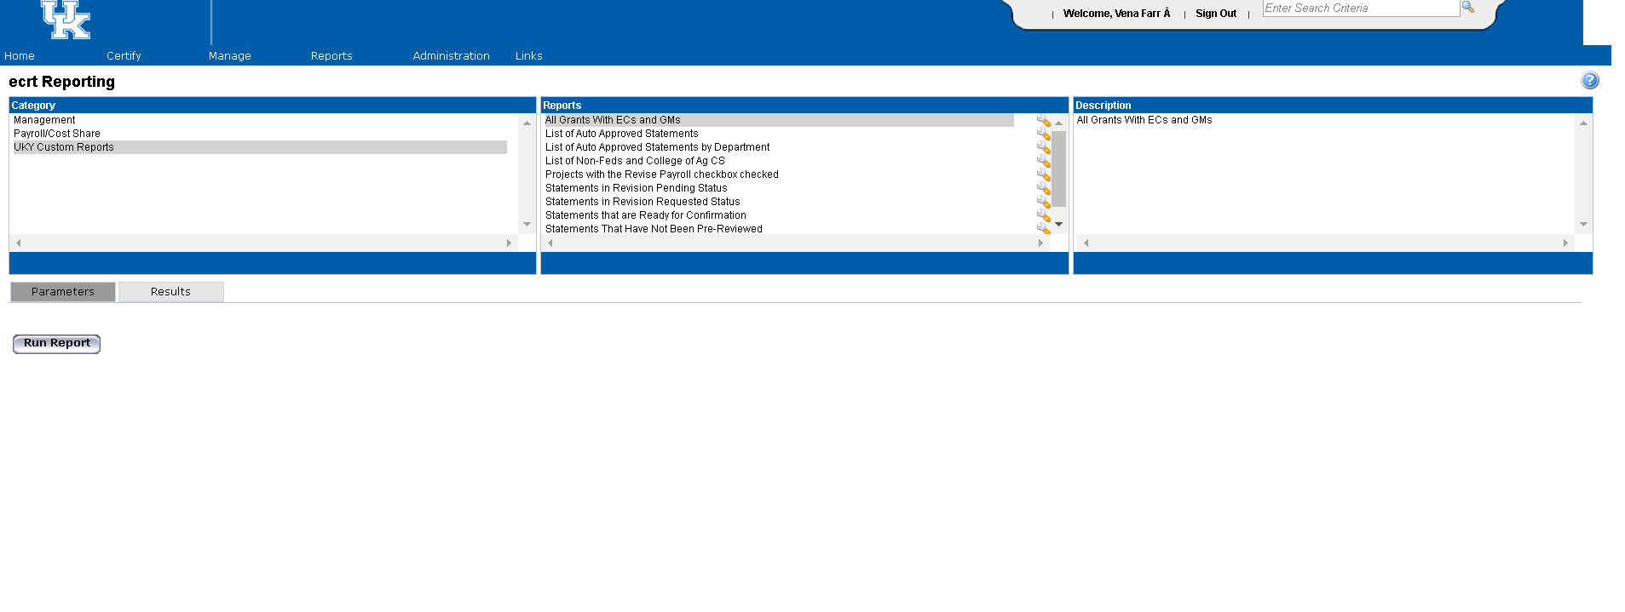
- Select “Run Report” under the parameters as indicated by the purple arrow above.
- The results will display as a list as shown below. This will list only the grants that are associated to the college/departments that you are associated with. The columns indicate the grant number, the grant name, the effort coordinator, if the effort coordinator is primary, and the grant manager if applicable.
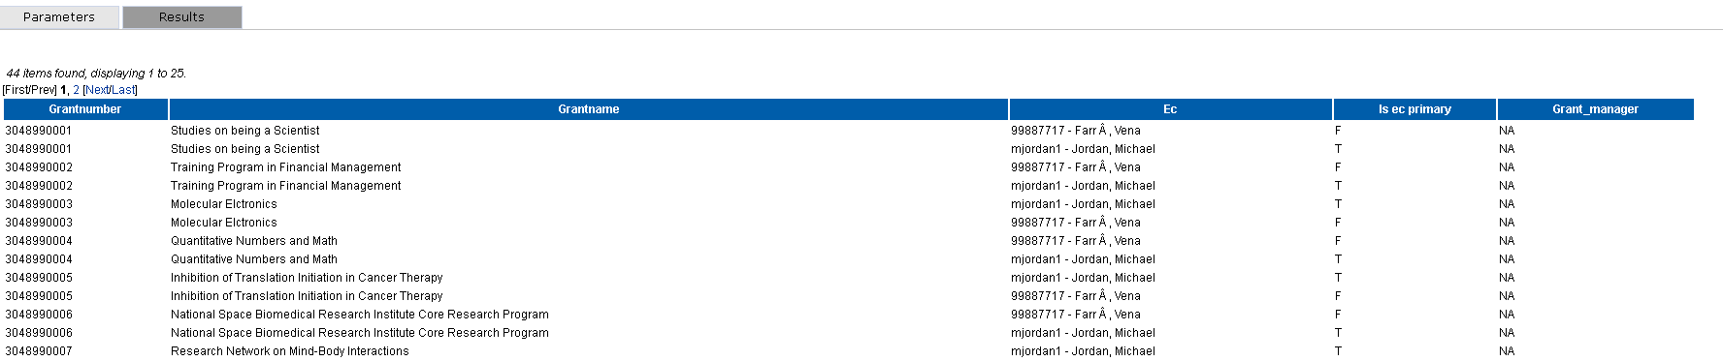
Note: Effort Coordinators on this report include any college effort coordinators, primary department effort coordinators, and backup department effort coordinators. The column “Is ec primary” will be set to “T” if the effort coordinator is the primary department effort coordinator.
- Review the information to make sure that you recognize the people associated with the projects.

Statements That Have Not Been Pre-Reviewed
- From the reports page, under “Category” you will select “UKY Custom Reports” and select “Statements That Have Not Been Pre-Reviewed” from the reports section.
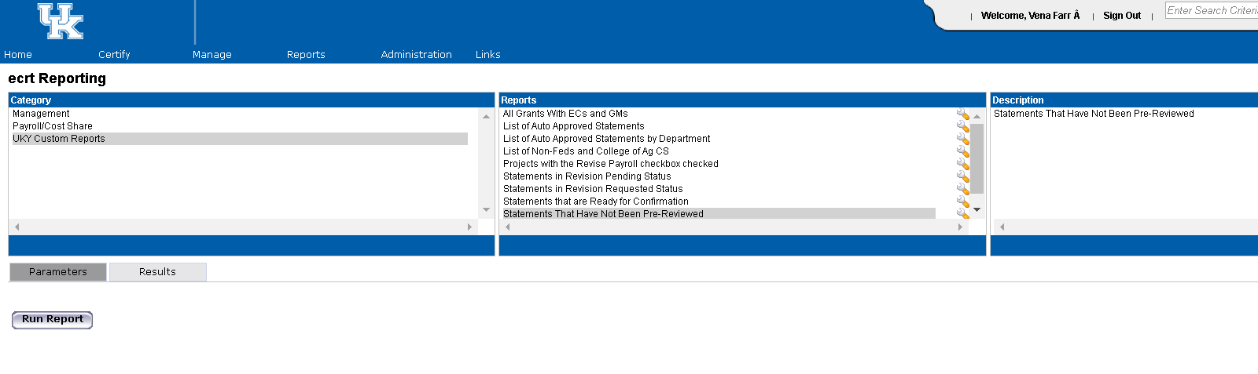
- Under the “Parameters” click “Run Report.”
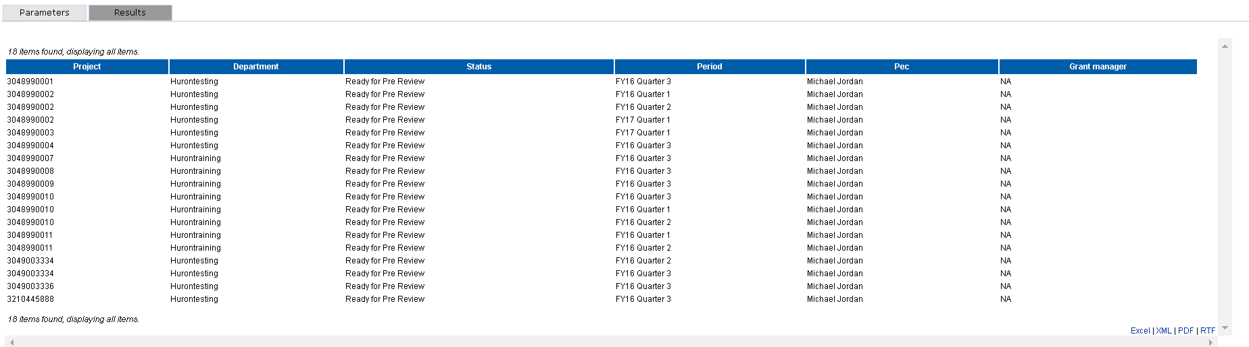
- This report gives you a list of all of the statements that are outstanding to be Pre Reviewed with the grant number, department, current status, period, primary department effort coordinator and a grant manager (if applicable). This would be a good report to run once we are in the confirmation period in order to determine what statements are outstanding.

