Payroll Loaded to a PreReviewed Statement
This report was designed in order to help identify any transactions that have been posted to a project statement once it has been Pre Reviewed. Use this report after notification of payroll loads in order to ensure the accuracy and integrity of the Pre review of the project statement.
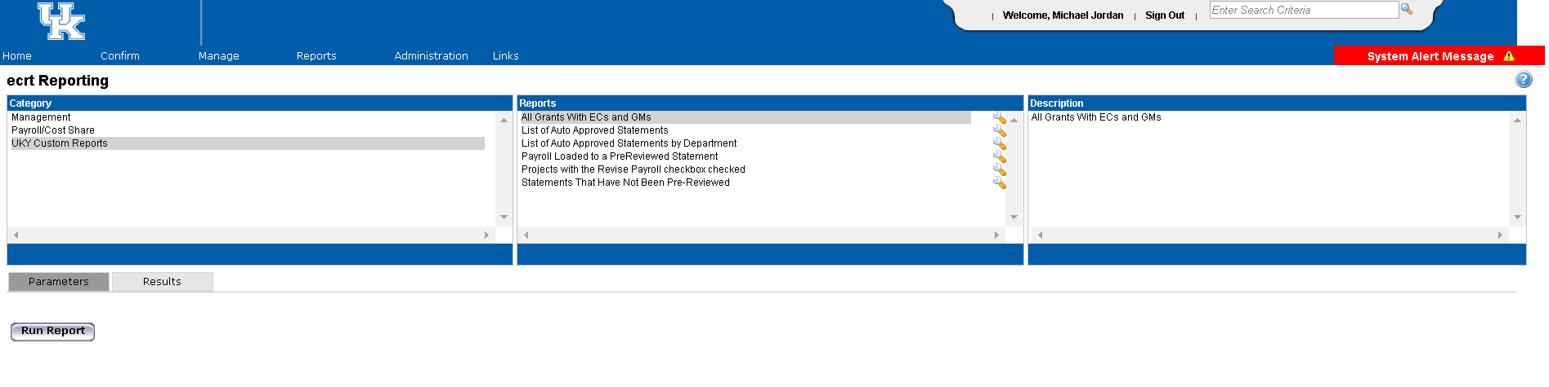
- From the reports menu, select “UKY Custom Reports” under the Category. Then select “Payroll loaded to a PreReviewed Statement” under Reports.
- Use the parameters screen to choose the period of performance dates for the quarter that you would like to review.
Note: Period of Performance refers to standard quarters based on our current fiscal year. For example, quarter 1 for Fiscal year 2017 would be Period of Performance Start Date 07/01/2016 and Period of Performance End Date 09/30/2016.

- Click Run Report.
- The report will generate on the results tab, and you will automatically be routed there. This will provide you with the Employee that was affected, grant number, department code, grant name, the payroll amount loaded, the period start and end dates, the payroll load date, and the date that the statement was pre reviewed. Please note that the report shows each transaction per individual that had payroll post after the statement was Pre Reviewed.

