University of Kentucky Endowment Services
Endowment Fund Create and Change Form Instructions
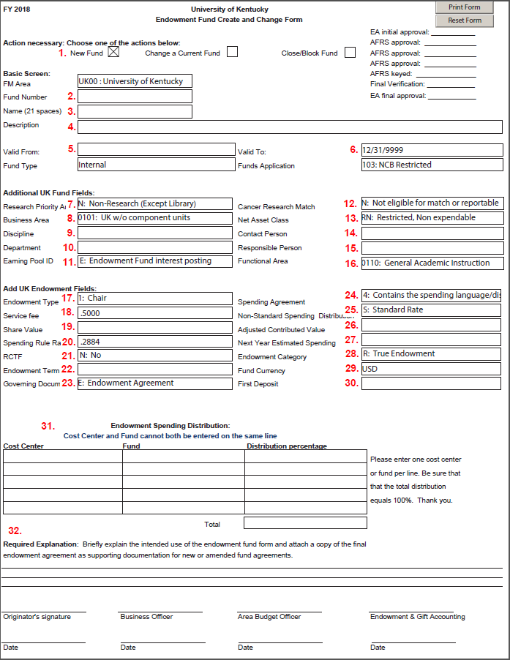
New Accounts
- Choose New Fund.
- Fund Number: Leave Blank, Endowment Accounting will assign a fund number
- Name: Enter a short title, can be anything you want
- Description: The name must match the fund name in the Agreement
- Valid From: The date that is on the Agreement
- Valid To: Always 12/31/9999
- Research Priority Area: Choose the Research Priority Area from drop down list
- Business Area: Select Business Area from drop down list
- Discipline: Enter your discpline that is assigned based on department number
- Department: Enter your department number
- Earning Pool ID: Always E-Endowment Fund interest posting
- Cancer Research Match: Always N-Not eligible for match or reportable
- Net Asset Class: Select the Net Asset Class from drop down list
  - RN- Select for True endowments
  - RE- Select for Term and Quasi endowments
- Contact Person: Enter your contact person
- Responsible Person: Enter your responsible person
- Functional Area: Choose your functional area from drop down list
- Endowment Type: Choose your endowment type based on your agreement from the drop down list
  - Chair
  - Professorship
  - Fellowship
  - Scholarship
  - Lectureship
  - Enrichment
  - Other
- Service Fee: This field is already entered and cannot be changed
- Share Value: Leave Blank, Endowment Accounting will complete
- Spending Rule Rate: This field is already entered and cannot be changed
- RCTF: Choose if this fund is receiving RCTF match funds or not from drop down list
- Endowment Term: Leave blank, Endowment Accounting will complete
- Governing Document: Select Governing Document from drop down list. Majority of the time, this will be E.
- Spending Agreement: Select Spending Agreement from drop down list. Majority of the time, this will be 4.
- Non-Standard Spending Distribution: Majority of the time, this will be S
- Adjusted Contributed Value: Leave Blank
- Next Year Estimated Spending: Leave Blank

- Endowment Category: Select the Endowment Category from the drop down list
  - R-Select for True endowments
  - T-Select for Term endowments
  - Q-Select for Quasi endowments
- Fund Currency: This field is already entered and cannot be changed
- First Deposit: Leave Blank
- Endowment Spending Distribution: Enter the percentage that is to be distributed between the cost center and fund. For new endowments, the percentage has to be 100% to the fund for one year after the first deposit into the fund. After one year, the department can submit a form to change the percentage.
- Required Explanation: Enter a brief description of the intended use of the fund
For a brand new endowment, a cost center request form will also need to be submitted. This is the spending distribution cost center. The only income that is allowed in this cost center is the spending distribution income earned from the endowment fund. Other gifts cannot be deposited into this cost center.
Change a Current Fund
- Click on the Change a Current Fund box at the top of the form.
- Fund Number (#2): Enter the current 07* endowment fund number
- Name (#3): Enter the short title for the endowment
- Description (#4): Enter the long title for the endowment that matches the agreement or amendment
- Enter any other changes in the correct fields on the form
- Required explanation (#32): Enter a brief description of the changes to the endowment fund
Close/Block Fund
- Click on the Close/Block Fund box at the top of the form
- Fund Number (#2): Enter the current 07* endowment fund number
- Name (#3): Enter the short title for the endowment
- Description (#4): Enter the long title for the endowment that matches the agreement or amendment
- Required explanation (#32): Enter a brief description with the reason the endowment fund will be closed
Form Submission
Submit the Endowment Fund Create and Change form to your business officer and budget officer for approval. The budget officer sends the approved forms to Endowment Accounting. Once Endowment Accounting reviews the form, it is forwarded to Accounting & Financial Reporting Services (AFRS). AFRS approves and keys the form. This process can take 3-5 business days.

