Payroll Report
The Payroll Report is a payroll summary report for an individual, department or account and a date range.
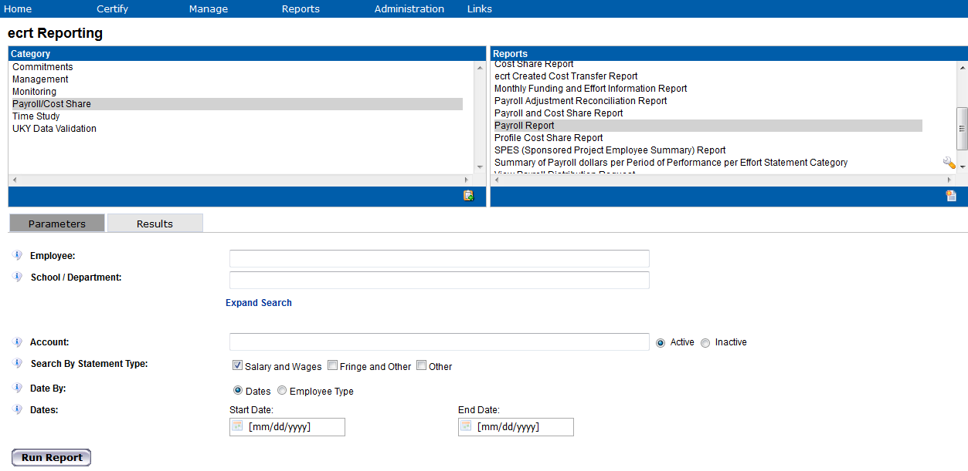
Navigate to the Reports Page > Select Payroll/Cost Share from the Category header > Find Payroll Report in the Reports header

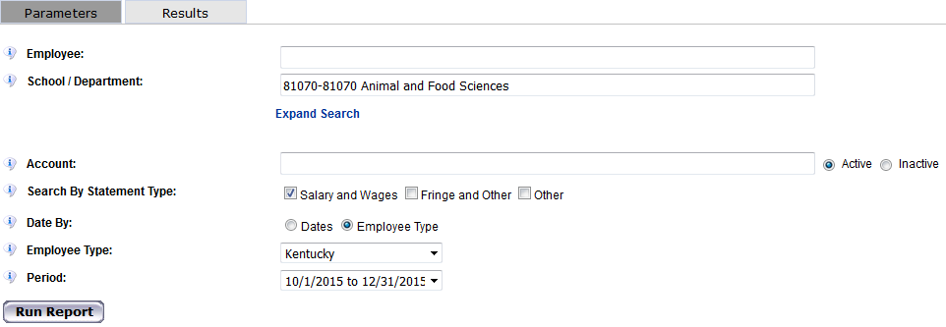
Payroll Report by Department -

In the example above, we are running the payroll report for the Department 81070 Animal and Food Sciences, for all employees in that department who are included the Kentucky employee type, and for the period 10/1/2015 to 12/31/2015.
Type in the first three characters into the desired parameter field (in our example, the Department field). This will populate a drop down menu from which you can select the Department Name.
Note: All employees will be included under the Kentucky employee type
After you input all desired parameters, click the Run Report button.
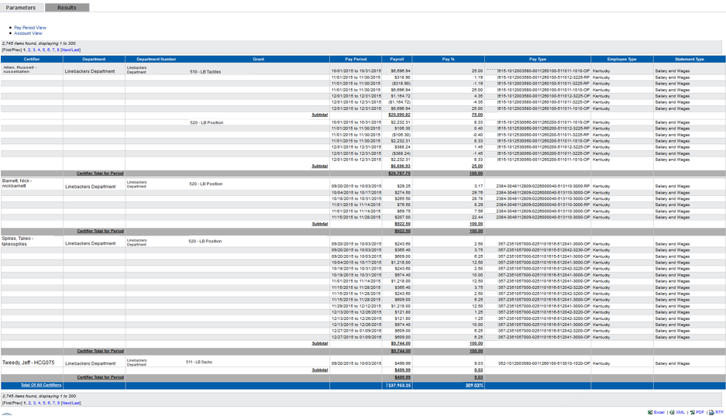
The report displays the name of the employee, the employee’s primary department name and number (the department that was input in the parameters tab), the account (shown below as Grant), the pay period, the payroll amount, the percentage of the total statement payroll for the account, the pay type, and the employee type of the individual at the time the statement was created.

Note: This report can be exported to excel using the hyperlink at the bottom right of the report

The payroll report displays the following columns:
Certifier | Name of the employee
Department | Home department of the corresponding employee
Department Number | Home department number of the corresponding employee
Grant | The account/project the corresponding employee was paid from
Pay Period | The pay period which payroll hit the corresponding grant
Payroll | Dollar amount of payroll paid from the grant for the pay period
Pay % | The percentage of payroll dollars as it relates to the employee’s total pay for the period
Pay Type | Additional details about the payroll transaction (see below)
Employee Type | Kentucky
Statement Type | Salary and Wages

The Pay Type column provides additional details about the payroll transaction for the corresponding pay period.
Example:
The string is defined as follows:
Person Number (Assignment Number) – Account Number (WBS Element) – Fund – GL Account – Wage Type – RP
Note, the end of the string will be one of the following:
- RP – Retro Pay
- OP – Original Pay
- JE – Journal Entry

The Fund Code includes whether it is:
INT – internal
EXT – external
CS – cost share

Retro Payroll – Note that all retro payroll will be included in the ‘For Period’ payroll report.

For example, if a payroll transaction posted in January 2016 that was for the pay period 12/13/2015 to 12/26/2015, the payroll transaction will appear in the December 2015 payroll report and will appear on the Quarter 2 project statement.

Payroll Report Calculations:

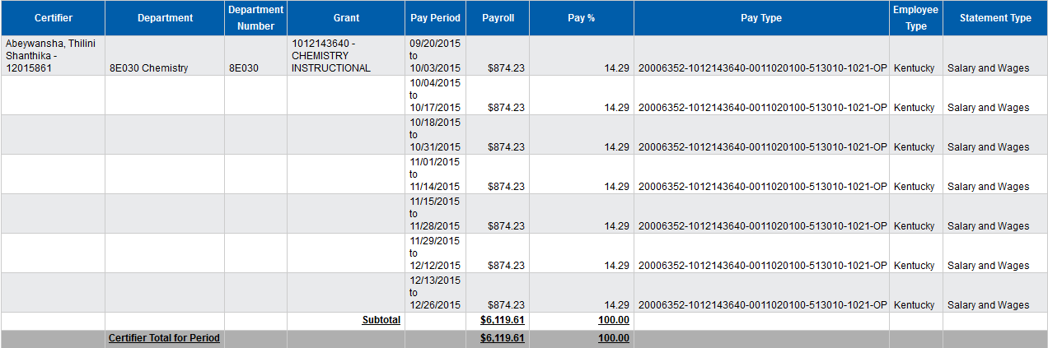
The payroll report will show the amount charged to each account during each pay period, the total amounts charged to each account during the period, and the percent of total pay during the period for each account.

Pay % Calculation:
Pay Period 9/20/2015 to 10/03/2015
Payroll dollars paid for the pay period: $874.33
Total payroll for the confirmation period: $6,119.61
Percentage of payroll for the pay period: 14.29% ($874.33/$6119.61)

Total Pay % Calculation:
When the payroll report is run for the Department, the total payroll dollars and percentage for that department are located at the bottom of the report in the ‘Total of All Certifiers’ row.

The report is adding up the dollars and percentages in the Pay and Pay % column to calculate these totals.

Also note that this report can be exported to excel for further analysis.

Payroll Report by Employee –
To view payroll for an employee, input the employee’s name or employee ID in the Employee field.
The report will show the pay that was charged to each account during each pay period within the period defined in the parameters, the total amounts charged to each account during the period, and the percent of total pay during the period for each account.
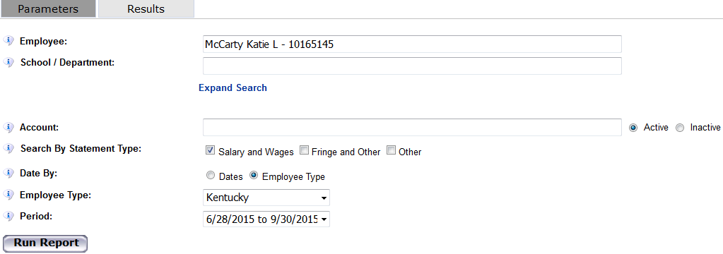
The user running this report must be associated to the employee’s Home Department to run the payroll report for that employee. You can view the employee’s home department on the department dashboard.

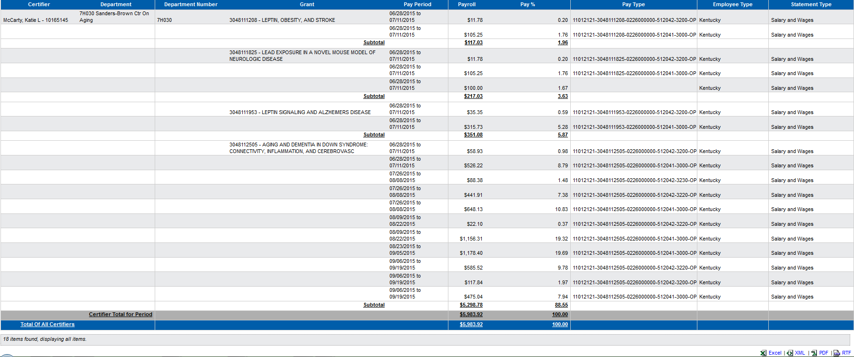
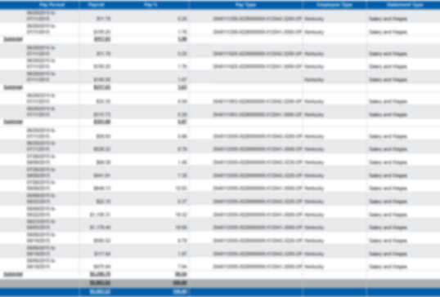

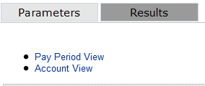
The report defaults on an Account View showing the employee’s payroll amount broken-down by pay period.
Click the Pay Period View hyperlink at the top left of the report to view all payroll for the employee for the period, broken-down by pay period.

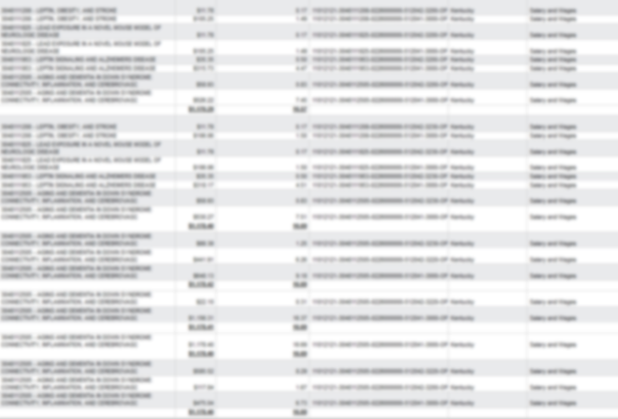
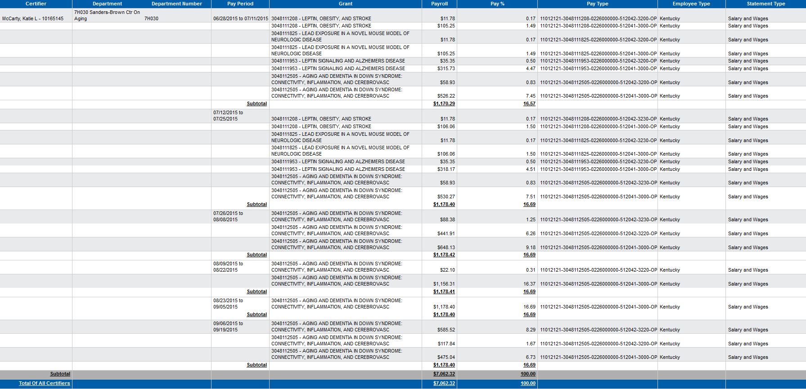
The report now displays the name of the employee, the employee’s primary department name and number, the pay period, the account (shown below as Grant), the payroll amount, the
percentage of the total statement payroll for the account, the pay type, and the employee
Payroll Report by Account –
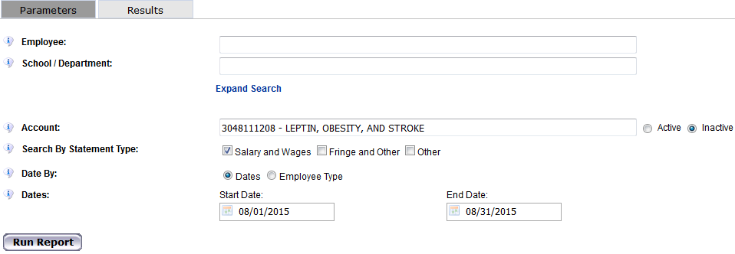
To view payroll for an account, enter the account number in the Account field.

The report will show the list of employees paid from the account during the date range selected. The report also shows the total payroll dollar amount paid from the account for the date range selected.
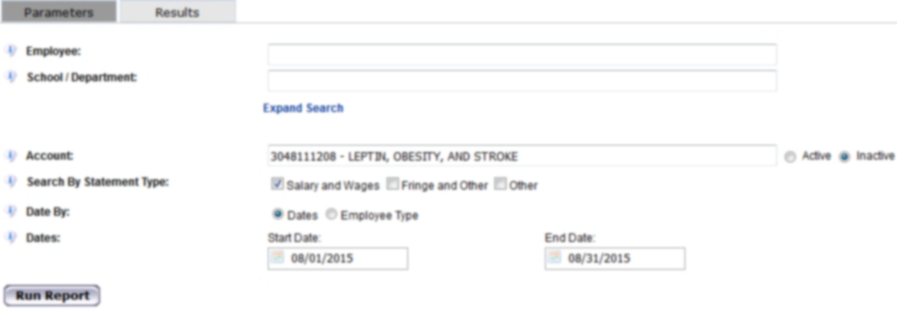
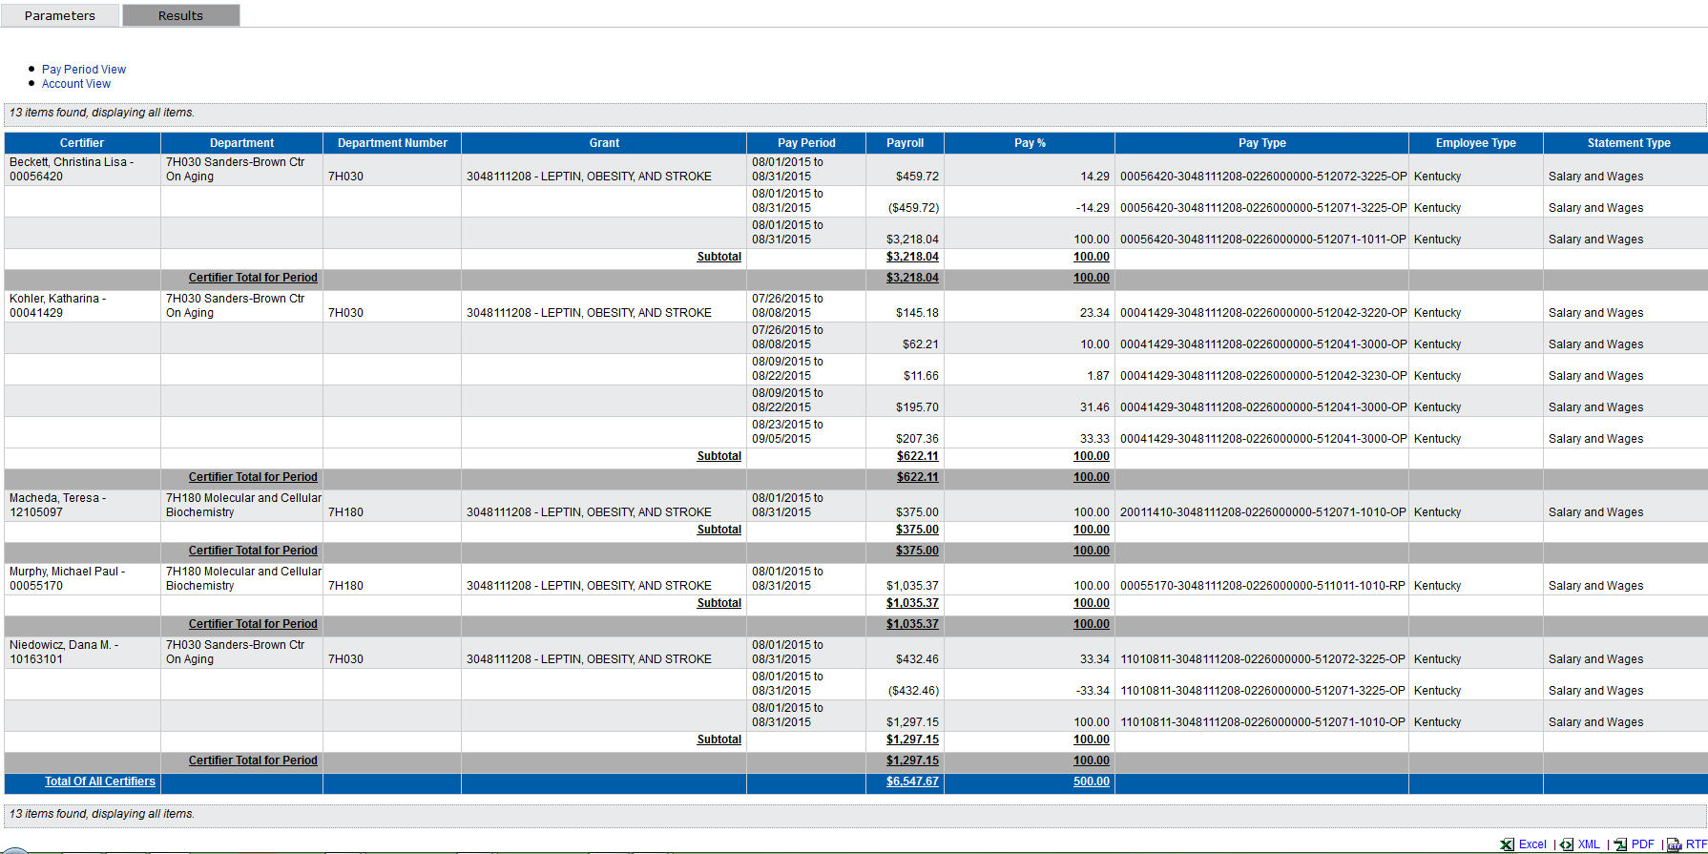
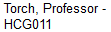
The Active radio button should be used for project’s that have not ended. The Inactive radio button should be used for project’s with end dates past the current date.

