Payroll Reports from the Project Statement
- There are payroll reports that are available from the Project Statement that can help you in reviewing the payroll expenditures for a particular project.

- From the project statement, select the or icon to view more payroll information. These icons are found on the Project Statement under the Payroll info column.
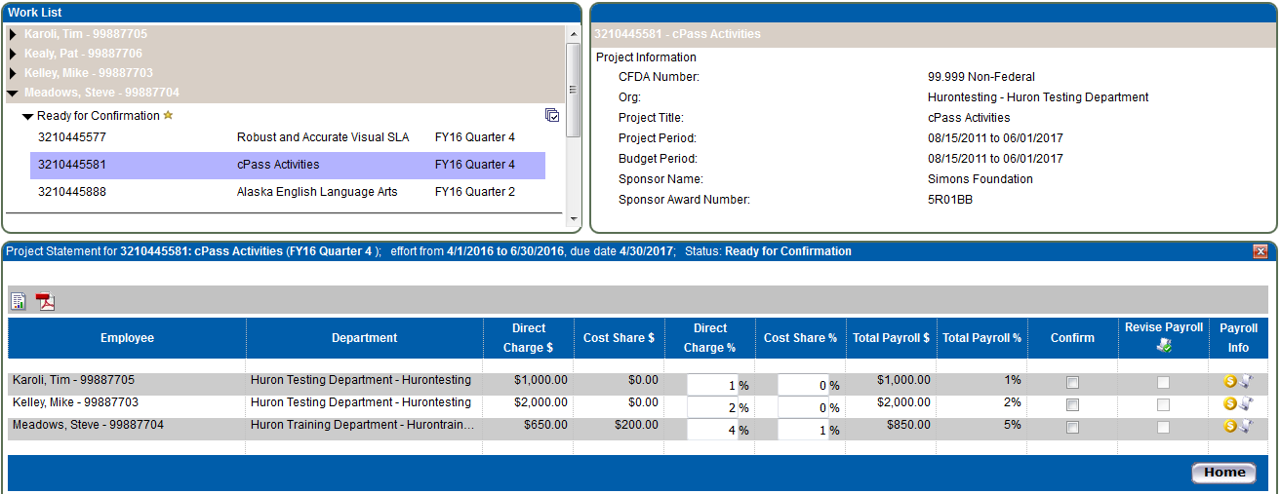

- Click this icon to generate the payroll report for the employee. The payroll report shows the payroll that appears on the project statement.
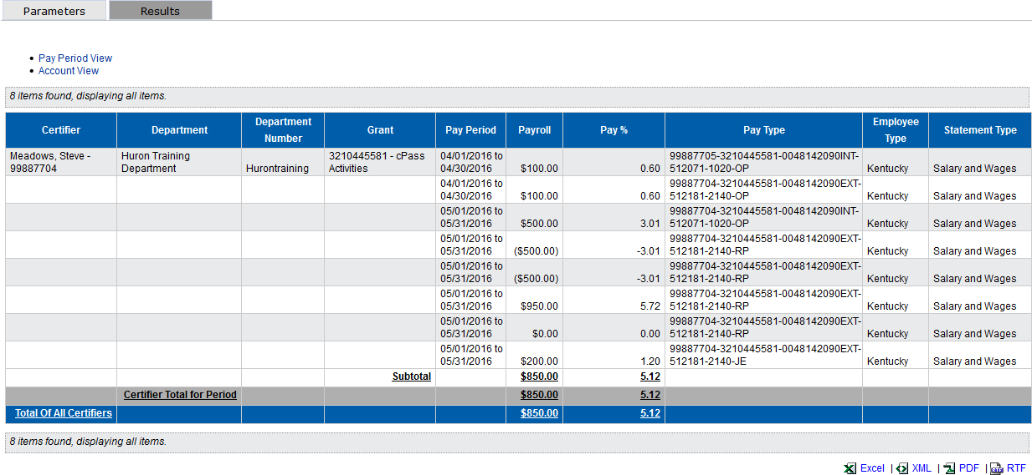

Project Statement:

The report defaults on an Account View showing the employee’s payroll amount broken-down by pay period.
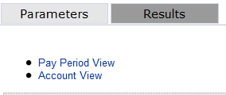
Click the Pay Period View hyperlink at the top left of the report to view all payroll for the employee for the period, broken-down by pay period.

- The Pay Type column provides additional details about the payroll transaction for the corresponding pay period.

Example: 99887704-3210445888-0048142090EXT-512181-2140-RP
The string is defined as follows:
Person Number (Assignment Number) – Account Number (WBS Element) – Fund – GL Account – Wage Type – RP
Note, the end of the string will be one of the following:
- RP – Retro Pay
- OP – Original Pay
- JE – Journal Entry

The Fund Code includes whether it is:
INT – internal
EXT – external
CS – cost share

Retro Payroll – Note that all retro payroll will be included in the ‘For Period’ payroll report.

For example, if a payroll transaction posted in January 2016 that was for the pay period 12/13/2015 to 12/26/2015, the payroll transaction will appear in the December 2015 payroll report and will appear on the Quarter 2 project statement.

- Once you are done reviewing this information, just close the second browser screen to return to the project statement page.

- Click this icon to view the employee’s 100% payroll for the period.
