**Looking up a Non-Federal Project**

This guide is intended to show Principal Investigators how to access project statements for non-federally funded sponsored projects. Formal confirmation is not required for these projects.

**For best results do not use internet explorer to access the URL. Instead we recommend that you select Chrome or Firefox as your browser.**

1. Log in to the myUK portal page. At the top of the page select either the Enterprise Services tab or the Faculty Services tab. Next select the ecrt Payroll Confirmation subtab.

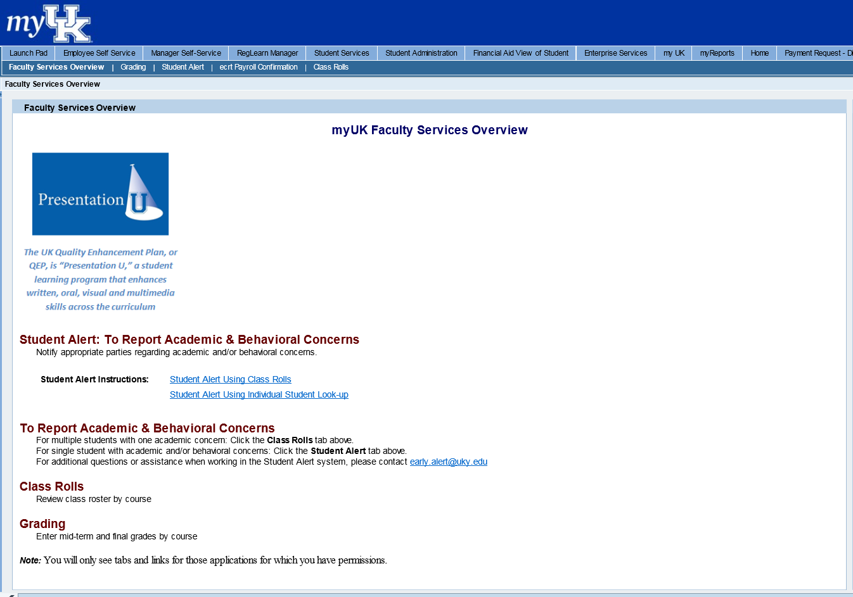

1. Click on ECRT Payroll Confirmation and the welcome screen will appear. Click on the ECRT Payroll Confirmation link to be routed to the software.

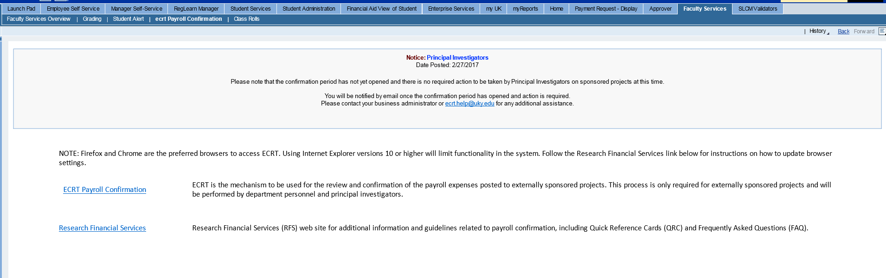

1. From the ECRT Welcome page, press the continue button to navigate into the system.

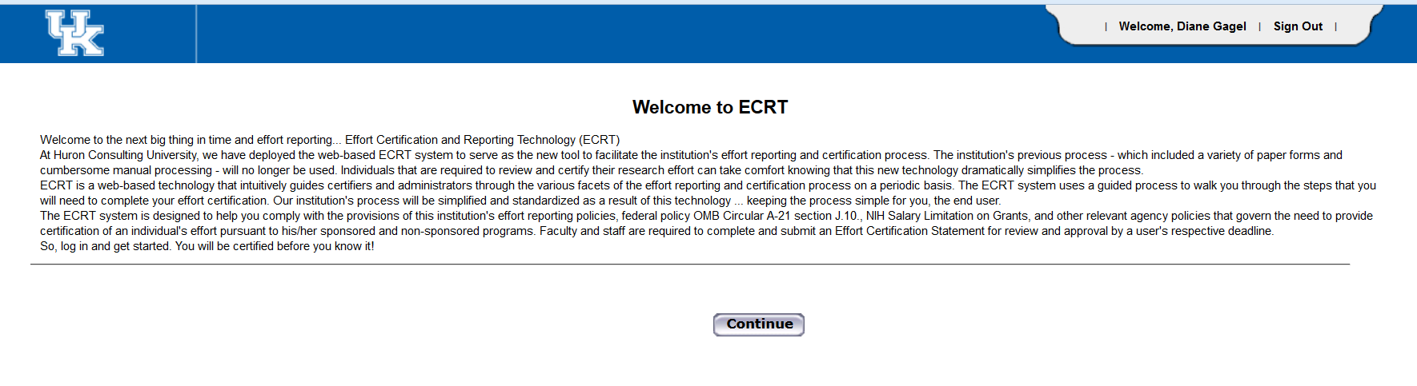

1. Once logged in, the screen will default to your homepage where your worklist is located.

To look up a non-federal project, you can use the search box in the upper right of the screen (indicated by the green circle). Begin typing the project number if known. This will take you to the Account Summary page for the project.

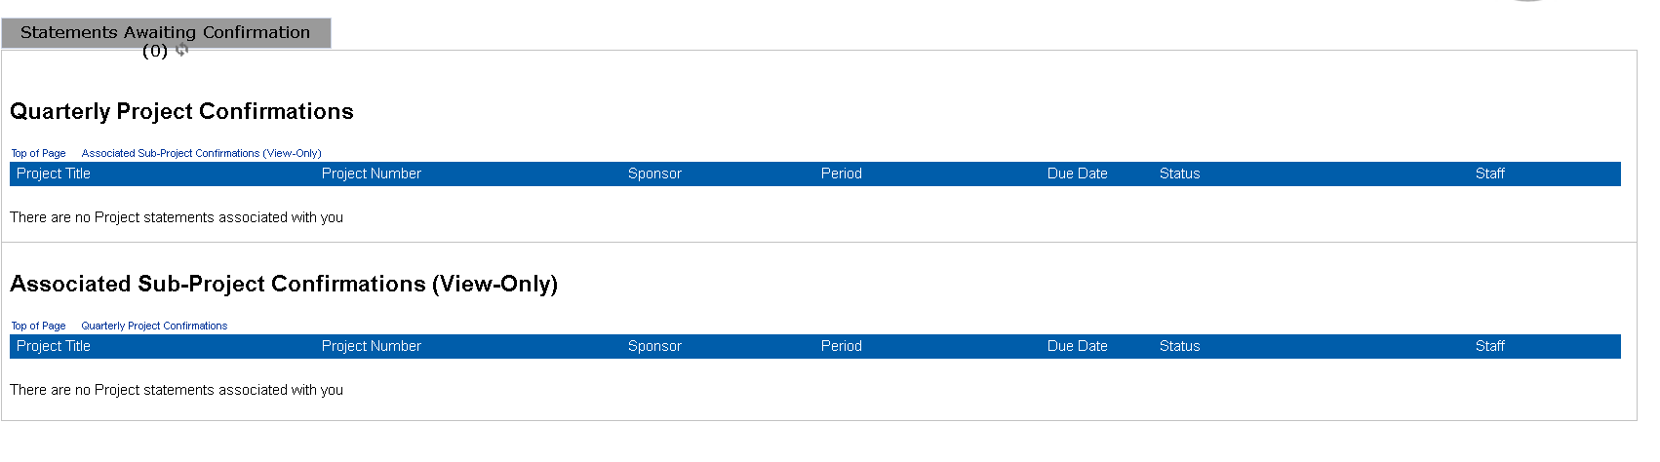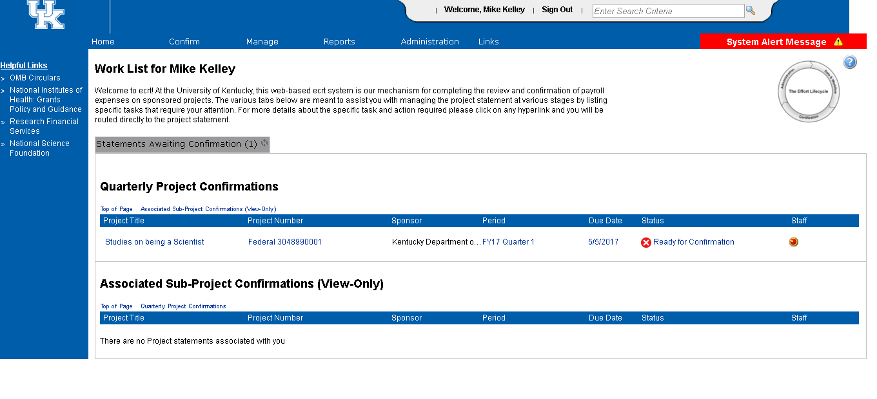

1. 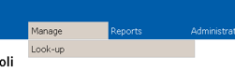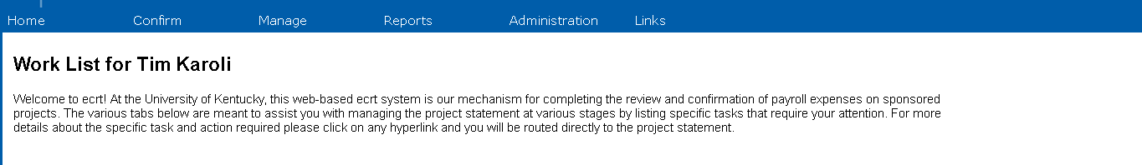If the project number is not known, you may also use the Look-up Page. Hover over Manage on the menu bar and then select Look-up.
2. Once on the Look-up page, you can search by typing in the first 3 letters of the title of the project. This will produce a list of projects containing the same unique combination of letters. Select the project you wish to review and you will be routed to the Account Summary page.

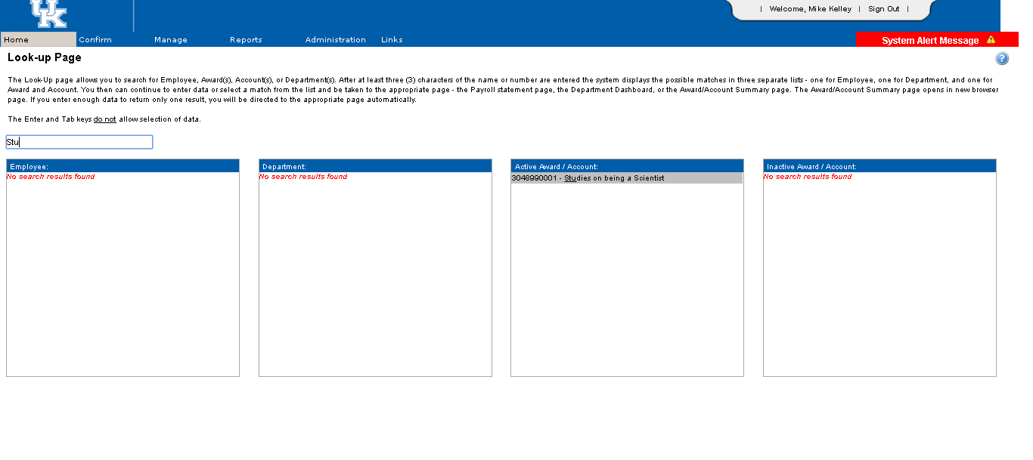

You can also search by entering the first 3 numbers of the project. Select the project number you wish to review and you will be routed to the Account Summary page.

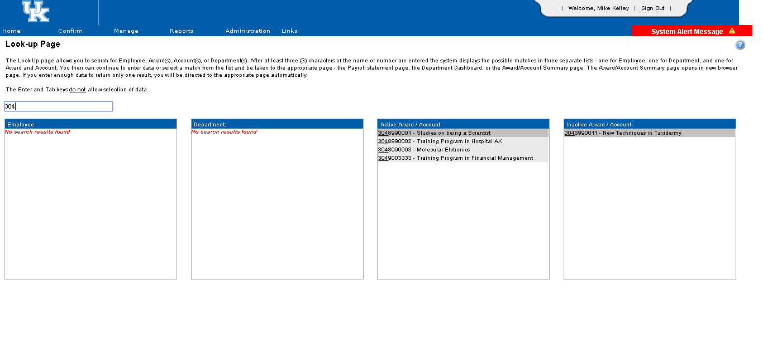

1. The Account Summary Page includes a variety of information about the project. You can select the statement that you would like to review by clicking on any of the status icons under “Project Confirmation Status” OR by clicking on a selected reporting quarter under “Period”.

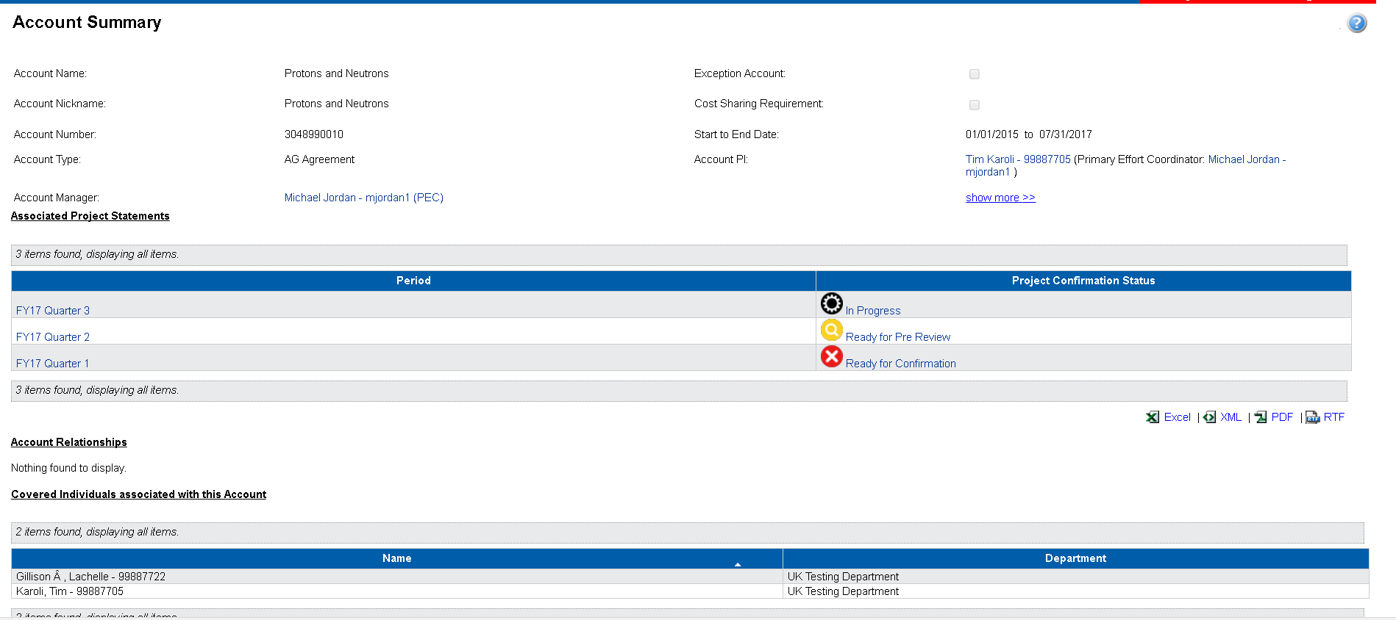

1. On the project statement page, you will find a variety of information about the project.
   1. The box in the upper right corner of the page contains information specific to the sponsored project, which can also be found on the GMGRANTD tab in SAP.
      1. For example, the Sponsor Award Number equates to the External Reference Number you see listed on the monthly PI reports.
      2. Project Period indicates the entire length of the award period. For example, if your project is a 5 year award from NIH, the project period would reflect the entire 5 years, just as it does in SAP.
      3. Budget Period may be shorter than project period. Again, using the example of a 5 year award from NIH, if you have only received incremental funding through the second year of the award, the budget would only reflect the 2 years for which we are authorized to incur expenses.
   2. 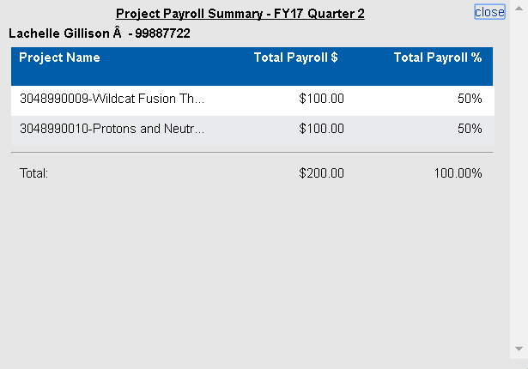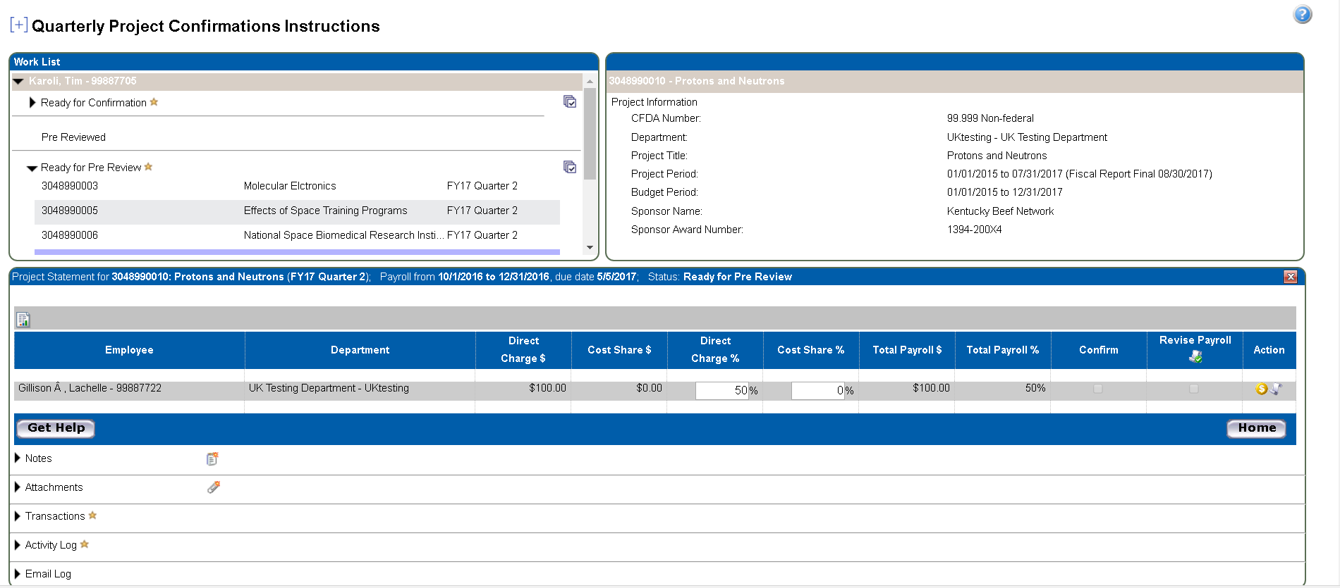The main section of the page contains the detailed information associated with the project which needs to be reviewed and, if reasonable, confirmed. **PLEASE NOTE** – the percentage referenced next to the dollar amount represents the percent of total compensation the individual received during the reporting quarter. Supplemental pay, such as a summer research payment, will be included in the denominator of the percentage calculation. For a quick overview of all pay for the reporting quarter, click on the scroll icon in the Action column on the project statement. This will open a pop up window that will show all cost objects that the person was charged to during the quarter.
2. Continue reviewing each statement as desired.
3. To log out of ecrt, click the Sign Out link in top right corner of web page.



1. Once logged out, the following message will appear. Please just close or X out of this page.

