ecrt Users Guide
A Quick Guide for College Effort Coordinators Monitoring the Pre Review and Confirmation Processes
The role of the College Effort Coordinator is one of oversight and monitoring designed to ensure that those assigned to “task” roles are completing their assigned tasks timely and receive any additional assistance they may need. As such, the College Effort Coordinator will not have specific tasks to perform in the ecrt software. The tabs within the software are different than those of the Department Effort Coordinator roles.
For best results do not use internet explorer to access the URL. Instead we recommend that you select Chrome or Firefox as your browser.
- Log in to the myUK portal page. At the top of the page select the Enterprise Services or Faculty Services tab. Next select the ecrt Payroll Confirmation subtab.
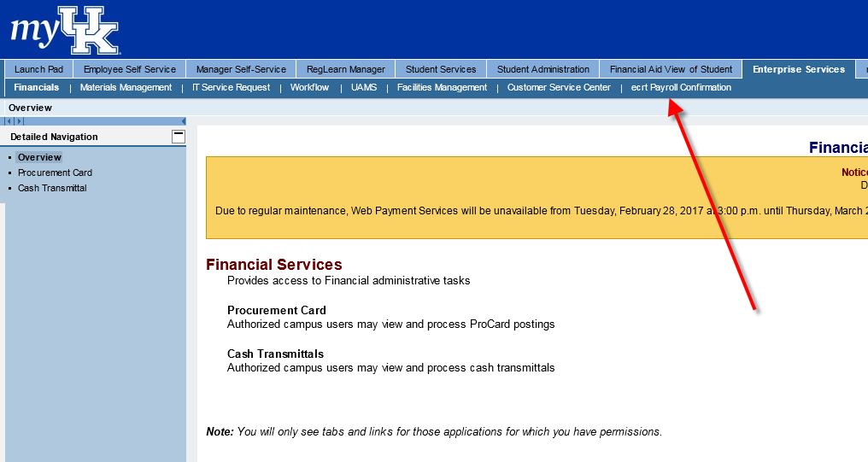

- Click on ECRT Payroll Confirmation and the welcome screen will appear.

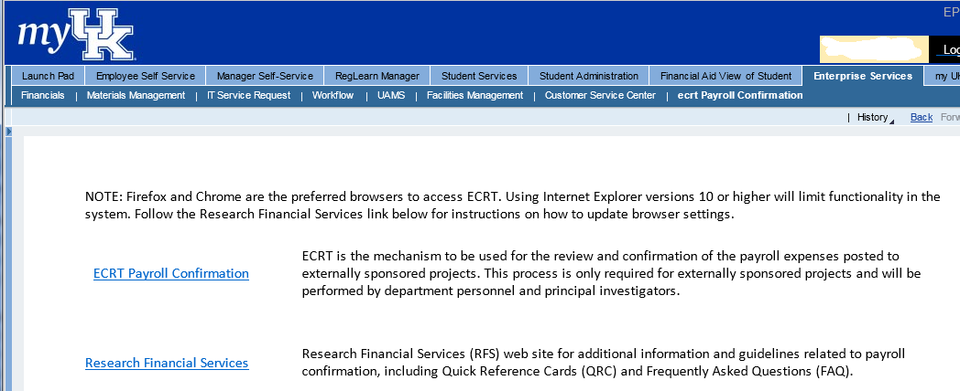

- From the ECRT Welcome page, press the continue button to navigate into the system.

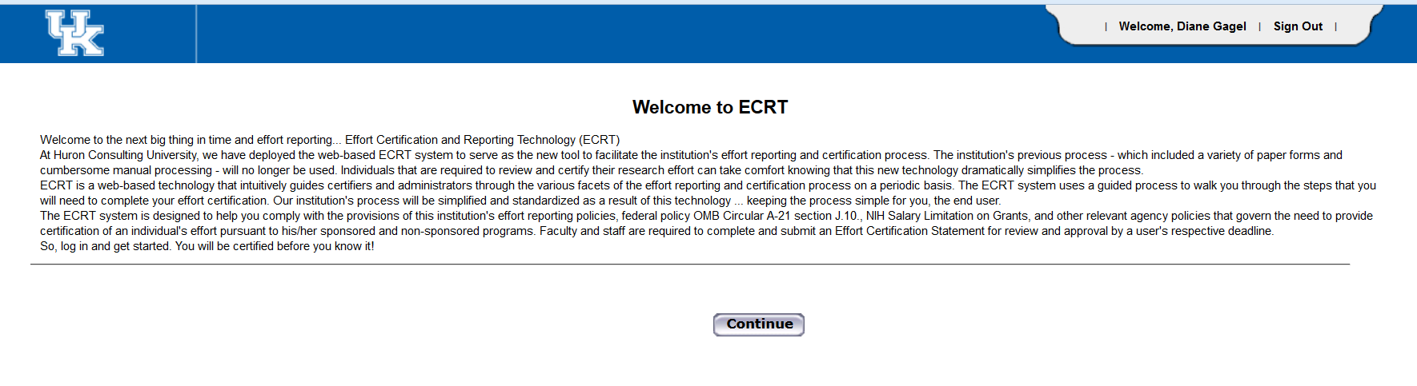

- Once logged in, the screen will default to your homepage:

To look at Department information, hover over “Manage” and select Department Dashboard.
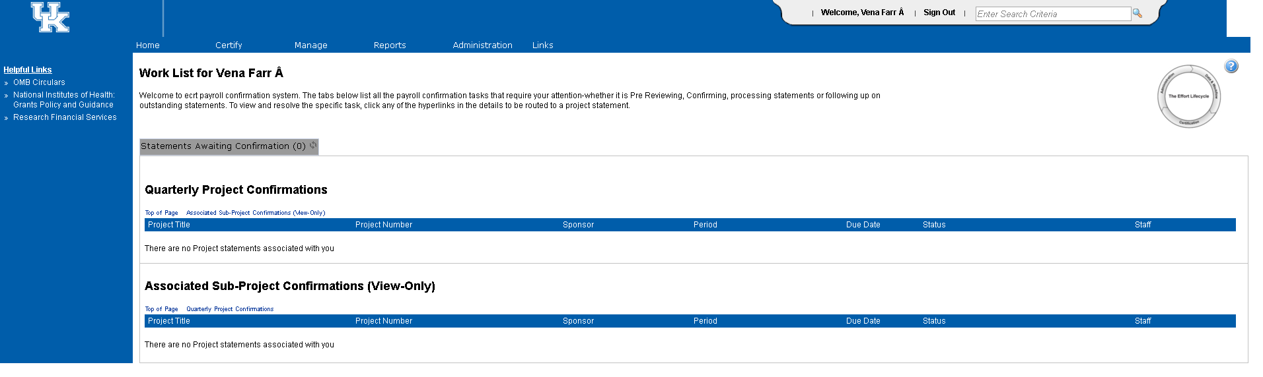

- As a College Effort Coordinator, you will have access to all of the departments within your college. Use the drop down menu to select the department that you would like to view:
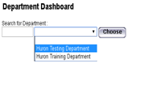
When you get to the Department Dashboard, there are four tabs.
- People tab: Nothing will appear here
- Project Certifications tab: Lists all the projects in the department and shows the statuses of the project statements.
  - You can click on any of the status icons to be routed to a project statement.
  - Status icons start with the newest quarter on the left. Yellow status icons means that the Primary Department Effort Coordinator has a task to complete. One exception is the yellow icon with a triangle in the middle for “Pre Reviewed.” This just means that the statement has further to go in the workflow process. Blue icons indicate there are revision tasks for the Primary Department Effort Coordinator to complete.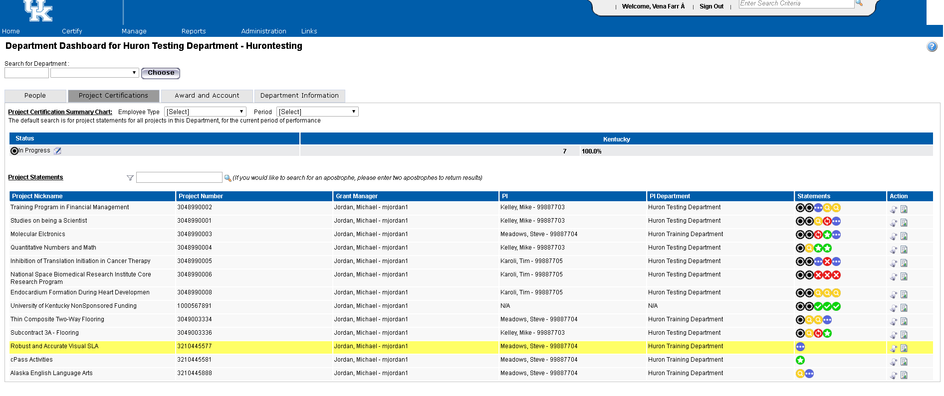

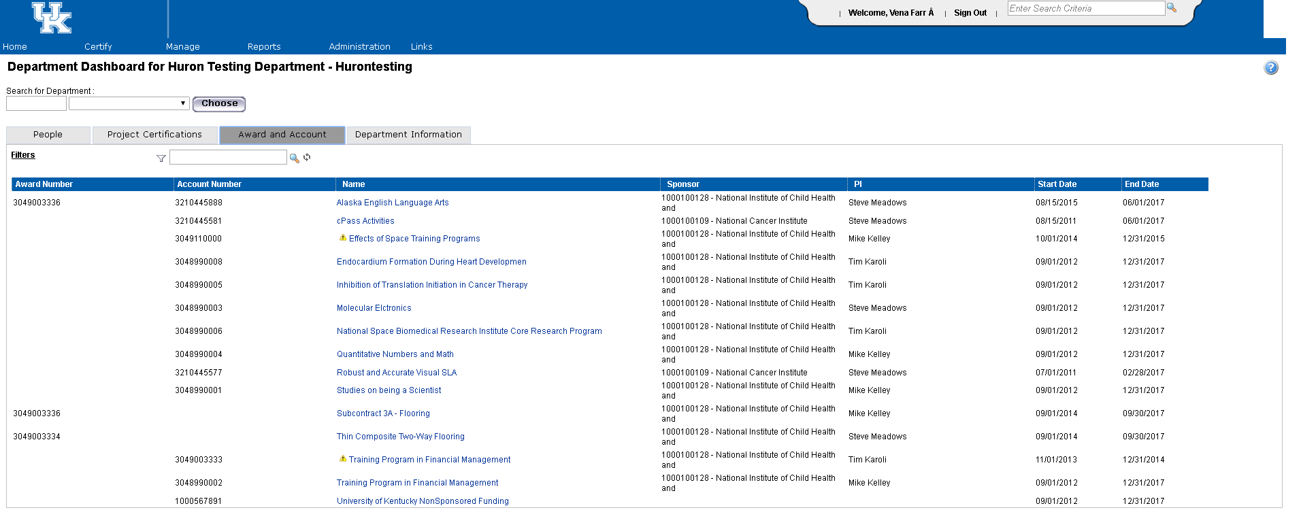
- Award and Account tab: Lists all accounts, including cost centers, associated with the department. While there is no required formal action to be taken on cost centers as part of this process, you are welcome to use this same tool for monitoring/reconciling activity on cost centers as well.

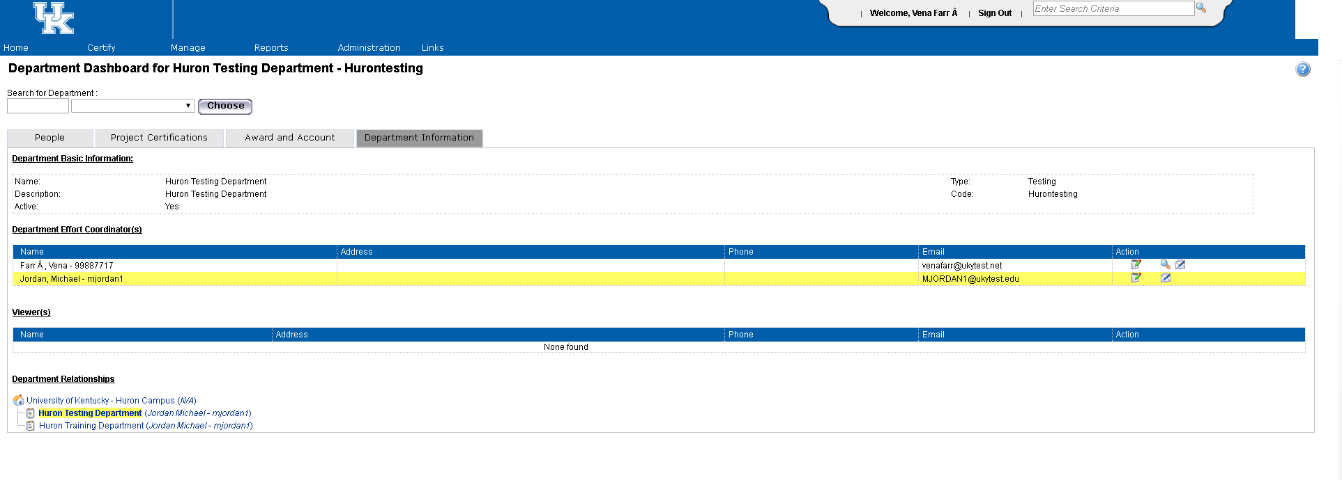
- Department Information tab: Shows the department information, effort coordinators, and the relationships in the hierarchy.
- If you need to look at specific information about a project, you can hover over “Manage” and go to “Look Up” or you can use the search box in the upper right hand section of the page (indicated by the yellow arrow in screen print above). The feature at the upper right is used only for project numbers (cost centers, WBS elements).
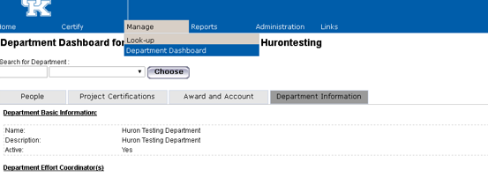

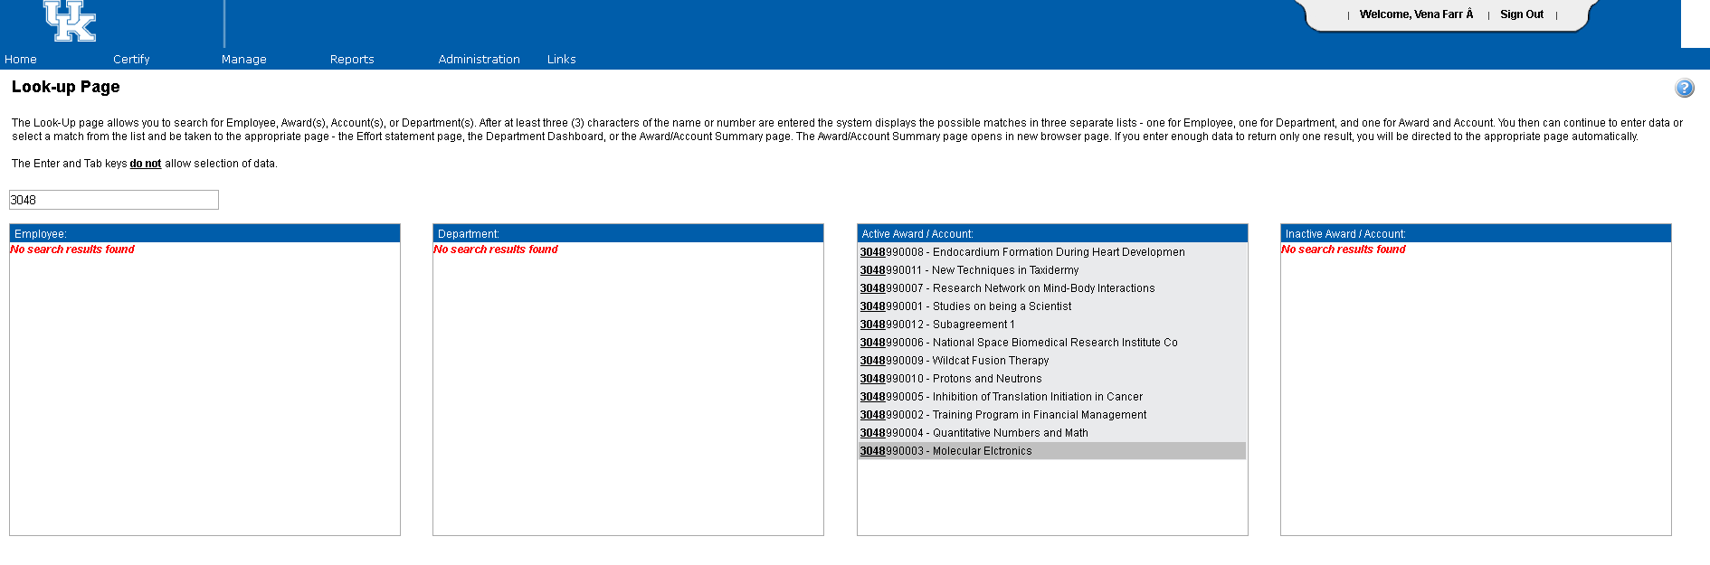
- The “Look Up” page allows you to search for information based on the project number, employee name, employee number or department name. Start typing the desired information and the tool will populate information from your college that contain those unique combinations somewhere in the data string.
Note: There are separate boxes for Active Award/Account and Inactive Award/Account. There is a difference between what we call inactive in SAP and what is inactive in ecrt. An award/account is considered inactive in ecrt if the project end date is prior to the date you are reviewing the information.

- Selecting a project will route you to the Account Summary page. This page has details similar to that of GMGrantD in SAP.
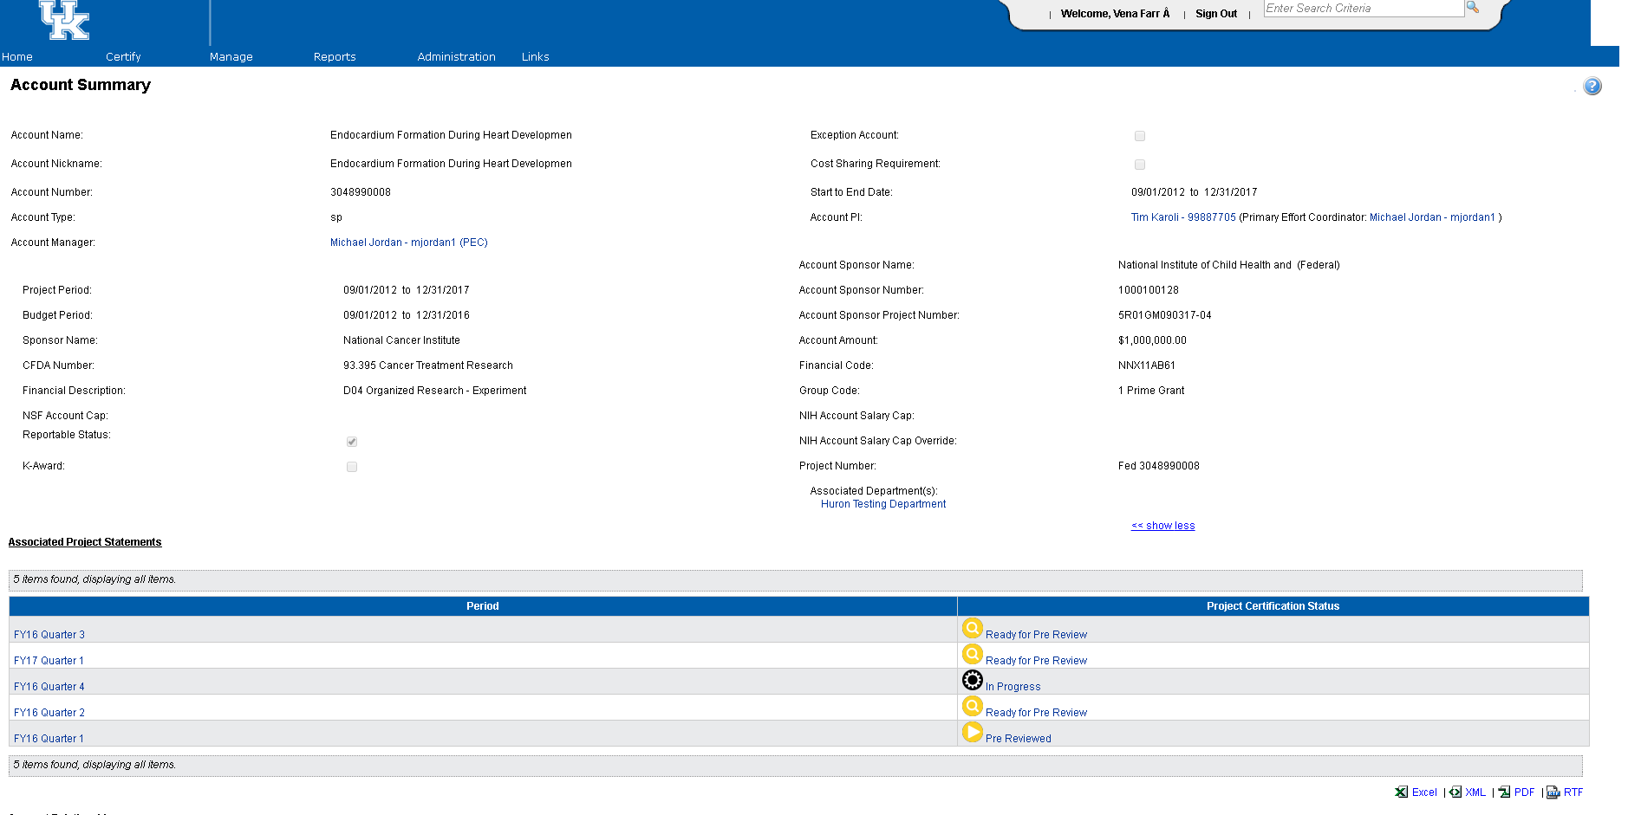
You can click on any of the project statements under the Associated Project Statement to be routed to a project statement page.

- The Project Statement is what the Primary Department Effort Coordinator will be pre reviewing.
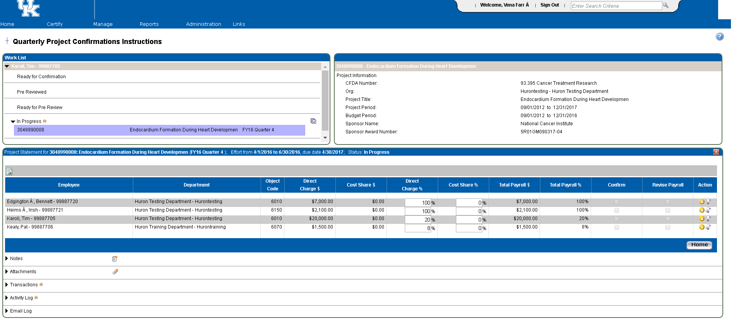

- On the project statement page, you will find a variety of information about the project.
  - The box in the upper left corner of the page is the work list. This contains a complete list of all projects and their associated Principal Investigators for which you (as the College Effort Coordinator) have the responsibility for monitoring the completion of the workflow processes of the statements.
  - The box in the upper right corner of the page contains information specific to the sponsored project, which can also be found on the GMGRANTD tab in SAP.
    - For example, the CFDA number is an indication as to whether or not the project contains federal funds. If there are no federal funds associated with the project, this field will be populated as 99.999.
    - Project Period indicates the entire length of the award period. For example, if your project is a 5 year award from NIH, the project period would reflect the entire 5 years, just as it does in SAP.
    - Budget Period may be shorter than project period. Again, using the example of a 5 year award from NIH, if you have only received incremental funding through the second year of the award, the budget would only reflect the 2 years for which we are authorized to incur expenses.
  - The main section of the page contains the detailed information associated with the specific project which needs to be pre reviewed. The blue ribbon on the project statement indicates the time period contained on the statement as well as the due date. Note – due date indicates when statement must be both pre reviewed and confirmed (if applicable).

- During the pre review process the Primary Department Effort Coordinator should:
  - Verify that all individuals that should be paid from the grant or cost shared on the grant appear on the project statement.
  - Compare the dollars per individual on the project statement to the project budget.
    - Do the amounts per individuals match what was requested to be entered by the payroll person?
    - If there is a variance between the expected amount and actual amount charged. Why?
    - Is an individual being cost shared when they should be direct charged or the reverse?
    - Is there anyone being charged to the project that you did not anticipate?
    - Is there anyone missing from the statement whose payroll should have been charged?
    - Other variances?
  - If a determination about the accuracy and completeness of the payroll expenditures cannot be made based on available information, the Primary Department Effort Coordinator may need to consult with others in the unit such as the Payroll Specialist, College Grants Officer, etc. so that any missing or erroneous information can be corrected timely and will reduce the need for repeating the process at a future time.

