There is Nothing wrong at Wal-Mart that….

There is nothing wrong at Wal-Mart that a $20 increase in the share price would not cure! The recent NY Times article on Democratic politicians campaigning around the country on an anti Wal-Mart theme got me to thinking about the entire issue again. If the Democrats want to re-take the House and Senate, I hope that they are able to come up with a better idea for getting elected than by bashing Wal-Mart.

Too be sure, Wal-Mart as a company does have problems, a lot of them. For starters, their profits declined for the first time in ten years last quarter in part because they had a mess in Germany, and ended off dumping all their stores there to a competitor at a loss estimated at over 800 million dollars. The primary customer Wal-Mart caters to, low- and moderate-income working-class people, are being hit by high gasoline prices. And Wal-Mart faces some competitors, like Target, who have gotten smarter and smarter at what they do, have adopted many of Wal-Mart’s innovations such as inventory coordination with suppliers, and cater to a customer a little higher on the income ladder, less affected by high gasoline prices and an emerging economic slowdown.

The Democrats would have you believe that Wal-Mart’s basic problem is that they under-reward their workers, both in salaries and fringes. Wal-Mart counters with the argument that wages and fringes are more than adequate to attract all the workers they need with the needed job skills. The Democrats who are mounting political campaigns on this theme are really using an old labor union argument, an argument grounded on the idea that workers judge how they are doing solely by the size of their paycheck along with the amount of benefits the company pays for such as health care insurance, and that workers benefit only if there is a clear distinction between labor and ownership of the company.

To traditional labor unions, the economic pie created by the company is fixed, and workers benefit if the labor unions are able to negotiate away a larger share of that pie in the form of worker wages and benefits. An increase in shareholder value represents a larger share of the wealth benefiting the owners not the workers, and therefore an increase in the share price in part represents a failure of the union to adequately make demands on the behalf of its members. Otherwise the company would not be showing as large a profit growth and the share price would not have risen. It is amusing to see how these old, largely discounted views re-emerge in new ways during political campaigns, and the possibility of workers sharing ownership in the company as a benefit gets lost in the discussion. Give the Democrats now pushing these themes credit for promoting ideas largely discounted by economists as paths to prosperity for all.

Many years ago, Wal-Mart chose another route. That route recognized that even low-wage workers would be attracted to jobs that allowed them to gradually gain an increasing share of ownership of the company that employed them. That is, with a rising share price and stock ownership by employees, it was less necessary to pay money out directly in wages and benefits to employees. Further, workers who increasingly owned the company they worked for through shares of stock would be less likely to organize as unions.

All of this worked well for a time. Look at Wal-Mart’s split-adjusted share price

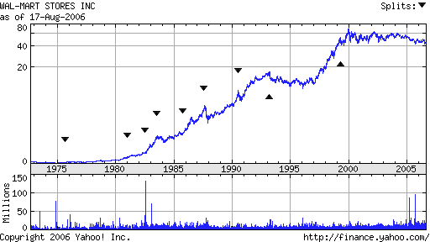

since 1975. Look at all the stock splits that occurred through 1999. But note that despite profit growth, the share price plateaued in early 2000 and has stayed in the mid $40 range since then. An employee who began work for Wal-Mart 6 years ago would see any shares received as “dead money” with a lower return than an interest-bearing savings account.

To be sure, other US behemoths also under fire for exerting too much monopoly power have much same share price pattern. Look at Microsoft, a company in technology that has faced similar accusations over the years with regard to monopoly power. We see a very similar recent share price pattern.
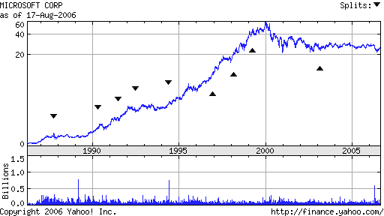

I guess if I were a Microsoft employee, my concerns would be very similar to the concerns of a Wal-Mart employee. Stock ownership is not growing net worth of the employee in any significant way for either company, and therein lies the real problem.

Think about this. It’s funny. Two of the US-headquartered companies that are most attacked for exerting too much monopoly power, and neither can get their share price to grow.

Monopoly power is never permanent. Look at how Dell, with their custom PC manufacturing mail-order setup, was eating Hewlett Packard and Compaq’s lunch for several years. Then the latter two companies merged, and the then-CEO saw share prices drop further. Then the CEO was replaced more or less under fire. But the combined company was able to find a new, much smarter CEO.

Here is Dell versus HP over the last two years. The up-tick in HP stock coincides closely with when the new CEO took over, in February, ’05.

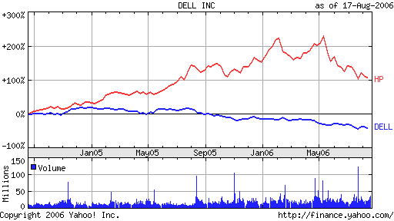

If Wal-Mart shareholders were seeing decent appreciation in the share price in recent years, my bet would be all the discussion about Wal-Mart mistreating employees would be a non-issue, and certainly not an issue worthy of mounting a political campaign for House or Senate. But right now, bashing Wal-Mart has “traction” in some circles and anything with traction cannot be ignored in a political campaign. I’m amused by all of this for a lot of reasons. For starters it illustrates that when capitalism increases shareholder value then every shareholder, including low-wage workers who own stock, can benefit. But I’m also amused by the fact that about the time a company seems to be getting a lot of unfavorable press for having too much monopoly power, that is often the point in time when the company starts to self-destruct from its own internal managerial problems.

Internationally, Wal-Mart is not the retailing competitor it is in the US. Its European strategy seems to be more or less in shambles. They have had success in some regions of the world, most notably Mexico and parts of Asia. But in other parts of the world they are not seen as a strong player or even as a potentially dominant retailing force. A lot of the company’s overall growth still hinges on doing well in the US. The problem is, the good US locations for Wal-Mart stores have already been built out. Wal-Mart has stores in 8 North Dakota cities, including two in Bismarck and a newly opened Superstore in Minot, replacing an older, but apparently very successful smaller store there. The smallest city in North Dakota with a Wal-Mart is currently Devil’s Lake, population 6,000. But they are planning on building in a 9th location, Bottineau, population 2,300. From a rural economic development perspective all of this is interesting but from a stock price perspective I don’t see how these small moves are going to significantly move the share price. Somehow I am not quite convinced that building a store in Bottineau, or other similar location, is going to be what moves the share price again. This strategy may have worked when the company was a small, regional discounter, but it takes more than a pin prick to move an elephant!

David L Debertin
Professor of Agricultural Economics
University of Kentucky
Lexington, Kentucky 40546-0276
ddeberti@uky.edu

