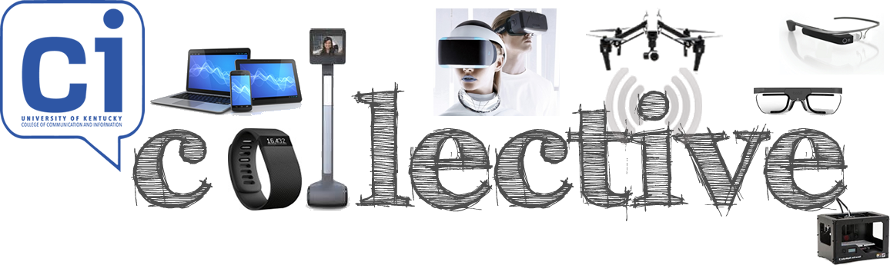
Digital Media Laboratory

An adaptive and flexible center supporting interdisciplinary research on human-computer interaction and related areas in understanding how people use communication technology and learn from information systems.

Primary ROI
- Evaluate prototypes of emerging technologies
- Showcase select products from lab partners
- Provide hands-on training for technology-related projects
- Develop applied solutions for UK administrative and research needs
- Attract high school students to UK through summer programs
- Sponsor training workshops for students and faculty
- Generate income for university partner programs

- Main Entrance and Reception (≈80’ sq. ft.) /Check-in Area (≈22’ X 20’)
- Focus Group (≈18’ X 20’) and Observation (≈18’ X 20’) Spaces
- Adjoining User (n=3) (≈10’ X 14’ each) & Observation Usability Rooms (n=3) (≈10’ X 14’ each)
- Usability Testing of Mobile, Remote and Portable Devices
- Intern Office Space for Undergraduate (≈230 sq. ft.) and Graduate Students (≈230 sq. ft.)
- Lab Manager Office (≈80 sq. ft.)
- Testing Spaces (n=8)
- Human-Robotics Research Space (Suitable Technologies & Double Robotics) (≈300 sq. ft.)
- Drone Research Space (≈300 sq. ft.)
- Wearable Technology Research Space (≈200 sq. ft.)
  - System integration technology
  - Medical technology
  - Other Health and Fitness technology
- Eye-Tracking Research Space (≈300 sq. ft.)
- 3-D Printing and Maker Space (≈350 sq. ft.)
- Video Game Research Space (Oculus Rift & Morpheus Research) (≈570 sq. ft.)
- Multimedia/Virtual Environment Simulation Space (≈300 sq. ft.)
- Home Automation Testing Space (≈500 sq. ft.)
- Training Facility (large classroom for up to 35 trainees) (≈1200 sq. ft.)
Wireless High Definition Playback and Projection Systems to support
Large Scale Collaborations

Ideas and images for possible floor plan layouts provided below.

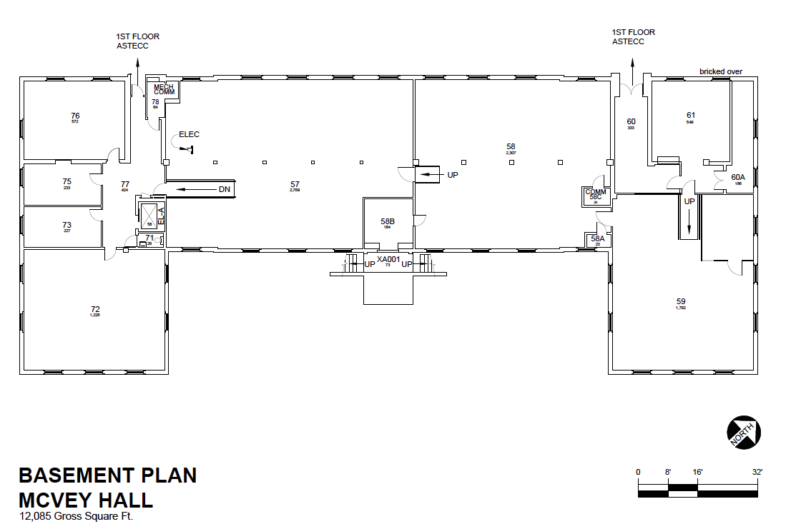
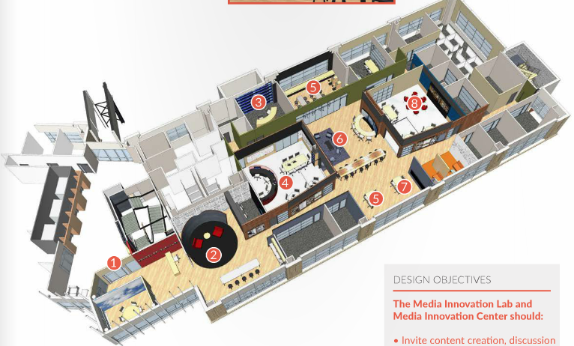
http://reedcollegeofmedia.wvu.edu/magazine/interactive-2014-magazine

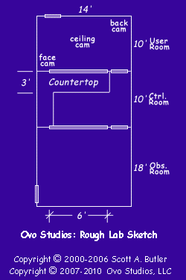
http://www.ovostudios.com/labdesign.asp

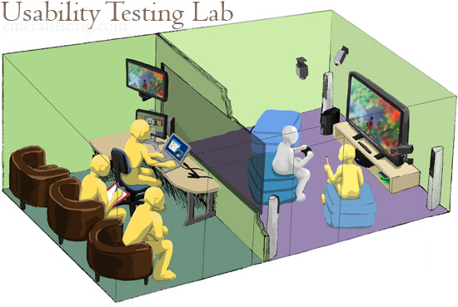

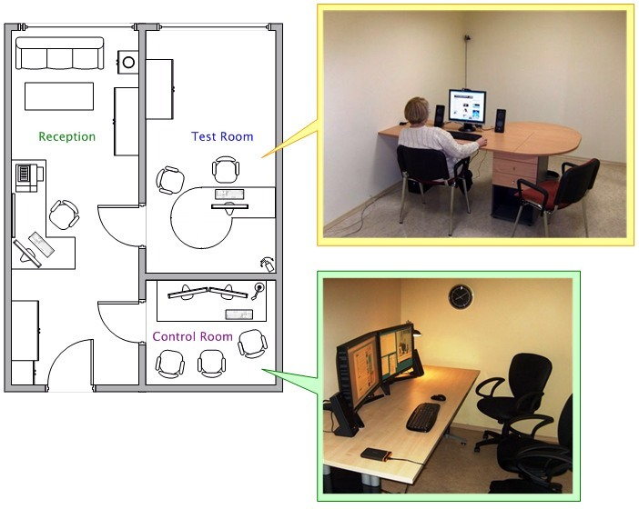

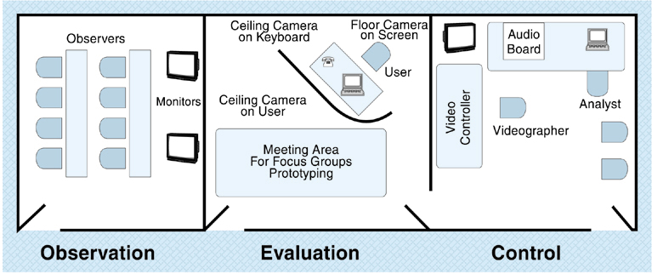

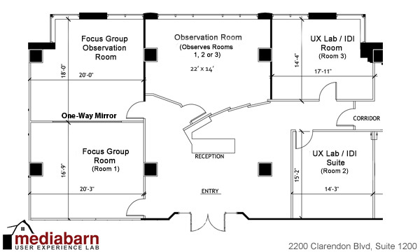

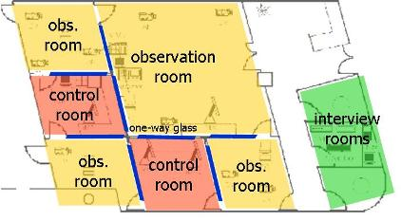
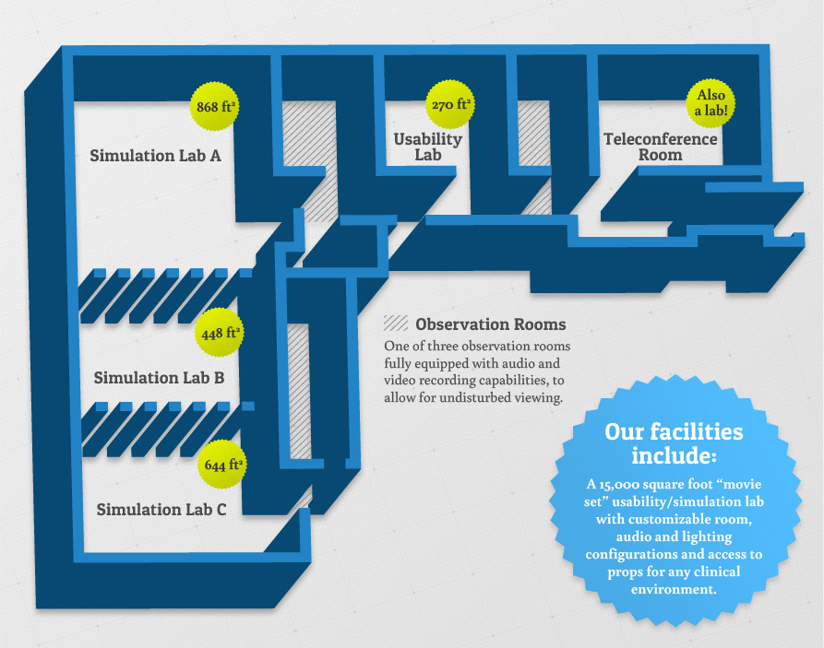

OTHER USABILITY LABS
http://www.usability.gov/

http://cics.cci.utk.edu/usability-lab-services

http://ielab.missouri.edu/#/lab/home
https://www4.uwm.edu/sois/research/iia/

http://internal.simmons.edu/students/slis/slis-tech/usability-lab
https://www2.kent.edu/slis/about/locations/usability-lab.cfm

http://www.liu.edu/CWPost/Academics/College-of-Education-Information-and-Technology/Palmer-School-of-Library-Information-Science/LIU-Usability-Lab

http://triton.towson.edu/~jlazar/uul/

http://www.ubalt.edu/cas/about-the-college/schools-and-divisions/division-of-science-information-arts-and-technologies/labs/usability-lab/

http://mashable.com/2015/04/30/smart-tech-on-in-body/

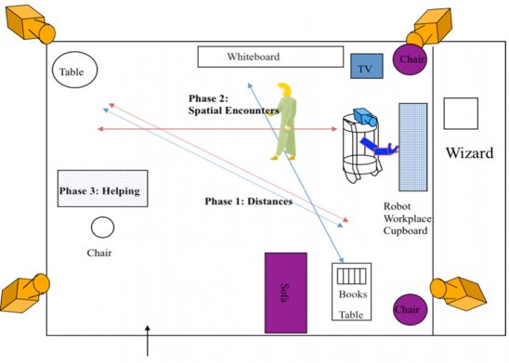
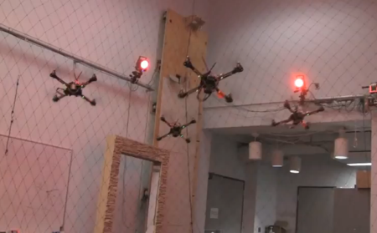
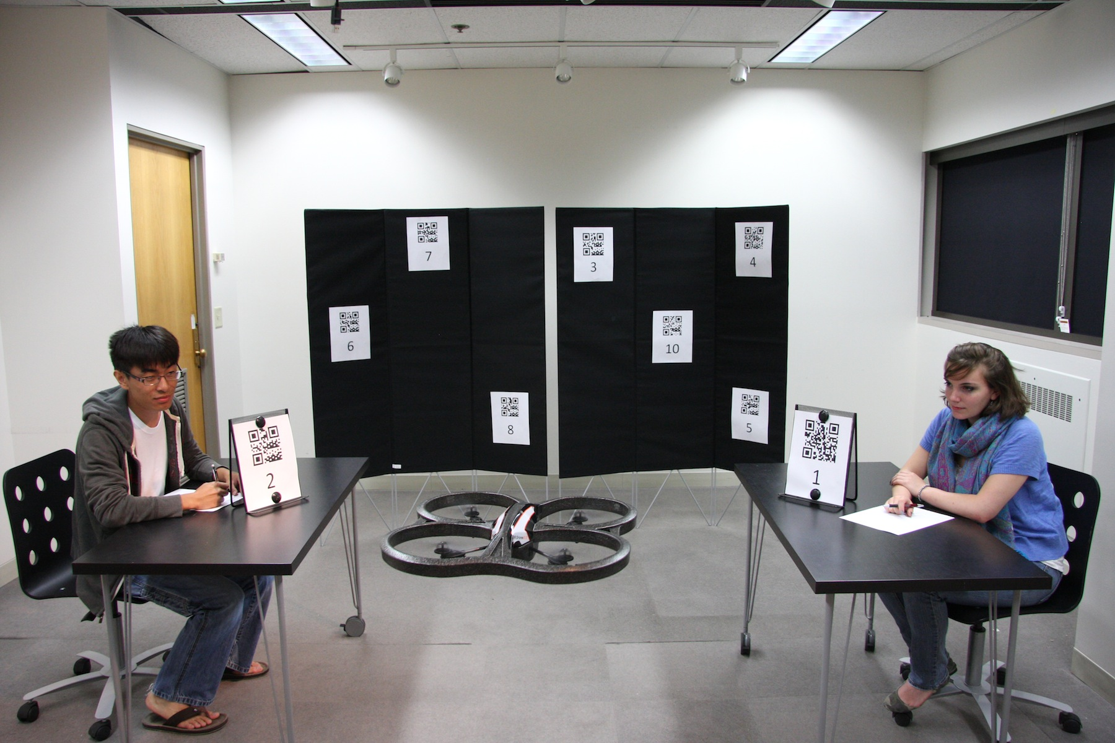

Information on Innovative Technologies

https://www.suitabletech.com/
https://www.suitabletech.com/beam-plus/
http://www.doublerobotics.com/
http://www.vgocom.com/
http://store.dji.com/
http://www.dji.com/product/inspire-1/feature
http://www.dji.com/product/phantom-3#page1
http://www.tobii.com/
http://www.tobii.com/en/eye-tracking-research/global/landingpages/tobii-glasses-2/
http://www.mechdyne.com/
http://www.mechdyne.com/research-and-education.aspx
http://mashable.com/2015/04/30/smart-tech-on-in-body/

