15. Wildfire, Angular Leaf Spot Pseudomonas syringae pv. tabaci tox+, tox-

(formerly known as P. tabaci, P. angulata; also P. syringae pv. tabaci, P. syringae pv. angulata)

Anne Jack, University of Kentucky, USA
General
Wildfire and angular leaf spot can affect tobacco in both the seedbeds / float trays and the field, although wildfire tends to be more of a problem in the seedbed and angular leaf spot in the field. Wildfire and angular leaf spot are not major problems in many tobacco producing areas, such as the USA, Brazil and Europe. In Africa, they are diseases of major importance which can cause devastating losses, especially in wet seasons. The bacteria that cause wildfire and angular leaf spot are identical in all respects except that the wildfire bacteria produce a toxin and the angular bacteria do not. Wildfire is therefore caused by the “tox+” strain and angular leaf spot by the “tox-“ strain.

Symptoms
The symptoms of the tox+ (toxin producing) and tox- (non-toxin producing) forms of this disease are quite different.
Wildfire (tox+) is characterized by a small brown or black watersoaked lesion, surrounded by a broad chlorotic halo (Figs. 15.1A, 15.2). The lesions increase in diameter and may coalesce until the diseased tissue eventually falls out leaving ragged holes. Wildfire can be systemic in seedlings, causing distortion (Fig. 15.4) of the apical bud and leaves.
The angular (tox-) lesion is brown, dark brown or black, much larger than the wildfire lesion, has little or no chlorotic halo, and has angular margins because the lesion is confined by the lateral veins (Figs.15.1B, 15.3, 15.5). In Africa, both diseases tend to be more severe at the top of the plant (Figs. 15.2, 15.3).

Source and Transmission
The bacteria are spread in wind-driven water droplets, from leaf to leaf and plant to plant within the field, from field to field and from infected weed hosts or tobacco regrowth. Driving rains and sand blasting winds exacerbate the problem considerably. These diseases can also be seed transmitted. Tobacco regrowth and debris from infected plants should always be destroyed at the end of the season, as they are sources of inoculum to infect overwintering weed hosts. In the semi-tropical areas where these diseases are a problem, winters are seldom cold enough to kill overwintering weeds and tobacco regrowth. Wildfire and angular leaf spot are favoured by cloudy wet weather.

Rotation and Site Selection
Disease spread is reduced by planting earlier fields downwind of later planted fields; the earlier planted fields often serve as an inoculum source. These diseases are generally worse in intensively used fields, and can be minimised by suitable rotations (Ch. 77).

Alternate Hosts
Many solanaceous weeds are hosts of this pathogen (Ch. 61). Examples are Apple of Peru (Nicandra physaloides) and Jimson weed / stinkblaar (Datura stramonium), shown in Fig.15.6. Such weeds should be removed from the proximity of the fields and especially seedbeds / greenhouses. This is particularly important in areas which do not have killing winter frosts, where weeds overwinter.
Resistant Varieties
Resistance to wildfire (race 0), derived from N. longiflora via Burley 21, is monogenic, complete and fully dominant. This resistance has proved very durable in most parts of the world, but in Africa, it broke down in the 1970s, with the emergence of race 1.
N. rustica derived resistance to races 0 and 1 of wildfire and angular leaf spot is also monogenic, complete and fully dominant. Race 1 resistant varieties were released in Zimbabwe in the early 1990s, but this resistance broke down in a relatively short time, with the emergence of race 2 of both wildfire and angular leaf spot in the late 1990s. No resistance to race 2 has been identified.
Polygenic resistance is generally low, but some of the newer multi-resistant Zimbabwean varieties have some polygenic resistance to race 2. The high level of monogenic resistance is shown in Fig. 15.7.

Sanitation
All seedbed tools, particularly those used for clipping / mowing, should be regularly sterilised with bleach or a copper-based compound.
Disease spread is minimised if clean fields are reaped before infected ones.
Plant debris should be ploughed under at the end of the season, and all regrowth destroyed. Any exposed infected plant material may serve as a source of next season’s inoculum. To be effective, this should be done by all growers in an area.

Fertility and pH
These diseases are favored by excessive fertility, particularly with high N and low K fertilisation. The use of excessive amounts of lime, which interferes with K uptake, can also increase disease severity.

Chemical Control
Streptomycin (e.g. Agri-mycin 17, Ag streptomycin) is registered for use on tobacco in some countries. However, because of the potential for developing antibiotic resistance and the human/animal health issues, it should be used with extreme caution. Streptomycin is not registered in Africa.
Seedbeds / float beds: Fumigation of seedbeds will usually eliminate initial inoculum in the seedbeds. Seedlings should be preventatively sprayed (Ch. 70) with a combination of a copper-based compound (e.g. Kocide 101, Copper Oxychloride) and the SAR (systemic acquired resistance) compound, acibenzolar-S-methyl (A-S-M e.g. Actiguard, Bion), if locally registered (Ch. 71). Note: in some countries, A-S-M is not registered for seedlings.
As always, use the registered rate, but with A-S-M, it is particularly important not to exceed the recommended rate because this product can be phytotoxic. Young plants are most vulnerable, and burley is more sensitive than other tobacco types. A-S-M should be used on burley seedlings with caution and only when necessary, as it can cause stunting.
Field: Copper sprays are not registered for field use because of residues; copper sprays applied in the field will result in unacceptable residues. The only chemical which can be used to control these diseases in the field is A-S-M (if locally registered). Field sprays (Ch. 69, Ch. 70) are more effective when used in combination with seedbed sprays. A-S-M is most effective when used as a preventative spray, but because of the cost, many growers only use it when symptoms appear.
Scouting
Both the seedbeds / float beds and the field should be scouted regularly. Particular attention should be paid to low-lying areas.
Seedbeds / float beds: Remove and destroy any infected seedlings, and all others within 1 m of an infected plant. Drench the surrounding area with disinfectant (e.g. bleach).
Field: Acibenzolar-S-methyl (A-S-M) applications should commence as soon as symptoms are observed if it is not already being used as a preventative measure.

Biological Control
No biological control agents have been found effective against these diseases.

Other
Wildfire and angular leaf spot can be transmitted by seed, so seed should not be collected from infected plants. Seed treatment with silver nitrate should be a routine precaution, and is required in many countries where these diseases are a problem. Use of certified seed will minimise the chances of starting a crop with infected seed.
Disease severity is increased by any practice resulting in thick, heavy leaves, such as low topping and excessive N, and by any practice which can injure the leaves, such as mowing the grass surrounding tobacco fields.

Summary
An integrated approach (Ch. 68) to the management and control of wildfire and angular leaf spot includes:
- Seed treatment with silver nitrate, ideally as part of the seed certification requirement
- Use of certified tobacco seed
- Rotation of seedbed sites
- Proper fumigation of the seedbed areas
- Preventative seedbed / floatbed sprays, correctly applied, of a combination of a copper-based compound and acibenzolar-S-methyl (if locally registered). Note: A-S-M should be used on burley seedlings with caution and only when necessary
- Scouting seedbeds and removing all seedlings within 1 m of an infected plant
- Eradication of alternate host weeds, particularly those near the seedbeds / floatbeds
- Sterilization of seedbed tools
- Site selection to avoid later planted crops downwind of earlier planted ones
- Correct fertilization and pH; avoiding excessive N, low K and high pH
- Minimizing of leaf injury; avoiding leaf breakage and not mowing too close to the field
- Correct topping, particularly avoiding low topping
- Regular scouting, particularly under conducive conditions (wet, cloudy, after rain)
- Field sprays of acibenzolar-S-methyl, preventatively or when indicated by scouting
- Minimizing spread by reaping clean fields before infected ones
- Destruction of all plant residue and regrowth at the end of the season

References
Cole, D.L. 1997. The efficacy of a plant activator CGA 245704 against field diseases of tobacco. Presented: CORESTA Agronomy & Phytopathology Group Meeting. Montreux.
Tobacco Research Board of Zimbabwe. Handbook of recommendations.
Shew, H. D. and G.B. Lucas. Eds. 1991. Wildfire and Angular Leaf Spot. Pages 30-32 in: Compendium of Tobacco Diseases. APS Press. ISBN: 0-89054-117-5.
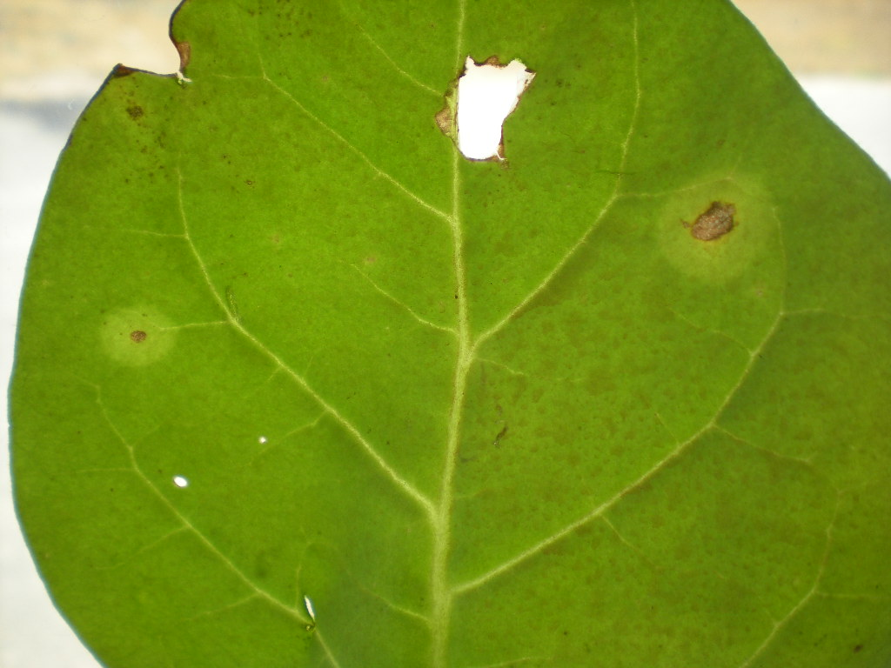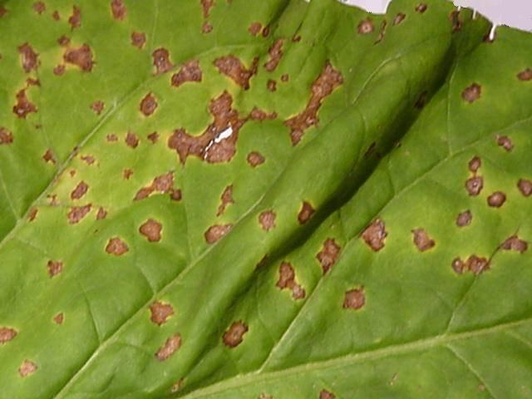
A Susan Dimbi, TRB, Zimbabwe B Anton Scholtz, LARSS, South Africa
Fig 15.1: Wildfire and angular lesions. A: Wildfire; with chlorotic halo surrounding lesion B: Angular; with no chlorotic halo and angular margins
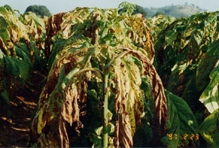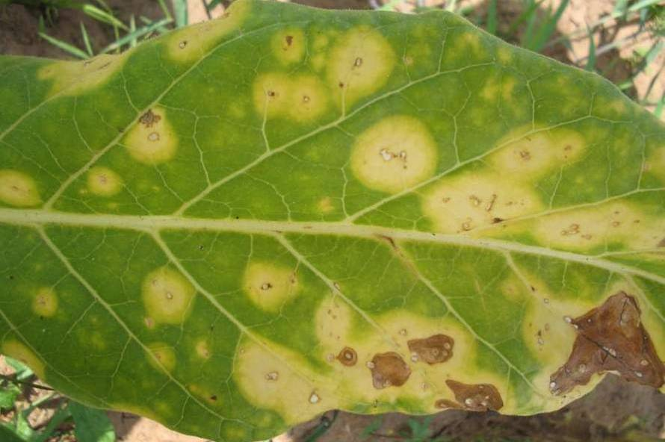
Michelle du Toit, Zimbabwe Chrissie Mainjeni, ARET, Malawi
Fig 15.2: Wildfire; Pseudomonas syringae pv. tabaci (tox +)
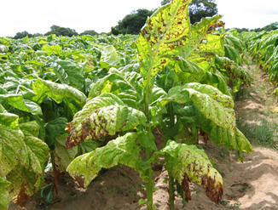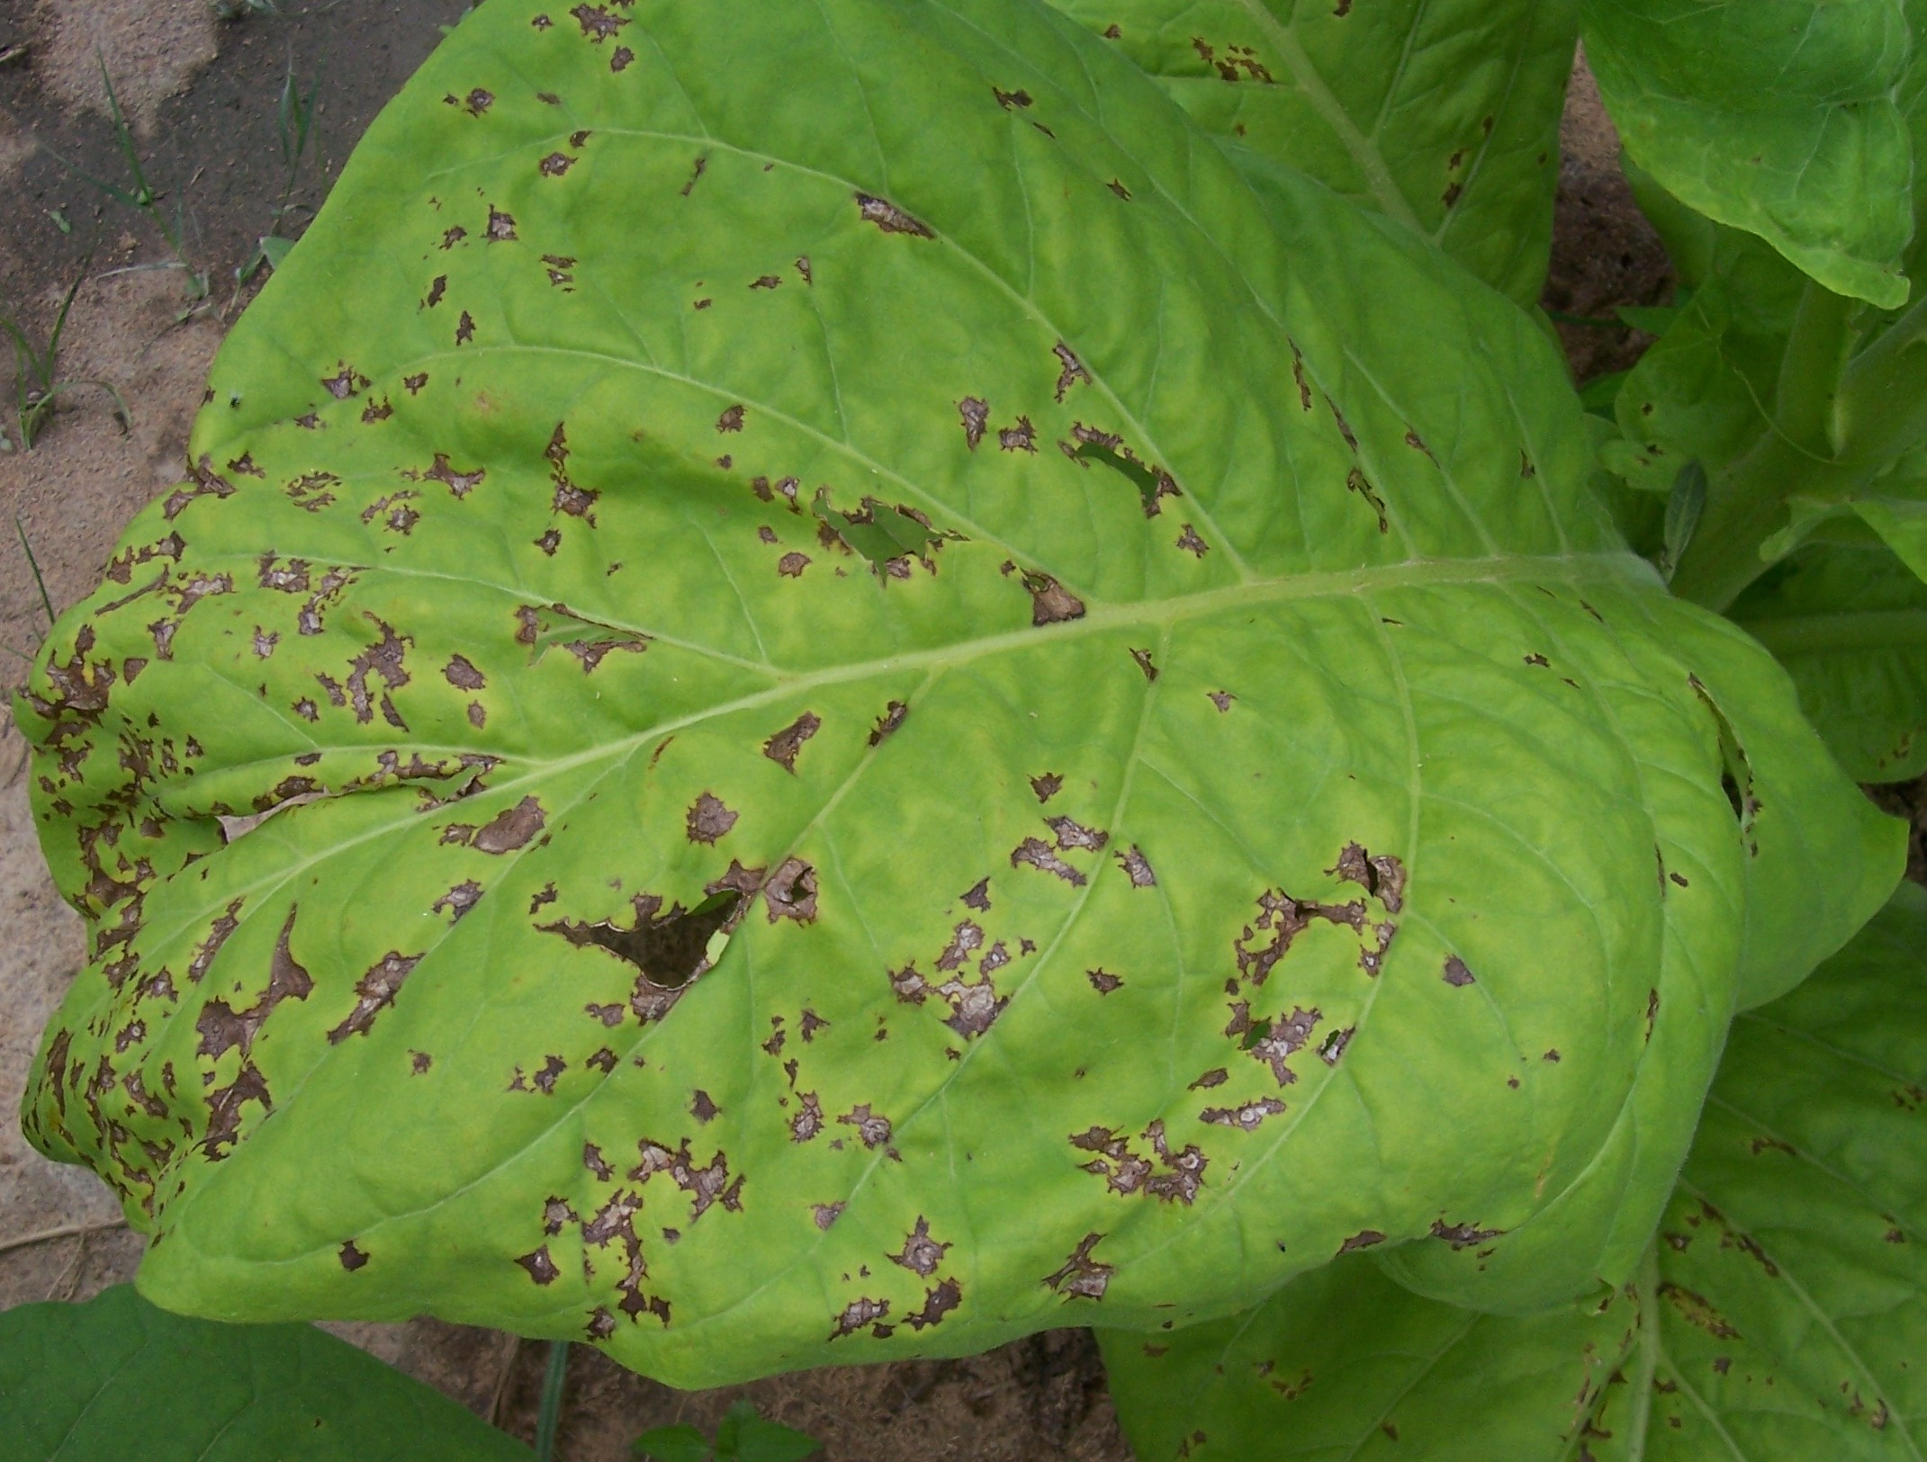
Michelle du Toit, Zimbabwe Susan Dimbi, TRB, Zimbabwe
Fig 15.3: Angular; Pseudomonas syringae pv. tabaci (tox -)
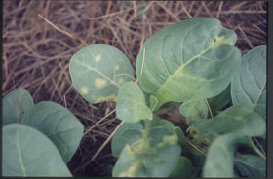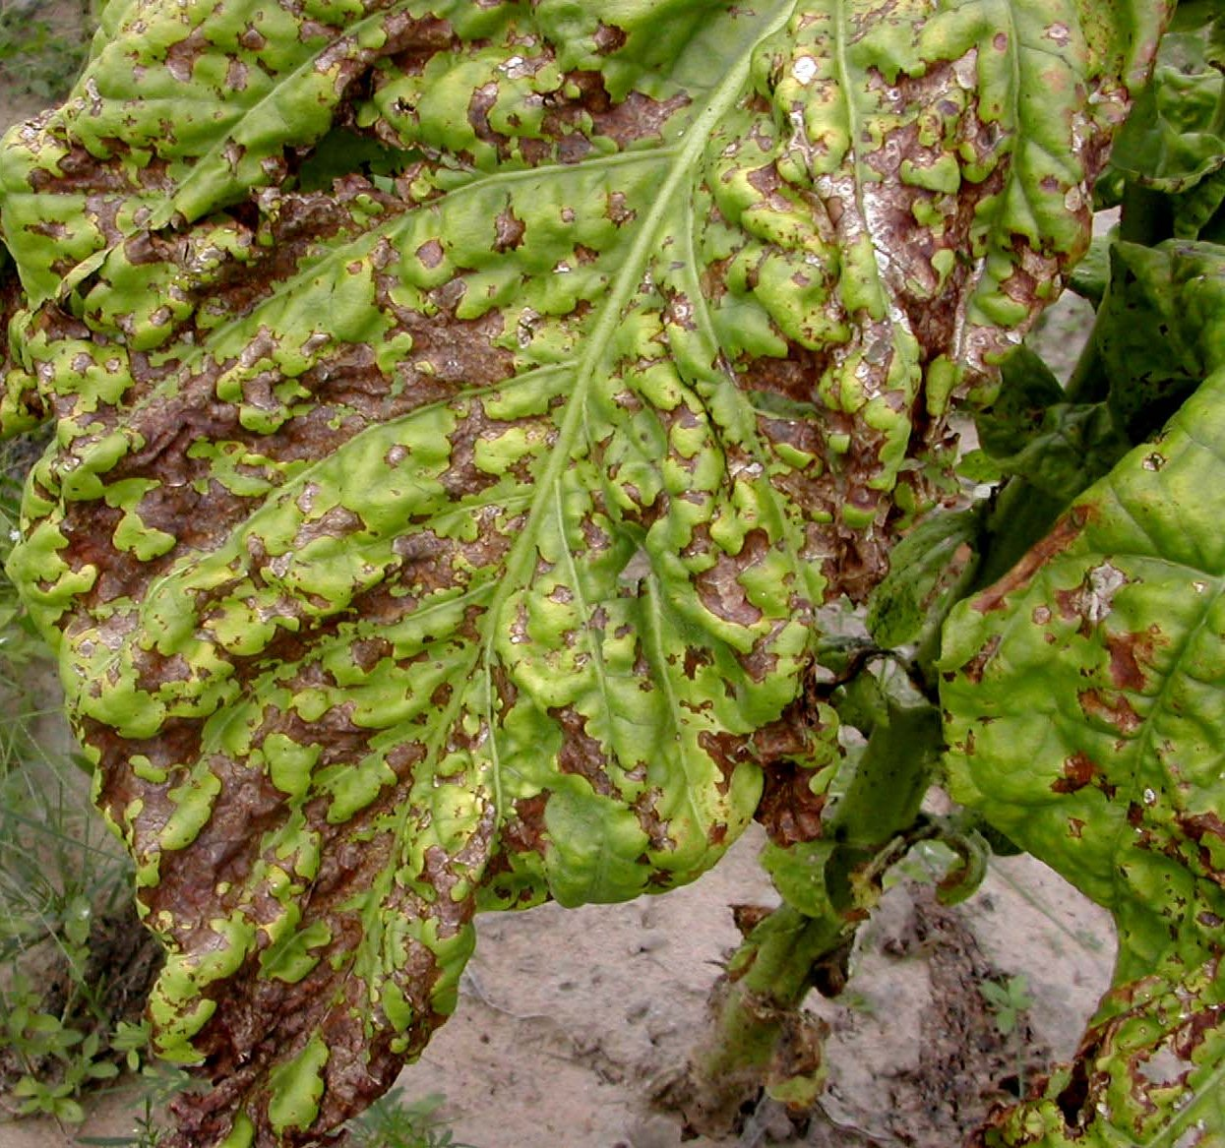
Michelle du Toit, Zimbabwe Susan Dimbi, TRB, Zimbabwe
Fig 15.4: Systemic wildfire on seedlings Fig 15.5: Severe angular leaf spot
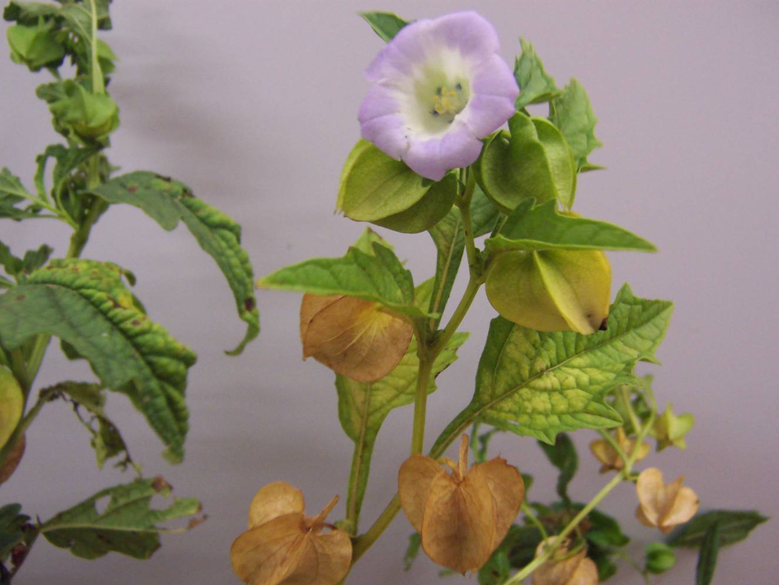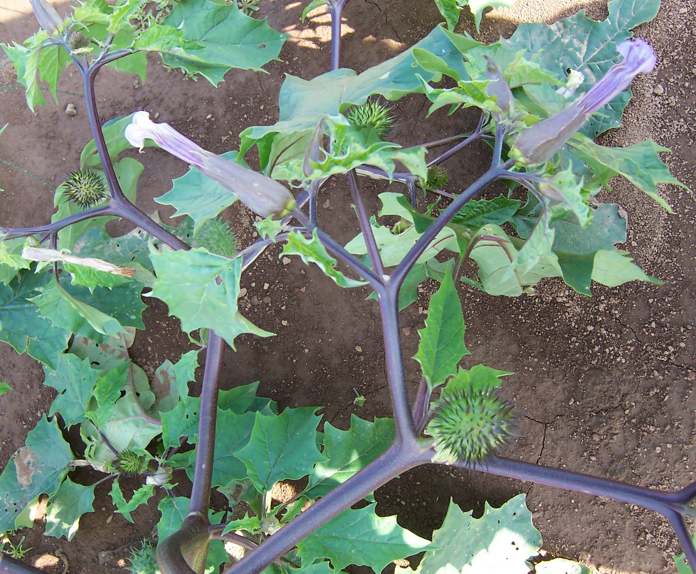
A Anton Scholtz, LARSS, South Africa B Anne Jack, UK, USA
Fig 15.6: Weed hosts of angular and wildfire. A: Apple of Peru (Nicandra physaloides)
B: Jimson weed / stinkblaar (Datura stramonium)
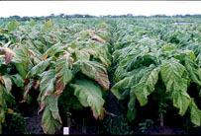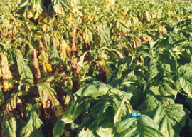
A Michelle du Toit, Zimbabwe B Michelle du Toit, Zimbabwe
Fig 15.7: Susceptible variety (left), resistant variety (right). A: angular B: wildfire

