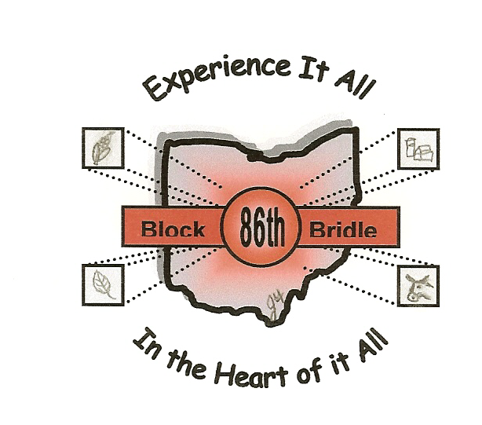

86th National Block and Bridle Convention

October 20-23, 2005

Columbus, OH

Dress Code and Code of Conduct

Dress Code:

Thursday, October 20
Registration and Check-in – Casual, travel clothes
Evening Opening – Casual but professional (nice jeans, slacks, button up shirts, etc.)

Friday, October 21
Tour Day – Long pants, closed-toe shoes are advised on tours. Dress appropriate for the tour, remembering that you want to make a good impression.

Saturday, October 22
The whole day is professional dress so please dress business casual.
Gentlemen: Dress slacks (NO jeans), dress shirt/sweater, nice shoes.
Ladies: Skirt or slacks (NO jeans), sweater or nice shirt, appropriate shoes.

Code of Conduct:

As a professional attending the National Block and Bridle Convention, each member must recognize and take the responsibility that he or she must conduct himself or herself in a professional and responsible manner at all times. In doing so, each member will follow the dress code, show up on time to all events, remain at a reasonable noise level when visiting with other members, and have the utmost respect for the hotel and the Convention Administrators at all times. Each member must realize that it is truly in his or her best interest to present himself or herself in a positive manner as he or she represents not only his or her own college but National Block and Bridle as well as the chapter hosting the event.

