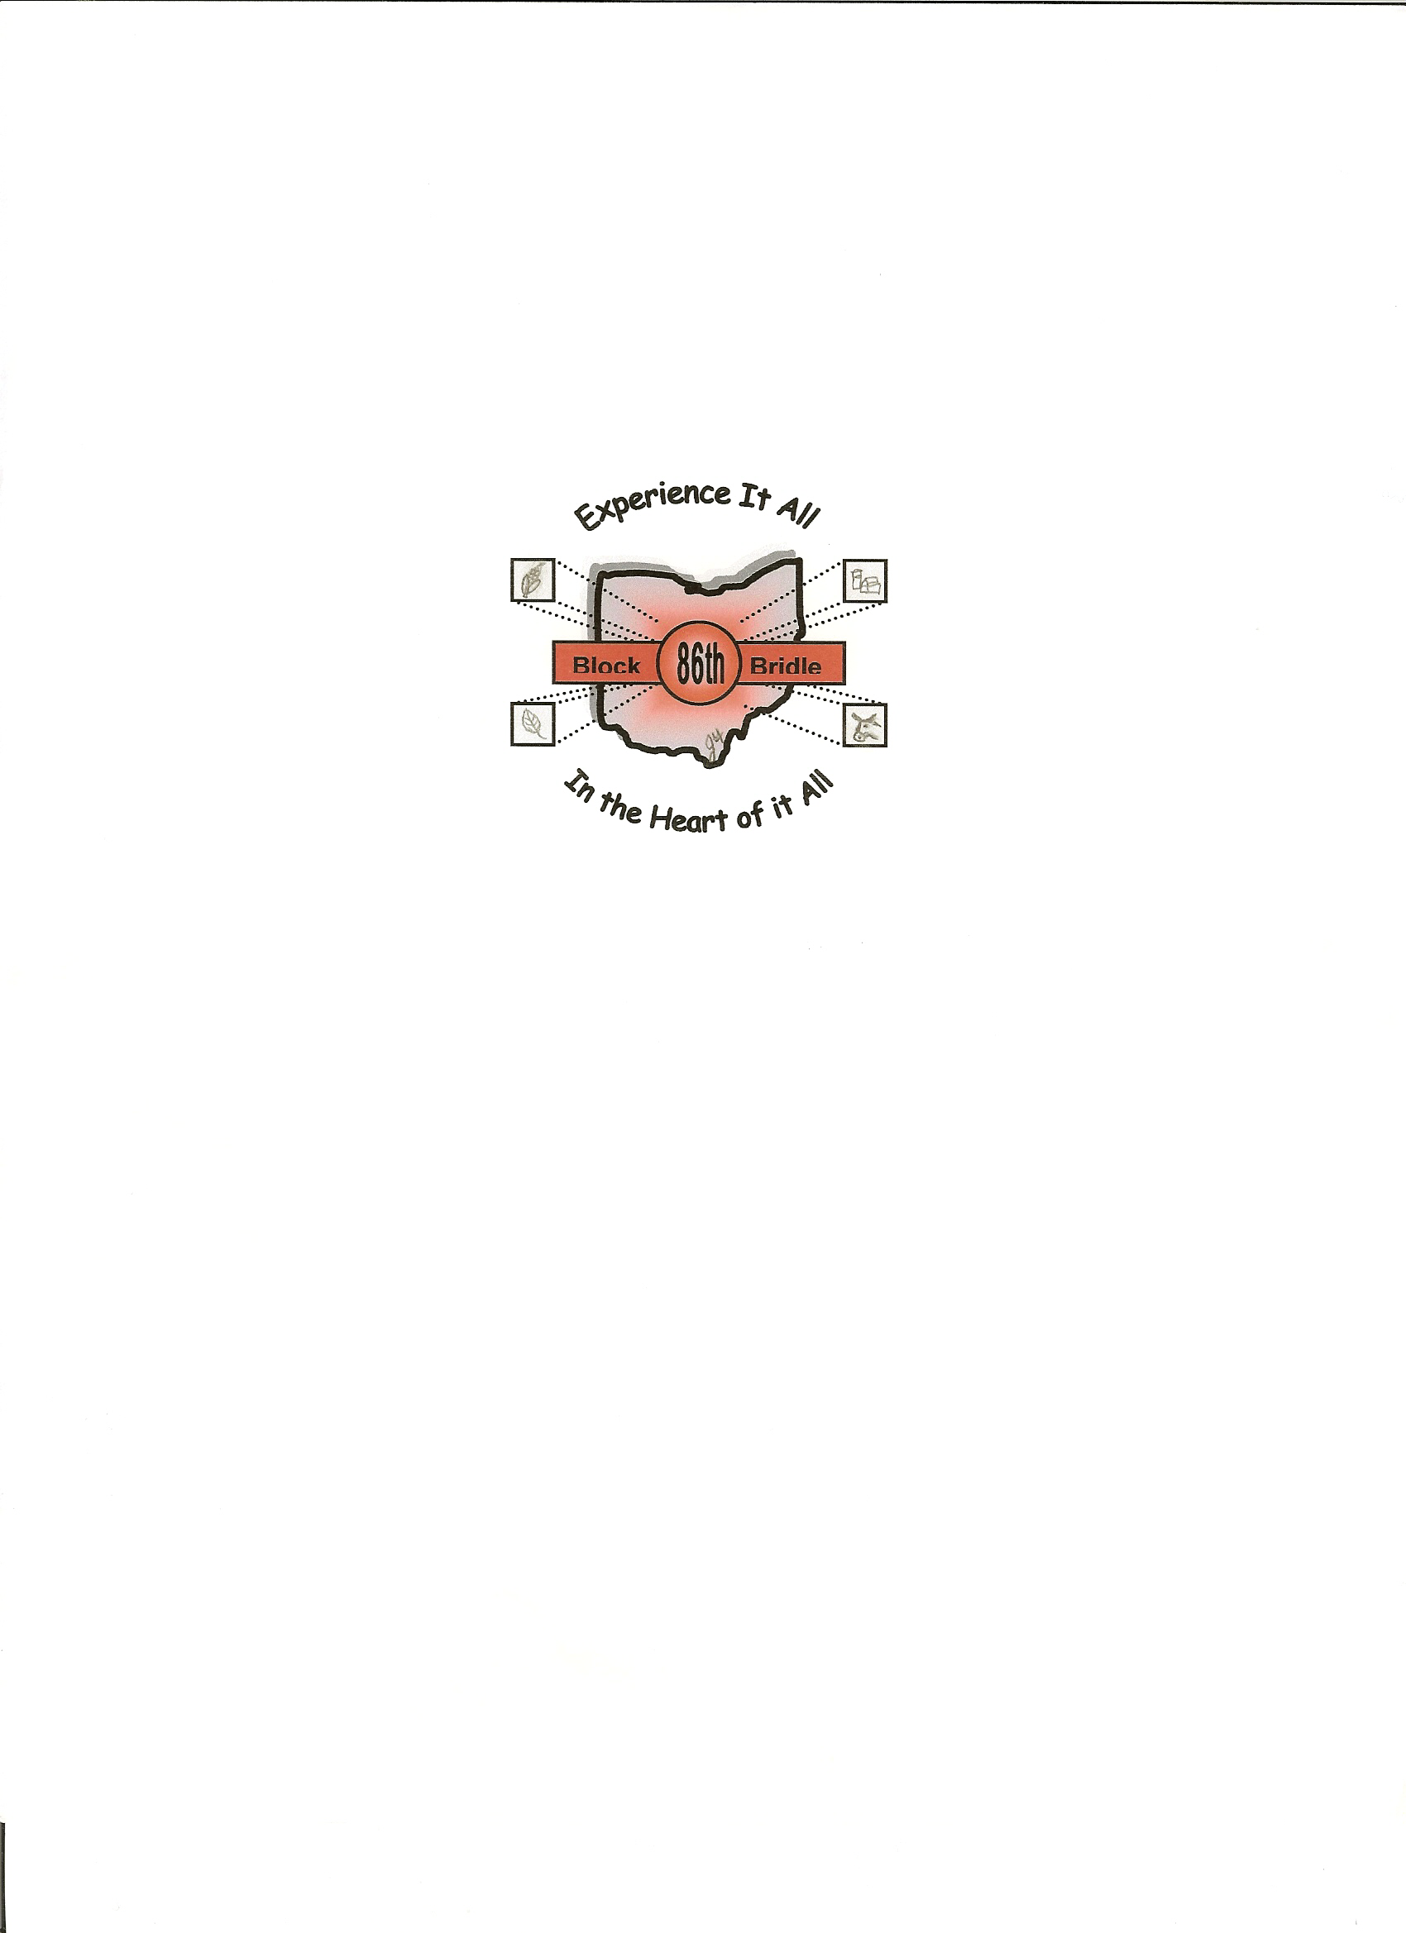

READ THIS DOCUMENT COMPLETELY BEFORE SIGNING. ITS EFFECT IS TO RELEASE THE OHIO STATE UNIVERSITY, ITS GOVERNING BOARD, AND THE STATE OF OHIO FROM ANY LIABILITY RESULTING FROM YOUR PARTICIPATION IN THE ACTIVITIES DESCRIBED BELOW, AND TO WAIVE ALL CLAIMS FROM DAMAGES OR LOSSES AGAINST THE UNIVERSITY WHICH MAY ARISE FROM SUCH ACTIVITIES, EVEN IF THEY RESULT FROM NEGLIGENCE.

RELEASE FROM RESPONSIBILITY, ASSUMPTION OF RISK, AND WAIVER
PARTICIPANTS FULL NAME: (PRINT)
DATE OF BIRTH (MO/DAY/YR):
ADDRESS:
CHECK ONE: | OSU STUDENT: |  |  |  | NON-STUDENT:
LOCATION OF ACTIVITIES: | Holiday Inn on The Lane – Columbus, Ohio and traveling tours
DATES OF ACTIVITIES: | START: | October 20, 2005 |  | END: |  | October 23, 2005
DESCRIPTION OF ACTIVITIES: | National Block and Bridle Convention held in Columbus, Ohio

I, the undersigned participant exercising my own free choice to participate voluntarily in the activities described above, and promising to take due care during such participation, hereby acknowledge that I have been informed of the nature of the activities and that I am aware of the hazards and risks which may be associated with my participation in the above-named activities, including risks of bodily injury, death or damage to property which may occur from known or unknown causes. I understand, accept, and assume all such hazards and risks, and waive all claims against the State of Ohio, The Board of Trustees of The Ohio State University, The Ohio State University, and other persons as set forth above. I understand that I am solely responsible for any costs arising out of any bodily injury or property damage that I may sustain through my participation in normal or unusual acts associated with the above-named activities, regardless of whose fault may be the cause of my injuries or damages, EVEN IF CAUSED BY CARELESSNESS OR NEGLIGENCE, so long as the conduct which caused the injuries or damages was not grossly negligent, or willful and wanton.

Further, I hereby indemnify and hold harmless the Board of Trustees of The Ohio State University and The Ohio State University, and their members, officers, agents, employees, and any other persons or entities acting on their behalf, and the successors and assigns for any and all of the aforementioned persons and entities, against any and all claims, demands, and causes of action whatsoever, whether presently known or unknown, or any person who suffers any injury, disability, death or other harm, to person or property or both, as a result of my participation in and/or presence at the above listed activities.

I have had sufficient time to review and seek explanations of the provisions contained above, have carefully read them, understand them fully, and agree to be bound by them. After careful deliberation, I voluntarily give my consent and agree to this Release From Responsibility, Assumption of Risk, and Waiver.

I HAVE READ, UNDERSTOOD, AND DO AGREE TO THE ABOVE TERMS ON THIS________DAY OF ________________, 20_____.
Signature of Participant whose printed name appears above:
Participant must sign in presence of witness over 18 years of age.

Signature of witness (over 18 years of age):

If participant is under the age of 18, his or her parent or legal guardian must also sign.
I, (printed name) ____________________________________________, am the parent or legal guardian of the participant who signed above. I have read and I understand the provisions of this document, and acting on behalf of the participant, I consent to the participant taking part in the activities described above, and I fully enter into and agree to the above Release From Responsibility, Assumption of Risk, and Waiver as authorized by law.
Signature of parent or legal guardian:

