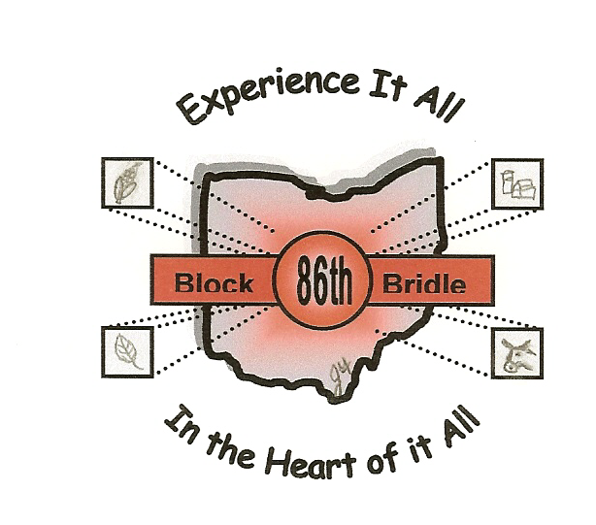

86th National Block and Bridle Convention
October 20-23, 2005
Columbus, OH

Registration Instructions

- Indicate the member’s name as it should read on the name tag
- Indicate if the member would like a shirt and the size needed (an extra $10 added to registration cost)
- Indicate which tour each person would like to go on; please note that these tours have limited space, so please respond early to ensure tour selection

Each club must submit the following:
- Chapter registration form
- The Code of Conduct signed by each participant
- Release forms (which can be found online) for each participant
- Registration fee:
    - $160 for early registration (plus $10 for shirt)
    - $180 for fall registration (plus $10 for shirt)

Deadline for early registration is June 1, 2005, and September 23, 2005 for fall registration. ALL registration forms must be received by the fall deadline.

Mail registration forms and payment to:
OSU Saddle and Sirloin Club
Animal Science Department
Room 122
2029 Fyffe Road
Columbus, OH 43210

Checks can be made payable to: The OSU Saddle and Sirloin Club

