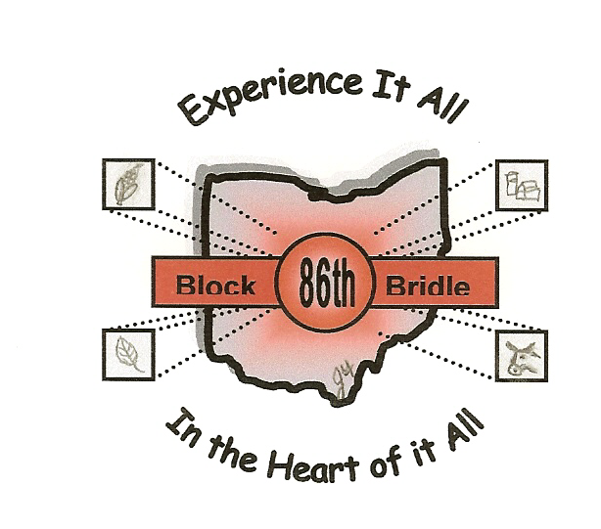

86th National Block and Bridle Convention

October 20-23, 2005

Columbus, OH

Schedule

Wednesday, October 19
3:00-10:00 pm Registration

Thursday, October 20
8:00 am-6:00 pm Registration
7:00 pm Opening Ceremonies – Guest Speaker
9:00 pm Advisor Meeting
9:00 pm-12:00 am Dance

Friday, October 21
Morning TOURS! (Breakfast and Lunch Provided)
Evening Explore Columbus – Ice Skating, Gameworks at Easton, Rock
Climbing, All-American Quarter Horse Congress, etc.

Saturday, October 22
7:00-8:30 am Breakfast
9:00 am Speaker – Hypnotist
10:00-11:45 am Sessions
12:00-6:00 pm Free Time
6:00 pm Banquet and Awards Program
?? – 1:00 am Dance – Will follow conclusion of awards program

Sunday, October 23
8:00 am Cowboy Church
Convention Adjourns

* Itinerary is subject to change

