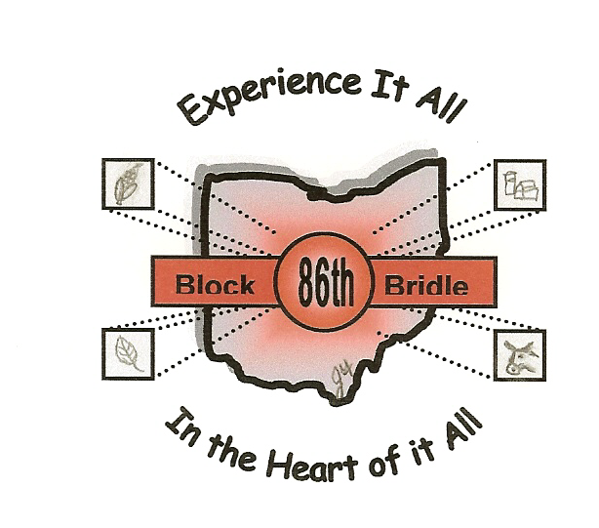

*****UPDATED*****

Tour Information

The tours have been divided up into the six sections of Ohio, these are the Northwest, Northeast, Southwest, Southeast, East and Central. You will be able to choose which of these sections you would like to travel to. I am including some general information about each tour, all of the updated information will be posted on the website:
http://www.blockandbridle.org/INFORMATION/CONVENSCHEDULE/convinfo05.htm

Northwest (2 Tour Options)
Option A
This tour will be traveling to Cooper Farms, a wholesale food supplier, selling a variety of fully-cooked and ready-to-cook poultry products to retailers, food service distributors and restaurants. (http://www.cooperfarms.com). Cooper Farms also produces animal feeds, turkey poults, table eggs and live hogs. You will have the opportunity to visit the hatchery and Cooked Meats’ Plant.

You will also tour Unverferth Manufacturing Company, Inc., which is a leading manufacturer and marketer of tillage equipment, hay, manure and grain handling equipment, and agricultural dual and specialty wheels. (http://www.unverferth.com/about.htm).

Unverferth Manufacturing Co Inc
Kalida, Ohio Facility
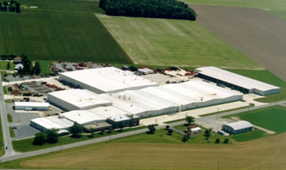

Northwest Option B
A tour of Firelands winery will give you an opportunity to see first hand how the wine is made. Your unique vantage point from the tour balcony will give you a clear view of the cellars, bottling room, champagne cellars, and warehouse. You will be able to see and experience an authentic working winery, taste their products (with an ID), and browse our wine boutique and gift shop (http://www.firelandswinery.com). This tour will also travel to Hord Livestock Co., which is a fully integrated family-run swine and grain operation (http://www.hordlivestock.com/index2.html).

Northeast
This tour will begin at the Pro Football Hall of Fame, and then will travel to
to Amish Country and touring the Hartzler Family Dairy and Ice Cream Shoppe. Hartzler Family Diary processes completely natural milk and ice cream products. The last stop on the tour will be at Heinie’s Cheese Factory, which makes organic cheese with milk provided by the Amish.

Southwest
This tour will be traveling to McCoy’s Real Genetics, a hog breeding facility for show pigs across the Midwest. You will be able to see how they select and evaluate which boar to breed to which sow depending on their genetic traits. You will also be able to travel to Van Roay Dairy LLC, this is a large operation dairy farm run by a Dutch Family.

Southeast
Champion Hill will be the destination of this tour. You will be able to tour the Angus beef cattle facility and view their high quality show steers, bulls, and breeding heifers.

Central
This tour will stay in the local Columbus area and tour Price-Barnes Organics Ltd, which specializes in premium bulk product sales of quality landscape products that provide nutrient rich, recycled organics for healthy lawns, shrubs, gardens and flowers. This tour will also travel to Riverwood Farms which has long been recognized as a leading seedstock nursery for superior livestock. Today, Riverwood is known from coast to coast for top quality sheep genetic. You will also have the opportunity to tour the OSU food Science and Technology Department on campus.

East
This tour will be visiting Dickinson Cattle Company, who raise Texas Longhorn cattle. The Ohio division is an integral part in the marketing and promotions of Texas Longhorns. There will also be other stops which have not been finalized.

