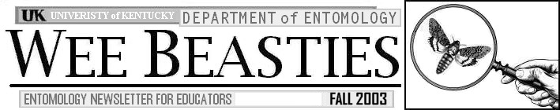

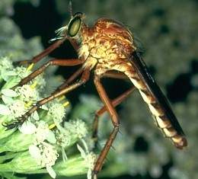

CONTENTS

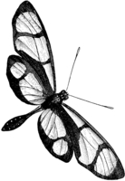
2003 Environmental Academy
Activity: Schoolyard Field Guide

Critter of the Month: Robber Fly

Book Review
Upcoming Events
Wee Beasties Mailing List
Contact Information

2003 ENVIRONMENTAL ACADEMY

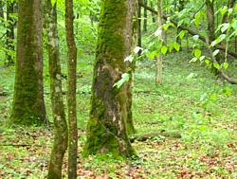
This summer, over two-dozen Kentucky science teachers and 4H agents took a Road Trip Across Kentucky to explore our state's tremendous ecosystem diversity. This week-long academy was designed and implemented by some of the finest environmental education experts in the state and took our teachers to Mammoth Cave, the Daniel Boone National Forest, and to several natural areas in between, providing a broad survey of Kentucky's physiographic regions.
An upland forest at Mammoth Cave National Park: one of the habitats investigated during the Road Trip Across Kentucky (B. Newton, 2003)
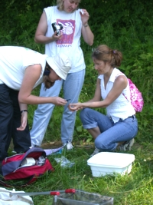
ENTOMOLOGY CONNECTION: On this road trip, teachers investigated changes within and between different habitats by examining a variety of living and non-living environmental factors. They identified trees, rated wildlife habitats, tested soils, and evaluated water quality. And, of course, they examined insect populations.

Using the same entomological sampling tools that scientific researchers use (including sweep nets, field guides, sticky traps, and Berlese funnels) teachers on our academy learned about the different insects that live in various Kentucky habitats.
Teachers use sweep nets to sample insects (B. Newton, 2003)

It wasn't long before our academy team members were identifying common insects and predicting what types would occur in different habitats. More importantly, by studying insects at the same time that they were learning about trees, wildlife, soil, and other environmental features, our academy trainees saw the ecology connections between all of these factors.

The academy was made possible through the combined efforts of the Tracy Farmer Center For The Environment and The University of Kentucky Cooperative Extension Service. If you are an intrepid educator, and want to learn more about the environment, contact us (see contact info below), or Stephanie Jenkins (swjenk2@uky.edu) at the Tracy Farmer Center For the Environment at (859) 257-4974 to learn about future training opportunities.

ACTIVITY: SCHOOLYARD FIELD GUIDE
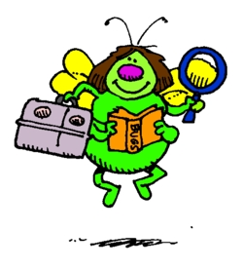
Insect field guides are mentioned quite often in the Wee Beasties newsletter. That's because entomologists use field guides a lot. A whole lot. In fact, most entomologists don't leave the house without a field guide (or two). The truth is, even the most experienced entomologist is always finding insects that he or she has never seen before, and a field guide is essential for quick identification of unusual insects.

Insect field guides are also great tools for the classroom. When a student brings in an unusual insect, a field guide can help to determine its identity and learn more about it. As a teacher, though, it might occur to you that there is another way that field guides can be used within a science curriculum. Instead of just reading field guides, have your students make one for the insects that live in your schoolyard, school garden, or any other outdoor area to which you and your students have access.

Making a field guide is easy. The first step is to allow your students to search the schoolyard on a warm day. Instruct them to look for insects, and to try and find one that really interests them. From there, your students can try to learn a little about the insect in the classroom and then return outside for more detailed observations. After each student becomes an "expert" on a different insect, they can each be responsible for creating one page in a field guide.

If you are interested in having your students work on a field guide, take a look at the detailed activity guide (PDF format; downloadable from the html version of this newsletter) which includes a copyable form that students can fill out for each page of the guide. Feel free to change this activity to suit the needs of your students or curriculum.

CRITTER OF THE MONTH: ROBBER FLY

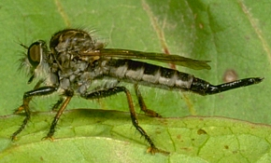
Robber flies are some of the most fascinating predators in the insect world. They are called robber flies because they are skilled at "snatching" other insects out of the air. Robber flies are great fliers and have no trouble capturing flies, moths, bees, and other flying insects, some of which are larger than themselves!

The creature at the top of this newsletter is a robber fly from the Diogmites genus that is very common in agricultural habitats. The robber fly pictured above is the more familiar "bee killer" robber fly, well known for preying on bumblebees and other large insects. Kentucky is home to these and several other robber fly species. Read more about these insects in the new Robber Flies entry of the Critter Case Files at:

www.uky.edu/Agriculture/CritterFiles/casefile/insects/flies/robber/robber.htm

Critter Of The Month is a new Wee Beasties feature. Each month, we will feature one of the critters from the Critter Case Files (www.uky.edu/Agriculture/CritterFiles/casefile/casefile.htm), University of Kentucky's on-line field guide to insects, spiders, and related critters.

BOOK REVIEW
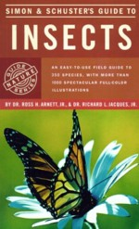
Simon & Schuster's Guide To Insects

by R. H. Arnett, Jr. & R. L. Jacques, Jr.

For many years, entomologists have relied on the Peterson Field Guide to The Insects by Borror and White as their number one field guide. Every entomologist has one or more copies, and most of us carry a copy around with us at all times. It has the best combination of pictures and technical information for quick order- and family-level identification of common insects.

Unfortunately, one field guide isn't enough. There are just too many different insects to fit in one book. So if the Peterson field guide is the best insect field guide, what is the second best? To which guide does an entomologist refer when the Peterson guide just isn't enough?

There is no good answer to that question. Most entomologists keep several field guides that they use as back-ups to the Peterson guide. The National Audubon Society Field Guide To North American Insects and Spiders (reviewed in the Fall 2001 Wee Beasties) is one of the most popular. There are others as well. One of the best is Simon and Schuster's Guide to Insects by Arnett and Jacques.
Simon and Schuster's guide covers a great percentage of the most commonly encountered insect types. It's identification system is much less technical that that found in the Peterson guise, but is sufficient for field identifications. Most importantly, the book contains photos of nearly 500 common insects. Photos like these are very useful identification tools, both for professional entomologists and students.

Some things to keep in mind: as with all field guides, the Simon & Schuster guide does not contain pictures of every insect. No field guide can. It also features many insects that occur west of the Rockies, so don't expect to find all of these insects in Kentucky. It is also important to mention that this book covers only insects: no spiders, millipedes, or other critters.

So if you only buy one insect field guide, it has to be the Peterson Field Guide to Insects. Sorry Simon & Schuster. But if your bookcase, budget, or backpack has room for two, Simon & Schuster's Guide to Insects makes a nice fit.

UPCOMING EVENTS

The Entomology Department will be present with displays, insects, and information at the following events and locations in the upcoming months:

DATE | TIME | PLACE/EVENT
Sept 20 | 11 am - 4 pm | Museum-Go-Round, 2nd Street near Lexington Children's Museum
Sept 24-27 | various times | University of Kentucky AG ROUND UP, U.K. Campus, Lexington
April 17 | 10 am - 2 pm | Fayette Co. Co-Op Nursery Bazaar

Tell your students or their parents about these events, or plan a field trip and join us!

WEEBEASTIES MAILING LIST

Would you like to receive a PDF copy of each fall and spring Wee Beasties issue via email as soon as it is printed? If so, send us some email at blnewt00@uky.edu and we will put you on the list! If you don't like PDF, we will also send you a link to the HTML version of the issue when it is published.

Contact Information:

If you have ideas, experiences, or information that you would like to share or would like information about educational resources available through the University of Kentucky, Department of Entomology, write, phone, or email:

Blake Newton
S-207 Agriculture Science Center - North
University of Kentucky
Lexington, KY 40546-0091
(859) 257-5107
Email: blaken@uky.edu

Educational Programs of the Cooperative Extension Service serve all people regardless of race, color, age, sex, religion, disability, or national origin.

UNIVERSITY OF KENTUCKY, KENTUCKY STATE UNIVERSITY, DEPARTMENT OF AGRICULTURE AND KENTUCKY COUNTIES COOPERATING.

Black and White insect images used with permission from www.arttoday.com
"Field Guide Bug" cartoon copyright C. Ware, 2000, used with permission
Other images courtesy of R. Bessin & B. Newton, University of Kentucky

