Business Office
Phone: 218-0483
Email: CHS-Business-Orders@uky.edu
Get forms online: http://bit.ly/chs_forms

How To Place Food Orders

All orders should flow through the Division’s Staff Support
How to place a food order (NOT UK catering)
- The Staff Support fills out order form for pre-approval.
  - Check the pre-approval box if you will be placing the order yourself.
  - Include Vendor Name, Address, Telephone Number and website (if applicable)
  - Include Requestor name and telephone number and ship-to address (if applicable)
  - Include the name of the event, the purpose and a list of attendees.
  - Include a cost center (must be a number, not the name of the account)
- Get appropriate electronic signatures
- Submit order form and necessary attachments to Business Office (submit electronically to the Business Office Order email (CHS-Business-Orders@uky.edu) and not to anyone’s personal email. Review Order Form and all attachments to ensure that they are accurate and complete before emailing to the Business Office.
- Business Office approves:
  - If a Procard is appropriate, the Business Office notifies the requestor by email of approval and internal order number and holds order form until the original credit card receipt and the list of attendees is received in the Business Office.
  - If a PRD is appropriate, the Business Office will approve and create PRD and forward to the Staff Support. If necessary, the Business Office will complete Vendor applications.
- Staff Support places order after they receive either the emailed approval from the Business Office or the PRD.
- Day of event:
  - Procards: Original credit card receipt needs to be returned to the Business Office for processing. Please note on receipt the internal order number so that the Business Office can match the receipt with the original order. If a tip is added, be sure to note the amount of the tip and the new total on the receipt.
  - PRDS: Receipt needs to be emailed to the Business Office (see email address above) with a copy of the PRD for processing. If a tip is added, please be sure to note the amount of the tip and the new total on the receipt.

******Please remember that food order forms should be submitted to the Business Office with plenty of lead time before the event (at least 3-5 days before the event). ******
How to place a UK Catering Order
If you are ordering from UK Catering, you do not need to complete the additional order form. Please follow the steps below:
- The Staff Support fills out order form for pre-approval.
  - Check the pre-approval box if you will be placing the order yourself.
  - Include Vendor Name, Address, Telephone Number and website (if applicable)
  - Include Requestor name and telephone number and ship-to address (if applicable)
  - Include the name of the event, the purpose and a list of attendees.
  - Include a cost center (must be a number, not the name of the account)
- Get appropriate electronic signatures
- Submit order form and necessary attachments to Business Office (submit electronically to the Business Office Order email (CHS-Business-Orders@uky.edu) and not to anyone’s personal email. Review Order Form and all attachments to ensure that they are accurate and complete before emailing to the Business Office.
- The Business Office notifies the requestor by email of approval and internal order number and holds order form until the original credit card receipt and the list of attendees is received in the Business Office. UK Catering is now paid via a Procard-the Business Office will give you the appropriate Procard to use when they send your approval.
- Staff Support places order after they receive either the emailed approval from the Business Office via this website:
https://uky.catertrax.com/index.asp

When you get to STEP 4: Checkout, please CC either Ruth or Katie or the Business Office email so that we will receive a copy of the reservation and invoice.
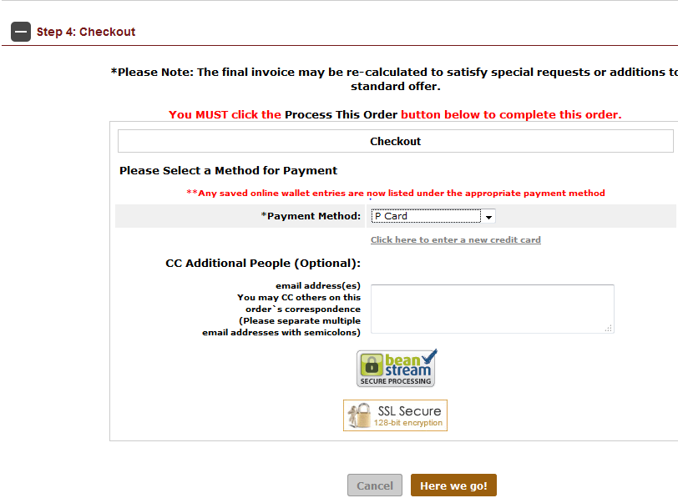

- Day of event:
Invoice needs to be returned to Ruth or Katie in the Business Office for processing. Please note on receipt the internal order number so that the Business Office can match the receipt with the original order. Please be sure to include the list of attendees.

Reimbursing employees for purchases not on procards (does not pertain to Travel):
In order to reimburse an employee for a purchase that could have been bought on the Procard, we will need a Request for Employee Reimbursement and Invoice Form completed and attached to the Order Form. The Business Office needs to sign as the Approving Official.

