The University has introduced TRIP as a new online travel document management system.
Effective January 1, 2017, all travel reimbursments must be processed through TRIP.

At this time the College of Health Sciences will continue to require the travel authorization form be submitted to the Business Office. This provides the business purpose for the trip, account numbers for funding the travel, and supervisor approval that the employee will travel and there are sufficient funds to cover expenses along with many other details.

Upon return the traveler, or their Administrative Assistant, can submit the paper reimbursement form and any receipts. Or the reimbursment request can be submitted via TRIP and all required receipts can be scanned into one document in chronological order and attached to the TRIP. Any supporting documents, such as agendas, can also be scanned and attached to the TRIP. If a paper copy is submitted the Business Office will create an online TRIP request in order to process the reimbursment.

When the travel information is entered into TRIP a unique number is generated. Please touch base with your business office contact if you plan to entered your reimbursment online to see if they have started the document. If so, you may only need to edit an existing document.

To start with TRIP you need to sign in to My UK and locate the Employee Self Service Tab. At the bottom right there is link to the Travel Requests and Travel Expenses. Select this link.

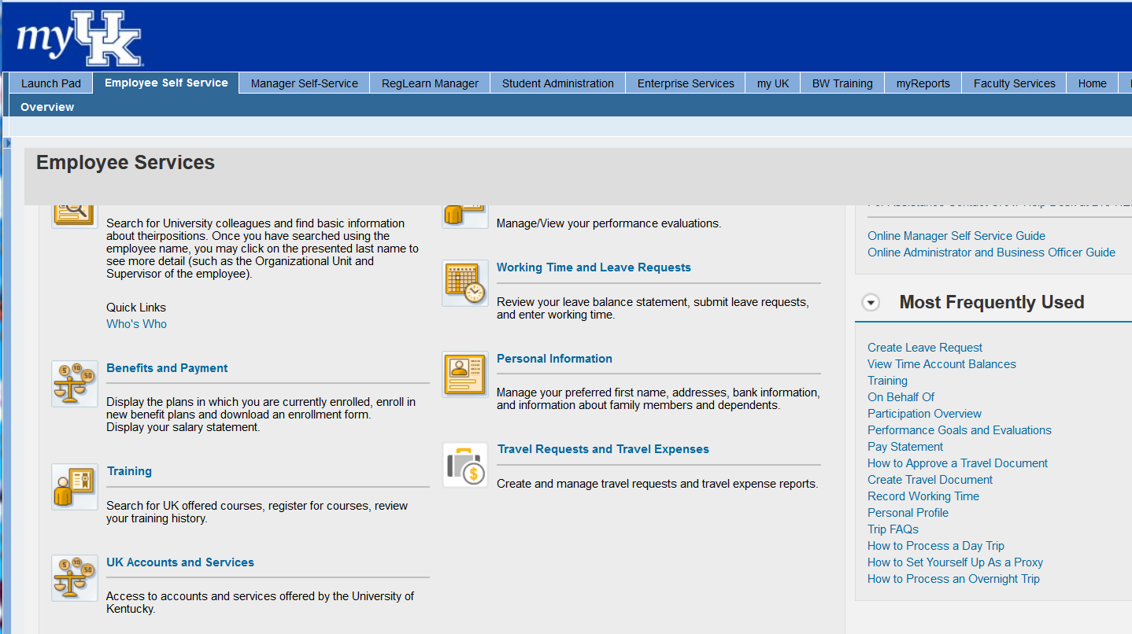

The following screen is returned.
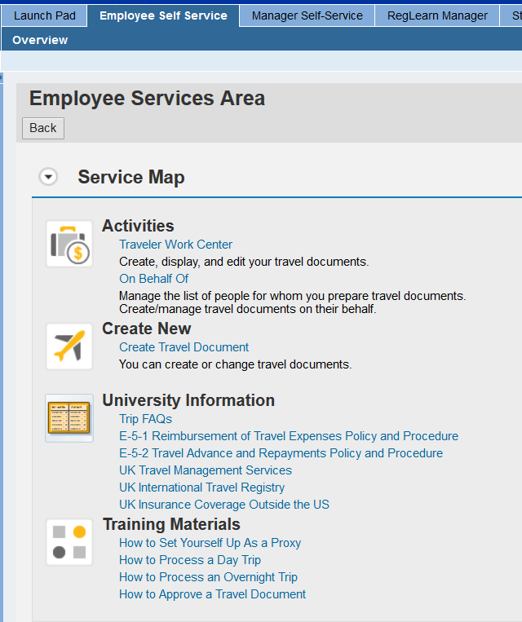

Options here are:

Under Activities there is an On Behalf Of link. – Admin Assistant (AA) or Business Office use this link to create a reimbursement document for your traveler. You can attach receipts electronically as one document.

Under Activities there is the Traveler Work Center link which allows the traveler to create, display or edit documents. You can see all reimbursements created for the employee. You can attach receipts electronically as one document.

Under the Create New section there is Create Travel Document that allows the traveler to create a new travel reimbursement document. You can attach receipts electronically as one document.

Under the University Information you can find FAQs and travel policies.

Under Training Materials there are links to step by step “How to” procedures for Setting Up a Proxy, Day Travel, Overnight Travel, and How to Approve Travel Documents.
Another location for training and information about TRIP is the UK Office of the Treasurer web page. There is a Quick Reference Cards tab on the right. Select the tab and you will find “How to” documents and explanations at the bottom of the page. Please note the TRIP Region Settings document. This is important on initial set up of your preferences so you can search for cities, states and countries.

http://www.uky.edu/EVPFA/Controller/payable.htm

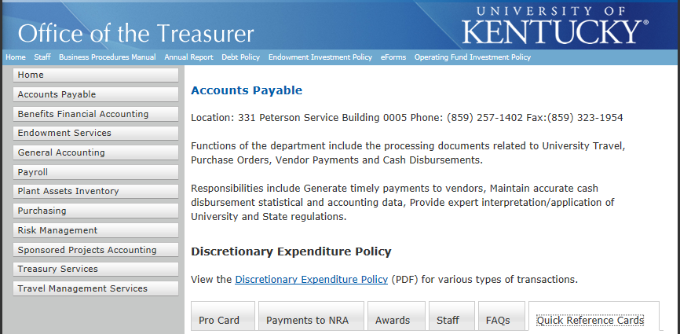

For Document Approval by Faculty, Staff or Supervisors

Refer back to Employee Self Service tab and the Traveler link for the Training Materials and the How to Approve Travel document.

If the TRIP document is created by a Proxy, the approval process will start with document submission to the traveler/employee. If created by the traveler/employee, the document will start routing with the employee’s supervisor. Once approved by the supervisor the document will route to the Business Office and then Accounts Payable. The traveler will receive an additional email when the check request is submitted to the bank. A direct deposit should be received in 3-5 business days. The deposit will be applied to the same account as the traveler’s payroll. Please notify the Business Office if the funds are not received.

Each person in the approval process will receive email notification that the document is ready for review and approval. If you have questions or require revisions contact the Business Office. Please do not reject the document as this will require us to re-enter the entire document.

To approve go to Enterprise Services/work flow/workflow items.

In the task list select the document to review the summary of the travel and expenses.
Scroll down for the attachment(s) to see the back-up documentation. (Employee Trip document is blank.)
Below the attachments you will see the approve button as well as the revise and reject buttons. Please do not use the reject button.

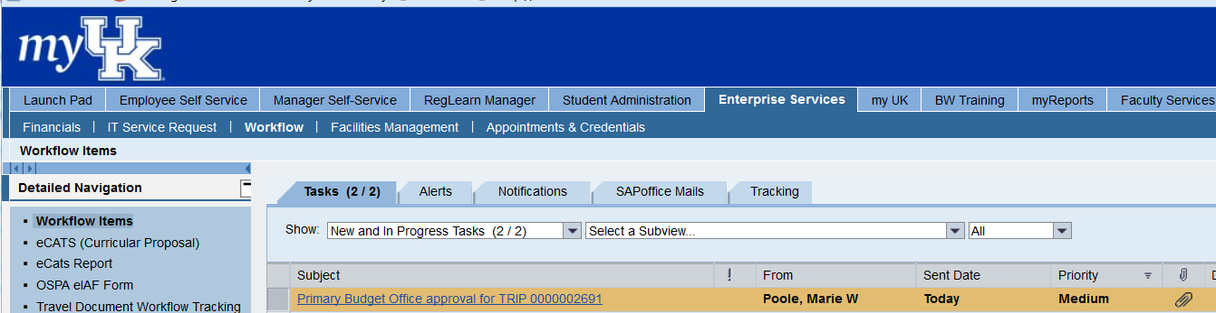

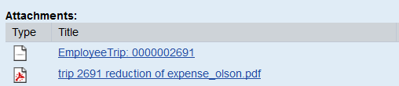

Travel document workflow tracking

To track the approval process go to the Enterprise Services/Workflow/Travel Document Workflow Tracking, enter the TRIP number and then select the button with the green check mark on the clock to execute. You will see a list of the responsible approvers and the progress of the document. The final approval will be Accounts Payable.

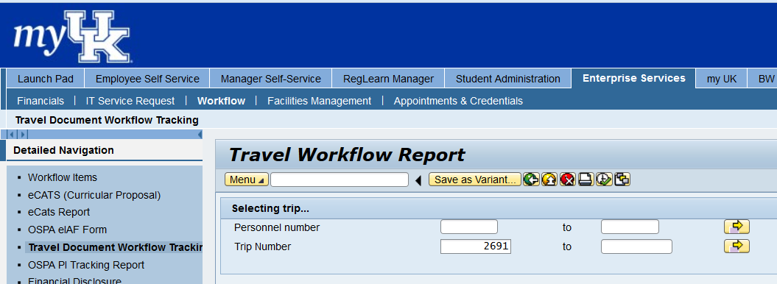

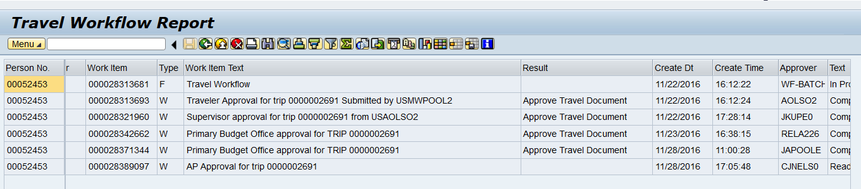

Travel Notes of interest
* Include travel leave and return times and dates.
* Per Diem – TRIP determines meal per diem based on dates, times and location.
* Please provide an agenda to confirm that meals are or are not included in the registration fee.
* Incidentals are not included in the per diem calculation.
* Special events or additional optional meals, usually dinner, are not allowed to be paid on the UK procard. If payment is required at time of registration traveler can pay for the cost with personal funds. Meals are per diem and not procard charges.
* If attendance is required at an optional dinner event justification and approval from a supervisor is required. An example would be if a faculty is the President of a Society and would be the host of the event. Another example would be if a faculty is receiving an award.
* Personal travel – some examples are leave or return from non-home or work location, additional time spent in a destination before or after a trip (time not required for business travel)
* Please check with the Business Office before purchasing airfare. This will allow us to obtain the required cost comparison on the same day as the purchase. The traveler will be reimbursed the lower of the two amounts upon return from the trip.
* Typically business travel includes the day before or the day after a conference as travel time. More time may be approved for foreign travel. If a conference ends at noon or early afternoon a traveler can typically travel home that same day.

