MEDICAL LABORATORY SCIENCE

STUDENT HANDBOOK

SECTION I: MLS PROGRAM INFORMATION AND POLICIES
A. Organization
1. College of Health Sciences 4
2. Medical Laboratory Science Contact Info 5
B. Program Overview 6
1. Accreditation 6
2. History of the Program 6
3. Mission Statement 7
4. Program Goals 7
C. Admission Requirements 7
1. Fair Practices of Student Recruitment 7
2. Foreign Graduates 8
3. General Requirements 8
D. Student Requirements 9
1. Technical Standards or Essential Functions 9
2. Health Insurance 11
3. Immunizations 12
4. Background Check and Drug Screen 13
5. HIPPA 13
6. ID Badge 13
E. Finances 13
1. Tuition and Fees 13
2. Program Expenses 14
3. Scholarships and Loans 14
a. College of Health Sciences Scholarships 14
b. MLS Specific Scholarships and Loans 15
F. Professional Conduct 16
1. Health Care Colleges Code of Student Professional Conduct 16
2. ASCLS Code of Ethics 17
3. Academic Integrity, Cheating, and Plagiarism 18
G. Program (in general) 19
1. Time Demands 19
2. Inclement Weather 19
2. Use of Electronic and Mobile Devices 19
3. Program Communications 20
4. Learning Management System 20
5. Decorum of Communication with Faculty 20
6. Schedule of MLS Classes 20
7. Student Advising 21
8. Student Awards 21
9. Travel Reimbursement for Hazard Students 21
H. Lab Policies 22
1. General Laboratory Safety 22
2. Dress Code and Professional Appearance 23
3. Blood Borne Pathogens 24
4. Chemical Hygiene 24
5. Fire Safety 24
6. Hazardous Waste 24
7. Lab Supervisor and Clean Up Duties 24
8. Drawing Blood 24
8. Use of Labs 25
I. Building Information 25
1. Student Lounge 25
2. Student Lockers 25
J. Student Memberships 25
1. MLS Student Club 25
2. Professional Organizations 25
K. University of Kentucky 26
1. Resources 26
2. ADA Accommodations 27
3. Tobacco Use 27
SECTION II: MLS ACADEMIC POLICIES 28
A. Program Curriculum 28
1. Course Descriptions 29
B. Progression in the Program 29
1. Timeline 29
2. Leave of Absence 30
3. MLS Program Probation 30
4. MLS Program Dismissal 31
C. Examinations and Course Grades 31
D. Student Complaints and Appeals 33
E. Attendance Policies 34
1. Making up Missed Work 35
F. Tardiness 35
G. Affective Behaviors 36
1. Laboratory/Lecture Affective Behaviors 36
2. Practicum Rotation Affective Behaviors 37
H. Graduation and Pinning Ceremony 37
I. Certifying Exam 37
J. Teach Out Policies 38
1. Permanent Closure 38
2. Temporary Closure 38
K. CHS Undergraduate Academic Probation and Suspension Policy 38
SECTION III: CLINICAL EXPERIENCE
A. Clinical Practicum Handbook 39
B. Affiliates 39
C. Clinical Site Assignments 40
D. Service Work 40
APPENDICES
A. CHS Undergraduate Academic Probation and Suspension Policy 42
B. Financial Aid Documents 45
C. Application for MLS Loan 47
D. Signature Pages 48

SECTION I: MLS PROGRAM INFORMATION AND POLICIES
A. ORGANIZATION
1. College of Health Sciences The MLS program is in the College of Health Sciences. Figure 1 shows the organization of the College of Health Sciences (CHS), so you can better understand the structure of the College.
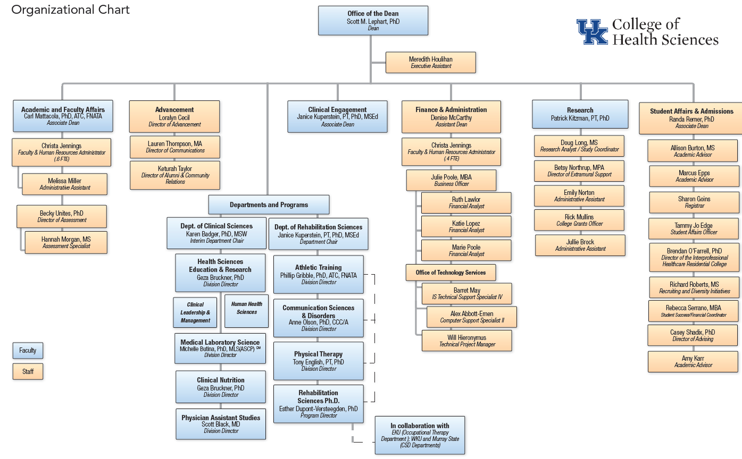

2. Medical Laboratory Science

MLS Contact Information

Name | Telephone | Email
Kim Campbell, M.S. Ed., MLS (ASCP)  Faulty | 859-218-0853 | kkcamp1@uky.edu
Steve Schwarze, Ph.D., MLS (ASCP)  Program Director | 859-218-0846 | steve.schwarze@uky.edu
Hunter Howard  Administrative Assistant (Lexington) | 859-218-0851 | Hunter.Howard@uky.edu
Margie Coots  Administrative Assistant (Hazard) | 859-218-3570 | margie.coots@uky.edu
Chad Guilliams, M.S. Ed., MLS (ASCP)  Faculty | 859-218-0855 | chad.guilliams@uky.edu
Stacy Gabbard, MA, MLS (ASCP)  Practicum Coordinator | 859 218-0850 | stacy.gabbard@uky.edu
Chad Guilliams, M.S. Ed., MLS (ASCP)  Faculty | 859-218-0855 | chad.guilliams@uky.edu
Bianna Music, MLS (ASCP)  MLS CERH Associate Director | 859-218-3680 | biannamusic@uky.edu
Jenna Faust | 859-218-0500 | Jenna.crain@uky.edu
Randi Ray | 859-218-0500 | Randi.ray@uky.edu

Mailing addresses:

900 South Limestone Street Center of Excellence in Rural Health

CTW Building, Room 124 75 Morton Boulevard

Lexington, KY 40536-0200 Hazard, KY 41701

859-218-0851 Toll Free: 1-855-859-2374

Fax: 859-323-8957

B. PROGRAM OVERVIEW
The 18-month program is offered on the Lexington and Hazard campuses of the University of Kentucky. The program provides sequential instruction in laboratory medicine for the student who has been well prepared in science and mathematics. Traditional students apply to the program in the second semester of the sophomore year and begin medical laboratory science courses in the fall of the junior year. Students complete an intense curriculum that includes lectures and student laboratory classes, and then complete a 20-24 week clinical practicum in one of our affiliated clinical sites. Opportunities exist for the student who wishes to complete clinical practice in rural Kentucky sites.

After completion of the MLS curriculum, students are well prepared for clinical practice in the modern, automated laboratory. Graduates are eligible to take national certification examinations as Medical Laboratory Scientists through the Board of Certification (BOC).

The University of Kentucky offers a Bachelor of Health Science degree in Medical Laboratory Sciences (MLS). Students with a bachelor degree in science from another university in the U.S. are eligible to obtain a Bachelor of Health Science after completion of the Medical Laboratory Science program requirements.

1. Accreditation
The MLS program at the University of Kentucky is accredited by the National Accrediting Agency for Clinical Laboratory Science (NAACLS). Contact information for NAACLS is:

National Accrediting Agency for Clinical Laboratory Sciences
5600 N River Rd
Suite 720
Rosemont, IL 60018
773.714.8880
773.714.8886 (FAX)
info@naacls.org (email)
http://www.naacls.org (website)

2. History of the Program
In 1933, the Department of Bacteriology (now Microbiology) was approved as an ‘Approved Training School for Technicians’ by the Board of Registry of the American Society of Clinical Pathologists. For the next thirty years (until 1964), the approved curriculum in Medical Technology was taught in the Department of Microbiology.

From 1964-1966 a certificate program was offered within the Albert B. Chandler Medical Center as the University Hospital School of Medical Technology under the Department of Pathology, College of Medicine.

In 1966, the College of Allied Health Professions was created and Medical Technology was one of the original departments in the new College offering a baccalaureate program. Mary Frances James, M.S., MT (ASCP) became the Program Director. Dr. Marie C. Vittetoe became program director upon the retirement of Mary Frances James in June 1978.

In 1988, the Department of Medical Technology became the Division of Clinical Laboratory Science (CLS). For the next two decades the Division of CLS sought innovative routes of expansion and growth.

In 2011, the CLS Program changed its name, to match certification credentials, to Medical Laboratory Science.

3. Mission Statement

The mission of the University of Kentucky Medical Laboratory Science Program is to help the people of the Commonwealth of Kentucky and beyond to gain and retain the highest level of health care by educating individuals to become high quality medical laboratory science practitioners and healthcare professionals.

4. Goals and competencies for graduates
The program vision is to be a nationally recognized program for our high standard of training and high quality graduates.

Program goals designed to address the program’s vision and mission are as follows:
- To graduate versatile medical laboratory scientists prepared to meet the workforce needs in the Commonwealth of Kentucky and the nation.
- To graduate healthcare practitioners that demonstrates professionalism reflective of the highest ethical standard of the medical laboratory science profession.
- To provide an educational foundation that can be advanced such as in the areas of administration, academia, advanced healthcare roles, industry and research.

C. ADMISSION REQUIREMENTS
1. Fair Practices of Student Recruitment
The University of Kentucky is committed to a policy of providing educational opportunities to all academically qualified students regardless of economic or social status and will not discriminate on the basis of race, color, ethnic origin, national origin, creed, religion, political belief, sex, sexual orientation, marital status, age, veteran status, or physical or mental disability.

The University of Kentucky is an equal opportunity university. We encourage applications from all academically qualified people interested in educational opportunities.

2. Foreign Graduates
If you are a foreign graduate, you need to: 1) submit your foreign transcripts to an approved credentialing company, 2) take the TOEFL test, and 3) submit your application to the University of Kentucky as soon as possible.
Your first step is to submit all of your higher education transcripts to World Education Services (WES). The MLS Program will only accept transcript evaluations from WES in consideration of admittance into the Program. This is usually a lengthy process which is why you need to submit these as soon as possible. Once your transcripts have been evaluated, by WES, we can appropriately advise you for the Medical Laboratory Science Program and/or consider your application for admittance.
Your second step is to take the TOEFL test and submit scores to the MLS Program. In order to be eligible for admissions into the MLS Program, a minimum combined TOEFL iBT score of 120 is required with a minimum score of 26 in each category: Reading, Listening, Speaking, & Writing. Refer to the TOEFL website (http://www.ets.org/toefl) for more information regarding the test.
Your third step is to submit your University of Kentucky undergraduate application. As a foreign graduate, admission may be a lengthy process as foreign transcripts, WES evaluation, and TOEFL scores are individually reviewed. In addition, course syllabi may be required to ensure equivalency therefore we highly encourage submission of syllabi along with the above documents. This review is to ensure that you have met all general education core requirements and MLS prerequisite courses, and to ensure sufficient undergraduate credit hours. This review process (by the University of Kentucky undergraduate admissions office) needs to be completed for the MLS Program to adequately evaluate your MLS application. If this review process is in progress during the MLS application review period, it is possible for foreign graduates to be accepted on a conditional basis pending completion of missing courses/credit hours.
3. General Requirements
Prospective students must complete an application packet in order to be considered for admissions into the MLS program.
Below are the admission requirements for entry into the MLS Program:

Prerequisite Courses
In addition to the University of Kentucky General Education (UK core) and Graduation Writing requirements, students seeking admission to the MLS program must complete the following pre-requisite or pre-professional courses. The following courses need to be completed before beginning the MLS program. These courses must be completed in order to be granted a Bachelor’s of Health Science degree in MLS and to sit for the BOC exam.

- 1 semester of general biology with laboratory
- 2 semesters of general chemistry with laboratory
- 1 semester of organic chemistry with laboratory
- 1 semester of general microbiology with laboratory
- 1 semester of statistical methods
- 1 semester of human physiology (or combined course in physiology and anatomy)

Academic Performance
The minimum GPA for entrance into the MLS program is a 2.5 on a 4.0 scale and successful passing of the MLS pre-requisites.

Application Packet
- Completion of application to the Medical Laboratory Science Program
- Submit three recommendation forms
- Provide official copies of all higher education transcripts

Interview Process
After the deadline for applying to the MLS program, qualified applicants may be required to participate in a brief interview by MLS faculty member(s).

A student is ultimately accepted to one campus or the other and may not change campus of attendance. Occasional attendance at the alternate campus for specific class sessions will be considered with approval of faculty of record for the class.

Other Requirements
Completion of application to the University of Kentucky (if currently not a UK student). More information regarding applying to the University of Kentucky can be found at: http://www.uky.edu/Admission/admissions. Information regarding transfer policies and credits can be found at http://www.uky.edu/Admission/policy.htm.

D. STUDENT REQUIREMENTS
1. Technical Standards/Essential Functions
In addition to the Technical Standards from the College of Health Sciences, MLS students must be able to meet other essential functions in order to complete the program successfully. Students must be able to complete the program in ways that will not endanger themselves or other person.

Observational Skills
A graduate of any of the MLS Programs must be able to conduct laboratory work in areas such as, but not limited to, cell identification, based on microscopic study of cells and tissues in normal and pathological states. The student must also be able to withstand long hours at the microscope and the work bench. Vision related requirements include, but are not limited to, interpretation of color reactions, reading measuring devices, instrument read-outs, written and illustrated material, observing slides and overheads, discrimination of microscopic structures within a cell, interpretation of staining methodologies, observing anatomic structures, and discriminating numbers and patterns associated with diagnostic tests.

Communication Skills
Communication skills required include oral communication and written communication skills necessary for effective and efficient communication with faculty, staff, patients, students, and other members of the health care team. English is the preferred language. The student must be able to accurately read and record observations in a clear and legible manner. This includes laboratory reports, proficiency testing, instruments logs, quality control, reports, and exams. Effective communication skills are essential so that a student can relate information to patients conveying a sense of compassion, empathy, and respect. The student must respect the privacy of others.

Sensory and Motor Function
A student or the Medical Laboratory Science must possess proficient hand to eye coordination. A wide variety of complex laboratory equipment will be used for training including standard light microscopes, stereo microscopes, fluorescent microscopes, phase microscopes and inverted microscopes. Students must be able to perform microscopic manipulations. Students must also be able to accomplish diverse tasks such as examination of a bacteriological specimens or plates, perform complex chemical analyses and perform immunologic testing. A student must be able to operate the laboratory equipment necessary for the testing including but not limited to micropipettes. A student enrolled in the Medical Laboratory Science Program may also be called upon to perform venipuncture or capillary punctures under normal conditions or under emergency conditions.

Critical Thinking Skills (Intellectual-Conceptual Integrative and Cognitive Abilities)
A student must possess the ability to accurately perform and interpret laboratory testing. Included in these skills are measurements, calculations, reasoning, analysis, judgment, numerical recognition, and synthesis. Problem solving and interpretation of laboratory results are critical skills of the profession. The ability to incorporate and assimilate new information from peers, instructors, and literature is essential for problem solving. A student must be able to interpret many modes of data presentation including but not limited to tables and graphs. The understanding of research is an important area and the student must be able to effectively design a research project.

Behavioral Attributes
The student must exhibit behavioral attributes that include empathy, integrity, honesty, concern for others, good interpersonal skills, interest, and motivation. A student must possess the emotional health required for full use of their intellectual abilities, exercising good judgment, completing all responsibilities attendant to the care of patients and developing mature, sensitive, and caring relationships with classmates, instructors, patients, and other health care providers. This may require the ability to be aware of and react appropriately to emotional responses. A student must maintain a professional demeanor and performance after long hours and personal fatigue. Students must have the endurance to tolerate physically taxing workloads and to function effectively under stress. The student must be able to adapt to changing environments. Students are expected to accept appropriate suggestions and criticism and if necessary, respond by modification of the behavior.

2. Health Insurance
The MLS Program requires student to provide documentation of health insurance, for coverage during practicums, upon entering the Program. All MLS students are required to have UK student health insurance or a comparable plan (coverage as a dependent is acceptable). You must have proof of health insurance prior to the first day of class of the fall semester (junior year). Otherwise you will not be permitted to attend any MLS courses until completed.

For more information regarding the UK student health insurance please visit the student health website at: http://ukhealthcare.uky.edu/uhs/student-health/student-insurance/.
For UK student health insurance eligibility, an undergraduate student must be enrolled in at least six (6) credit hours at the University of Kentucky.

3. Immunizations
University Health Service (UHS) welcomes University of Kentucky Health Science College students to our clinic. These compliance requirements have been established to protect health care providers, as well as their patients during clinical encounters. These requirements reflect CDC guidelines and UK HealthCare policies. If you have a medical contraindication to one or more of the vaccine requirements, please provide UHS with documentation from your primary care provider. Deadlines for completion of compliance are set by the individual colleges. The following immunizations are required for all students involved in clinical activities:
Tuberculosis Screening  New Health Science College students are required to complete a 2-step TB Skin Test* or 2-step equivalent (IGRA).**  If you have had a TB test within the last year, please submit/bring a copy with you to your appointment.  Upper classmen must complete a TB skin test or  IGRA test on an annual basis.  Documentation of a negative Mantoux TB skin test is accepted from other institutions and must include (1) date given, (2) date read, (3) reading in millimeters, (4) name of facility and credentials of person administering and reading test.  If known history of positive TB test or IGRA test, documentation must include date of reading in millimeters and chest x-ray. If these records are unavailable, UHS requires a 2-step TB skin test or equivalent IGRA. Students with a positive PPD will participate in annual TB screening by answering a TB symptom questionnaire.  *2-step TB Skin Test: two (2) TB skin tests within one year  **IGRA: Blood test for TB | Hepatitis B  A series of three injections at recommended intervals. It is strongly recommended to check a Hepatitis B surface antibody (blood test) 4-8 weeks after dose # 3.  MMR  Proof of immunity to Rubella, Rubeola, and Mump. One of the following maybe used as documentation:  - Two MMR vaccines with the first dose at 12 months of age or older;  - Rubella, Rubeola, and Mumps disease diagnosed by healthcare provider*;  - Documentation of protective Rubeola, Rubella, and Mumps titers  Varicella  Proof of immunity to varicella by one of the following:  - Chicken Pox or Shingles disease diagnosed by a healthcare provider*;  - Positive antibody titer;  - Documentation of two varicella vaccines with the first dose at 12 months of age or older
Tdap (Tetanus, Diphtheria, Acellular Pertussis  Documentation of one dose of Tdap vaccine at age 11 or older  NOTE: Td (tetanus/diphtheria) vaccine is NOT the same as Tdap | Seasonal Influenza  One dose of the seasonal influenza vaccine is required if a student is present in a UK HealthCare facility at least one day during designated influenza season (October 1 – March 31)

Immunization records must be verified by University Health Services (UHS) and then submitted into CastleBranch document manager. UHS is located on the second floor of the University Health Service building at 830 S. Limestone Street, Lexington, KY 40536.
If you have a medical contraindication to one or more of the vaccine requirements, please provide UHS with documentation from your primary care provider. If you do not meet the immunization requirements you will be required to remove yourself from all MLS courses.
HAZARD STUDENTS: You need to have your immunization records evaluated by the Student Health Services (electronically) prior to the first day of the fall semester of your junior year in the MLS Program.

LEXINGTON STUDENTS: You need to have your immunization records evaluated by the Student Health Services (electronically or in person) prior to the first day of the fall semester of your junior year in the MLS Program.

4. Background Check and Drug Screen
The College of Health Sciences requires Criminal Background Checks and Drug Screen Testing for all students entering our College. This is to ensure a safe environment for both students and the public. The College of Health Sciences has worked with CastleBranch to establish acceptable screening procedures. You must have completed your background check and drug screen before the first day of class of the fall semester (junior year). Otherwise you will not be permitted to attend any MLS courses until completed.
5. HIPPA
The federal government has begun implementation of the Health Insurance Portability and Accountability Act. This law has many purposes and provisions. Those that affect all health care providers most directly relate to ensuring the privacy and security of protected health information. Federal law requires that all health care employees and health professions students receive training about HIPPA. Training is MANDATORY. More information regarding this training will be presented by CHS Student Affairs office. Training must be completed and documentation submitted to the MLS Program within two weeks of the beginning of the fall semester of your junior year.

6. ID Badge
The MLS program pays for all students to receive a UK Healthcare ID badge. Students need to wear their ID badge at all times while on campus. This applies to both Hazard and Lexington campuses and includes the student laboratory. Obtaining a UK Healthcare ID badge will be facilitated by the MLS Program and details will be forthcoming.

E. FINANCES
1. UK Tuition and Fees
Please go to the UK Registrar’s web site for Tuition and Fees to access the most current policies. The site may be accessed at:
- http://www.uky.edu/Registrar/feesgen.htm

The web site contains information about:
- Fee payment policy.
- How to pay fees.
- Late registration policy and fees.
- Financial delinquency.
- Withdrawal from the University.
- Refund and fee liability policy.

The most current deadlines for UK Tuition and Fee Policies may be accessed on the UK Academic Calendar at:
http://www.uky.edu/registrar/content/academic-calendar

2. MLS Program Expenses
- Tuition and fees
  - Information can be found at http://www.uky.edu/Registrar/feesgen.htm
  - The numbers of credit hours required within the program, per semester, are located in Section III under item A (Program Curriculum).
- Textbooks
  - Required textbooks must be obtained by the beginning of each semester
- CD-ROMs and other multimedia resources
  - May be required as a resource for a MLS course
- Uniforms (scrubs)
  - Each student is responsible for meeting uniform standards
- Transportation
  - Students are responsible for their own transportation for all clinical experiences and any assigned field trips
- Health and safety requirements
  - Students must maintain health insurance and maintain compliance with immunization requirements
- Criminal background check and Drug Screen
  - Students must comply with the College of Health Sciences criminal background check and drug screen requirement
- Graduation fess
  - Regular college graduation fees and costs
  - http://www.uky.edu/Commencement/index.htm
- Miscellaneous
  - Markers (sharpies) for lab, calculator, other supplies
- Certifying exam
  - http://www.ascp.org/Board-of-Certification/GetCertified
3. Scholarships and Loans
a. College of Health Sciences Scholarships
The College of Health Sciences has scholarships available only to students who have been admitted to one of the professional programs. Once admitted to a professional program, students will be notified of all scholarships available to you during your program. Notification will be through email.

For more information on CHS scholarships:
http://www.uky.edu/healthsciences/prospective-students/scholarship-opportunities

b. MLS Program Scholarships and Loans

The Medical Laboratory Science Program has limited funding available for scholarships and loans. All MLS students, regardless of location or track, can apply for these scholarships and loans.

Overview of Scholarships:

- Mary Francis James Scholarship
In honor of Mary Frances James. (Established in 1994.) Ms. James was the Medical Technology Program Director from 1966-1978.

- M.S. Rawlins Scholarship
In honor of Virginia Baird Rawlins and family. (Established in 1977.) Ms. Rawlins was a former medical technologist and graduate of the class of 1938.

- Jacqueline K. Resinger Fellowship
Jacqueline (Jackie) K. Resinger is a MLS alumnus and College of Health Sciences Hall of Fame recipient. (Established in 2012.)

- MLS 80th Gala Scholarship
In 2013, the MLS Program celebrated its 80th anniversary with an evening gala. During this event alumni and friends donated/pledged funds for a MLS student scholarship.

- Harriet Hendershot Smith
In honor of Harriet Hendershot Smith. (Established by Mrs. Smith’s daughter in 2011.) Mrs. Smith graduated from the Medical Technology Program in 1940.

- Deborah O’Bryan Crowe
A graduate of the program currently living in Nashville, TN. Established in 2016.

Scholarships are Available For:
The MLS Program scholarships are awarded for the summer semester of your junior year (between year 1 and year 2) in the MLS Program. During this summer semester you are taking MLS classes in both summer session 1 and summer session 2.

How to Apply for Scholarships:
The application process for scholarships is managed by the CHS Student Affairs office. (MLS Scholarship Committee will award the scholarships.) You will be notified either by the MLS Program Director or the Office of Student Affairs when the on-line scholarship application is available.

Scholarship Award Criteria:
Each individual scholarship has established criteria set by the donors. The majority of the scholarships are based on academic performance within the MLS Program. However, applications are reviewed on the basis of grade point average, need, professionalism, and the amount of available funds.

Overview of Loans:
The MLS Program offers student loans through the M.S. Rawlins fund.

Loans are Available For:
The MLS Program scholarships are awarded for the summer semester of your junior year (between year 1 and year 2) in the MLS Program.

How to Apply for Loans:
The application process for loans is managed by the MLS Program. Students must complete a paper loan application, found as an appendix of this handbook, and submit it to the MLS Program by April 1st.

Loan Award Criteria:
Loan applications are reviewed on the basis of need, grade point average, professionalism, and the amount of available funds.

F. PROFESSIONAL CONDUCT
1. Health Care Colleges Code of Student Professional Conduct
The credibility of a health care professional is based, to a large extent, on maintaining a high degree of trust between the professional and the individuals he or she serves. Each health profession has a code of professional conduct administered by a professional organization or regulatory agency that prescribes and imposes high standards of conduct and principles of professionalism upon its members. Students must understand and adhere to these standards during their education in preparation for careers in which they must conduct themselves in the manner expected by their profession. Consequently, students in the health care colleges have a particular obligation to conduct themselves at all times in a manner that reflects appropriate professional moral and ethical character.

To access the Health Care Colleges Code of Student Professional Conduct (HCC Code):
http://www.uky.edu/regs/files/HCCcode.pdf

2. ASCLS Code of Ethics
As students that are enrolled in a program of professional study, all students are expected to abide by professional conduct standards. It is expected that each student will adopt the Code of Ethics of their profession and maintain a demeanor appropriate to the Code at all times.

ASCLS Code of Ethics

Preamble
The Code of Ethics of the American Society for Clinical Laboratory Science sets forth the principles and standards by which Medical Laboratory Professionals and students admitted to professional education programs practice their profession.

I. Duty to the Patient
Medical Laboratory Professionals' primary duty is to the patient, placing the welfare of the patient above their own needs and desires and ensuring that each patient receives the highest quality of care according to current standards of practice. High quality laboratory services are safe, effective, efficient, timely, equitable, and patient-centered. Medical Laboratory Professionals work with all patients and all patient samples without regard to disease state, ethnicity, race, religion, or sexual orientation. Medical Laboratory Professionals prevent and avoid conflicts of interest that undermine the best interests of patients.
Medical Laboratory Professionals are accountable for the quality and integrity of the laboratory services they provide. This obligation includes maintaining the highest level of individual competence as patient needs change, yet practicing within the limits of their level of practice. Medical Laboratory Professionals exercise sound judgment in all aspects of laboratory services they provide. Furthermore, Medical Laboratory Professionals safeguard patients from others' incompetent or illegal practice through identification and appropriate reporting of instances where the integrity and high quality of laboratory services have been breached.
Medical Laboratory Professionals maintain strict confidentiality of patient information and test results. They safeguard the dignity and privacy of patients and provide accurate information to patients and other health care professionals. Medical Laboratory Professionals respect patients' rights to make decisions regarding their own medical care.

II. Duty to Colleagues and the Profession
Medical Laboratory Professionals uphold the dignity and respect of the profession and maintain a reputation of honesty, integrity, competence, and reliability. Medical Laboratory Professionals contribute to the advancement of the profession by improving and disseminating the body of knowledge, adopting scientific advances that benefit the patient, maintaining high standards of practice and education, and seeking fair socioeconomic working conditions for members of the profession.
Medical Laboratory Professionals accept the responsibility to establish the qualifications for entry to the profession, to implement those qualifications through participation in licensing and certification programs, to uphold those qualifications in hiring practices, and to recruit and educate students in accredited programs to achieve those qualifications.
Medical Laboratory Professionals establish cooperative, honest, and respectful working relationships within the clinical laboratory and with all members of the healthcare team with the primary objective of ensuring a high standard of care for the patients they serve.

III. Duty to Society
As practitioners of an autonomous profession, Medical Laboratory Professionals have the responsibility to contribute from their sphere of professional competence to the general well being of society. Medical Laboratory Professionals serve as patient advocates. They apply their expertise to improve patient healthcare outcomes by eliminating barriers to access to laboratory services and promoting equitable distribution of healthcare resources.
Medical Laboratory Professionals comply with relevant laws and regulations pertaining to the practice of Clinical Laboratory Science and actively seek, to change those laws and regulations that do not meet the high standards of care and practice.

Pledge to the Profession
As a Medical Laboratory Professional, I pledge to uphold my duty to Patients, the Profession and Society by:
- Placing patients’ welfare above my own needs and desires.
- Ensuring that each patient receives care that is safe, effective, efficient, timely, equitable and patient-centered.
- Maintaining the dignity and respect for my profession.
- Promoting the advancement of my profession.
- Ensuring collegial relationships within the clinical laboratory and with other patient care providers.
- Improving access to laboratory services.
- Promoting equitable distribution of healthcare resources.
- Complying with laws and regulations and protecting patients from others' incompetent or illegal practice
- Changing conditions where necessary to advance the best interests of patients.

3. Academic Integrity, Cheating, And Plagiarism
Students in MLS Program are expected to adhere to the highest standards of academic honesty. Cheating, plagiarism, and destruction of course materials violate the rules of the University. For more information on the University’s policy on academic integrity please see Students Rights and Responsibilities, Part II, Section 6.3 (http://www.uky.edu/StudentAffairs/Code/part2.html). Violations of the university’s rules regarding academic honesty can lead to a failing grade in the course and suspension, dismissal or expulsion from the University. Instances of academic dishonesty will be reported to appropriate University officials as required by University rules and procedures.

A link to a paper “Plagiarism: What is it?” may be found at the Ombud web site or can be accessed at http://www.uky.edu/Ombud/Plagiarism.pdf.

G. PROGRAM (IN GENERAL)
1. Time Demands and Study Habits
As with any professional education program, the MLS program can be considerably time consuming (all semesters). You are expected to balance the demands of your classes and study time with work and/or other personal activities. Please be aware that the time demands may make it difficult for the student to hold a job during the MLS program thus faculty recommend limited employment.

Students are encouraged to form study groups among classmates. As this program is rigorous and demands a considerable amount of study time, it will be behooving to stay abreast of the material each day. Students that wait until test time to study are more likely to have a poor performance.

If students are unclear on how to study, the Office of Student Affairs provides a seminar to help students. It is imperative to learn the material as it will be required to pas Board of Certification test.

2. Inclement Weather
Hazard: It is the policy of the University of Kentucky and the Center for Excellence in Rural Health (CERH) to keep all offices open and classes meeting as scheduled except under extraordinary weather conditions. The MLS Program will follow the cancellation or delayed announcements of the CERH. The announcements regarding the cancellation of classes (closure of facility) or a delayed opening are typically made by 6 a.m. The CERH has a notification system available to students for announcements that may be sent via email, text, or phone calls. Additionally, information will be available from the Center phone line at (606)-439-3557, WYMT TV, Radio Stations 97.9 & 101.1, or the Center web site at http://www.kyruralhealth.org/ .

If classes are cancelled in Hazard, but not in Lexington, ITV lectures will be recorded and made available to CERH students. Missed laboratory sessions, due to inclement weather, will be rescheduled. This might possibly require having class on a Friday

If classes are not cancelled or delayed and road conditions in your area make it dangerous for you to travel, the prudent thing to do would be to remain home and then get the information that you missed from a classmate. To check road conditions, you may use the "511" system of “he” Kentucky State Police. Just dial those three numbers and the machine will prompt you through road conditions for your area.

Lexington: It is the policy of the University of Kentucky to keep all offices open and classes meeting as scheduled except under extraordinary conditions.

If severe weather should result in changes to the university schedule, the university will follow specific procedures about when those decisions are made and how they will be announced. Details of those procedures are available at http://www.uky.edu/PR/News/severe_weather.htm.

All faculty, staff and students should note that announcements regarding the cancellation of classes and closure of offices, or a delayed opening will normally be made by 6 a.m. through the local news media. The most up-to-date and complete information will be available from the UK Info line at 257-5684, UK TV Cable Channel 16, or the UK web site at http://www.uky.edu/.

3. Use of Electronic And Mobile Devices

Generally, cell phone use is not permitted for any reason. All cell phones must be placed in the “off” or “silenced” position while in class. Cell phones are NOT allowed in the student laboratory for risk of contamination.

See http://www.cdc.gov/salmonella/typhimurium-laboratory/011712/index.html and http://www.cdc.gov/mmwr/preview/mmwrhtml/mm6243a6.htm?s_cid=mm6243a6_e for documented cases of infections spread from contaminated personal items that were taken into a microbiology student laboratory.

If a ringing cell phone becomes habitual, you may be asked to leave the classroom returning only once the class is over. This will count as an unexcused absence.

Students are NOT permitted to take pictures or videos of lab activities.

If there is a situation where a student might need to be notified during a session, please alert the instructor to this potential and carefully monitor your phone.

All other electronic devices such as i-Pods, MP3 Players, and electronic game devices should be turned off.

4. Program Communications
Official communication between the MLS Program (faculty and staff) and students is through the University of Kentucky’s student email address. Therefore, MLS students are expected to check their UK email DAILY. The secondary communication method is via the Canvas Learning Management System via announcements and discussion boards. Therefore, MLS students are expected to check their Canvas courses DAILY.

5. Learning Management System
Program policy is for class materials to be posted on Canvas (learning management system by Instructure). Faculty members may deviate from this policy as necessary.

Exams will be taken via learning management system unless otherwise noted by faculty member.

6. Decorum of Communication With Faculty
In the University setting, addressing faculty members by their titles followed by their last names is fitting. For those having achieved doctoral degrees, addressing those faculty members as “Doctor _________________,” is suitable. For other faculty members, “Mr./Ms./Mrs. _________________,” is best. If you have the opportunity to address those faculty with administrative positions, using their titles such as “Dean _______________” is appropriate.

7. Schedule of MLS Classes
Once finalized, the schedule of classes will NOT be changed unless extreme circumstances arise and deemed necessary by MLS faculty member or program director.

8. Student Advising
An academic advisor is available to you in the College of Health Sciences, Office of Student Affairs. It is recommended that you meet with your advisor periodically, but no less than once a semester, to discuss your admissions into the program, course registration for upcoming semesters, and graduation information. Once accepted into the MLS Program, your academic advisor is the MLS Program Director. Topics that you may desire to discuss with your academic advisor include: course registration, leaves, financial concerns, academic and non-academic grievances. You may also select any MLS faculty member to consult with as a professional (regarding career or graduate school) advisor as necessary. All advising and guidance received within the MLS Program and by the College of Health Sciences will maintain confidentiality and impartiality.

For more details regarding the UK academic and registration window calendars can be found at http://www.uky.edu/registrar/calendar.

9. Student Awards
Medical Laboratory Sciences Faculty Award (2 awardees)

Each year the MLS faculty selects a junior student (one student from the Hazard campus and one from the Lexington campus) who best exemplifies scholarship and professionalism. This award is presented annually at the CHS Awards Ceremony.
- To be eligible for the faculty award, a student must have a 3.5 GPA based on MLS courses only.
- From the list of eligible students, any faculty or staff member within the MLS Program may nominate one or more students based on:
- Interaction with faculty
- Interaction with peers
- Performance in student laboratories relative to general attitude, preparation for lab, willingness to repeat work if indicated, etc.
- Should there be more than one nominee, the nominees will be further evaluated on the following characteristics:
- The student has been elected by classmates to an office in the student club
- The student has attended state or regional professional meetings
- The student has been elected or selected as an officer in a state professional society (e.g., Kentucky Society for Clinical Laboratory Science)
- The student has attended continuing education courses not connected to the
State Society meeting
- The student has submitted a paper for publication or for a student-paper award
- The student has participated as a volunteer in service projects
(Nominees will be asked to submit information addressing the above criteria.)
- In the event that there should remain a tie between 2 students, teaching faculty and staff will select the award winner by ballot.

10. Travel Reimbursement for Hazard Campus Students
The Center will reimburse for the number of cars required to transport multiple students to the Lexington campus. Reimbursement will be at the standard University mileage rate on the date of travel. Students must car pool. Students must submit travel reimbursement for the number of cars required to transport students for each actual trip. Students must make carpooling decisions in advance and inform CERH administrative associate that reimbursement will be sought (prior to travel). If the CERH administrative associate does not have your name prior to travel, you will not be eligible for reimbursement. Reimbursement is not available for travel for electives or for any activities not required by the MLS Program.

H. LAB POLICIES
1. General Laboratory Safety

General Rules of Conduct
We expect you to:

- Always follow the safety rules.

- Do not smoke, eat, drink, chew gum, or apply make-up in the laboratories. (Drinks are NOT allowed in the student laboratories.)

- Do not put fingers, pencils, or other objects in your mouth.

- Do not store food in the laboratory, or in laboratory refrigerators or freezers.

- Wash your hands with soap and water after handling patient specimens or cultures, and before leaving the laboratory (EVERYTIME).

- Never pipette by mouth!

- Use a chemical fume hood when working with volatile, caustic or toxic chemicals.

- Follow the guidelines for waste disposal (some items are discarded in regular trash cans, others are not). Avoid excess bio hazardous waste.

- If you spill or drop anything, clean it up immediately. If you are not certain how to clean it up, consult an instructor for guidance.

- Clean the bench top where you are working before and after each laboratory session. Use the disinfectant wipes provided.

- Do not wear your lab coat outside of the student laboratory.

- Report any accident or injury to an instructor, no matter how minor.

- Handle all glassware, equipment and specimens with care.

- Label all reagents and specimens properly and legibly.

- Keep a clean working area. Lab books and notebooks should not clutter the area. Keep cabinet doors and drawers closed. Keep chairs pushed in when not in use.

- Do not leave until you have cleaned up your work area and returned supplies and equipment to the appropriate areas.

- Consider laboratory reports as confidential medical information, which is not to be shared with unauthorized persons.

- Use good penmanship. Reports are to be legible and neat.

- Personal electronic equipment is NOT allowed in the laboratory, including cell/smart phones. Store in your assigned locker.

- Book bags, hats, coats, etc.… MUST be stored in your assigned locker. Small personal items, such as pens and markers used in the laboratory may be kept in laboratory drawers. If you leave valuable items in these drawers, we are not responsible if they are lost.

- No personal items such as pictures, CD players, radios etc. are permitted to be posted or utilized in the lab or classroom.

- Be on time and ready to work at the assigned start of each lab session. Directions given by the lab instructors will not be repeated for any student who arrives late.

- Note the location of fire extinguishers, eye wash stations, safety showers, fire safety blankets, first aid kits, and telephones.

2. Dress Code and Professional Appearance
Professional dress projects a positive image via an exterior appearance that distinguishes the person as a professional.

Dress:
- Students will be required to wear “scrubs” or uniforms on days when laboratory sessions are held. On other days students should wear conservative clothing befitting a professional health care provider.
- No shorts or revealing shirts or tops will be worn at any time. Proper undergarments must be worn and must not be visible.
- No head dress is allowed unless for medical or religious purposes.
- You must wear shoes with closed toes and you must wear socks. (Sandals and/or open toed shoes are not permitted in the laboratory.)

Personal Hygiene:
Good personal hygiene is to be maintained at all times. All students will bathe regularly and wear an effective deodorant. Strong aromatic scents should not be used.

Hair and Nail Maintenance:
All long hair will be pulled back and fastened during laboratory periods. Beards/mustaches must be neatly trimmed. Fingernails, real or artificial, must be kept trimmed and should not compromise the integrity of your gloves.

Jewelry:
Jewelry represents a potential for cross infection. The less jewelry the better. The following are permitted: a watch, up to three rings, small earrings, modest bracelets and necklaces.

Lab Coats:
Students are provided with a fluid impermeable, disposable laboratory coat. This coat must be worn when working in the laboratory and fully fastened. Hooks are available for storing lab coats in the laboratory. Please write your name on the inside of your coat.

3. Blood Borne Pathogens
MLS students will receive blood borne pathogens training via an on-line safety class. Training must be completed and documentation submitted to the MLS Program within two weeks of the beginning of the fall semester of your first year.

4. Chemical Hygiene
MLS students will receive chemical hygiene plan training via an on-line safety class. Training must be completed and documentation submitted to the MLS Program within two weeks of the beginning of the fall semester of your first year.

5. Fire Safety
MLS students will receive fire safety training via an on-line safety class. Training must be completed and documentation submitted to the MLS Program within two weeks of the beginning of the fall semester of your first year.

6. Hazardous Waste
MLS students will receive hazardous waste training via an on-line safety class. Training must be completed and documentation submitted to the MLS Program within two weeks of the beginning of the fall semester of your first year.

7. Lab Supervisor and Clean Up Duties
The students of the Medical Laboratory Science program will be divided into “lab-groups” and assigned, on a weekly basis, a category of tasks to complete in which to maintain the structure and cleanliness of the student laboratories. On a weekly basis, one student from each session will be assigned as “lab supervisor” and is responsible for the entire student laboratory. The role of the lab supervisor is to act as a leader and delegate authority to others, in an appropriate manner, to accomplish any tasks, even those not stated below, ensuring the student laboratory is clean, orderly and ready for the next lab session. These duties and tasks simulate the responsibilities of working in a clinical laboratory thus preparing students for their new work environment.

8. Drawing Blood
No student is allowed to draw blood from another person except under proper supervision and appropriate circumstances.

9. Use of laboratories
Student may use the MLS student laboratories only when supervised by an MLS faculty member.

I. BUILDING INFORMATION
1. Hazard Student Lounge/Lockers

On the second floor of the Stumbo-Bailey building is a student lounge available to all students at the CERH. This lounge has refrigerators, vending machines, tables/chairs, coffee machines, microwaves, toaster, and a CERH information board.

Lockers are available in the small rooms outside of the restrooms.

2. Hazard Building Use:

Building Use Policy – Center of Excellence in Rural Health

Purpose: To provide students attending programs at the Center of Excellence in Rural Health-Hazard (CERH) facilities and support needed for their educational program

Policy: The Bailey-Stumbo Building in Hazard offers excellent physical space for all programs at the CERH including state of the art classrooms and laboratory spaces, ample computer labs and study spaces, and a break area. Faculty and staff offices are proximal to student space, and include space for visiting faculty in addition to Hazard-based faculty and staff. Use of the building is governed by the following:

Hours of Operation: Regular business hours of the CERH are 8:00 a.m. – 5:00 p.m. Students may also have access to the building for studying before and after those hours, however students may NOT be in the building between the hours of midnight and 6:00 am. After-hours access is limited to STUDENTS ONLY and students must have IDs available to show to security.

Computer Labs: The computer lab is on third floor (Room A-307). The lab is available seven days a week; holidays included during permitted building hours (6 a.m. – midnight). This lab is available for all students taking courses on campus. The computers and printing are EXCLUSIVELY for educational purposes. Violation of this rule may result in revocation of these privileges. When printing class materials, please be mindful to minimize load – i.e. print slides in handout form and not one slide per page. No food or drinks allowed.

An additional computer lab is on 2nd floor (Room B-215). This lab is reserved for UK students and CERH staff. The same rules apply for this space.

Program Labs: There are specific rules for each laboratory space. Do not use any of these labs without permission. No individuals other than those enrolled in the academic programs may be in the labs at any time without explicit approval from the responsible faculty member.

Study Rooms: Study rooms are available on 3rd floor. Room A-311 (near the computer lab) two rooms in the computer lab (A-307 B&C) and one room at the end of the hall (A-333). You will share these rooms with students from other academic programs. Do not “reserve” spaces or leave materials in the room when you are not present. Leave the rooms clean, including cleaning off the white boards. Note if you are going to return and want to save notation on a portion of the white board, please leave a note to that effect.

Classrooms: Although classes tend to be held in the same classrooms frequently, these spaces are shared spaces. With the exception of short breaks between classes, students may not leave belongings in the classrooms.

Lockers: Each student is assigned an individual locker. Lockers for females are located on the second and third floors. There are three locations; the hallway outside classroom A-329, outside the third floor ladies’ restroom and outside the second floor ladies’ restroom. Lockers for males are located on the second, third and fourth floors outside the men’s restrooms and outside the kitchen area on 4th floor. Efforts are made to provide lockers based on proximity to labs. It is strongly suggested that you obtain a lock for your locker. The Center will not be responsible for missing articles. Articles must not be placed on top of lockers or in hallways. Each program will assign a date by which lockers must be emptied by the graduating students. Any lockers not emptied by that time will be opened (including cutting locks) by Center staff and all items will be discarded.

Student Lounge: On the 2nd floor of the Center is the Student Lounge area, which includes several tables, a refrigerator, and a microwave oven. Please note that keeping this area and the appliances clean is the responsibility of the students. These are a privilege—not a right. As such, if they are not maintained in a sanitary fashion, they will be removed by the administration of the Center. For the benefit of all, please keep this area clean. NOTE: Facilities within the faculty and staff area are not for student use.

Parking: Parking is available for students off site with shuttle bus transportation available during regular hours. Students will be informed of these hours, as well as complete the paperwork for parking hang tag during the first week of classes. Students may NOT park in patient areas around the Center or visitor areas around the hospital, including those around the Psychiatric Facility AT ANY TIME. Violation of this restriction will result in ticketing, towing, and/or charges of violation of the Student Code of Conduct. The shuttle van is available only until 7 p.m. If you anticipate being in the building later than that, you may move your vehicle to a designated CERH Patient Parking spot AFTER 5:30 p.m.

Smoking: The University of Kentucky Center of Excellence in Rural Health and the Appalachian Regional Healthcare campuses are BOTH smoke-free. Smoking is not permitted within the building or on the grounds.

3 .Lexington Student Lounge/Lockers

On the first floor of the Charles T. Wethington (CTW) building is a student lounge available to all CHS students. This lounge has a refrigerator, vending machines, tables/chairs, microwaves, and a few student computers.

MLS students will be assigned a student locker on the second floor of the CTW building. Students must use their own lock. Students are not allowed to bring books or personal items to the student laboratory so be prepared to use these lockers.

J. STUDENT MEMBERSHIPS CLUB

1. MLS Student Club (Lexington) and MLS Student Club (Hazard)
The purpose of the Medical Laboratory Science Clubs are as follows:

- To promote the medical laboratory science profession (e.g., recruitment, Lab Week).

- To promote involvement in community and service activities.

- To promote involvement in professional societies and/or continuing education (e.g., KSCLS state meetings, ASLCS student governance).

- To provide opportunities for development of professional network.

- To provide opportunities for development of future medical laboratory science leaders.

The clubs have membership dues, a slate of officers, and regular meetings. More information regarding the clubs will be forthcoming.

2. Professional Organizations (with student memberships)
ASCLS
The American Society for Clinical Laboratory Science (ASCLS) is the professional society of CLS/MLS and has been for over 75 years. A professional society is ideal for networking (e.g. finding employment possibilities); for continuing education through scientific meetings, workshops and seminars; for staying current through publications; for advocacy in the governmental arena and for promoting high professional standards. Student membership to this society is available.
For more information: http://www.ascls.org
For student membership information: http://www.ascls.org/join-ascls/join

KSCLS
Kentucky Society for Clinical Laboratory Sciences (KSCLS) is the state chapter of ASCLS. This group of professionals from across the Commonwealth of Kentucky joins to promote scholarship and continuing education. KSCLS sponsors an annual meeting, usually in the spring, that provides a variety of continuing education and professional opportunities.

MLS students at UK are encouraged to join ASCLS and KSCLS. Membership benefits include discounts on registration fees for the KSCLS annual meeting, networking with students in MLS programs around the state, and access to scholarships and loans. In addition, student members are eligible to apply for awards for scientific papers from both KSCLS and ASCLS. Student assemblies of both organizations hold meetings during the respective annual scientific meetings. Students will be required to attend the annual KSCLS Spring meeting as part of the Professionalism course.

If possible, students may be dismissed from classes in order to attend the annual KSCLS meeting. This varies year to year.

For more information: http://www.kscls.org
State dues are paid with ASCLS membership (see above)

Other
In addition to ASCLS and KSCLS, there are discipline specific professional societies that you may be interested in joining. A few examples include American Society of Clinical Pathologists (www.ascp.org), the Kentucky Association of Blood Banking (KABB), and the American Association of Clinical Chemists. MLS faculty can assist you with identifying appropriate professional societies.

K. UNIVERSITY OF KENTUCKY
1. University Resources and Services
- Academic success including
  - Academic support
  - Academic advising
  - http://www.uky.edu/AcademicSuccess/
- Division of Student Affairs including
  - Counseling center (consultation and psychological services)
  - Testing center
  - Disability resource center
  - Student center
  - http://www.uky.edu/StudentAffairs/index.html
- Career center
  - http://www.uky.edu/careercenter/
- Financial aid
  - http://www.uky.edu/FinancialAid/
- University Health Services
  - http://ukhealthcare.uky.edu/uhs/
- Libraries
  - http://www.uky.edu/Libraries/

2. ADA Accommodations
Academic Accommodations: If you have a documented disability that requires academic accommodations, please see the program director as soon as possible during scheduled office hours. In order to receive accommodations in this course, you must provide the MLS Program Director with a Letter of Accommodation from the Disability Resource Center (Room 2, Alumni Gym, 859-257-2754, email address jkarnes@email.uky.edu ) for coordination of campus disability services available to students with disabilities. We can then collaborate on the best solution.
3. Tobacco Use
The University of Kentucky campus became completely tobacco-free on all campus grounds and parking areas on November 19, 2009. For more information go to http://www.uky.edu/TobaccoFree/

SECTION II: ACADEMIC POLICIES
A. PROGRAM CURRICULUM
Once accepted into the MLS program (following completion and successfully passing background check and drug screen) students will begin their first year in August and graduate in December of their second year. The MLS program consists of 60 credit hours.

YEAR 1 – FALL
MLS 400 | Laboratory Techniques and Phlebotomy | 2
MLS 410 | Medical Laboratory Biochemistry | 3
MLS 420 | Clinical Immunology & Serology | 3
MLS 460 | Clinical Hematology | 3
MLS 465 | Clinical Hematology Laboratory | 2
MLS 461 | Clinical Microbiology | 3
MLS 466 | Clinical Microbiology Laboratory | 2
 | TOTAL | 18

YEAR 1 – SPRING
MLS 430 | Clinical Mycology and Parasitology | 2
MLS 462 | Clinical Chemistry | 3
MLS 467 | Clinical Chemistry Laboratory | 2
MLS 463 | Immunohematology | 3
MLS 468 | Immunohematology Laboratory | 2
MLS 464 | Body Fluids & Hemostasis | 2
MLS 469 | Body Fluids & Hemostasis Laboratory | 2
MLS 471 | Professionalism in MLS | 1
 | TOTAL | 17

YEAR 1 – SUMMER SESSION (May)
MLS 440 | Molecular Techniques | 3
 | TOTAL | 3

YEAR 1 – SUMMER SESSION (June & July)
MLS 450 | MLS Education & Management | 3
MLS 480 | Clinical Hematology Practicum | 4
 | TOTAL | 7

YEAR 2 – FALL
MLS 470 | Clinical Correlations | 3
MLS 481 | Clinical Microbiology Practicum | 4
MLS 482 | Clinical Chemistry Practicum | 4
MLS 483 | Immunohematology Practicum | 4
 | TOTAL | 15

1. Course Descriptions
Course descriptions can be found in the current UK Bulletin (course catalog) found at http://www.uky.edu/Registrar/Bulletin.htm

B. PROGRESSION IN THE PROGRAM
The following academic progression requirements shall apply to all students enrolled in the Medical Laboratory Science program:

Grading Scale Used in MLS Program:
A 90-100%
B 80-89%
C 70-79%
D 60- 69%
F below 60%
- Timeline
Students must complete the program within 5 years of beginning. If a student cannot complete the program within the stipulated time, he/she will be required to reapply to the MLS Program.

If a student completes the MLS Program but does not complete degree requirements for their Bachelor’s degree hen the following policy may apply:

Completion of MLS Program yet Incompletion of requirements for Bachelor’s Degree:
If a student attempts to complete the requirements for a Bachelor’s degree yet it has been more than 5 years after successful completion of any MLS course, the student must show competence in the MLS courses older than 5 years. The student must either:
- Retake the lecture course(s) and must successfully pass with a C or better. Practicums are not required.
- Audit the lecture course(s) and take the final exam(s). Student must pass the final exam(s) with at least 75% showing competency in this discipline. Student will maintain original grade(s) in this course.
- Student may take a discipline specific challenge exam(s) through a MLS independent study course. Students must pass this exam with at least 75% showing competency in this discipline. If failure to pass the challenge exam the student must then attempt to audit or repeat the course.
If a student attempts to complete their Bachelor’s degree requirements yet it has been more than 10 years after successful completion of any MLS course, the student must re-take (repeat) the MLS course(s).

2. Leave of Absence
A student who finds himself/herself in need of an extended absence must take a leave of absence from the MLS Program.

A leave of absence is only considered if the event requiring the leave qualifies as an acceptable extraordinary circumstance. Events that qualify include (not a comprehensive list): pregnancy, pregnancy related health issue, serious illness, surgery (elective surgery does not qualify), traumatic injury, rehabilitation from traumatic injury, and the death, illness or call to military service of a spouse or loved-one requiring the student to be primary caregiver of dependents. The two categories of leaves are 1) personal leave of absence and 2) medical leave of absences.

- Personal Leave of Absence: Students must be in good academic standing.

- Medical Leave of Absence: A student anticipating an absence of 10 or more class days must secure a medical leave of absence.

Leaves may range from a number of weeks to a maximum of one semester (4 months).
A request for a leave of absence (personal or medical) must be submitted in writing to the MLS Program Director along with any supportive documentation (physician’s note, diagnosis, etc.…). The letter must (1) define the reason for the leave of absence, and (2) include intent to return to complete the program.

Leaves of absences must be approved by the majority of the MLS faculty. Once granted the student must work with the Program Director to establish a timeline for return and completion of the program. The Program Director and student will agree, in writing, on the plan for the completion of the program. Depending upon when the student leaves, if it is necessary, the student will be offered an available position/seat in the next program year.

3. Medical Laboratory Science Program Probation
Regardless of academic standing in the University, MLS students will be placed on program probation if he/she student earns a “D” in any MLS course (courses with MLS prefix). Students will be required to repeat the course during the next offering of that course. Probation will affect progression within the MLS Program (see below). Students placed on program probation will be notified via official letter.

Program probation will hinder progression within the MLS Program. (For example, if you make a “D” in Medical Biochemistry the Program Director will not allow you to take Clinical Chemistry but you may be allowed to take the other courses offered that semester.) Determination of this is at the discretion of the Program Director and information regarding this will be shared in the official notification letter.

Students admitted to the MLS Program may advance into their clinical practicum rotations on the condition that he/she has earned a minimum grade of “C” in every MLS course that has a corresponding laboratory course or laboratory component.
- If a student has earned less than a “C” (or withdraws from a MLS course) in one MLS course (thus on program probation) with a corresponding laboratory course or laboratory component, he/she will NOT be allowed to begin ANY clinical practicum rotation until the course is successfully repeated.
- Those earning less than a “C” in a course (thus on program probation) without a corresponding laboratory course or laboratory component, might be allowed to begin their practicum rotations. These cases will be assessed by the Program Director and dealt with on a case by case basis.

A student shall be removed from probation when the student earns at least a grade of “C” in any course with a MLS prefix in which previously the student earned a grade below “D”.

4. Medical Laboratory Science Program Dismissal
A student shall be dismissed from the MLS Program if the following occurs:

- If a student earns a final grade of a “D” twice in the same course, the student will be dismissed from the program. (Note, retaking the course does not remove previous grade.)

- If a student earns a final grade of “D” in any two MLS courses, the student will be dismissed from the Program.

- If a student receives a final grade of “E” in any MLS course (or “F” for fail in any of the MLS practicum courses), the student will be dismissed from the Program.

Students dismissed from the program will be notified via official letter. Students dismissed from the program may re-apply, one-time, to the Program through the admission process.

C. EXAMINATIONS and COURSE GRADES
For exams given in MLS courses, the following guidelines and policies apply:

- Personal items including textbooks, flash cards, purses, electronic devices (including smart watches), and coats are NOT allowed on the desktop (floor, back of the room).

- Students are to use non-programmable calculators or calculator software on computer. No CELL PHONES allowed.

- Students may be assigned seats for examinations.

- No billed hats worn during examinations.

- Students must request permission from the proctor to leave the room for any reason.

- If a student is to be absent for a scheduled exam, he or she must notify the instructor prior to the start of the exam. Failure to do so may result in receiving a zero. Make up exams are to be complete within one week of returning to class. If the exam is not taken within this time frame the student will receive a zero.

- Questions concerning exam grades or exam question integrity must be asked within one week of receiving grade. After one week these questions will be dismissed.

- MLS faculty members will include any additional exam policies in his/her syllabi.

- Exams are given via Canvas unless otherwise noted by faculty member. Highest standards of academic honesty apply to all examinations.

Some examples of academic dishonesty include but are not limited to:
- Use of textbooks, notes or any unauthorized materials (including fellow classmate) during an exam
- Looking at other student’s tests during an exam
- Collaborating on assignments and exams when collaboration is not allowed
- Copying or emailing assignments or exam questions to another student when your Professor has not permitted you to do so
- Having someone take an exam for you or taking the exam for someone else
- Obtaining exams or questions from exams through illicit means (copying and pasting during an exam)
- Use of unauthorized websites during computerized exams
- Assisting someone in one of these behaviors
- Telling students, in other sections of the course or those who have not yet taken a quiz, exam or practicals during the semester or those in future semesters, what information or questions were used by your Professor
- Giving someone else the answer(s) to assignments, quizzes or exams
- Using an article or quoted material from a periodical or the internet and presenting it as your own
- Handing in a paper purchased from the internet or a term paper source
- Retyping or retitling another student’s paper and handing it in as your own
- Students are not allowed to keep examinations or have copies of examinations.

- Scores on final examinations are usually not posted/Course grades are usually not posted until the last MLS final has been completed.
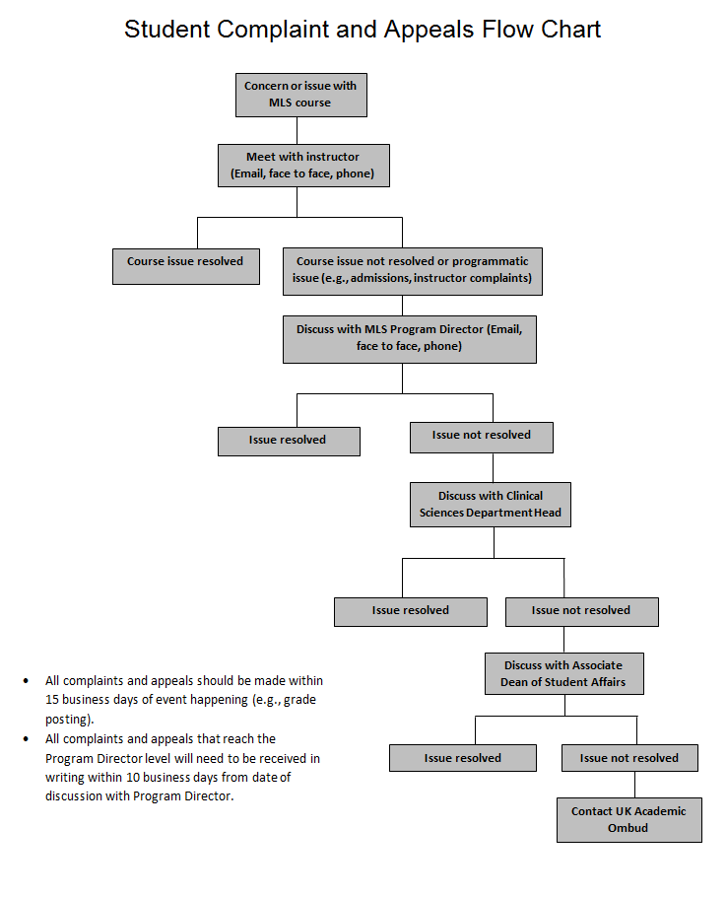
D. STUDENT COMPLAINTS AND APPEALS
To learn more about the role of the UK Academic Ombud, go to http://www.uky.edu/Ombud/ForStudents_Grades.php.

E. ATTENDANCE POLICIES
Each MLS instructor will include in the course syllabus specific information about his or her attendance policy however the following is Program policy:

University of Kentucky ruling S.R. 5.2.4.2 defines the following as acceptable reasons for excused absences:
- serious illness;
- illness or death of immediate family member;
- University-related trips;
- major religious holidays;
- other circumstances you find to be “reasonable cause for nonattendance”.
Refer to S.R. 5.2.4.2 for more details on excused absences.

The MLS Program requires:
- Documentation of serious illness. Serious illness excludes colds, minor bacterial and viral infection/illnesses and seasonal allergies.
- Documentation of illness or death of family member
- Documentation of university related trip unless it is a MLS trip
- Absences due to major religious holiday must be brought to the attention of the faculty member prior to the absence

Students are expected to attend all lecture and laboratory sessions. If you CANNOT attend (regardless of whether it is excused or unexcused) you are expected to call or email the instructor or the MLS office PRIOR to the start of that class session. Sending a message through another student DOES NOT meet the requirement of notification.

The MLS programs DOES NOT allow students to make up laboratory sessions that are missed for unexcused reasons. Planning and preparation are done under the assumption that all students will be present. The MLS program and faculty does not have the time, samples, staffing or budget for make-up lab sessions. Material missed must be learned on your own and you may be penalized for absences.

Make up laboratory sessions for excused absences will be addressed by each faculty member and may involve additional laboratory sessions or making up missed session during regularly scheduled lab session.

If you arrive to lab later than 20 minutes after the start of lab and did not notify the instructor or MLS office prior to the start of the lab session, you will be asked to leave resulting in an unexcused absence.

Any student missing 20% of an entire lecture or laboratory course (unexcused absences) will automatically receive a “D” in the course regardless of calculated score.

Any student missing 20% of an entire lecture or laboratory course (excused absences) will be required to petition for a “W” or take an “I” in the course. (UK Senate rule 5.2.4.2 Excused Absences)

1. Making up Missed Work
Each MLS faculty member will define his/her own policy for making up missed work from an absence or late work in their syllabi. See above for information about missing laboratory sessions.

F. TARDINESS
Tardiness is defined as arriving 5 minutes or more after the official start time of class. Three tardies constitute an unexcused absence. Each faculty member will define additional consequences of tardiness in their syllabi.

G. AFFECTIVE BEHAVIORS
While enrolled in the MLS Program, both on campus and at clinical affiliates, the student will:

A. Demonstrate reliability by:
- Arriving to lecture and laboratory session on time
- Being prepared for laboratory sessions
- Notifying instructors of absences
- Making plans to complete missed work/exams promptly
- Returning from breaks on time
B. Demonstrate professional work habits by:
- Maintaining clean work station
- Checking for proper specimen identification
- Completing work in time expected
- Documenting work in legible handwriting
- Demonstrating the ability to multi-task
- Adhering to dress code
- Adhering to lab safety policies
C. Demonstrates appropriate interpersonal skills by:
- Showing respect and concern when communicating with patients
- Showing respect to instructors and fellow classmates
- Working cooperatively in group situations
- Willing to assist others
- Communicating professionally with other health care personnel
- Respecting the confidentiality of patient information
D. Demonstrates responsibility by:
- Accepting responsibility for work produced
- Demonstrating an interest in learning
- Taking initiative
- Accepting responsibility for errors made
- Reacting to criticism in a mature manner

1. Laboratory/Lecture Affective Behaviors
Affective behaviors are evaluated twice a semester during your first year (fall and spring) in the MLS program, thus at mid-term and at the end of the semester. All MLS instructors, teaching that semester, will evaluate students’ affective behaviors. One comprehensive evaluation is then given to students.

Any “X” in the Never (1) or Sometimes (2) column indicates that this area needs improvement. The mid-term evaluation will not be graded; instead it should be used as a guide for improvement. The end of semester evaluation will be graded (total points out of a possible 80 points) and contributes to your overall grade in MLS 465 (fall) and MLS 469 (spring).

Please see the “Laboratory/Lecture Affective Behavior Evaluation” below.

Laboratory/Lecture Affective Behavior Evaluation

Student Name: ___________________________________ Date: ______________________

To the student: Affective behaviors are evaluated twice a semester during your first year (fall and spring) in the MLS program, thus at mid-term and at the end of the semester. All MLS instructors, teaching that semester, will evaluate students’ affective behavior. One comprehensive evaluation is then given to students.

Any “X” in the Never (1) or Sometimes (2) column indicates that this area needs improvement. The mid-term evaluation will not be graded; instead it should be used as a guide for improvement. The end of semester evaluation will be graded (total points out of a possible 80 points) and contributes to your overall grade in MLS 465 (fall) and MLS 469 (spring).

 | The student: | Never  1 | Some-times  2 | Usually  3 | Always  4
1 | Effectively and respectfully communicates with instructors and peers
2 | Demonstrates an interest in learning
3 | Arrives to laboratory and lecture sessions on time
4 | Has dependable attendance
5 | Comes to laboratory and lecture sessions prepared
6 | Adheres to all laboratory safety policies
7 | Adheres to dress code
8 | Completes work within the specified time frame
9 | Demonstrates the ability to work independently
10 | Demonstrates the ability to work as an effective team member
11 | Demonstrates carefulness and awareness of the need for accuracy and precision
12 | Takes initiative to help others when appropriate
13 | Strives to improve organization skills
14 | Demonstrates ability to multi-task as necessary
15 | Demonstrates ability to trouble shoot and/or problem solve as necessary
16 | Accepts responsibility for cleaning up workstation and general lab areas
17 | Submits legible handwritten documents
18 | Accepts responsibility for own actions
19 | Adheres to confidentiality and HIPPA rules
20 | Practices good personal hygiene habits
Comments (required for any score of 2 or less):

2. Practicum Rotation Affective Behaviors
Affective behaviors are evaluated while students are in clinical practicum rotations. More details and the evaluation form will be provided in the MLS Clinical Practicum Handbook.

H. GRADUATION AND PINNING CEREMONY
A formal pinning ceremony for awarding graduates with a Medical Laboratory Science pin, indicating completion of the MLS Program will be held prior to the University of Kentucky commencement ceremony. All graduates are required to attend. The date, time and place will be announced during the Fall Semester of your second year.

The pinning ceremony will consist of two student speakers, one from the Hazard campus and one from the Lexington campus. Students may nominate themselves to be the student speaker and MLS faculty/staff members may also nominate students. The MLS faculty will select the student speakers from the pool of nominees.

Information regarding the University of Kentucky’s commencement ceremony can be found at: http://www.uky.edu/Commencement/

I. CERTIFYING EXAM
Medical Laboratory Scientists are certified through the Board of Certification (BOC) of the American Society of Clinical Pathology.

In order to be eligible for the examination at the Medical Laboratory Scientist level, you must possess a bachelor’s degree and complete a professional practicum accredited by the National Accrediting Agency for Clinical Laboratory Sciences (NAACLS). When you complete the MLS program at UK and have satisfied bachelor’s degree requirements, you are then eligible to take the BOC certifying exam.

The granting of the degree is not contingent upon passing any type of external certification or licensure examination.

Information (including exam fees) about the BOC certifying exam can be found at: http://www.ascp.org/Board-of-Certification/GetCertified

The MLS Program Director or Clinical Coordinator will discuss the process of applying for the national certification examination during the fall semester of your second year. It is your responsibility to complete the application process and schedule your examination. It is also your responsibility to pay to take the exam.

More information about the BOC exam will be provided in the MLS Clinical Practicum Handbook.

J. TEACH OUT POLICIES

1. Permanent Closure
In the event that the Medical Laboratory Science Program at the University of Kentucky (Hazard and Lexington campuses) would close permanently, the Program would no longer accept new students. Those currently enrolled in MLS courses would be allowed to complete the necessary courses to finish his or her degree.

In the event the Medical Laboratory Science Program at one, of the two, campuses would close permanently, the Program would no longer accept new students at the closing campus. Those currently enrolled in MLS courses would either be allowed to complete the necessary courses to finish his or her degree and/or will be accommodated at the other campus.

In the event of a permeant closure situation, a teach out plan must be developed and submitted to NAACLS within 30 days of the official announcement of the closure of the program.

2. Temporary Closure
In the event that a catastrophic event occurs that results in an interruption of the university’s ability to operate the MLS Program’s campuses, the Program would attempt to continue courses through the Canvas learning management system. Attempts to continue student laboratory courses include either virtual laboratories or relocation to clinical affiliates unaffected by the event.

In the event that a catastrophic event occurs that results in an interruption of the university’s ability to operate one campus of the MLS Program, the Program would attempt to relocate the lecture and student laboratory courses to the other campus.

In the event that a catastrophic event interrupts the operation of one or more of the MLS Program’s clinical affiliates, steps will be taken to place students at other functioning clinical sites to finish the remainder of their training.

K. COLLEGE OF HEALTH SCIENCES UNDERGRADUATE ACADEMIC PROBATION AND SUSPENSION POLICY
Please refer to Appendix C documents for information regarding the CHS academic probation and suspension policy.

SECTION IV: CLINICAL EXPERIENCE

A. CLINICAL PRACTICUM HANDBOOK
The MLS Clinical Practicum Handbook includes specific details about the clinical practicum rotations. A copy of the most recent edition of this publication will be provided prior to entering practicum rotations in the summer.

B. AFFILIATES
Disclaimer: The number of student rotation slots at each affiliated clinical site varies yearly based on the needs of individual hospitals. The clinical practicum site may decide not to take students if they are experiencing major changes (e.g., remodeling, mergers). In addition, the clinical practicum site has the right to accept or reject any student.

The MLS program has affiliation agreements with the clinical practicum sites listed below. The program cannot send a student to a facility with which there is no affiliation agreement.

The Lexington affiliated clinical sites, at time of publication, are:
Name | Location
U.K. Healthcare Chandler Medical Center | Lexington, KY
Baptist Health (Central Baptist) Lexington | Lexington, KY
St. Joseph Hospital (KentuckyOne) | Lexington, KY
St. Joseph East (KentuckyOne) | Lexington, KY
VA Medical Center | Lexington, KY
Lexington Clinic | Lexington, KY
Clark Regional Medical Center | Winchester, KY
St. Joseph Mount Sterling (KentuckyOne) | Mt. Sterling, KY
King’s Daughter Medical Center | Ashland, KY
Ephraim McDowell Regional Medical Center | Danville, KY
St. Claire Medical Center | Morehead, KY
Frankfort Regional Medical Center | Frankfort, KY
Hardin Memorial Hospital | Elizabethtown, KY
Norton Hospital | Louisville, KY
Baptist Health Paducah | Paducah, KY
Lake Cumberland Regional Hospital | Somerset, KY
Baptist Health Madisonville | Madisonville, KY
Taylor Regional Hospital | Campbellsville, KY
Mid-America Clinical Laboratories | Indianapolis, IN

The Hazard affiliated clinical sites, at time of publication, are:
Name | Location
Hazard Regional Medical Center | Hazard, KY
Appalachian Regional Healthcare Reference Laboratory | Hazard, KY
Highlands Regional Medical Center | Prestonsburg, KY
Pikeville Medical Center | Pikeville, KY
Whitesburg ARH Hospital | Whitesburg, KY
Baptist Health Corbin | Corbin, KY
Kentucky River Medical Center | Jackson, KY

Note: Clinical practicum sites are divided by campus however this is not obligatory. Thus if you prefer a site designated for the other campus please let us know and it might be possible to accommodate your request.

C. ASSIGNMENT
You are eligible for clinical placement when you are enrolled in the MLS Program and have taken the required courses and earned satisfactory grades. (See MLS Program Probation Policy.)

Out of courtesy, students will be asked to rank their ideal clinical practicum site geographic location (this may be done more than once). From this information, the practicum coordinator and program director will then match the student to a clinical practicum site. Students will be matched in the spring semester. Practicum rotations begin in June with specific dates provided during the orientation.

DISCLAIMERS:
  - Every effort is made to match students to their ideal clinical practicum site geographic location however if that is not possible you will be placed in an alternate site. The alternate site may require relocation or travel. The MLS Program guarantees students placement in a practicum site but location is ultimately determined by the practicum coordinator in consultation with the program director.
  - In addition, due to a limited number of sites in the campus area (Hazard/Lexington) we cannot place ALL students in the immediate campus area (Hazard/Lexington). Thus, some students will have to relocate or travel to their clinical practicum site.
  - Although we strive to place a student at 1 site for all rotations, it is sometimes necessary for student to be assigned to 2, possibly 3 sites, to achieve completion of all rotations. Assignment to multiple sites will require travel and/or relocation.
  - On occasion, due to last minute requests made by the practicum site, assignments must be changed close to the practicum start date. Unfortunately, this is not in the control of the practicum coordinator or program director. In these instances, assignment will be made based on any open practicum slots therefore relocation or travel is likely.

D. SERVICE WORK
The following is the UK MLS service work policy for students and is applicable during practicum rotations. Sometimes students are offered paid positions at their practicum rotation site and this is entirely voluntary for both parties. The laboratory does not have to offer paid positions to students nor does the student have to accept an employment offer if not interested.

If a student does accept a paid position within the same laboratory as performing practicum rotations, then the paid hours or work is known as service work. Service (or paid) hours and practicum rotation hours must be separated by the employer and student.
No UK MLS student may engage in service hours while present as a student completing practicum rotation hours. Service hours may be completed prior to or after practicum rotation hours.

If you are employed by the practicum rotation site, you must be compensated for your work and follow the employment policies of that facility. While you are on service (or paid) hours, you are not covered by the University of Kentucky’s liability insurance as this only applies to practicum rotation hours.

Proposal to Institute a College of Health Sciences Undergraduate Academic Probation and Suspension Policy
The College of Health Sciences (CHS) is a selective admissions college, with several undergraduate programs all requiring students to obtain a minimum grade point average (GPA) to be eligible for admission. While many students desire to obtain CHS degrees from one of our undergraduate programs, some fall short academically. With the increasing emphasis on academic success, progression toward a degree, and retention at all levels, it is important for students who are not able to overcome academic challenges in the coursework in each CHS major to select another major in which they can succeed in a more timely manner. Thus, this proposal addresses the need to help steer students toward academic success as early as possible.

Undergraduate Program Probation

A College of Health Sciences (CHS) student is placed on CHS probation if the student earns a grade-point average (GPA) of less than 2.0 in any given term (semester), even if the student's cumulative UK GPA is 2.0 or higher. Students on CHS probation are required to meet with their academic advisor and develop a remediation plan.
There are 2 possible scenarios for the student placed under probation/remediation:

- Scenario 1: The student successfully completes the remediation plan, earning a semester GPA of 2.0 or higher AND earns at least a grade of "C" (2.0) in each course required for the major (pre-requisite courses and major courses).
o At this point, the student is removed from CHS probation and regains good standing status in the College.
- Scenario 2: The student does not successfully complete the remediation plan and fails to meet any or all requirements for removal of probation.

Undergraduate Program Suspension from the College of Health Sciences

A CHS student may be suspended for any of the following reasons:

- The student fails to successfully complete a probationary remediation plan.
- The student earns a GPA of less than 2.0 in any given semester AND has a cumulative UK GPA below 2.0, including the first semester at the University of Kentucky.
- The student earns less than a 1.5 GPA in any semester.

In all cases, the suspended student will be required to select a new major outside of the CHS.

Note: If a student admitted to a selective admissions program fails to meet the programs academic standards, the programs policies for probation and suspension, if more stringent, supersede the College’s Academic Probation and Suspension policy.

Removal from Suspension

A student suspended from the College of Health Sciences may petition for re-admittance only if he/she has obtained a cumulative GPA in accordance with the respective program’s admission standards (see list below) and completed all pre-requisite courses and major courses with a “C” or better. Students who fail a major course and are placed on suspension must petition the program to repeat the major course while on suspension. Students have the opportunity to use the three repeat options that the University allows in order to facilitate the improved GPA required and individual course grades. In accordance with the University policy, courses may only be repeated one time. Any additional retakes will not count if the second attempt does not result in the “C” or better needed for a pre-requisite or major course.

Program | GPA minimum
Clinical Leadership and Management | 2.0
Communication Sciences and Disorders | 3.0
Human Health Sciences | 3.0
Medical Laboratory Sciences | 2.5

It is important to note that our college has high admissions standards for each of our selective admissions programs. Thus, this is taken into consideration when making readmission decisions in the College of Health Sciences.

Student Affairs Academic Standing Sub-Committee

An Academic Standing Committee will be formed and comprised of a representative from each of the undergraduate programs, the Assistant Dean of Student Affairs, Academic Affairs Chairperson, and an academic advisor. The Assistant Dean of Student Affairs will serve as the chair of this committee. The Academic Standing Committee will meet regarding suspension and probationary status once a semester after final grades are posted. The committee will convene to hear appeals at least twice a year and more often as needed.

Appeals

Students who are placed on suspension may appeal their status to the College of Health Sciences Student Affairs Academic Standing Sub-Committee. The student must submit documentation regarding any circumstances that influenced their academic performance for review by the committee. This includes, but is not limited to, a personal statement explaining their situation and how they plan to rectify this in the future. Students are welcome to submit letters of support

from individuals who have knowledge about their situation and can provide insight into how the student is addressing the issue(s).
All appeals must be submitted electronically by January 10 or July 1 to the Office of Student Affairs. While students are in the appeals process, he/she may maintain their current major in the College of Health Sciences.

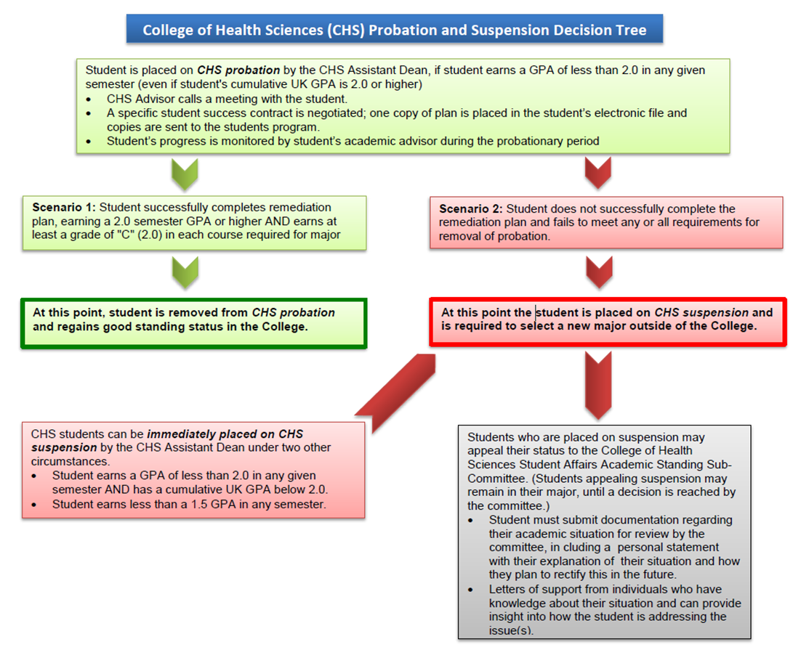

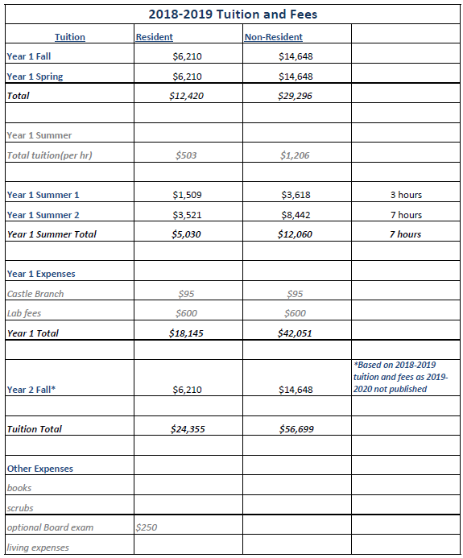
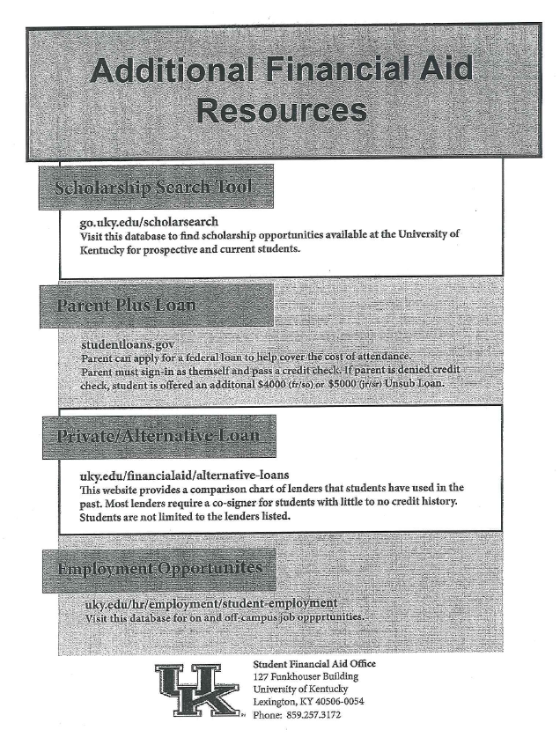

APPLICATION FOR MLS PROGRAM STUDENT LOAN

DEADLINE: Loan application deadline is April 1st of the spring semester.

INSTRUCTIONS: Complete form with attached narrative and submit to MLS administrative assistant by deadline above.

PERSONAL INFORMATION

Student Name: _____________________________________________________________

Loan Amount Requested: $________________

FINANCIAL INFORMATION
The following expense categories are the ones that will be considered for funding. Please itemize your expenses only for the period for which the request is being made.

EXPENSES INCOME
Tuition and Fees $__________ Parent/Guardian $___________
Housing $__________ Spouse $___________
Meals $__________ Savings $___________
Books/Supplies $__________ Social Security $___________
Health Insurance $__________ Veteran’s Benefits $___________
Employment $___________
Other: ____________ $___________

Total Expenses $_______________ Total Income Resources $___________
ADDITIONAL FINANCIAL AID

Scholarships (List) Amount
________________________________________ ______________
________________________________________ ______________
________________________________________ ______________

Grants/Fellowships (List) Amount
________________________________________ ______________
_______________________________________ ______________
_______________________________________ ______________

Loans (List) Amount
_______________________________________ ______________
_______________________________________ ______________
_______________________________________ ______________

PERSONAL NARRATIVE
Please attach a typed narrative to this application.

SIGNATURE______________________________________ DATE____________

Medical Laboratory Science Student Handbook

Statements of Understanding

I have access to a copy of the current Medical Laboratory Science Student Handbook.

Any questions I asked regarding the contents in the Student Handbook were answered to my satisfaction.

I understand that there are academic requirements, background check, medical insurance, safety trainings, and immunization requirements for entry into the Program and/or once classes begin.

I have read the technical standards or essential requirements of this profession and believe I can meet them.

I have read, understood, and agree to abide by the general laboratory policies.

I have read, understood, and agree to abide by the academic policies regarding progression in the Program.

I have read, understood, and agree to abide by the academic policies regarding attendance and tardiness.

I have read, understood and accept the process for assignment of clinical practicum rotation sites.

Student Name
(please print)_____________________________________________________________

Student Signature _________________________________________________________

Date ________________________________________________

Permission to Use Photos

I, __________________________________________, hereby give the faculty and staff of the Medical Laboratory Science Program, College of Health Sciences, University of Kentucky, permission to publish and use pictures of me on the MLS website, Facebook, and/or in Program recruitment materials.

_____________________________________ _____________________________
Signature Date

