PRACTICUM ROTATION

MEDICAL LABORATORY SCIENCE STUDENT HANDBOOK FOR PRACTICUM ROTATIONS

TABLE OF CONTENTS

GENERAL INFORMATION
MLS Clinical Coordinator’s Information Page 3
Course Information Page 4
Practicum Site Contact Information 5
Practicum Goals 8
PRACTICUM POLICIES 10
Practicum Rotation Assignment and Placement 11
Hours 11
Attendance 11
Personal Appearance 13
Cell Phones and Smart Phones 13
Professional conduct and Ethics 13
Confidentiality 16
LIS/HIS 17
Medical records and Patient Data 17
Health Insurance 17
Lines of Communication 17
Criminal Background Checks/Drug Testing 17
Severe Weather 18
Safety Policies 18
Student Immunization Requirements 18
On Site Orientation 19
Practicum Progression 20
Service Work 20
PRACTICUM ASSESSMENT 21
Trajecys 22
Methods of Evaluation 28
Definition of Evaluation Terms 30
Practicum Checklist Example 31
Affective Behavior Evaluation and Technical Performance Form 34
Daily Log Sample Entries 36
Grading 38
Deadlines (for Document Submission) 39
Online Evaluations 40
RESPONSIBILITES 41
Student 42
Clinical Supervisor/Preceptor 43
Clinical Coordinator 43
APPENDIX A
Policy on Education Exposure to Blood Borne Pathogens 44
STATEMENTS OF UNDERSTANDING 51

MLS Clinical Coordinator’s Information Page

Students | Clinical Coordinator | Address | Phone Number | Email | Fax Number
Lexington | Mrs. Stacy Gabbard | Room 126C Wethington Building  900 South Limestone Street  Lexington, KY 40536-0200 | 859-218-0850 | stacy.gabbard@uky.edu | 859 323-8957
Hazard | Mrs. Bianna Music | 750 Morton Blvd.  Hazard. KY 41701 | 859-218-3680 | biannamusic@uky.edu | 606-439-0766

course Information Page

COURSE NUMBER | NAME | CREDIT
MLS 480 | Clinical Hematology Practicum | 4
MLS 481 | Clinical Microbiology Practicum | 4
MLS 482 | Clinical Chemistry Practicum | 4
MLS 483 | Immunohematology Practicum | 4

NAME  PRACTICUM SITE CONTACT INFORMATION – Lexington campus | HOSPITAL | PHONE NUMBER | LOCATION | EMAIL
Evelyn Spalding | Baptist Health Lexington  (Central Baptist)  Laboratory Manager | (859) 260-5139 | Lexington | evelyn.spalding@BHSI.com
Nancy Walker | Lexington Clinic  Laboratory Manager | (859) 258-4143 | (South Broadway) Lexington | Nwalk@lexclin.com
Jane Eubanks | Saint Joseph East (KentuckyOne Health)  Laboratory Manager | (859) 967-5702 | Lexington | eubaja@sjhlex.org
Leola Hampton | U.K. Healthcare Chandler Medical Center  Laboratory Quality Management Director | (859) 323-0043 | Lexington | leola.hampton@uky.edu  Randi.ray@uky.edu
Vicki Richardson | Lexington Veterans Affairs Medical Center  Pathology and Laboratory Service Quality Improvement Manager | (859) 233-4511 ext. 5627 | Lexington | Vicki.richardson2@va.gov
Elaine Mattingly | St. Joseph Hospital  Blood Bank Supervisor | 859-313-1500 | Lexington | suemattingly@sjhlex.org
Jena Flood | Baptist Health Paducah  Laboratory Director | (270)415-7699 | Paducah | Jena.flood@BHSI.com
Carole Hackett | Frankfort Regional Medical Center  Laboratory Manager | (502) 226-7578 | Frankfort | Carole.hackett@Hcahealthcare.com
Ann Adams | Ephraim McDowell Regional Medical Center  Laboratory Facilitator | (859)-239-2240 | Danville | aadams@emrmc.org
Amy Kenney | Clark Regional Medical Center  Director of Laboratory Services | (859)737-8355 | Winchester | Amy.Kenney@LPNT.net
Brenda Davis | Norton Hospital (Norton Healthcare)  Laboratory Clinical Coordinator | 502-629-7961 | Louisville | Brenda.davis@nortonhealthcare.org
Karen Ringenberg | Norton Hospital (Brownsboro Location)  Laboratory Manager | 502-446-8050 | Louisville | Karen.ringenberg@nortonhealthcare.org
Donna Fannin | St. Claire Regional Medical Center  Laboratory Manager | (606) 783-6721 | Morehead | donna.fannin@st-claire.org
Shawn Boggs | Kings Daughter Medical Center | (606)408-0292 | Ashland | shawn.boggs@kdmc.kdhs.us
Charles Hayko  Patrick Covault | Hardin Memorial Hospital Laboratory Manager  Laboratory Supervisor | (270) 706-1653 | Elizabethtown | Chayko@hmh.net  pcovault@hmh.net
Carole Juniet | The Christ Hospital | (513)585-1406 | Cincinnati | Carol.Juniet@thechristhospital.com
Steven Dudley | Mid- America Clinical Laboratories | (317)803-0770 | Indiana | sldudley@macl1.com
Grant Bennett | Taylor Regional Hospital | (270)789-5802 | Taylorsville | gabennett@trhosp.org

NAME | HOSPITAL | PHONE NUMBER | LOCATION | EMAIL
LouAnn Maggard | Hazard ARH Regional Medical Center  Lab Manager | (606) 439-6665 | Hazard | lmaggard@arh.org
Martha Potter | Appalachian Regional Healthcare Reference Lab  Lab Administrator | (606) 487-7452 | Hazard | mpotter@arh.org
LeAnn Hubbard  Paula Keathley | Pikeville Medical Center  Director of Laboratory Science | (606) 437-3500  Ext 3260 | Pikeville | Leann.Hubbard@pikevillehospital.org  Paula.keathley@pikevillehospital.org
Scott Mullins | Highlands Regional Medical Center  Laboratory/Respiratory Manager | (606) 889-3208 | Prestonsburg | scottm@hrmc.org
Regina Antrim  Doris Stringer | Lake Cumberland Regional Hospital  Laboratory Manager | 606-678-3160 | Somerset | Regina.Antrim@LPNT.net  Doris.Stringer@lpnt.net
Tiffany Combs | Kentucky River Medical Center  Director of Laboratory Services | (606) 666-6445 | Jackson | Tiffany_Combs@quorumhealth.com
Martha Smith | Manchester Memorial Hospital | (606) 598-5401 Ext 3140 | Manchester | Martha.smith@shss.org
Allison Peppi | McDowell Regional Medical Center | (606) 377-3449 | McDowell | apeppi@arh.org
Greg Jarvis | Baptist Health Corbin | (606) 523-8677 | Corbin | gjarvis@bhsi.com
Kim Williams | Flaget Memorial Hospital | (502)350-5117 | Bardstown | kimberlywilliams@sjhlex.org
Sherie Caudill | Whitesburg ARH | (606) 633-3516 | Whitesburg | smcaudill@arh.org
PRACTICUM SITE CONTACT INFORMATION – Hazard campus

PRACTICUM GOALS

During the clinical practicums the medical laboratory science student will:

- Perform assigned tasks under the direction of a practicum preceptor according to established policies and procedures.

- Develop skills in laboratory tasks by:

  - performing test and related tasks
  - operating and maintaining instruments
  - evaluating acceptability of laboratory data
  - correlating patient laboratory data
  - evaluating and comparing procedures and methods
  - reporting patient values according to standard procedures
  - obtaining and evaluating acceptability of patient specimens

- Demonstrate skill development after initial instruction and practice by:

  - completing checklist tasks according to written criteria
  - recording clinical practicum progress in a daily log book
  - completing unknowns, if applicable

- Enhance knowledge by completing assigned reading, study materials and review questions for each unit. Topics will include:

  - pathophysiologic evaluation and correlation of data
  - clinical tests
    - theory and principle
    - performance limitations
    - clinical significance
    - normal values and reporting criteria
    - quality control
    - specimen requirements
  - safety considerations
  - principle of operation, maintenance, and troubleshooting procedures for instruments

- Demonstrate cognitive knowledge by:

  - maintaining a daily log of practicum activities as directed
  - responding correctly to verbal questions

- Demonstrate professional attributes including, but not limited to:

  - honesty and integrity
  - respect for persons and patient confidentiality
  - awareness of limitations
  - willingness to comply with safety regulations
  - willingness to accept responsibility for own actions
  - adherence to hospital and laboratory policies and procedures
  - punctuality and being dependable
  - being collegial and cooperative
  - responsible to patient and community
  - concerned for the welfare of patients

PRACTICUM POLICIES

PRACTICUM ROTATION ASSIGNMENT AND PLACEMENT
You are eligible for clinical placement when you are enrolled in the MLS Program and have taken the required courses and earned satisfactory grades. (See MLS Program Probation Policy.)

Students will be asked to rank their ideal clinical practicum site (this may be done more than once). From this information, the clinical coordinator and program director will then match the student to a clinical practicum site. Students will be matched in the spring semester. Practicum rotations begin in June with specific dates provided during the orientation.

ASSIGNMENT DISCLAIMERS: Every effort is made to match students to their ideal clinical practicum site. However, if that is not possible you may be placed in an alternate site. The alternate site may require relocation or travel.

In addition, due to a limited number of sites in the campus area (Hazard/Lexington) we cannot place ALL students in the immediate campus area (Hazard/Lexington). Thus, some students will have to relocate or travel to their clinical practicum site.

Although we strive to place a student at 1 site for all rotations, it is sometimes necessary for student to be assigned to 2, possibly 3 sites, to achieve completion of all rotations. Assignment to multiple sites will require travel and/or relocation.

WHEN CLINICAL ROTATION CANNOT BE GUARANTEED: The UK MLS Program provides clinical placement for all MLS students from mid to late June through mid to late November. In the unlikely event that a clinical practicum site is, at the last minute, unable to fulfill their obligation of training a student then every effort will be made to find another practicum site. (Fortunately, there is an almost 4 week cushion between the “typical” end date of practicums and graduation thus a delayed start is possible.) In the event that an alternative practicum site cannot be found within a reasonable time frame the student might be delayed one semester in graduation.

PRACTICUM HOURS
Specific times for arrival and departure will be determined by the clinical site and specific department practicum preceptors. The student should note that the time for arrival will vary by clinical site and rotation area.

During each work day, one half hour lunch will be scheduled by the practicum preceptor. Breaks will also be determined and scheduled by the practicum preceptor.

ATTENDANCE
Attendance in the clinical practicum for ALL of the scheduled days is required. Primarily, attendance is Monday through Friday, for 8 hours, during day shift hours (see Hours section above).(Occasionally, clinical sites might request that students attend four days for 10 hours per day or three days for 12 hours per day to parallel their staffing schedule. Students may expect to spend roughly 40 hours per week at the clinical site. Students are expected to seek out opportunities to learn, to gain experience, and to assist scientists/technicians when appropriate. When checklists are completed, students must continue to make the most of their educational experience throughout the required schedule for each rotation. Please note required numbers of attempts on the checklist are minimal. You need to continue practicing to become proficient so take advantage of the opportunities to do so.

Absences
The student is expected to adhere to the absence (and tardiness) policy that is in place at the assigned clinical site. Excused absences consist of serious sickness, bereavement of immediate family, academic functions, or other special circumstances such as court appearance, jury duty, and childbirth.

*The student will also be allowed two clinical interviews during practicum rotations. Documentation must be proved to the clinical practicum coordinator.

In the event of a necessary absence, the practicum preceptor/clinical supervisor and the MLS clinical coordinator MUST be informed at least 30 minutes prior to the scheduled time to report on the day the student will be absent. Each day the student must “call-in”, even if it was predetermined the previous day. It is the responsibility of the student to contact the appropriate individual(s) at each institution (university and hospital). Lack of notification will automatically result in an unexcused absence. Any student with more than 3 unexcused absences may be dropped from the clinical rotation.

Students should not be tardy or absent from practicums to study for tests or complete other course work requirements, sick pets, oversleeping, routine medical/dental appointments, etc.

Any request by a student to be excused from the practicum should be verified by the practicum preceptor/lab supervisor and with the UK MLS clinical coordinator.

If a student is dismissed from a practicum due to absences, the student will fail the practicum which will result in dismissal from the clinical program.

Make Up Days
Excused and unexcused absences must be made up. The clinical site has discretion as to when this day or days will be made up. In the event that time cannot be made up by the end of the semester, the student will receive an “Incomplete” and will be responsible for making up the days during the following semester at the convenience of the clinical site.

Tardiness
The student is expected to report to his/her assigned department and be ready to work by the scheduled time. Tardiness is not permissible. Tardiness is defined as greater than 7 minutes past the scheduled starting time or as leaving prior to being dismissed from the site. Three unexcused tardy incidents will be counted as an unexcused absence, and a make-up day will be required. If the student expects to be late by 15 or more minutes, then he/she must contact the practicum preceptor. Failure to notify appropriate personnel or failure to make-up missed clinical days may result in failure to satisfactorily complete the course.

PERSONAL APPEARANCE
- Attire
  - Students should be aware that clinical affiliates may choose to enforce a stricter dress code and/or behavior code and students must follow this policy. Students not conforming to these codes may not be accepted at the clinical site(s) and, consequently, may jeopardize their continued enrollment and progress in the program.
  - Scrubs are recommended and if not required then attire should be business casual.
  - Sweatshirts nor jackets are to be worn over top of scrubs. If temperature is an issue, the student should dress in layers.
  - Denim pants and shorts should not be worn at any time.
  - Caps and hats (including knit hats or toboggans) should not be worn at any time.
  - Uniforms, laboratory coats, and shoes will be clean, neat, and in good condition at all times.
  - Visible tattoos need to be covered at all times (if possible) and no facial piercings can be worn while during practicums.
  - Identification badges may be provided by each site. If identification badges are not provided, the student shall wear their UK MLS Student identification badge. They are to be worn in plain view at all times while on the premises of the clinical site.
- Personal Hygiene
  - All students will bathe regularly and wear an effective deodorant. Strong aromatic scents should not be used. Conservative hair-style and color and fingernail length is required. All long hair will be pulled back and fastened.

CELL PHONES AND SMART PHONES
Students are NOT to receive or place phone calls, text, surf the web, or check email on their personal phone during clinical hours except during breaks. Exceptions will be made for emergencies and with the consent of the preceptor.

PROFESSIONAL CONDUCT AND ETHICS
Student will conduct themselves in a professional manner at all times during the Clinical Practicum. SEE Healthcare College Code of Student Professional Conduct and ASCLS Code of Ethics below. Both apply to MLS student while in practicum rotations. Specific conduct codes as defined in each institution’s policy manual will be adhered to while at the site as well.

Health Care Colleges Code of Student Professional Conduct
The student will be required to follow the Health Care Colleges Code of Student Professional Conduct.

ARTICLE 1: INTRODUCTION
Rationale
The credibility of a health care professional is based, to a large extent, on maintaining a high degree of trust between the professional and the individuals he or she serves. Each health profession has a code of professional conduct administered by a professional organization or regulatory agency that prescribes and imposes high standards of conduct and principles of professionalism upon its members. Students must understand and adhere to these standards during their education in preparation for careers in which they must conduct themselves in the manner expected by their profession. Consequently, students in the health care colleges have a particular obligation to conduct themselves at all times in a manner that reflects appropriate professional moral and ethical character.

Applicability
The purpose of the HCC Code is to provide a professional behavior code that applies uniformly to all students enrolled in a degree program, leading ultimately to a profession requiring licensure or certification, offered by any of the health care colleges (“HCC students”). The health care colleges are: Dentistry, Health Sciences, Medicine, Nursing, Pharmacy, and Public Health.

ARTICLE 2: STANDARDS
A HCC student shall be expected to adhere to accepted standards of professional practice.

All HCC students must possess the qualities of appropriate professional moral and ethical character. Each student must apply these standards to his or her academic career as well as his or her professional career. A student's continued enrollment shall depend on the student's ability to adhere to recognized standards of professional practice and conduct. The standards are drawn from the duly legislated practice acts of the professions that have educational programs in the health care colleges of the University.

Violation of one or more of the standards shall be sufficient grounds for the dean of the appropriate health care college to initiate a review of the status of the student's continued enrollment in courses or programs of the college.

ARTICLE 3: PROHIBITED CONDUCT
This Article summarizes a representative, but non-comprehensive, list of violations of this HCC Code that are punishable, disciplinary offenses. The list includes items specific to the training programs of the health care colleges as well as those in the UKCSC. Some overlap among items is to be expected. At a minimum, health care college students shall not:

- Commit any offenses enumerated under the UKCSC to the extent that the violation reflects adversely on the student’s professional moral and ethical character;

- Misappropriate or illegally use drugs or other pharmacologically active agents;

- Engage in any behavior that may endanger clients, patients, or the public, including failure to carry out the appropriate or assigned duties, particularly when such failure may endanger the health or well-being of a patient or client, or treatment is dispensed without appropriate faculty supervision;

- Engage in behavior or action that deceives, defrauds, or harms the public or the public’s perception of the profession;

- Falsify or, through negligence, make incorrect entries or failing to make essential entries in health records;

- Deliberately deceive a patient or client through failure of the HCC student to disclose his or her student’s status unequivocally to the patient;

- Fail to maintain client or patient confidentiality including failure to follow the Health Insurance Portability and Accountability Act (HIPAA) standards;

- Obtain any fee or compensation by fraud or misrepresentation;

- Engage in any course of conduct, act, or omission that would be considered unprofessional conduct as a basis for discipline under the professional standards recognized by the licensing, certifying, or professional association or agency of the health care college student's intended profession for which the health care college student is in training;

- Fail to report a felony conviction pursuant to Article 4 in this HCC Code.

To access the entire Health Care Colleges Code of Student Professional Conduct (HCC Code): http://www.uky.edu/regs/files/HCCcode.pdf

As students that are enrolled in a program of professional study, all students are expected to abide by professional conduct standards. It is expected that each student will adopt the Code of Ethics of their profession and maintain a demeanor appropriate to the Code at all times.

ASCLS Code of Ethics
The student will be required to follow the principles and standards set forth by the American Society for Clinical Laboratory Science (ASCLS).

I. Duty to the Patient:

Clinical laboratory professionals are accountable for the quality and integrity of the laboratory services they provide. This obligation includes maintaining individual competence in judgment and performance and striving to safeguard the patient from incompetent or illegal practice by others.

Clinical laboratory professionals maintain high standards of practice. They exercise sound judgment in establishing, performing and evaluating laboratory testing.

Clinical laboratory professionals maintain strict confidentiality of patient information and test results. They safeguard the dignity and privacy of patients and provide accurate information to other health care professionals about the services they provide.

II. Duty to Colleagues and the Profession:

Clinical laboratory professionals uphold and maintain the dignity and respect of our profession and strive to maintain a reputation of honesty, integrity and reliability. They contribute to the advancement of the profession by improving the body of knowledge, adopting scientific advances that benefit the patient, maintaining high standards of practice and education, and seeking fair socioeconomic working conditions for members of the profession.

Clinical laboratory professionals actively strive to establish cooperative and respectful working relationships with other health care professionals with the primary objective of ensuring a high standard of care for the patients they serve.

III. Duty to Society:

As practitioners of an autonomous profession, clinical laboratory professionals have the responsibility to contribute from their sphere of professional competence to the general well-being of the community.

Clinical laboratory professionals comply with relevant laws and regulations pertaining to the practice of clinical laboratory science and actively seek, within the dictates of their consciences, to change those which do not meet the high standards of care and practice to which the profession is committed.

Pledge to the Profession:

As a clinical laboratory professional, I strive to:
- Maintain and promote standards of excellence in performing and advancing the art and science of my profession.
- Preserve the dignity and privacy of others.
- Uphold and maintain the dignity and respect of our profession.
- Seek to establish cooperative and respectful working relationships with other health professionals.
- Contribute to the general well-being of the community.

I will actively demonstrate my commitment to these responsibilities throughout my professional life.

CONFIDENTIALITY
All patient and institutional information will be held in the strictest confidence at all times. The discussion of any patient information outside of the “classroom” setting is not permissible. Confidential information concerning the institution is not to be discussed with any unauthorized individuals.

Students may be required to sign a confidentiality statement at the hospitals. Violation of this policy and/or of other hospital or laboratory policies may result in the dismissal of the student from the hospital and clinical practicum course(s).

LABORATORY INFORMATION SYSTEM/HOSPITAL INFORMATION SYSTEM
Each facility has established policies and procedures relating to use of their respective hospital and/or laboratory information computer system. This includes the use of passwords, keys, or code words and patient data entry. Students should adhere to the protocol as communicated by the clinical supervisor and/or practicum preceptor. In some institutions, students are allowed the opportunity to learn the respective computer systems and report results under the direct supervision of the practicum preceptor.

MEDICAL RECORDS AND PATIENT DATA
Students have completed HIPPA training and will abide by HIPPA policies.

HEALTH INSURANCE
The clinical site does not provide for health coverage. Therefore, the student must obtain (and provide evidence of) appropriate coverage via insurance or other method. If an exposure or accident does occur, notify the practicum preceptor immediately. Each facility has established policies and protocols to adhere to in these circumstances in addition to the UK Policy on Educational Exposure to Blood Borne Pathogens. (See Appendix A.) The student may be responsible for payment of services such as testing and prophylactic treatment.

LINES OF COMMUNICATION
Under most circumstances, the student should communicate directly with the practicum preceptor. The practicum preceptor should communicate with the student and if necessary the MLS clinical coordinator may be notified by the practicum preceptor.

The laboratory manager or director should be approached only if a student’s action(s) have compromised the professional and/or policies of the laboratory or the safety of personnel and/or patients.

Any concern or problem may be brought to the attention of the appropriate UK MLS Clinical Coordinator after the student has followed the appropriate lines of communication.

CRIMINAL BACKGROUND CHECKS/DRUG TESTING
Some clinical affiliates of the MLS program may require criminal background checks and/or drug testing prior to acceptance of the student into clinical facilities. Students who do not pass the criminal background check and/or drug test may be unable to attend clinical courses and therefore may be unable to complete their program of study. Any fees or cost associated with background checks and/or drug testing are the responsibility of the student.

SEVERE WEATHER
During adverse weather conditions, students are expected to report to clinical rotation sites at the scheduled time as long as it is possible and safe to do so. This policy remains in effect regardless of UK announced delays and cancellation of classes. Practicum preceptors/lab managers must be contacted prior to the rotation start time to discuss any safety issues that may prevent a student’s ability to report to his/her assigned practicum.

SAFETY POLICIES
Occupational Safety and Health Administration (OSHA) requirements must be observed at all times for your safety and the safety of your peers and patients. Students must adhere to all safety and policy regulations in the student laboratory and in the clinical laboratory. Students who fail to follow safety and policy regulations will be asked to leave the facility. Students who fail to follow safety and policy regulations for a second time may be suspended from or dismissed from the program at the discretion of the program director. Students who are subject to penalty may request review by the MLS program director or the Dean of the College of Health Sciences.

STUDENT IMMUNIZATION REQUIREMENTS
All students must meet the immunization requirements including annual TB screening. Clinical sites will require documentation and it is the students’ responsibility to provide this, and maintain compliance of immunizations.
NOTE: Once Practicums start, UK MLS students will no longer pay the Student Health Fee (as all courses are now considered distance learning). Thus, if you get your TB screening at UHS, you will be charged. Most clinical sites will screen students free of charge or at a discounted rate. In addition, TB screens can be performed at the health department for a small fee.

Tuberculosis Screening
Baseline tuberculin screening must be performed before you are allowed into clinical settings. Documentation of a negative Mantoux PPD skin test within 6 weeks of initial enrollment must be provided to the Division on the first day of orientation. If you have a history of a positive TB skin test, please provide documentation of the skin test, a copy of the chest x-ray report if one was performed, and records of any medication that you have taken as a result of the positive skin test.

Rubella, Rubeola, Mumps
Proof of immunity to rubella, rubeola and mumps is required if you were born in 1957 or later. You may use one of the following for documentation:
- written physician documentation of two MMRs after one year of age, or
- written physician documentation of rubella, rubeola, and mumps diseases, or
- written medical documentation of positive rubella, rubeola, and mumps titers.
If you do not have documentation, you will be required to have the appropriate number (1or 2) of MMR vaccine(s).

Hepatitis B Vaccine
The Hepatitis B vaccine series is required. The complete series consists of 3 doses at 0, 1, and 6 months. If you have already received Hepatitis B vaccine or have had a Hepatitis B titer, please provide written documentation from a physician including dates the vaccine was given and/or the titer was performed.

Varicella Immunity
You must demonstrate immunity to varicella (chicken pox). If you have had chickenpox, you have met the requirement; no further documentation other than verbal history is necessary. If you have not had chickenpox, you will be required to have a varicella titer to determine whether you are immune. If the titer is negative, i.e. you have no immunity to chicken pox, you will be required to receive a dose of varicella vaccine and a second dose a month later. If you already have had a positive varicella titer or have received the vaccination series, you must provide written documentation from a physician stating the positive titer results or the dates the vaccine was given.

Proof of vaccinations may be required by the hospital clinical sites. Students not completing these requirements prior to practicum will not be allowed to start the practicum.

Seasonal Influenza
One dose of the seasonal influenza vaccine is required if a student is present in a UK HealthCare facility at least one day during designated influenza season (October 1 – March 31). This may be required by clinical practicum sites other than UK Healthcare.

ON-SITE ORIENTATION
An in-house orientation will be conducted by the Practicum preceptor or designee for each medical laboratory science student. In addition, the student may be required to attend a hospital/new employee orientation. The following items should be addressed:

- Identification badges.

- Parking assignments and/or permits.

- Lunch & Break hours and policies.

- Tours of the facility and laboratory. Availability of student workstations and library facilities will be identified

- Organizational Chart.

- Institutional and/or departmental policies. All policies pertaining to the Medical laboratory science student will be reviewed by the student and the practicum preceptor and/or instructor.

- Facility and Laboratory Safety. Some facilities will require the student to successfully pass a safety exam.

- Personnel. Introductions to practicum preceptors, pathologists, and other appropriate laboratory personnel.

- Laboratory Information Management. Review policies and procedures relating to access codes/passwords etc. on the LIS or HIS.

- Policies and procedures for medical records.

PRACTICUM PROGRESSION
Practicum progression relates to the continuation or progression as deemed by the practicum preceptors and site. Thus, if a practicum site requests that the UK MLS Clinical Coordinator remove a student from their laboratory due to unsatisfactory progress regardless of reason (e.g., lack of skill, lack of knowledge, unsatisfactory affective behavior) the student will be removed immediately as this only occurs when grievances are severe.

The UK MLS Clinical Coordinator will consult with the MLS Program Director and dependent upon the severity and validation of the grievances one of two actions will occur. 1) The practicum coordinator will attempt to find another practicum site for the student. If a second practicum site is obtained and the student is asked to be removed from the second site, the student will fail the practicum rotation thus resulting in dismissal from the Program. 2) Or grievances will be presented to the MLS faculty members and they will vote upon failing the student from the practicum or allowing the student to enter a second practicum site. Failure to complete a practicum rotation will result in dismissal from the program.

SERVICE WORK
The following is the UK MLS service work policy for students and is applicable during practicum rotations. Sometimes students are offered paid positions at their practicum rotation site and this is entirely voluntary for both parties. The laboratory does not have to offer paid positions to students nor does the student have to accept an employment offer if not interested.

If a student does accept a paid position within the same laboratory as performing practicum rotations, then the paid hours or work is known as service work. Service (or paid) hours and practicum rotation hours must be separated by the employer and student.
No UK MLS student may engage in service hours while present as a student completing practicum rotation hours. Service hours may be completed prior to or after practicum rotation hours.

If you are employed by the practicum rotation site, you must be compensated for your work and follow the employment policies of that facility. While you are on service (or paid) hours, you are not covered by the University of Kentucky’s liability insurance as this only applies to practicum rotation hours.

PRACTICUM ASSESSMENT

Assessments will be completed using the online software
Trajecsys Online Reporting System ® @ trajecsys.com

This system can be accessed from any computer or mobile device. The checklists are below for demonstration purposes only. You may provide your preceptor with a copy but the online version should be submitted for evaluation by the Medical Laboratory Science Program.

Student Menu and Instructions

The Trajecsys Student Menu was designed to be as user friendly as possible. This “cheat sheet” highlights the primary functions that most students will utilize on a daily basis.

Student Home Page
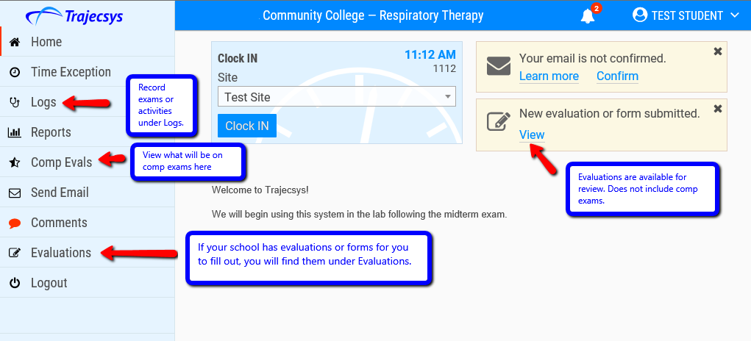

Clock In/Out - Students will clock in each day at their clinical site and clock out at the end of their shift. NOTE: This also may be done on the student’s smartphone; use phone browser to go to Trajecsys.com, log in, agree to share location (on phone); select site and click Clock In/Out button.

Reports - Students may access these items on the Reports menu page:
- Time summary
- Skill summary (compilation of log sheet entries and linked comp exam results; click comp date hyperlink to view item-by-item results)
- Evaluation results other than comps (use either the Evaluation Summaries or Completed Evals/Forms for evaluation results – same info in different formats)

Time Exception - Students will file a time exception if they did not clock in or out for some reason; typically students should use the clock in/out feature on the home page. However, if they forget, they must file a time exception for each missing clock record. If a student forgot to clock in AND out on the same day, the student must file two time exceptions - one for each missing clock record. If filing a time exception on a day that the student was absent, only one time exception is needed if “Absent” is selected as the reason.

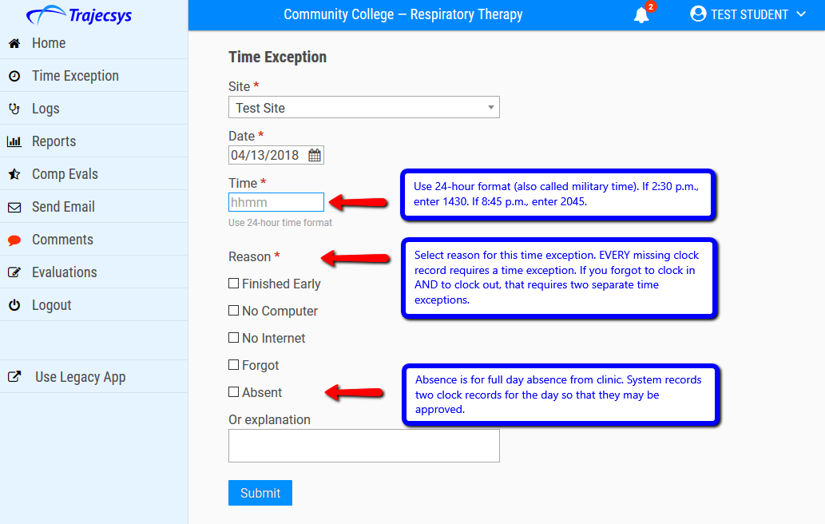

Daily Log Sheets - Students will complete the items on the Logs menu page. Each school may designate different items that are presented on this page. Your selections may differ from these:

- Date of exam or activity practiced
- Clinical site
- Key - ask program leader what to use for the key field
- Name of supervising employee (if not in list, click New and add full first and last names, then click Add)
- Click Add Logsheet; then select:
- Major study
- Procedure
- Time
- Comments
- Any other requested items

Evaluations - This menu item is used for evaluations or other forms that students will complete. (Note: not all programs will have this menu item.)

Troubleshooting - The User Guide can be accessed by clicking your name which will be located in the upper right hand corner.

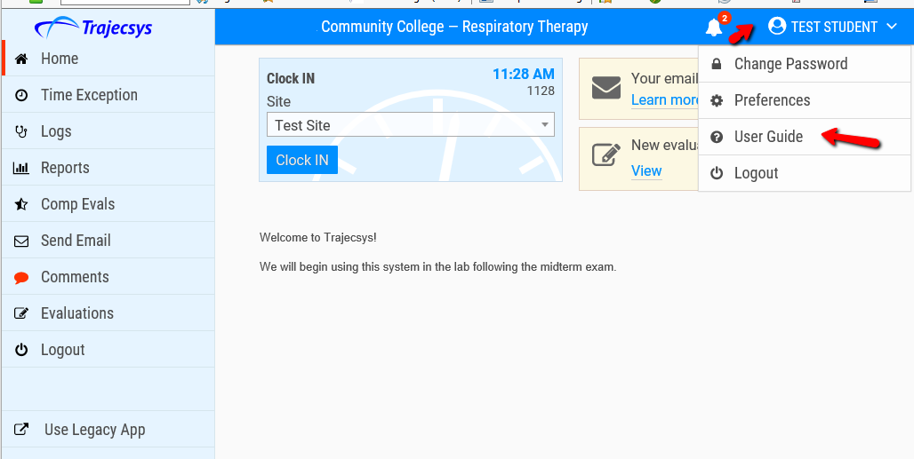

Recording Time Records in Trajecsys

Logging into Trajecsys

Log into Trajecsys on a computer or on a smart phone (if your program allows smart phone clock records) at this link: https://www.trajecsys.com/programs/login.aspx. Students can choose to bookmark the Trajecsys Login page.

Clocking In and Out
Each day when students arrive at and depart from a clinical site, they will log in on a computer (or smart phone) and select the clinical site from a dropdown on the home page. Then the student will click the clock in / out button. This is the screen on a computer:

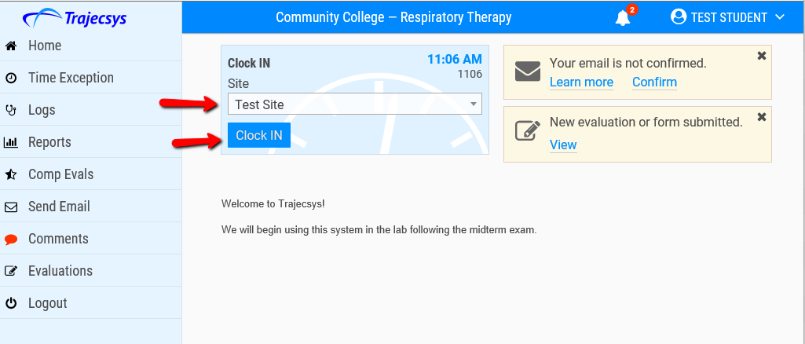

You will be automatically logged off from the system after clocking in/out on a computer; this is to protect your records in case you were to forget to log out. When you change sites, remember to select the new site on this page; otherwise, your times will be recorded for the wrong site.
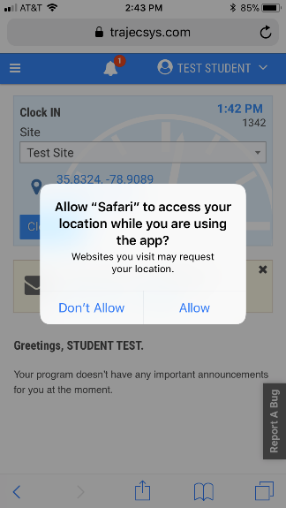
After logging in on a smart phone, you should see a message asking to share your location with Trajecsys. You must click “Allow.” It's important that this is selected correctly the first time because some phones do not present the option again without resetting location services in the phone Settings. If "Don't Allow" is selected and no option is given the next time, the student should access the GPS page in the User Guide for information about resetting location services. Students should always check with the program administrator to determine program policies related to use of GPS / smart phone clock records. We recommend that students also read the pages related to resetting location warnings and how to improve accuracy.

Students should see “Good Accuracy” on the phone screen before they click the clock in/out button. If the phone message states “Insufficient Accuracy,” students should wait until their phone has captured a good geolocation; this may require students (rarely) moving to another part of the building.

Time Exceptions

If you don’t file a clock in or out record, you must file a "time exception" instead. Using the clock in/out page is always preferred over filing time exceptions. A time exception is required for every missing clock record. If a student forgets to clock in AND forgets to clock out, this requires two separate time exceptions to correct the two missing clock records. One time exception is not sufficient to replace two missing clock records. Again, time exceptions should be used rarely; students should use the clock in / out button on the home page to record time records.
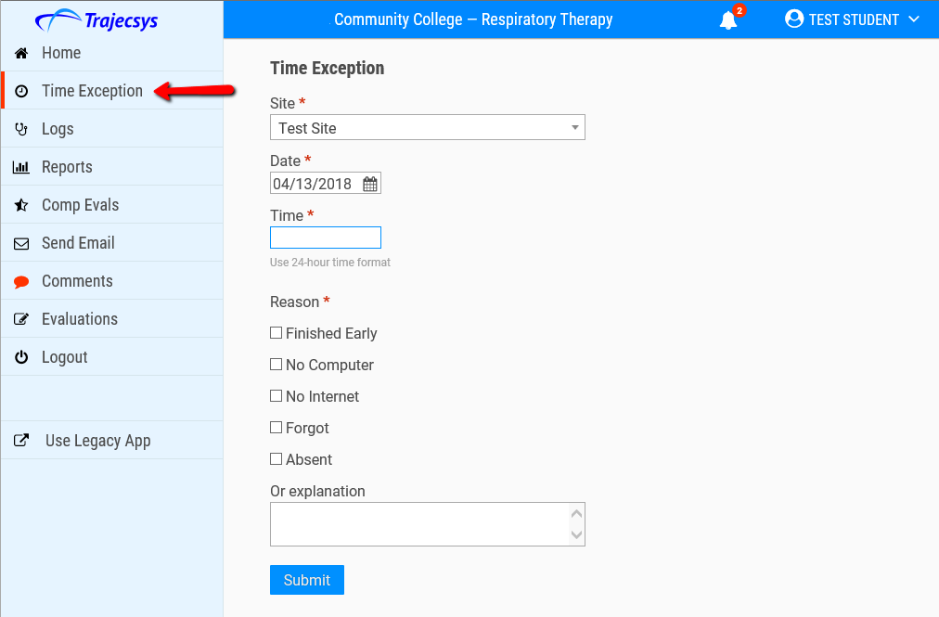

View of Instructor’s Screen when evaluating student

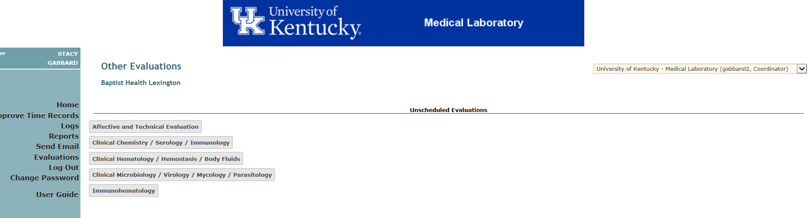
Chemistry Checklist Screenshot
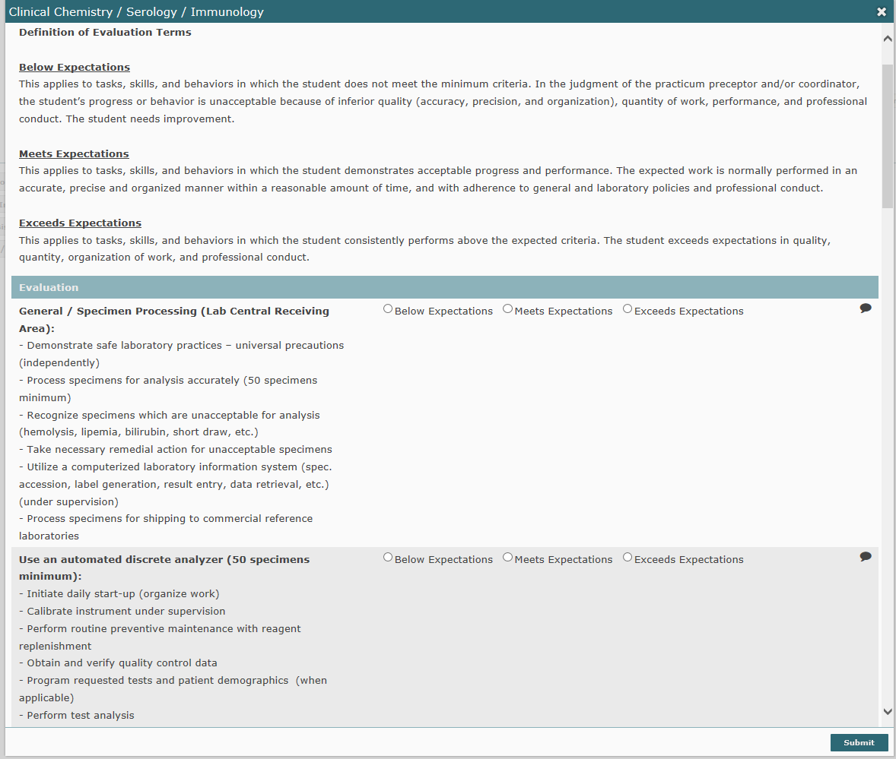

Affective and Technical Behavior Evaluation Screenshot
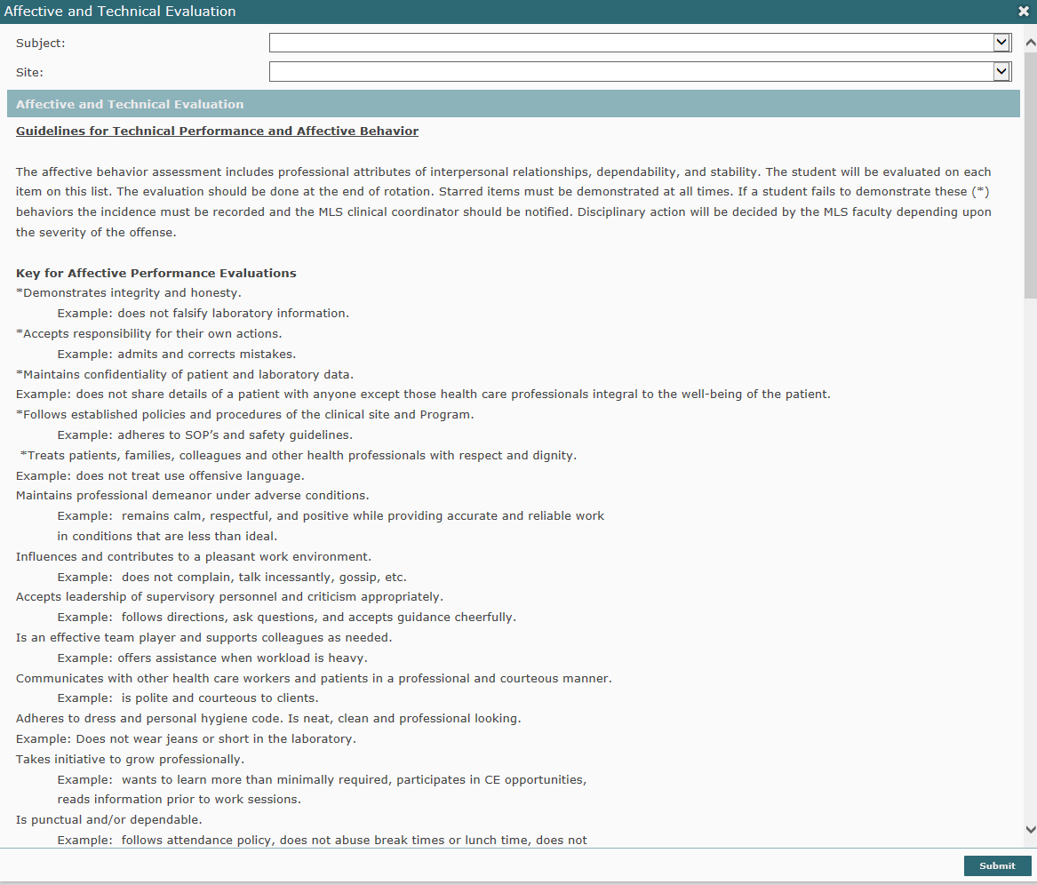

Methods of Evaluation

The student’s knowledge, skills, and affective behavior will be assessed by written examinations/exercises, task performance, and observation by practicum preceptors during all practicums. The final grade for a course will be determined by the scores earned in the categories as described below:

- PRACTICUM ROTATION CHECKLISTS:
These are the laboratory tasks and skills that are detailed for each rotation and unit. Certain tasks within each area may be identified, (by star), as critical. The student must demonstrate acceptable progress and performance for these tasks in order to receive a satisfactory grade in the course. Additional tasks may be included as determined by the clinical affiliate. Students will be evaluated by practicum preceptors using the following: Below Expectations, Meets Expectations, and Exceeds Expectations. Definitions for these are provided.

- TECHNICAL PERFORMANCE & AFFECTIVE BEHAVIOR:
A student’s performance in the practicum area comprises their technical skills and affective behaviors. Both will be evaluated by their practicum preceptors(s) for each rotation area. Practicum preceptor(s) will complete one evaluation at the end of the student’s rotation. The student should note that certain attributes are more critical than others. Unacceptable assessment in these identified areas will result in the lowering of the overall affective behavioral evaluation and may be grounds for probation or dismissal from the program. Students will be evaluated by practicum preceptors using the following: Unsatisfactory, Satisfactory and Outstanding. Definitions for these are provided.

- DAILY LOGS submitted at the end of the WEEK:
Each student must record their daily activities. Students must answers the following each day in the log:
- This includes documentation of instrumentation utilized
- test names
- abnormal results seen and approximate number either performed or observed
- brief description of problem solving and trouble shooting incidents
- Time of arrival and departure
- Special incidents, concerns, problems, and other pertinent items should also be recorded.
The daily log must be submitted to the MLS 480 discussion board on Canvas on a weekly basis. In addition to daily logs, the MLS clinical coordinator will pose a question or questions every week to the class by Wednesday. You must respond to the posting with an answer(s) every week as well.

Definition of Evaluation Terms

Below Expectations/Unsatisfactory

This applies to tasks, skills, and behaviors in which the student does not meet the minimum criteria. In the judgment of the practicum preceptor and/or coordinator, the student’s progress or behavior is unacceptable because of inferior quality (accuracy, precision, and organization), quantity of work, performance, and professional conduct. The student needs improvement.

Meets Expectations/Satisfactory

This applies to tasks, skills, and behaviors in which the student demonstrates acceptable progress and performance. The expected work is normally performed in an accurate, precise and organized manner within a reasonable amount of time, and with adherence to general and laboratory policies and professional conduct.

Exceeds Expectations/Outstanding

This applies to tasks, skills, and behaviors in which the student consistently performs above the expected criteria. The student exceeds expectations in quality, quantity, organization of work, and professional conduct.

University of Kentucky Medical Laboratory Science Program
MLS 480 Clinical Hematology Practicum
Performance Tasks

Student Name: ______________________________ Clinical Site: ______________________________________

Some performance tasks have numerical values. These are minimum values and the clinical instructor has the right to change the number required. The clinical instructor should check all that apply in Performance. In addition, other tasks may be requested which are not included in this checklist. You will perform those as deemed appropriate by your instructor.

Performance Task | Performance | Evaluation | Date/Tech
1. Use automated Hematology instrument under supervision (50 specimens minimum):  a. Initiate daily start-up  b. Perform routine preventive maintenance including reagent replenishment  c. Obtain and review quality control data  d. Program requested tests  e. Perform test analysis  f. Interpret results (e.g., cell counts, indices, RDW, histograms, scattergrams) relative to detection of specimen abnormalities  g. Demonstrate knowledge of instrument principle  h. Recognize abnormal/critical results and take appropriate action according to laboratory policy  i. Perform trouble-shooting when necessary (under supervision) | Observed  Performed supervised  Performed independently  Discussed (if technology not available)  Non applicable | Below Expectations  Meets Expectations  Exceeds Expectations
2. Perform routine Hematology procedures:  a. Prepare acceptable blood films for manual differentials (minimum 25)  b. Reticulocyte counts (minimum 10)  c. Erythrocyte sedimentation rates (minimum 10) | Observed  Performed supervised  Performed independently  Discussed (if technology not available)  Non applicable | Below Expectations  Meets Expectations  Exceeds Expectations

Performance Task | Performance | Evaluation | Date/Tech
3. Perform leukocyte differentials (minimum 30 specimens):  a. Correlation of analyzer results with cell count estimates and morphology  b. Routine differentials(independently)  c. Abnormal differentials (perform under supervision)  d. Normal and abnormal RBC morphology  e. Platelet count estimates | Observed  Performed supervised  Performed independently  Discussed (if technology not available)  Non applicable | Below Expectations  Meets Expectations  Exceeds Expectations
4. Special Hematology testing (observe or perform under supervision) when available:  a. Hemoglobin solubility test  b. Hemoglobin electrophoresis  c. Malaria and blood parasite screen  d. Bone marrow aspiration and/or examination (observe) | Observed  Performed supervised  Performed independently  Discussed (if technology not available)  Non applicable | Below Expectations  Meets Expectations  Exceeds Expectations
5. Perform routine Hemostasis procedures:  a. Prothrombin Time (minimum 25)  b. Activated Partial Thromboplastin Time (minimum 25)  c. Fibrinogen assay (as available)  d. D-dimer (minimum 5 preferred)  e. Thrombin Clotting Time (as available)  f. Perform routine preventive maintenance procedures on automated or semi-automated hemostasis analyzer | Observed  Performed supervised  Performed independently  Discussed (if technology not available)  Non applicable | Below Expectations  Meets Expectations  Exceeds Expectations
6. Special Hemostasis testing (observe or perform under supervision) when available:  a. Platelet function Analysis (if available)  b. PT and APTT mixing studies (if available)  c. Factor activity assays (if available)  d. Factor inhibitor assays (if available)  e. Special Coagulation Assays - Protein C, Protein S, Antithrombin, Lupus Anticoagulant, LMWH, VWF, Platelet Aggregation (if available) | Observed  Performed supervised  Performed independently  Discussed (if technology not available)  Non applicable | Below Expectations  Meets Expectations  Exceeds Expectations

Performance Task | Performance | Evaluation | Date/Tech
7. Quality Assurance (under supervision):  a. Review calibration with instructor  b. Review quality control records for one month with instructor  c. Review quality assurance plan with instructor  d. Interpret statistical analysis of proficiency testing results | Observed  Performed supervised  Performed independently  Discussed (if technology not available)  Non applicable | Below Expectations  Meets Expectations  Exceeds Expectations
Comments:

Clinical Instructor/Evaluator: __________________________________________ Date ___________________

Affective Behavior and technical performance Evaluation

Student Name___________________________ Practicum Area________________________________

AFFECTIVE BEHAVIOR
Descriptor | Outstanding |  | Satisfactory |  | Unsatisfactory
*Demonstrates integrity and honesty.
*Accepts responsibility for their own actions.
*Maintains confidentiality of patient and/or laboratory data.
*Follows established policies and procedures of the clinical site and Program.
*Treats patients, families, colleagues and other health professionals with respect and dignity.
Maintains professional demeanor under adverse conditions.
Influences and contributes to a pleasant work environment.
Accepts leadership of supervisory personnel and criticism appropriately.
Is an effective team player and supports colleagues as needed.
Communicates with other health care workers and patients in a professional and courteous manner.
Adheres to dress and personal hygiene code. Is neat, clean and professional looking.
Takes initiative to grow professionally.
Is punctual and/or dependable.
Is able to organize, multitask and prioritize assignments/duties.
Takes initiative to be independent practitioner while being aware of limitations.
TECHNICAL PERFORMANCE
Descriptor |  | Outstanding |  | Satisfactory | Unsatisfactory
*Adheres to safety guidelines and maintains good laboratory practice.
Utilizes the appropriate equipment and techniques for all laboratory tests.
Develops ability to organize and increase productivity from the first day to the last day in the rotation without sacrificing accuracy of testing.
Reports all abnormal results to supervisor; repeats or performs confirmatory testing as indicated.
Performs quality control procedures according to SOP, results fall within 95% confidence intervals, if outside acceptable limits, notifies supervisor.
Can function with minimal supervision by the end of the rotation adhering to the policies and procedures of the laboratory.
Records and reports test results with at least 99% accuracy and in a timely fashion.
Process specimens with 100% accuracy.
Can answer verbal questions with at least 80% accuracy and be prepared with background theory and knowledge to related clinical area.
Follows verbal directions.
Adheres to the established policies and procedures of the clinical rotation site.

Record comments supporting “Unsatisfactory” or additional comments:

______________________________________________________ _____________________________________________
Evaluator Date

_______________________________________ ___________________________
Student Date

*These attributes with a star are considered critical ones. Thus, assessment of “unsatisfactory” in any of these attributes will result in an “unsatisfactory” overall evaluation and may result in the student being placed on probation and/or dismissed from the clinical site.

DAILY LOG SAMPLE ENTRIES

YOUR NAME
Clinical Facility Name
Practicum area

Wednesday, May 29, 20XX
Arrived: 6:25 am
Departed: 3:30pm
Received an overview of all the tests performed in the manual chemistry lab: Rapid HIV, Fetal Fibronectin, Fetal Lung Maturity, G6PD, Lithium, Osmolality, Urine Preparation/Acidification. Performed QC on FLM, Osmometer, Li, FFN tests and did maintenance on Abbott TDX-FLX. Performed several osmolalities (one critical value of 321 for serum), pretreated urines with HCl for Ca testing, entered information into Cerner for creatinine clearance tests (height, weight, volume), prepared vitreous fluid with hyluaridinase (specimen very viscous so this compound breaks it down to be more liquid-like) and programmed the LX20 to run Na, K, Cl, Glu, BUN, creatinine. These test values help determine the time of death; ran one stat HIV test on a pt. In labor and delivery (neg.).

Thursday, May 30, 20XX
Arrived: 7am
Departed: 3:30pm
QC’d reagents and learned to make .8% suspensions from 3-5% and packed cells. Did ABO/Rh on three cord bloods (all O+), one adult pt. (B+) & my own cells (B- :confirmed neg. Rh with Du test & Du control; had to troubleshoot Du ctrl b/c was neg. after check cells, cell washer was not washing adequately). On all specimens, performed DAT. One cord blood had + DAT so did elution. Anti-D was eluted from cord blood cells. Got a neonatal specimen on the baby that had pos. DAT on cord blood and an additional neonatal specimen and performed type/screen. I crossmatched a unit for the pos. DAT specimen b/c doctor “ordered” 20 mL of RBC for a replacement transfusion. We determined the correct blood type and requirements (O-, IRR, LEUKP, <7 days) for x-fusion and prepared satellite bag of 25mL (made in a way that the orig. exp. Date of bag was not jeopardized) from original unit, irradiated the unit and made a syringe to use in the transfusion.

Friday, January 17, 20XX
Arrived: 6:30am
Departed: 3:00pm
Performed QC for retics and set up a retic. Counted about 8 abnormal diffs. Set up and ran 3 sed rates. Had to reject 1 sed rate due to insufficient amount. Did QC for body fluids on hemacytometer; there were 3 WBCs and 5 RBCs. My instructor and I looked at a bronchial lavage using the hemacytometer. The right middle lobular quadrant had 41 WBCs, the left lower lobular quadrant had 21 WBCs and there were several mesothelial cells. While looking at the right middle lobular quadrant my instructor pointed out how fast the cilia was moving around a particular cell, I thought it was a parasite but I was told that it was not. I still didn’t get to find out what type of cell it was but it looked very neat! Also, my instructor let me look at a diff. that she was counting and I saw a WBC with a lot of gram negative rods inside it, she took it over to Micro to let them a look at the slide. Oh, I had to set Kohler on the microscope that I was working on before I got started.

Friday, January 31, 20XX
Arrived: 6:20am
Departed: 3:10pm
Mycology: made three tease mounts for CAP Proficiency Tests and identified two of them: one being Nigrospora and other being Fusarium; plated four specimens, read an API that identified isolate as C. tropicalis but original plate resembled C. albicans and the CMA displayed a mixture of C. albicans and C. tropicalis – we tried to troubleshoot but never figured out exactly why the culture/API/CMA didn’t agree (possible contamination, dual fungal infections or wrong specimen subcultured) – tech called it most resembling C. albicans being that all fungals are treated alike.
Parasitology: performed 10 CDT (2+), 7 WBC (3+), 1 Crypto/Giardia (neg.).

NOTE: Daily Logs should follow above format and should not be more than two pages long, should be 10-12 point font in Times New Roman text. Do not use bold or italics, unless to illustrate an unusual occurrence.

Clinical Practicum GRADING

MLS 480 Clinical Hematology Practicum
MLS 481 Clinical Microbiology Practicum
MLS 482 Clinical Chemistry Practicum
MLS 483 Immunohematology Practicum

 | Grade | % of Total
Practicum Rotation Checklists |  | 50%
Technical Performance and  Affective Behavior |  | 20%
Daily Log and Questions |  | 30%
Total Score |  | 100%

Grade Scale: PASS/FAIL

The grade for the clinical practicum rotation is P (passing) or F (failing). A grade of P will be assigned if the student successfully obtains 75%. Each student must participate in all discussion board posts and questions in order to receive credit. Post must be submitted by the deadline in order to receive credit.

DEADLINES

Daily Logs and Questions:
The student will submit a weekly encounter of the daily activities on the following Monday by 7 AM on the MLS 480 discussion board. The first student to post their log will start the link and title it as: “Daily Log Week of XX”. Each student thereafter will submit their log as a REPLY to the initial link. If logs are submitted late, points will be deducted from the overall daily log grade for the respective practicum area. If you are not scheduled for a rotation that week, you are required to submit a posting stating such.

In regards to clinical coordinator questions posted by Wednesday, students will respond to these on a discussion board by Monday at 7AM.

Technical Performance and Affective Behavior:
Each student is required to have practicum preceptors complete a technical performance and affective behavior evaluation at the end of each rotation. The student is responsible for providing the clinical faculty with these forms during the rotation for documentation and to ensure their completion. It is the student’s responsibility to remind the clinical faculty to complete them within 1 week of completion of that practicum.

After completion of the rotation, this form is to be faxed* or emailed to your assigned clinical coordinator (stacy.gabbard@uky.edu or Biannamusic@uky.edu) no later than one week after completion. (Example: chemistry rotation ends on Friday, June 17, all documentation must be submitted by Friday, June 24.)

Students are not allowed to fax or email the forms for the practicum preceptor. Students should follow-up with preceptors to ensure forms were submitted to the appropriate UK MLS Clinical Coordinator. Failure to do so will result in points deducted from the technical performance and affective behavior portion of practicum grade.

Practicum Rotation Checklists:
Each rotation area has a specified list of skills and tasks. The student is responsible for providing the clinical faculty with these forms during the rotation for documentation and to ensure their completion. It is the student’s responsibility to remind the clinical faculty to complete them.

Students should follow-up with preceptors to ensure forms were submitted to the appropriate UK MLS Clinical Coordinator. Failure to do so will result in points deducted from the performance rotation checklist portion of practicum grade.

ONLINE PRACTICUM EVALUATIONS

Students are required to evaluate each practicum rotation in order to ensure best and effective practicum experiences. Students will evaluate practicum rotations using an online survey software system. Ample time will be given to complete these evaluations. Students will be sent email reminders to ensure completion of these surveys. Surveys are used within the MLS Program and if data is requested by a practicum sites it will be sent in an aggregate manner (for example, all hematology rotation evaluations will be sent) post rotations in order to provide anonymity to students.

In addition, practicum sites will be asked to complete annual evaluations of the UK MLS students in order to ensure that they are properly prepared for practicum rotations.

RESPONSIBILITIES

Student Responsibilities
The student is responsible for the following:
- Contact the rotation supervisor at least three weeks prior to the start of the rotation to determine what time to report, who to report to, what to wear, and any other special instructions, including where to park.

- Compliance with all clinical site documentation and/or training requirements such as immunizations, background check/drug screens, new badge acquisition, orientations, etc as mandated by Human Resources, Educational Coordinator, and/or rotation supervisor.

- Abide by the rules and policies of the clinical sites including:
  - Days and hours of rotation.
  - Safety guidelines.
  - Adhering to allotted lunch and break times.
  - Who to notify in the event of an absence (please note: medical appointments, dental appointments, and business appointments should be made after hours or on weekends). In addition to notifying the clinical supervisor/preceptor the clinical coordinator must be notified.
  - Make up of any time missed due to absences.

- Abide by the dress code and conduct code of clinical site and found in this handbook.

- Adhere to the rotational schedule.

- Provide own lodging, transportation, food, and other necessary expenses. The clinical rotation sites do not reimburse.

- Adhere to the affective behaviors as outlined in the handbook.

- Confirm that preceptors completed and submitted practicum rotation checklists and affective behavior/technical performance forms within one week after finishing the rotation.

- Completion of daily logs and questions.

- Print practicum rotation checklists and affective behavior and technical performance evaluation forms for practicum preceptors.

- Complete online evaluations of each practicum rotations (4 evaluations).

- Provide clinical preceptors/supervisors with thank you cards/notes as a token of appreciation for their knowledge and time.

- Take notes as clinical preceptors do not have the time to repeat instructions numerous times.
Clinical Supervisor/Preceptor Responsibilities
The clinical supervisor/preceptor is responsible for the following:
- Provide in-service training in the areas where the student is assigned. This includes all employee policies, start times, break times, and lunchtime, the principle of operation for instrumentation, procedures for determining acceptable test results, and the procedures for reporting result. The student should also be instructed in what to do if the test results are not valid.

- Assure that the student is exposed to all techniques and procedures listed in the checklist provided.

- Provide the student with feedback on his/her performance periodically throughout the rotation.

- Counsel the student relative to a poor performance.

- Notify the MLS clinical coordinator as soon as possible if a problem arises. The clinical coordinator and the supervisor should work together with the student to ensure success.

- Complete and submit the practicum rotation checklists and affective behavior/technical performance form of the student and submit to the Clinical Coordinator within one week after student completes his/her rotation.

Clinical Coordinator Responsibilities
The clinical coordinator for the medical laboratory sciences practicums is responsible for the following:
- Serve as the contact person for any issues (either site related or student related) surrounding the rotation.

- Ensure that the student has fulfilled the immunization requirement.

- Ensure the student has health insurance.

- If a problem arises with a rotation schedule the clinical coordinator will work with the student and site to resolve it.

- Ensure that the student has had all the orientation information for the university. In addition, the clinical coordinator will ensure that the student has had blood borne pathogen training and chemical safety training before starting the rotation.

- Ensure that the student has satisfactorily met the affective, knowledge, and technical objectives for the rotation.

- Assign the grade for the rotation.

APPENDIX A

UNIVERSITY OF KENTUCKY HEALTH CARE COLLEGES

POLICY ON EDUCATIONAL EXPOSURE TO BLOOD BORNE PATHOGENS

I. Purpose and Definition

The purpose of this policy is to delineate the management of incidents of exposure to blood borne pathogens including hepatitis B virus (HBV), hepatitis C virus (HCV), and human
immunodeficiency virus (HIV) that involve University of Kentucky health care colleges students, including visiting students, during the time when they are in an educational setting.

An educational exposure to blood-borne pathogens is defined as a percutaneous injury (e.g. a needlestick or cut with a sharp object), contact with mucous membranes or contact with skin (especially when the exposed skin is chapped, abraded, or afflicted with dermatitis, or the contact is prolonged or involving an extensive area) with blood, tissues, or other bodily fluids to which universal precautions apply, which occurs in the educational setting.

A student is someone enrolled in an academic or training program at the University of Kentucky.

Lended student/visiting student/visiting resident is someone registered at another university, but on an official affiliation agreement-approved clinical rotation at the University of Kentucky.

A source patient is the patient from whom the exposure originates.

II. Prevention

All University of Kentucky health professions students will receive yearly information about universal precautions, blood borne pathogens, and the student directives portion of this policy. This information will be appropriate to the students’ level of training and area of training. This training will be provided via the associate dean in the various colleges, or another designee, who has responsibilities for the education program.

III. Protocol for Managing Educational Exposure to Blood Borne Pathogens

A. General
Effective management of educational exposure to blood borne pathogens requires coordination among multiple units of the Medical Center. It requires training in prevention of injury and in the management of injuries when they occur.

- Educational Exposure to Blood Borne Pathogens - Students in Educational Experiences within the Commonwealth of Kentucky
- All students with an exposure will be directed to perform basic first aid immediately. These first aid directives will be the same as those provided to employees with occupational injuries and will be developed by University Health Service. All students should have appropriate initial laboratory tests per current CDC guidelines performed as soon as they can get an appointment but no later than the next business day.

- All students on an educational rotation in the Commonwealth of Kentucky will be directed to contact immediately the University Health Service in the event of an educational exposure. (Students on educational rotation outside the Commonwealth will be handled as delineated below in Section C.) Students will be directed to contact the on-call University Health Service physician if the University Health Service is closed. The reason that students will be expected to contact University Health Service immediately is because of the need for rapid assessment about prophylactic medications, the completion of appropriate initial laboratory tests, the rapid prescribing of medications if indicated, and the limited capacity of a student to assess his/her own injury.

Students will cooperate with the University Health Service in obtaining lab results of the "source patient" including, but not limited to, executing appropriate consents and authorizations. The University Health Service shall request the facility providing the educational experience to assist obtaining the status of the source patient pursuant to KRS 214.625.

Students will provide, to University Health Service personnel, the following information, if available, concerning the exposure:
Approximate time of exposure
Location of exposure (e.g., hospital, office, etc.)
Source of the exposure (e.g., blood, contaminated instrument, etc.)
Type of exposure (e.g. skin, mucous membrane percutaneous)
Length of exposure (e.g., seconds/minutes/hours)
Status of the source patient: Negative, Positive, or Unknown HIV, HBV, and HCV Status
Whether or not patient is at risk for HIV, HBV or HCV infection because of:
- Multiple Blood Transfusions 1978-1985
- IV Drug User
- Multiple hetero- or homosexual partners
- Known HIV positive and/or have symptoms of AIDS, HBV or HCV
- Significant blood or bodily fluid exposure has occurred.

3. If the University Health Service physician believes that prophylactic medication is indicated, the physician will prescribe it. The physician will prescribe by telephone a supply of the medication sufficient to last until the HIV status of the source patient is known to the appropriate dispensing pharmacy. The dispensing pharmacy will vary depending upon the location of the student. University Health Service will make the list of pharmacies available to personnel who may prescribe the medications. The University Health Service will prescribe the same prophylactic medications for students as those prescribed for employees with exposure to blood borne pathogens.

For students on educational rotations at Chandler Medical Center or within 50 miles of the Chandler Medical Center, the baseline laboratory test will be completed at the University Health Service, and the prescribing pharmacy will be either the UK Hospital or Kentucky Clinic pharmacy. If a decision to start PEP therapy is made by the on-call physician, the student’s personal health insurance will be utilized as the primary insurance source. If the student does not have personal health insurance, or if the student’s personal health insurance refuses to pay for the PEP therapy, the Office of the Provost will cover the costs associated with up to 28 days of PEP therapy.

For students on educational rotations in the Commonwealth of Kentucky more than 50 miles from the Chandler Medical Center, alternate laboratory testing sites and pharmacy sites will be identified. This identification will be by county, will be furnished to University Health Service personnel, and will be told to the student at their Orientation to the educational activity. In addition, course directors will know the locations of the pharmacies and laboratories capable of performing appropriate baseline testing. The Office of the Provost will reimburse the cost of the appropriate initial laboratory tests to the lab performing the tests and will reimburse the cost of an appropriate initial supply of medication to these pharmacies. Further cost of PEP therapy will be deferred to the student’s personal medical insurance. If the student does not have personal health insurance, or if the student’s personal health insurance refuses to pay for prolonged PEP therapy, the Office of the Provost will cover the costs associated with up to 28 days of PEP therapy. In the event that the Office of the Provost is covering the costs associated with a prolonged course of PEP therapy, the student may be asked to obtain those medications from the UK Hospital or Kentucky Clinic Pharmacy.

The student will be responsible for obtaining the initial supply of medication.

- Students must contact the University Health Service at the time of injury and must follow-up with University Health Service as soon as practical or as directed by the University Health Service physician/staff. All students will report the injury to the supervising clinician/preceptor. Students on educational rotations in Kentucky, but out of Fayette County, will also report the injury to the course director .

- In all situations of educational exposure to blood borne pathogens (whether or not the exposure is considered high-risk), all students will report to University Health Services for follow-up testing (as determined by the University Health Service), counseling, and continued prescription of medication (if appropriate). Students on rotation in Kentucky will have blood testing done at the University Health Service.

- All students will complete a University of Kentucky Chandler Medical Center Reportable Occurrence Form and Occupational Exposure Form, and bring these completed forms to University Health Service for their scheduled appointment. These forms will be available on the patient care units in the University Hospital, the Chandler Medical Center AHEC Office, the AHEC regional offices, and the Education Offices of the various health care colleges of the University.

- All source patients are to be encouraged to have blood work as designated by the protocol current at the present time (presently HCV antibody, HIV antibody, and Hepatitis B surface antigen.)
The University Health Service Blood Borne Pathogen Program Nurse Coordinator will coordinate obtaining blood samples/reports from source patients at the Chandler Medical Center and in the Lexington-Fayette County area. In other locales, the University Health Service and the course director will work with the community preceptor to complete the necessary blood work on the source patient.

The Office of the Provost will reimburse the appropriate party (e.g., hospital, laboratory or attending physician or provider) up to $ 800 to cover the costs of these tests (HCV antibody, HIV antibody, and HBS AG), after results are forwarded to the University Health Service. Invoices are to be sent to Rita Wilkie, Office of the Associate Provost for Faculty Affairs, room 205 Frazee Hall, Lexington, KY 40506-0031.

- Educational Exposure to Blood Borne Pathogens - Students in Educational Experiences Outside the Commonwealth of Kentucky, but inside the United States
- All students with an exposure will be directed to perform basic first aid immediately. These first-aid directives will be the same as those provided to employees with occupational injuries and will be developed by University Health Service. All students should have appropriate initial laboratory tests per current CDC guidelines done as soon as they can get an appointment but no later than the next business day. All students on an educational rotation outside the Commonwealth of Kentucky will be directed to contact the appropriate health service at that institution in the event of an educational exposure. Students will be counseled to identify this location as part of their orientation to the facility. The reason that students must contact the appropriate health service immediately is because of the need for rapid assessment about prophylactic medication, the completion of an appropriate initial laboratory tests, the rapid prescribing of this medication if indicated, and the limited capacity of a student to assess his or her own injury.

2. Students will be directed to have source patient information available for their discussion with the appropriate personnel at the outside facility, if available, concerning the exposure
Approximate time of exposure
Location of exposure (e.g., hospital, office, etc.)
Source of the exposure (e.g., blood, contaminated instrument, etc.)
Type of exposure (e.g. skin, mucous membrane percutaneous)
Length of exposure (e.g., seconds/minutes/hours)
Status of the source patient: Negative, Positive, or Unknown HIV, HBV and HCV status
Whether or not patient is at risk for HIV, HBV or HCV infection because of:
- Multiple Blood Transfusions 1978-1985
- IV Drug User
- Multiple hetero- or homosexual partners,
- Known HIV positive and/or have symptoms of AIDS, HBV or HCV.
- Significant blood or bodily fluid exposure has occurred.

3. If health personnel at the outside facility believe that prophylactic medication is indicated, the physician will prescribe it. The student may ask that the physician prescribe a supply of the medication sufficient to last until the HIV status of the source patient is known and a definitive decision is reached regarding the need for prolonged PEP therapy. This will allow the student to begin medication and consult with University Health Services personnel as well. The student will be responsible for obtaining the medication and paying for it. The Office of the Provost will reimburse the student up to $600.00 for the costs of the initial supply of medication.

4. In all situations of educational exposure to blood borne pathogens (whether or not the exposure is considered high-risk), students will contact University Health Service for follow-up testing, counseling, and continued prescription of medication (if appropriate). If it is possible for the student to return to UK immediately, all of these activities will occur in University Health Service at no cost to the student. If the student is unable to immediately return to UK, blood testing and medication may have to be obtained off campus; this may entail cost to the student.

5. All students will complete a University of Kentucky Chandler Medical Center Reportable Occurrence Form and Occupational Exposure Form, and bring these completed forms to University Health Service for their scheduled appointment. These forms will be available on the patient care units in University Hospital, in the Chandler Medical Center AHEC Office, at the AHEC regional offices, and in the Education Offices of the various health care colleges of the University.

6. All source patients should have blood work, including HCV antibody, HIV antibody, and Hepatitis B surface antigen. The student should coordinate these test results being sent to University Health Service.

The Office of the Provost will reimburse the appropriate party (e.g., hospital, laboratory or attending physician) up to $800 to cover the costs of these tests (HCV antibody, HIV antibody, and HBS AG), after results are forwarded to UK.

- Primary responsibility for coverage of PEP therapy will be deferred to the student’s personal medical insurance. If the student does not have personal medical insurance, or if the student’s personal medical insurance refuses to cover the cost of PEP therapy, the Office of the Provost will cover the costs associated with up to 28 days of PEP therapy. In the event that the Office of the Provost is covering the costs associated with a prolonged course of PEP therapy, the student may be asked to obtain those medications from the UK Hospital or Kentucky Clinic Pharmacy.

D. Educational Exposure to Blood Borne Pathogens - Students in International Rotations
1. Students/residents who elect to do international rotations will be required to contact the University of Kentucky Office of International Affairs and sign appropriate forms, including a waiver of these procedures, prior to leaving for that rotation.

IV. Responsibilities

A. University Health Service is responsible for:
- participating in the regular review of appropriate policy for the management of educational exposure to blood borne pathogens;
- providing students with 24-hour/day access to advice about the nature of an educational exposure and the need for prophylactic medication;
- knowing locations where prophylactic medication can be prescribed and obtained; and
- providing appropriate testing, counseling, medical care to students with educational exposures.

B. The Office of the Provost is responsible for:
1. providing funds for reimbursement of certain costs of student’s appropriate initial laboratory testing, source patient testing, and in some instances, prophylactic medication.

C. The college course directors are responsible for:
1. informing faculty and students about this policy;
2. obtaining information on participating pharmacies in the various AHEC regions.

D. Medical Center associate deans with educational responsibilities are
responsible for:
1. informing students about this policy and provide training in universal precautions suitable to the training and level of the student;
2. disseminating information to students about participating pharmacies;
3. working with University Health Services to address any student-specific issues, and to review this policy on a regular basis.

E. University of Kentucky students are responsible for:
- reading the student information sheet and following the guidelines.
- identifying the appropriate contacts at UK Chandler Medical Center, AHEC sites, and rotations outside Kentucky.
3. submitting the cost of PEP therapy to their personal medical insurance carrier and complying with requirements of that insurance carrier (including but not limited to seeing their primary care provider).

F. Lended students/visiting students/visiting resident students are responsible for:
1. contacting the University of Kentucky Health Service for guidance. Care will be provided only if exposure is high risk and no other option for care is available through lending institution.
2. paying for all expenses associated with testing, medications and related costs.

- This policy will be reviewed on an annual basis by the health care colleges’ Academic Deans and University Health Service.

References

- Centers for Disease Control and Prevention. Updated U.S. Public Health Service Guidelines for the Management of Occupational Exposures to HBV, HCV, and HIV and Recommendations for Postexposure Prophylaxis. MMWR 2001;50(No. RR-11)

- Centers for Disease Control and Prevention. Updated U.S. Public Health Service guidelines for the management of occupational exposures to HIV and recommendations for Postexposure Prophylaxis.
MMWR 2005;54(No. RR-9)

Revised 03-27-2013 Rita Wilkie

Medical Laboratory Science Practicum Rotation Handbook

Statements of Understanding

I have access to a copy of the current Medical Laboratory Science Practicum Rotation Handbook.

I have also been provided an opportunity to ask the Medical Laboratory Science Program Director and/or MLS Clinical Coordinator questions about content which I do not understand.

I understand that I must contact the practicum site and arrange with the laboratory contact person first day logistics (e.g., arrival time, parking, dress code, etc.) as soon as possible.

I have read, understood, and agree to abide by all practicum policies within this handbook.

I have read and understand the criteria upon which the practicum rotations will be assessed.

I have read and understand the responsibilities of all parties involved in practicum rotations.

Student Name
(please print)_____________________________________________________________

Student Signature _________________________________________________________

Date ____________________________________________________________________

