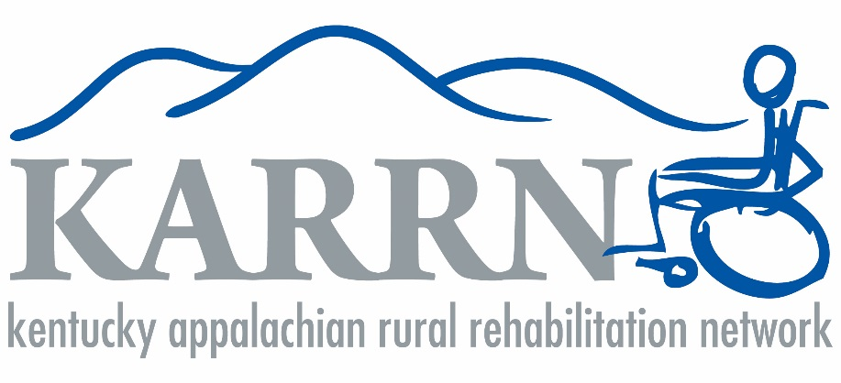

2018 ACCOMPLISHMENTS

Service

- To date (since 2012), Project CARAT has served 2,047 individuals, given away 5,378 items and saved $900,007.

- In early 2018, CARAT opened a new site in Lexington, “HDI CATS.”

- Kentucky Indiana Paralyzed Veterans of America (KIPVA) is now referring donors with durable medical equipment to CARAT for reuse.

Education/Outreach

- KARRN Conference had its highest attendance to date, with 227 attendees. Our HDI partners and community partners presented the sessions.

- Stroke Support Group: 15-20 people present each month for a total of 240; Multiple guest speakers on various topics

- Stroke Survivor & Caregiver Support Group educated 406 students in Perry County during Stroke Awareness Month.

- Stroke Survivor & Caregiver Support Group performed free blood pressure readings, stroke risk screenings, and educated 165 adults during Stroke Awareness Month.

- Stroke survivor & caregiver videos were posted on social media; one video had 14,483 views, the others had hundreds of views.

- Support group survivors and caregivers recorded PSA at the local radio station; shared on social media and reached 1,064 viewers.

- Shared the recording of the live radio show to social media and received 290 views.

- Diligently working within the community to create the KAART center - held a workshop in Hazard for community partners and UK College of Design to develop materials.

Advocacy

- KCSCI had its fifth Congress at a new location, which was well-attended.

- KCSCI/Independence Place received a Christopher and Dana Reeve Paralysis Foundation Grant to look at inclusion and employment.

- The Berea ABLE (Achieve and Build Lifetime Empowerment) support group for those with disabilities was established. ABLE is a “free, confidential, volunteer, low-key support group.”

New Collaborations

- UK College of Design faculty and students presented to the Hazard group and shared their materials they have developed for the KAART Center thus far

- UK College of Engineering/classes
- Many KAART Center partners, more news soon

Grants/Funding

- Fundraising page launched:
https://uky.networkforgood.com/causes/13760-karrn-fund
*Please share

Peer-Reviewed Publications (Students’ names are underlined)

- Sutton KM, Kitzman PH, Hunter EG, Hudson K, Wallace C, Sylvia V, Brock J. Engaging Individuals with Neurological Conditions and Caregivers in Rural Communities in a Health Research Team. Prog. In Comm. Health Partnerships: Research, Education and Action (2018, accepted)

- Kheibari A, Victor G, Gutti SS, Gutti S, Rao S, Kitzman P, and Dignan M. Smoking and Stroke in Appalachian Kentucky. Neurology and Neurobiology (2018) 1(1): 2-4. http://dx.doi.org/10.31487/j.NNB.2018.10.006

Poster Presentations (Students’ names are underlined)

- Hunter, EG, Kitzman, P. Patient centered outcomes: Partnering with people with neurologic disability from rural communities to understand priorities. American Occupational Therapy Association National Conference, Salt Lake City, Utah, April 2018.

- Kitzman P, Hunter B, Hudson K, Sylvia V, Sutton K, and Wallace C. Perceived health and healthcare needs for people with neurological conditions and caregivers transitioning back to rural communities. INAPTA and KPTA 2018 Joint Conference. Louisville, KY (2018 accepted). Refereed.

- Kitzman P, Hunter B, Hudson K, Sylvia V, Sutton K, and Wallace C. Perceived health and healthcare needs for people with neurological conditions and caregivers transitioning back to rural communities. Combined Sections of the American Physical Therapy Association (2018), refereed.

- Harrison A, Hunter B, Bordy P, Thomas H, Stokes E, and Kitzman P. Living with Traumatic Brain Injury in a Rural Setting: Supports and Barriers Across the Continuum of Care. Combined Sections of the American Physical Therapy Association (2018), refereed.

- Kitzman P, Espinosa-Bard C, and Jones J. Rural Healthcare Accessibility for Individual with Disabilities. Kentucky Rural Health Association (2018; Breakout session presentation).refereed

Other Publications or Media

- Stroke Survivor & Caregiver Support Group featured (front page) in the Hazard Herald, May 17, 2018 edition for stroke awareness month proclamation signings.

- Stroke Survivor & Caregiver Support Group featured in the Hazard Herald, October 4, 2018 edition for winning an award.

- Keisha Hudson, Dr. Hammock, and other support group members were invited to be on the local live radio morning show to discuss stroke awareness, signs & symptoms.

- WYMT news station reporter came to the May support group and we were featured in a news story that night.

Awards and Nominations
- Stroke Survivor & Caregiver Support Group won the Community Service Award at the 2018 Stroke Care Network Summit in August and was presented with a $250 check.

- Nominated for Voter’s Choice Award for the 2018 RAISE Awards from the National Stroke Association- received over 2,500 votes online and placed second.

