University of Kentucky
Design Guidelines for Greek Park

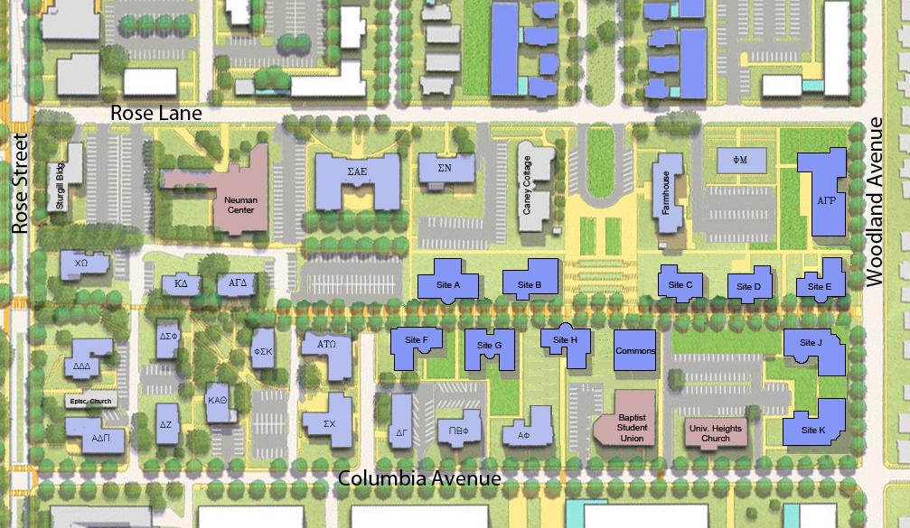
2016

Sasaki Greek Park Plan
Design Guidelines for Greek Park

The Greek Park Plan: The following guidelines will aide the process of moving forward with future projects, both new and renovations, by providing a better understanding of the constraints that guide the Greek Park Physical Development Plan. The Design Guidelines are based upon the Secretary of the Interior’s Standards for Rehabilitation especially as it pertains to renovations. The intent is to promote the preservation of historic materials and distinctive features that contribute positively to Greek Park. The Standards can be applied to projects of nearly every description, including historic buildings and structures, related landscape features, and new construction.

Project Review: When a Greek organization wishes to make modifications to an existing structure or to build a new facility the University will outline the next steps for moving ahead, including selecting and employing a consultant, drafting a lease agreement, establishing an architectural program, and how to proceed with design and construction. The University will review every future project in the Greek Park, regardless of the scope or method of delivery.

Definitions:

Common Area: Open space available for common use that is maintained by the University of Kentucky.

Porch: A covered shelter projecting in front of the main entrance of a building.

Building Footprint: The aerial visible first floor projection at grade to the edge of the built area.

Building Envelope: The building envelope is the physical separator between the interior and exterior of a building. Components of the envelope are typically: walls, floors, roofs, fenestrations and doors. Fenestrations are any opening in the structure: windows, skylights, clerestories, etc.

Buildable Area: A rectangular area designated for the construction of a fraternity/sorority house.

Main Level: The elevation set for the floor that contains the main entry
foyer and common living areas.

Greek Park: The area bounded by Rose Street, Columbia Avenue,
Woodland Avenue and Rose Lane.

Main Walk: A 20’ wide walkway extending from Woodland Avenue to Rose
Street through the middle of Greek Park.

Buildable Areas: Each buildable area indicates the maximum allowable extents for a building footprint for a given location. Generally all improvements need to be within this defined area. A main entry porch may extend up to 8 feet beyond the buildable area as measured to any attached step riser, projecting eaves or portico. Each buildable area has a stipulation that there will be a minimum of two levels and a maximum of three levels above the main entry elevation. Generally the highest point on the roof should be no higher than 44’ above the main entry level. Basements are permitted for all of the buildable areas and are required where the grade slopes away significantly from the level of the main walkway. The main level is to be set approximately one foot above the Main Walk with the building’s primary entrance facing the walk. The intent is to provide access for the disabled via a sidewalk and not a ramp.

The open spaces around the footprints of the buildings within the buildable areas are part of the common area for the Greek Park. Transformers may also be placed outside the buildable area and screening is required.

Street Setbacks: Some buildable areas are located near a public street and require setbacks to maintain consistency with surrounding residential areas. Generally the setbacks for streets in the Greek Park area are as follows:

- Rose Lane 40’
- Woodland Avenue 30’
- Columbia Avenue 40’
- Rose Street 40’

Building Design: The vision for the Park is a thematic look that retains the unique personalities of the existing buildings. Each fraternity or sorority house shall be primarily used for residential purposes and shall be designed in the Neoclassical Greek Revival or Federalist style. The materials and details shall be consistent with a residential scale. The primary materials shall be used consistently on all facades and should be selected for ease of long-term maintenance and consistency with the park’s vision. Because the Greek Park is a community in a park like setting there is no “back yard” and each building needs to present itself well to all its neighbors.

Exterior walls shall be masonry, primarily red brick with un-tinted natural mortar (i.e. “Old Colonial”) in harmony with the W.T Young Library. Natural cut limestone may also be used, particularly for water tables, lintels, sills, quoins, capstones and columns.
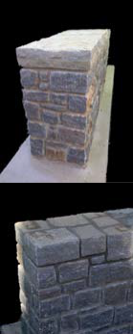
Redwood, cedar is preferred for trim and siding. Cementitious Board is allowed but shall be limited to areas from and above the roof soffit (such as dormers) or on the gable end of the house. Vinyl siding or other synthetic materials are not permitted.

Significant building elements such as cornice lines, building datum lines, pronounced entries /porticos, colonnades, stairways, and masonry detailing comprise a vocabulary of “design features” that help to create a cohesive campus identity. Designs which respond to and incorporate these common features will further the goal of the Greek Park’s visual unity.

Gutters shall be copper or aluminum with a finish to match the trim or brick/stone color.

Roofs shall be pitched at 6/12 or greater with gable ends. The roof finish may be slate, gray asphalt shingle or flat seam copper/zinc.

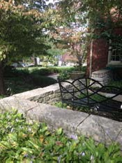
All exterior materials and finishes, including shingles, shall be pre-approved by the University Architect and assembled in a sample wall on the site for review before any work on the building envelope begins.

The University of Kentucky Design Standards will apply to all aspects of a project in the Greek Park that will be maintained by Physical Plant. (http://www.uky.edu/cpmd/official-design-standards)

Patios must be attached to the house and can be constructed of concrete, brick/clay pavers or natural stone. Certain cast stone materials may be used with the approval of the University Architect.

Elevated decks are permitted if they are no higher than the main level of the house. Treated lumber may be used for the deck structure, deck surface and stair treads, but not used for exposed vertical surfaces, stair railings, deck railings or screen walls.

Retaining walls and garden walls shall be faced with natural
limestone or of a brick matching the house they are associated with. Garden walls and seat walls should be faced front and back. Limestone walls should be laid in an ashlar pattern matching other limestone walls on campus. Caps for the limestone walls should be Kentucky Marble with a natural finish (uncut) and no overhang.
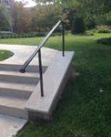
Limestone walls may also be designed without a capstone. Brick walls should be laid in patterns matching the house they are associated with. Caps for the brick walls should be cut limestone and may have a slight overhang to prevent water from washing the face of the brick.

Fencing or privacy walls can be masonry or of traditional metal design. Bolt-up metal fence and handrail systems are not permitted. Synthetic and wood fencing is not permitted.

Handrails (all) should be simple, traditional and fabricated from solid
metal for the rails and tubular painted steel for the support posts. Pickets should only be used in areas where codes require them and be solid. Supports for the railing should be spaced comfortably apart.

Out Buildings/Auxiliary Structures: No free standing structures are permitted in Greek Park. Small single story appendages intended for storage are also not permitted.

Parking: Parking within the Greek park is a shared resource and managed by Parking and Transportation. Each Greek organization within the Greek Park will be allocated permits to park in this area and then can determine who uses those permits.
Spaces for the disabled will receive priority. Dedicated spaces for functions like “House Director” will be at the discretion of Parking and Transportation.

Garbage and waste removal: the University of Kentucky will perform waste management. The University will determine the appropriate number and location for waste collection sites. Each fraternity and sorority will be responsible for taking their waste to one of these collection points. Collection points will be distributed in such away as to be as accessible and convenient as possible.

Grounds Maintenance and improvements: The University will be responsible for maintaining the grounds and the development of the common spaces. The University or the chapter, depending on a written agreement with the University may maintain plant beds immediately around each house.

Utilities: Some site utilities may be provided by the University. Some building areas are located near public utilities and thus can make connections to the infrastructure that exists. Utility connections will be dealt with on a case by case basis.

Building Systems: Each project to be maintained by the University of Kentucky will be required to follow the University design standards for building systems as they apply, including heating, ventilating and air conditioning, electrical service and wiring, plumbing, security and communications. These standards are available on the CPMD web site. (http://www.uky.edu/cpmd/official-design-standards)

Network Infrastructure: UK Information Technology Services (ITS) has developed the included guidelines to enable the networking infrastructure in the newly constructed Greek Park community. These guidelines focus on new construction and major renovations related to the Greek Park build-out and will not apply to all existing Greek facilities. These guidelines are not all-inclusive and ITS will amend as needed.

Benefits of the UK Enterprise Network
- Required for connectivity of the fire alarm system to the Utilities Facility Monitoring Dispatch Center (UK Delta Room) monitoring station. Provides enhanced reporting and faster response to fire alarm issues.
- Required for connectivity to the campus security system managed by the UK Police Department (UKPD).
- Higher data speeds when compared to external service providers.
- Network monitored and supported by full-time UK ITS staff.
- Better enables UK’s ability to manage all compliance and regulatory requirements for the enterprise network space. Example, using the enterprise network allows UK to enforce Digital Millennium Copyright Act (DMCA) compliance against piracy and copyright infringement to the device level.
- Utilizing an approved Cisco VOIP phone purchased through ITS will allow emergency alerts from the UKPD.
Funding Responsibility
- ITS will provide required fiber and equipment for establishing a distribution node within the UK enterprise network near the Greek Park community.
- The Greek organization is responsible for any fiber connections (including network device optics) from the established distribution node to the Greek property (building).
- The Greek organization will fund all networking equipment in the building including, but not limited to, network switches/data ports, wireless access points (WAP), Uninterruptible Power Supplies (UPS), Ethernet cabling, optical transceivers and VOIP devices (if required), and any required conduit from switch locations to wall jacks or wireless access points.
  - Manufacturer’s warranty will cover the network switch equipment, WAPs, UPS units and VOIP devices (ITS labor charges are applicable). The warranty period varies by model/manufacturer.
  - At the end of useful life, the Greek organization is responsible to replace the equipment.
  - All networking equipment is purchased through UK ITS plus installation/labor cost. This includes initial purchase of equipment and any maintenance/upgraded/replacement equipment after the initial installation.
- The Greek organization is responsible for installation cost plus the following monthly recurring charges (MRC):
  - Network data and or VOIP phone access fee for each staff member in the house (ex. house director).
  - Voice Mail. Actual phone device is a separate purchase. International Long Distance billed separately.
  - Fiber loop connectivity to the campus fire alarm system.
  - Monthly fee for each analog fax line (if required). International Long Distance billed separately.
  - Monthly fee for each analog elevator line (if required).
  - Contact UK ITS Business Office for current applicable fees.
- The Greek organization is responsible for providing a locked communication closet accessible by ITS staff.
  - Greek organization’s Facilities Manager will coordinate access to the communication closet.
  - ITS will consider a wall-secured and lockable enclosure if the communication closet is not feasible.
ITS Engagement
- The Greek organization is responsible for requesting an estimate for connectivity to the UK enterprise network. Information required includes building address, building contact, and a PDF of building floorplans.
- ITS will generate an estimate including costs for fiber connectivity, network equipment (switches and access points), conduit and labor.
- The Greek organization is responsible for funding the estimate if they elect to proceed with UK enterprise network connectivity.

Non-IT and Other Considerations
- The ITS network infrastructure scope of work does not include security cameras, door access control systems/panels/controllers or emergency call stations (Talkaphones). The UK Police Department (UKPD) should provide this information.
- The ITS network infrastructure scope of work does not include general IT, multimedia or audio/video (AV) support. A few examples that are not ITS supported include (but not limited to) internet streaming devices and services, multimedia presentation, cable or satellite TV service, printing and general desktop support issues.

Fire Safety Infrastructure: University of Kentucky Fire Marshal’s Office (UKFM) has developed the included guidelines to enhance the existing fire and life safety codes in newly constructed or renovated houses in the Greek Park Community. All construction shall meet the requirements of the currently adopted Kentucky Building Code (KBC), the International Mechanical Code (IMC), NFPA 72 Fire Alarm Code, and NFPA 13 Sprinkler Code. These guidelines are not all-inclusive and Greek organizations shall consult with the Fire Marshal’s office during design.

Fireplaces
Fireplaces installed inside the building are permitted in new construction and renovations. UKFM must approve all installations during the planning stages and they must meet all of the following conditions:
- Fireplaces shall be gas fueled. No solid fuel fireplaces will be approved.
- Fireplaces can be ventless if approved and installed per the manufacturer’s instructions and applicable code requirements.
- Fireplaces shall be constructed or installed per the KBC and manufacturer’s instructions.
- Fireplaces must be controlled with a timer system with controls located within 10 ft. of the fireplace.
- A fireplace usage policy shall be posted near the timer controls (provided by UKFM).
- The gas shall automatically shut off with fire alarm activation.
- Fireplaces shall be enclosed with an approved material. The enclosure shall be of a solid material that prevents access to the firebox while providing required ventilation per manufacturer’s instructions. The enclosure can be locked to provide maintenance only access.
- Fireplaces shall be maintained, inspected, and cleaned per the manufacturer’s recommendations.
Gas fueled fireplaces installed in residential occupancies will require the addition of carbon monoxide detection per section 908.7 of the KBC.

Knox Boxes
Knox Boxes shall be installed on each new or renovated building located on University of Kentucky property. The following requirements apply to all new installations:
- Knox Box shall be dual-keyed with one cylinder keyed for Lexington Fire Department access and one cylinder keyed for UK access.
- The Knox Box shall be openable with either key.
- The Knox Box shall be of the recessed mounting type.
- Tamper connections are not required.
- Knox Boxes shall be located within 6 ft. of the main entrance located on the address side of the building and mounted between 60 and 72 inches above the entrance threshold.
- Knox Boxes shall be securely mounted to the building’s structure in solid walls or installed with required backing plates per the manufacturer’s instructions.
- The Knox Box shall contain at least two hard-keys of each type that provide access to every space in the building. If electronic access is installed, the box shall contain at least two key cards for each floor of the building.
Posting of Evacuation Signs
Emergency evacuation signs shall be posted in each dwelling or sleeping unit in the building. Signs shall be reviewed and approved by the UKFM.

Fire Alarm Installation
Fire alarm systems shall be installed and tested per the requirements of NPFA 72, National Fire Alarm and Signaling Code. It is required that the fire alarm system for all buildings in the Greek Park be monitored by an approved and certified supervising station. This connection can be accomplished by either a local dialer on the fire alarm system or through a connection on the UKIT housing fiber loop which routes information to the monitoring station and the Utilities Facility Monitoring Dispatch Center (UK Delta Room). It is recommended that the fire alarm system be connected to the UK network infrastructure by means of the UKIT housing fiber loop.

Greek Facilities Not Connected to UK Network Infrastructure
If Greek organizations do not connect to the UK Enterprise Network the facility cannot be
connected to the UK Delta Room for fire alarm monitoring. This should be a rare occurrence and will only be permitted when reviewed and approved by the UK Fire Marshal’s office on a case-by-case basis. In these circumstances the following requirement shall be met:

- The fire alarm system shall be capable of being modified so that future connections to the UK Network Infrastructure will allow monitoring by the UK Delta Room. Submitted and approved designs shall state that the alarm manufacturer has equipment available that will allow communication of alarms, trouble signals, supervisory signals, etc. to the currently existing Simplex-based Network backbone.

Greek Facilities Connected to UK Network Infrastructure
Facilities connected to the UK Network Infrastructure shall be connected to and monitored through the UK housing fiber loop. All alarms, trouble signals, supervisory signals, etc. will report to the UK Delta Room and the Simplex monitoring station. This system is proven to be less expensive and more reliable while providing faster response and a higher level of safety for the occupants of the facility.

Additional Fire Alarm Requirements
The following items are required for all Greek Housing facilities regardless of connection to the UKIT fiber loop and are in addition to the requirements in the KBC, NFPA 72, UK Standards, and any other applicable codes:
- Manual pull stations shall be installed throughout the facility per the requirements in NFPA 72.
- All sleeping units shall have 520 hertz square wave fire alarm notification devices installed.
- Sleeping unit detection devices shall be connected to and report conditions to the fire alarm panel.
- Sleeping unit detection devices shall be programmed for Priority 2 signaling.

Security Infrastructure: University of Kentucky Police Department (UKPD) has developed the included guidelines to enable the installation of UK Central Security system devices in newly constructed or renovated houses in the Greek Park Community. The guidelines are contingent on the facility owner’s decision to select the UK Enterprise Network connection provided by UK Information Technology Services (ITS). These guidelines are not all-inclusive and Greek organizations shall consult with the UKPD officials during design.

Greek Facilities Not Connect to UK Enterprise Network
If Greek organizations do not connect to the UK Enterprise Network the facility cannot be connected to the UK Central Security System. This would be a rare occurrence, and would be allowed only with special approval. In these circumstances the following security recommendations should be followed:
- UK recommends the use of electronic access control into facilities and discourages physical keys for exterior entryways.
- UK recommends installing a security system utilizing Mercury-based panels and HID multi-class readers. This will allow significantly lower costs of future connection to the UK Central System if IT is upgraded. UKPD will not release UK Wildcard facility code or bit-format algorithm to disparate systems.
- UK recommends security cameras be installed at all points of ingress and egress on the perimeter. Cameras shall be:
  - High quality, IP cameras
  - ONVIF compliant
  - Utilize Power-over-Internet
  - Provide a minimum of 720p resolution (1280x720)
  - Be equipped with day/night functionality
- Recorded video shall be maintained for no greater or less than 30 days.
- UK recommends intrusion alarms be programmed to ensure UKPD is the first emergency contact for response. (859)257-8573.

Greek Facilities Connected to UK Enterprise Network
Facilities connected to the UK Enterprise Network shall install the minimum security standards listed below.
- Electronic access control at all perimeter doors. There shall be at least two points of card reader ingress. Perimeter doors that allow ingress shall have electronic access control that can be locked and unlocked remotely. Perimeter doors designed for egress only shall be installed with a minimum of a door position indicators.
- Wireless lock installation must be preapproved by UKPD. Wireless locks are prohibited for perimeter installation.
- Access control panel shall be installed in a secure locate that UKPD officials can gain access to (preferably UK ITS closet). This location shall be agreed upon during preconstruction meetings and in concert with UK ITS. All access control cabling shall be a home run to the near access control panel.
- Installation of all access control shall be completed by a certified Lenel OnGuard vendor. All programming shall be completed utilizing the UK’s Lenel VAR of Record for Lenel Licensing and Central System programming and turn up services. The contractor is responsible for providing VAR of Record reader counts, controller panel counts and locations as well as counts of any special components such as biometric readers or elevators that will require special programming.
- UK shall require the use of the UK Wildcard as the credential to access the facility. UK can issue the Greek organization a mutually agreed upon number of temporary cards for non-UK stakeholders who access the facility on a temporary basis. Greek organization shall follow UK Wildcard Office Temporary ID guidelines.
- All ingress and egress perimeter doors shall have a security camera installed to monitor who enters and exits the door. The cameras must meet the following requirements:
  - Cameras must be ONVIF compliant.
  - Cameras are IP-native.
  - Cameras utilize Power-over-Ethernet (PoE) for device power.
  - Cameras are designed to provide video streams at the minimum HDTV 720p
  - (1280x720) resolution at 30 frames per second using H. 264.
  - Cameras are equipped with Day/Night functionality, Wide Dynamic Range (WDR), color video to ½ lux, black and white below ½ lux and feature remote back focus capabilities.
- All camera recordings shall be recorded for no greater or less than 30 days. UKPD will work with UK ITS to determine any costs associated with video storage costs to which the Greek organization will be responsible for funding.
- Cameras shall be installed by an approved University vendor and all programming of cameras shall be completed by UK’s video management system vendor of record. Greek organization will be responsible for the any licensing costs associated with connecting the cameras to the UK Central Security System.
Facilities with the desire to install security components above the minimum requirements should refer to UK design standards (https://www.uky.edu/cpmd/official-design-standards) and reference 280000S04 Electronic Safety & Security and 087100S09 Main Campus Access Control and Door Hardware Standard (Security).

Facility Funding Responsibilities
All costs related to installation shall be the responsibility of the Greek organization. Greek organization shall maintain all security equipment and devices in working order and shall be responsible for the costs of repair and replacement. All repairs shall be coordinated through UK Central Security System ticketing (campusaccess@uky.edu). UKPD agrees to assist in troubleshooting and to assist in support of programming time zones (door schedules for events) and access levels for the facility.

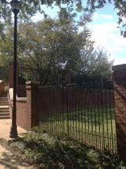
Screening: It is highly desirable to keep all mechanical equipment, with the exception of transformers, concealed inside the building envelope. All venting of mechanical equipment, in particular the kitchen equipment shall be vented through the roof in such a way that it is integrated with the architecture and/or concealed from view. Louvers need to be located and sized to work with the fenestration pattern so as not to seem arbitrarily placed. All visible elements of the building systems should be finished to blend and be compatible with other materials used for the building envelope.

When unsightly items (trash receptacles, transformers, heat pumps and other mechanical equipment) cannot be place inside the building they shall be screened from view. Screening can be accomplished utilizing a combination of elements and should be part of the design process. Fencing and screen walls alone may compound the problem, especially when the designer doesn’t recognize the problem until the project is under construction. Landscaping can be part of the solution but the plant materials should be so arranged that they don’t appear as a wall around the object. The placement of unsightly items should be dealt with during the design of the landscape.

Signs/graphics applied to the building: the name of the fraternity or sorority may be displayed above the main entrance door to the building. A fraternity or sorority crest may also be displayed along with the fraternity or sorority name. No other sign, lettering or graphics maybe used unless given prior approval from Facilities Management. The design of the name as well as the crest will require review and approval by Facilities Management.

Greek elements in the landscape: there are a variety of elements associated with fraternities and sororities that are displayed in the landscape. These range from cannons to anchors. Generally these items should be placed in the front of the building near the main entrance and incorporated into the landscape properly. All elements should be fabricated from quality materials and scaled appropriately. The design of these elements should be submitted to the University Architect for approval.

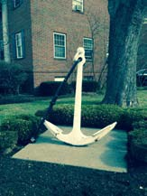

Campus signs: the University of
Kentucky has a campus sign policy (http://www.uky.edu/Graphics/ SignagePolicy.pdf). All signs not previously addressed in these guidelines fall under the campus sign policy. Each building will have a building identification sign conforming to the policy. Wayfinding signs giving direction to each of the houses in Greek Park will be placed at strategic locations. No other signs will be permitted.

[End of Document]

