Type: Class A (Type 1)

OPERATION STATE TABLE (Note 1)
State of Panel Alarm Contact "N.O." Supervision Contact "N.O."

Normal Open Closed
Pre Alarm/Suppression
System Open Closed
In Alarm (Discharge) Closed Closed
Acknowledged Open (Note 1) Open
Reset Open Closed
System Trouble Open Open

Central Station F/S Module (Note 2) Local Fire Alarm Ctr. Panel

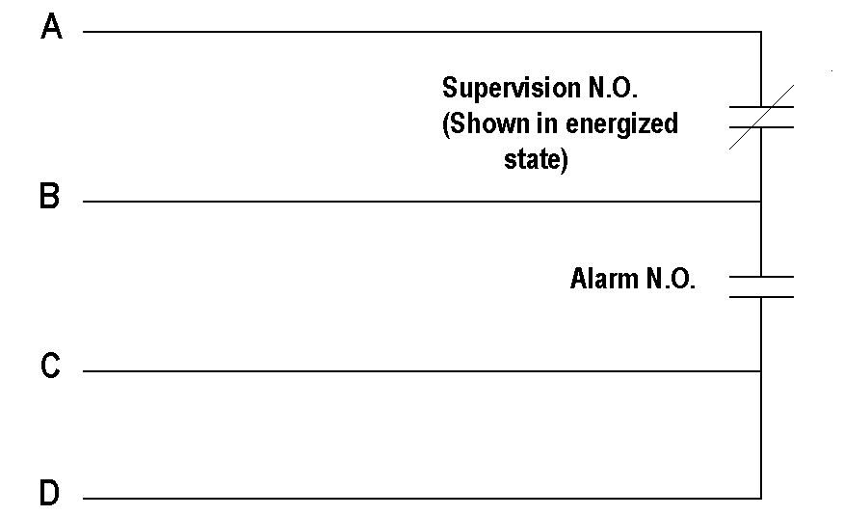
SCHEMATIC:

Note 1 Operation of the panel should be such that once an alarm condition is acknowledged, an alarm on another zone will close the alarm contacts again and report to the Central Station.

Note 2 Provide lightning protection on all inputs and outputs of the system, including power, that extend or are connected to a system that extends beyond the walls of the building or if the inputs and outputs share a conduit with wires which extend beyond the walls of the building. Tunnels are not considered as walls of the building unless they are directly under the building.

Note 3 The fire alarm system installer shall clearly label terminal strip A, B, C & D that are to be connected to the UK Central Station Equipment.

Note 4 Provide a 3/4" conduit and 4-12 AWG stranded wires from the main fire alarm control panel to the nearest SimplexGrinnell fire alarm rated network panel. Contact the UKPPD FMS Engineer to determine if the nearest fire rated panel is located in the building or is located in a surrounding building. If located in a surrounding building, use 4-12 AWG stranded wire in a direct burial quality PVC jacket in the underground raceway system.

Note 5 Coordination with and connection to the UK Central Station Equipment shall be made on this project and shall be coordinated through the assigned University of Kentucky Capitol Project Management Division (CPMD) Construction Manager. If a conduit duct route from the Main Fire Alarm Control Panel to the nearest SimplexGrinnell fire alarm rated network panel is not available and the UK CPMD design contact person cannot justify adding ducts on this project or any other project, this system may be connected to the UK designated fire alarm central station with a digital communicator. Digital communicator shall be compatible with the central station, shall be connected to 2 phone lines in accordance with NFPA and shall meet all applicable code requirements including but no limited to federal (NFPA), state (KBC), and local (LFUCC). Digital communicator shall be UL listed for the application and shall be supplied and installed in accordance with UK Standard 16720S04.

Note 6 Departmentally owned equipment connected to the central station monitoring systems will incur a monthly monitoring charge. The cost for this service is updated periodically.

