1. **Exterior**

All exposed and concealed conduit shall be rigid steel. Underground runs shall be Schedule 40 or 80 PVC. Underground conduit runs into a building must transition from PVC to rigid or EMT within 12” of entering the structure. Minimum size of PVC or rigid conduit shall be 3/4".

2.0 Interior

All exposed and concealed conduit shall be EMT with exceptions noted. Connectors shall be compression for 2” and smaller conduit. Setscrew or compression connectors may be used for 2-1/2” and larger conduit. Minimum size of EMT conduit shall be 3/4".

Surface mounted wall conduit must be Wiremold. No EMT conduit to be surface mounted on any walls.

Connections to vibrating equipment shall be flexible steel conduit with PVC jacket (LFMC). Flexible conduit connections shall not exceed 72”. Waterproof connectors shall be used with LFMC.

Conduit for recessed and semi-recessed light fixtures shall be connected with flexible steel conduit. Minimum flexible conduit size shall be 3/4". Flexible steel conduit connections shall not exceed 72”.

Conduit to under cabinet lights shall be 1/2" flexible conduit. Flexible conduit runs shall not exceed 72”. Flexible conduit may be used for installation through casework. A four-inch junction box must be installed every 72” of flexible conduit to facilitate pulling wire.

Flex conduit can be used above ceilings as whips as long as the length is less than 6 feet.

Flex conduit can be used in existing drywall installations for fire alarm devices. Installation in new walls must be EMT conduit and not flex.

Connectors to be used on all flex conduit needs to be the squeeze connectors. The screw on connectors are not allowed.

Boxes on the flex installations must be secured adequately in the drywall to prevent the flex from coming loose from the box.

All conduits shall be concealed within finished spaces.

Rigid conduit shall be used in all wet and damp locations

Horizontal conduit shall not be installed directly from the side of one junction box to another junction box. The conduit needs to be either installed vertically to each box or from the junction box bottoms at a level lower than 12 inches AFF. See sketch below.



3.0 Concrete Slabs

Conduit is not permitted to run horizontally in concrete slabs.

**4.0 Color**

Conduit in major renovations and new construction in Medical Center buildings shall follow the following coloring scheme:

Life Safety Branch – Yellow

Critical Branch – Orange

Normal Branch – White

Equipment Branch – Silver

Fire Alarm System – Red

HVAC Controls – Green

Data/Communications – Blue

Access Control - Purple

5.0 Junction Boxes

Large junction boxes (as shown in the picture below) may not be used in electrical conductor conduit runs for more than 3 circuits.

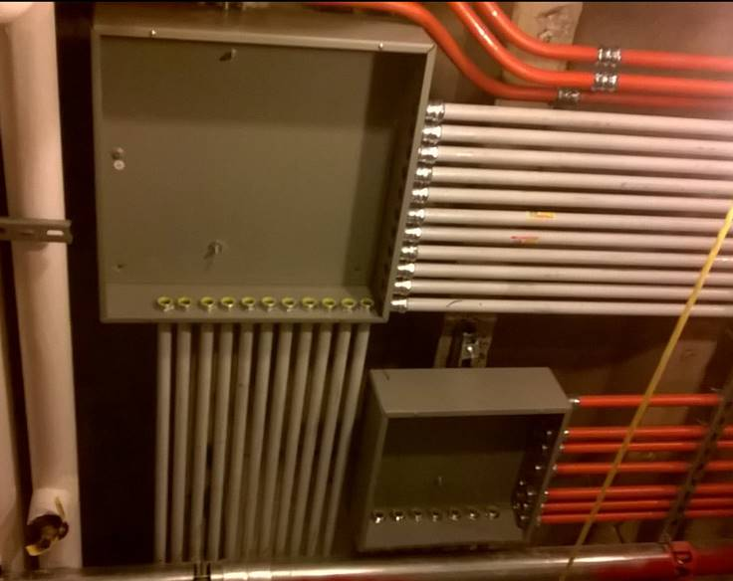

Not allowed

Not allowed

LB type junction boxes are prohibited in all conduits 1 ¼” or less. Use of LB junction boxes in conduits larger than 1 ¼” may be acceptable in special limited applications but require approval by the Medical Center Physical Plant Division project representative prior to installation.