Presiding: Shotwell, Christian, College of Agriculture, Food, & Environment

Present: Alexander, Martha, Institutional Equity & Equal Opportunity
Burchfield, Kari, College of Arts and Sciences
Buchheit, Rudy, College of Engineering
Burr, Stephen, ITS Enterprise Systems
Cox, Penny, Financial Services Administration
Frazier, James, UKHC/EVPHA Administration
Lang, Angie, Chief Experience Operations Officer
Lasley, Catie, Executive Director of Human Resources
Martin, Angie, Planning, Budget and Policy Analysis
Tearney, Michael, Retiree
Roberts, Myrin, Finance Administration
Schagane, Amanda, Alumni Career Services
Stamper Shannan, Office of Legal Counsel

Ex Officio:
Amos, Richard, Chief Benefits Officer/Executive Director Know Your Rx Coalition
Carbol, Gail, Benefits Manager
Wilson, Kimberly, Chief Human Resource Officer

Absent: Akpunonu, Peter, College of Medicine, Chem Safety/Environmental
Chen, Gang, Pharmacology and Nutritional Sciences
Ellis, Christy, Retail Pharmacy Services
Kelley, Scott, Marketing and Supply Chain
Sharpe, Joseph, Athletic Director Associate
Sizemore, Megan, College of Communication and Information
Younce, Elaine (designee)/Collins, Craig, HealthCare Admin

Recorder: Chavae Mock, Student Health Plan Administrator

Agenda Item & Speaker | REPORT | ACTION
Call to order – Chris Shotwell | Chris Shotwell called the meeting to order at 10:30 AM. | No action needed.
Review of the February 10th, 2021 Minutes | Chris Shotwell asked for review and approval of the minutes. | Penny Cox made motion to approve. Stephen Burr seconded. Minutes were approved.
Open Enrollment Changed – Richard Amos & Gail Carbol | Presentations are being given, as requested, in person and virtually.  Employees are encouraged to look at their benefits each year, even if they aren’t changing anything. Alex, UK’s interactive benefits counselor, is available for both current employees and recruits to help find the best benefit.  This year, the $550 rollover limit, has been waived for Flexible Spending Account holders. Employees may rollover any amount that remains in their account as of June 30th.  Employees will see a minimal premium increase in the HMO, PPO and Health Saver plans.  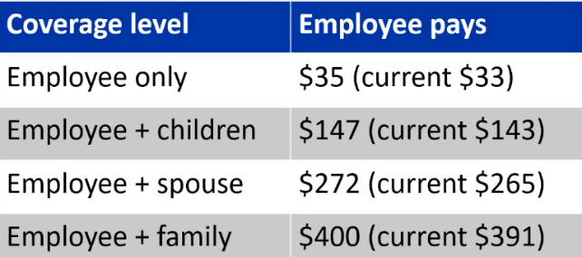  The EPO health plan will also see an increase in premium.  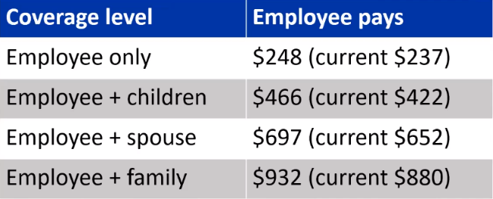  No changes to dental or vision benefits. Voluntary benefit plans will be all guaranteed issue. Critical Illness is a new voluntary plan that is now available. | No action needed.
Retirement Plan Update & Brokerage Activity – Richard Amos | Previously announced retirement plan changes have gone smoothly. Those changes included reduced fees and making the plan more streamlined. The Benefits office has been able to assist those individuals who have needed more assistance in understanding the changes.  Approximately 700 people, or 2.7% of our population, have opened a brokerage account. | No action needed.
GME Matching Retirement Plan Rollout – Richard Amos | There are approximately 877 Medical Residents, also known as House Staff, who will be permitted to participate in the retirement matching plan effective July 1st.  Prior years of service will count towards the 3-year vesting date. | No action needed.
Meeting convened – Chris Shotwell | Chris Shotwell ended the meeting at 11:16 AM

