View Positon Description for your Direct Reports

- Click the: https://ukjobs.uky.edu/hr/sessions/new

- Click the link that says “Click here to log in using your Link Blue Account.” Do not use the “Guest Users:” sign in option on this page.
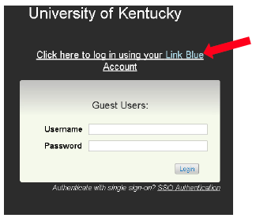
- Log in using your Link Blue credentials.

- In the top-left corner of the screen, click the three dots and then “Positions”:

Once selected, the menu bar on the top of the screen should change from blue to orange.

- Click the drop-down box at the top-right of the screen (currently showing “Employee”) and select “Supervisor.”

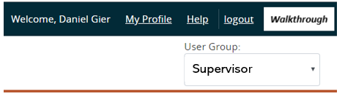

- Under the tab for “Position Descriptions,” click “Staff.”
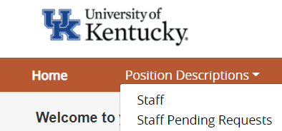

- Click the job title or position number of the position to view its specific position description. Scroll down to the header titled “Major Job Responsibilities” to review the position’s duties. The MJRs listed will be the same ones reflected in the Performance Evaluation system.

