View Your Own Position Description

- Navigate to either of these links:
  - https://ukjobs.uky.edu/hr/login (Save this link to your favorites for quick access.)
  - http://www.uky.edu/hr/employment/hiring-officials (This is the UK HR Employment website.)
    - On the Hiring Officials page, click on the box below located on the right side of the page:

- Select “Click here to log in using your Link Blue Account”. Do not sign in under “Guest Users”:
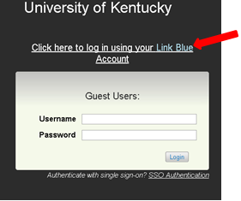

- In the top-left corner of the screen, click the three dots and then “Positions”:

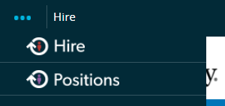
Once selected, the menu bar on the top of the screen should change from blue to orange.

- Confirm you are logged in as an Employee by checking your user group setting located at the top-right of the screen:

- Select “My Profile”:

- Click on the “Position Descriptions” tab:

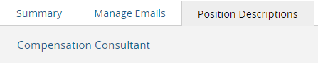

- Click on your official HR classification/title listed (i.e. Compensation Consultant). Your position description should appear on the screen.

