This document is intended to get you started quickly with BEx Analyzer 7.0. You will be able to open, run, and save queries; and export your data to Excel.
Instructions for creating and modifying queries will be available in the future.

Open and Run an existing Query
- Select the BW BEx Reporting beachball from the Launch Pad
- Click Add-ins.
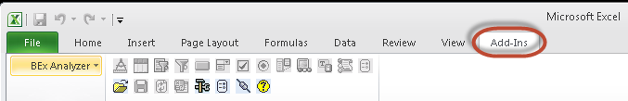
The BEx Analyzer 7.0 toolbar is displayed with most of the buttons greyed out.
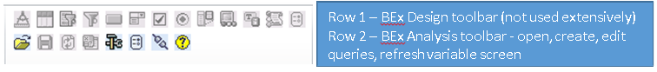

BEx Analysis Toolbox : Open
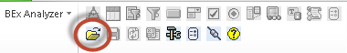
- Select the icon
- Select Open Query
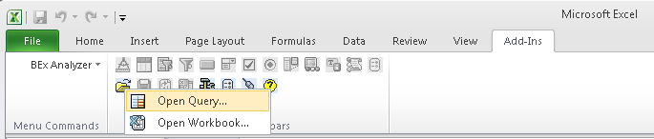

A list of your most recent searches will appear.
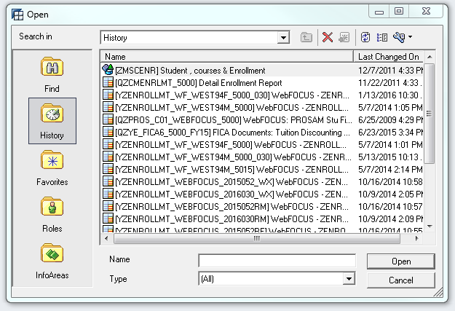
If your query is in the list
- Double-click to execute the query
If your query is not in the list,
- Select Find 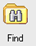
- Ensure both Search in Description AND Search in Technical Name are checked
- Enter the name or technical name of the query
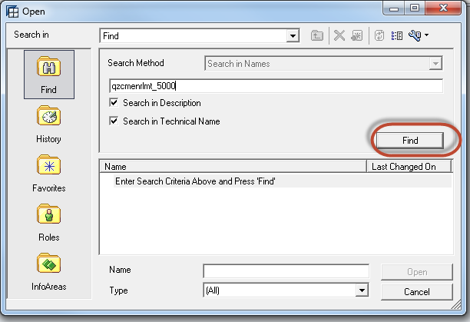
- Click Find to continue
Multiple queries matching your search criteria may be displayed
- Select the query you want

- Double-click to execute the query or select Open
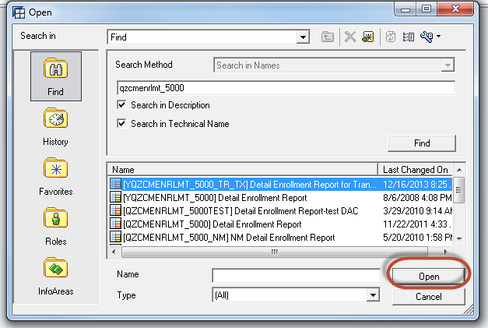
The Select Values for Variables screen will be displayed.
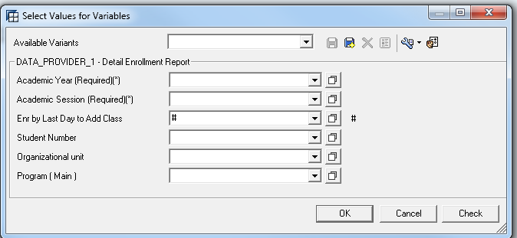
- Complete the variable screen by typing in values or click to select from the list of available variables.
Note: Fields marked “Required”, or “*” must be completed.
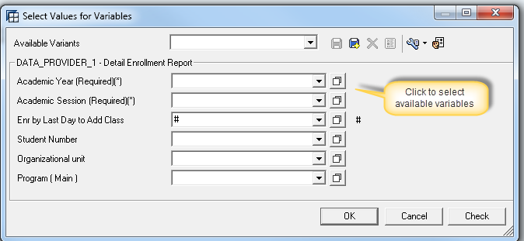
Multiple values can be entered by separating them with a semi-colon (2009;2012; 2015, etc.)
A list of available variables for Academic Year.
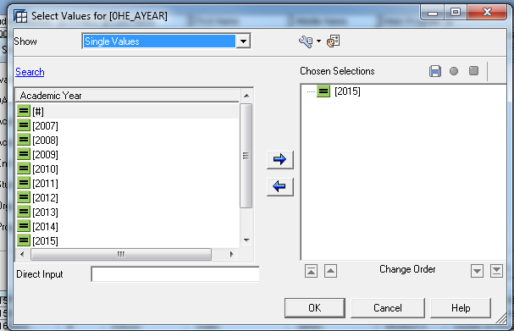

The operand default for variables is “equal to”. To change the operand of a variable
- Change Single Values to Value Ranges
- Select the operand and move it to Chosen Selections
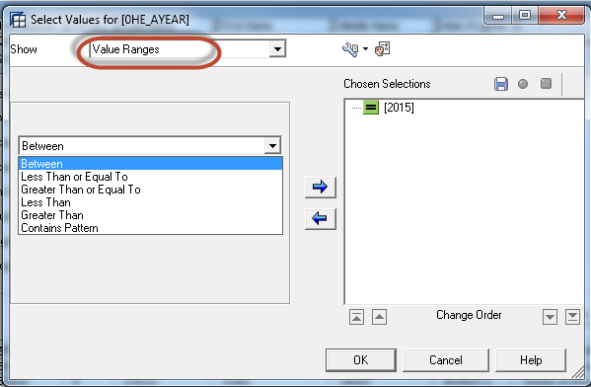
To change the way variables are displayed select the Tools icon (wrench) as shown below.
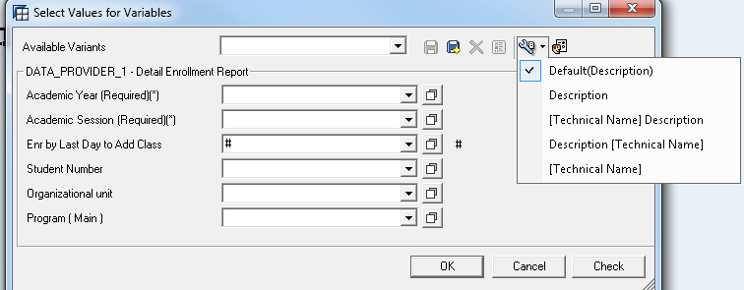

To personalize a variable(s) on the query
- Select icon
- Move the variable from Available Variables to Personalized Variables
- Select Modify Selections to further define the personalization
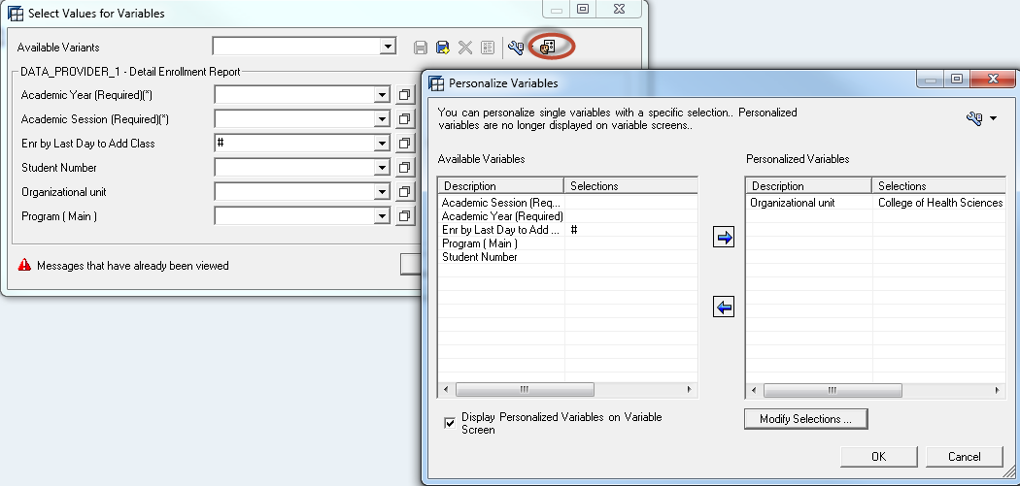
Reminder: Personalization is meant to save you time and key strokes. However, since it is an automatic way of setting a variable, it does affect reporting results. When running regular reports, it is easy to forget you have “personalized” a particular variable or parameter!
If you are getting unexpected results check for Personalization.
- Click OK after completing the Variable screen.
Your report will display.
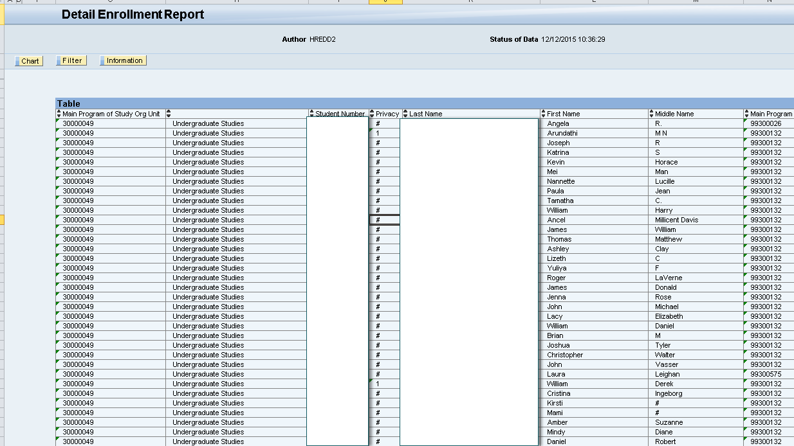

Displays the results of the report in a Chart format.
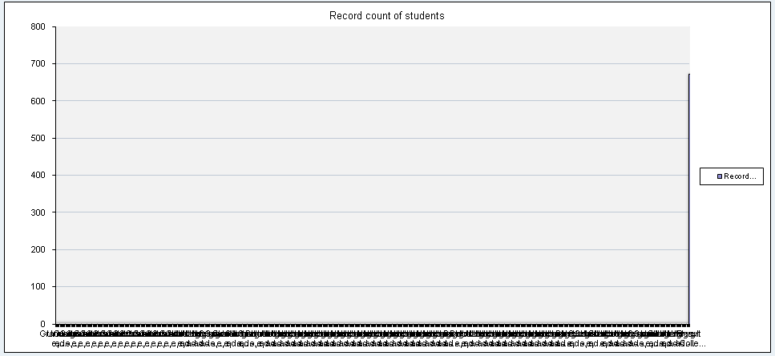
Displays additional fields you can use to filter the report.
- Double-click a field to add it as another column at the end of the report
- Right-click the field to select one of the following options
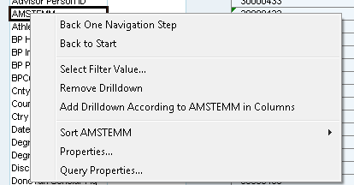

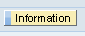 The Information tab shows the Status of Data (Last Refreshed), Query Description, and Query Technical Name.
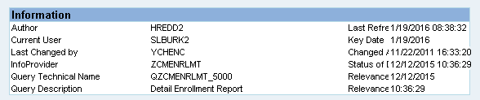

After a report has been run and one of the cells in the report is selected, new menu options will be available.
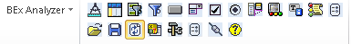
Again, the top row is the toolbar for Design. This will be addressed in a separate document.

BEx Analysis Toolbox : Save
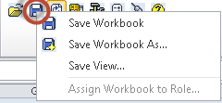
Generally, users at the University have not utilized Workbooks or Views. A Workbook is a file containing several worksheets (Excel terminology). Workbooks can be saved in your Favorites or in your Roles.
You can ignore this icon at this time.
To save your query to Excel, follow these steps:
- If the Information box is displayed, or if Filters are displayed, it is suggested you close each of these before saving the file to Excel.
  - Click on to close the window
  - Click on to close the window
- Select File
- Select Save As
- Navigate to the location you want to save your file to
- Enter a File name
- Change Save as Type from Excel Macro-Enabled Workbook (*.xlsm) to Excel Workbook (*.xlsx)
- Click Save to continue
When this message appears
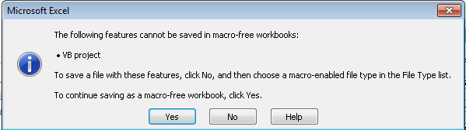
- Click Yes to continue
After the query has been saved as (*.xlsx), open the Excel document.
- Delete Rows 1 through 13
- Delete Columns A through F (or all empty columns before the Table begins)
These rows and columns are deleted because Visual Basic (VB) will no longer be active, and they are not needed in your Excel document. The saved document will now look like previous versions of Excel documents.
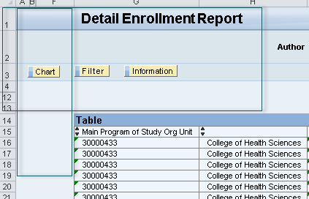

BEx Analysis Toolbox : Pause Automatic Refresh
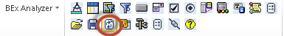
If you’ve made several changes to the query, added or removed fields, refresh the data to see the results by clicking on the icon shown above.

BEx Analysis Toolbox : Change Variable Values
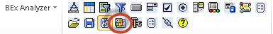
- Click this icon if you want to change any Variable values and rerun the report with new results

BEx Analysis Toolbox : Tools
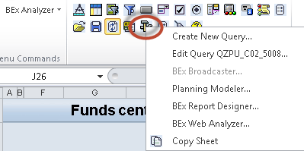
The Tools icon launches BEx Query Designer to create a new query or edit an existing query. The cursor must be in the result area of the table for the Tools icon to be highlighted. Details for creating a new query or editing an existing query will be covered in other documents.

Edit a query and save changes
- Click on the Tools icon
- Select “Edit Query”
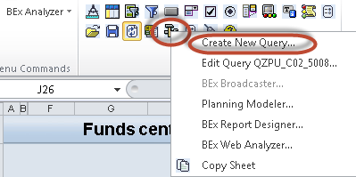
The new BEx Query Designer looks like this:
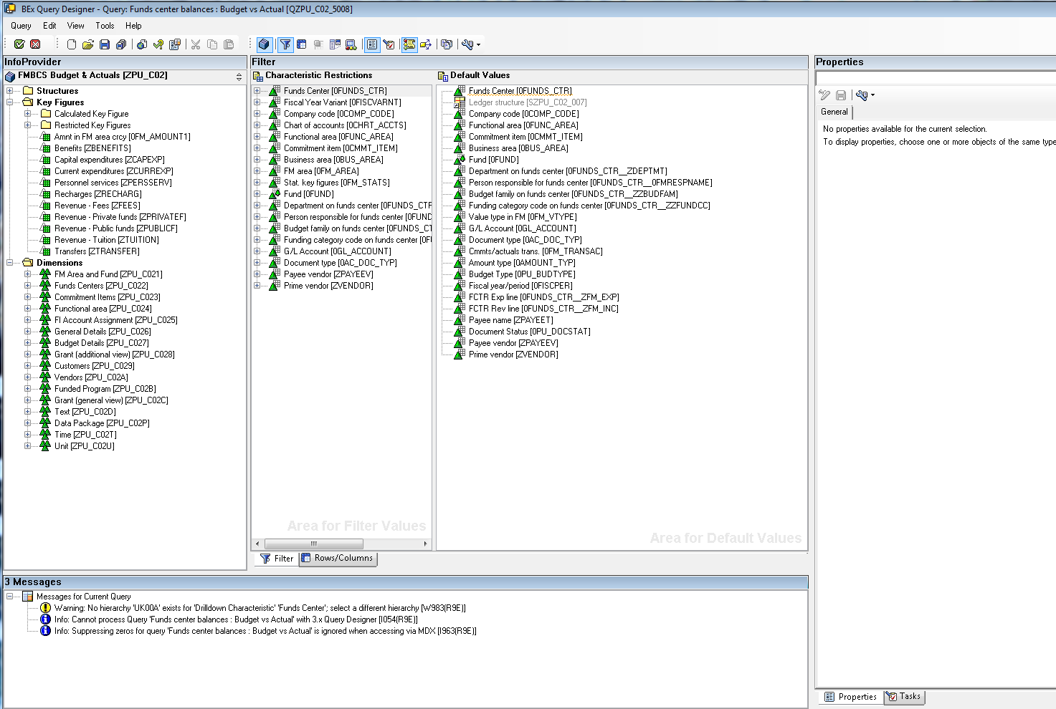
Make changes to the query.
- Select the Save icon to save your changes.
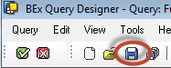
The following message will be displayed if the save was successful.
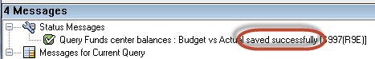

BEx Analysis Toolbox : Global Settings
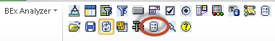
With this function, you can configure default settings for the whole application rather than for individual workbooks.
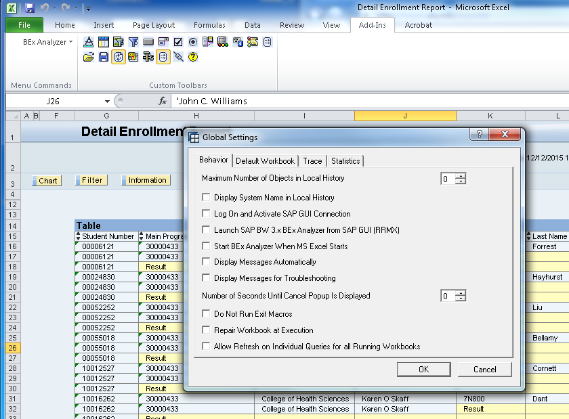

BEx Analysis : System information
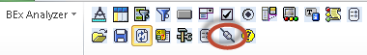
This option allows you to connect to a system, display system information, and disconnect from a system.
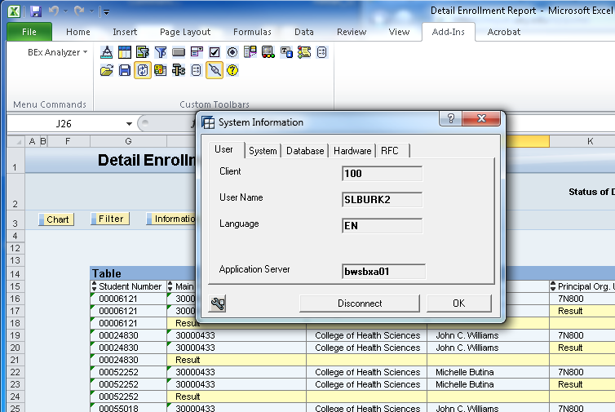

BEx Analysis Toolbox : Application Help
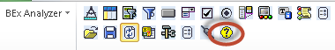
Use this option to obtain help on the screen you are working with. Application help provides instructions or information you may need to complete a task.

