How to process a JV with JV Workflow
Process: JV Workflow allows for paperless JV routing in SAP for document types SA and Z4. Attachments are uploaded to the JV in SAP for current processing and future reference.

Procedures
Gather the documentation necessary for the JV transactions and scan as PDF, in this case an expense correction. | 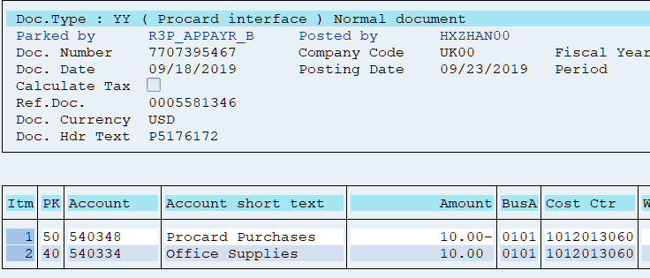
Enter JV using FV50 and save as complete. It is important to save as complete rather than park. JVs can be parked while in a draft status, but prior to initiating JV workflow, JVs must be saved as complete. Central Offices will not give final approval for posting to parked documents in JV workflow.  JVs can be uploaded using ZFI_PARK_FROM_  FILE. Choose the Save as Complete option. Documents must be saved as complete in order to be processed through JV workflow. Central Offices will only approve saved as complete documents. | 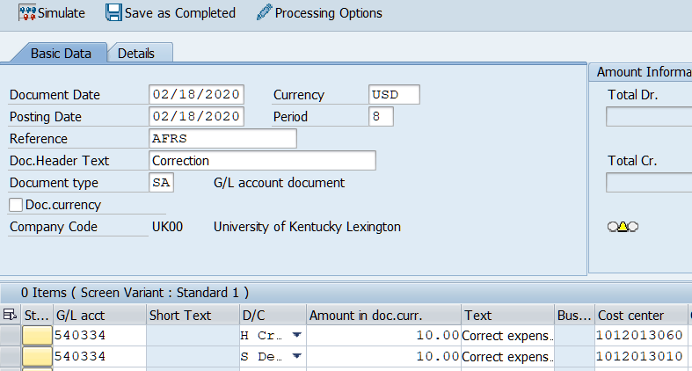  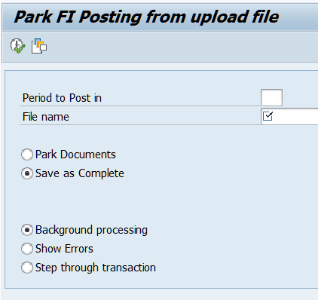
Turn the tree on, find the JV in the Complete documents folder and double click to display.  If the JV was uploaded using  ZFI_PARK_FROM_  FILE, query the JV using FB03 using document number to display. At this screen the Generic Object Services (GOS) menu icon for attachments and JV workflow is available for use. | 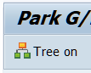  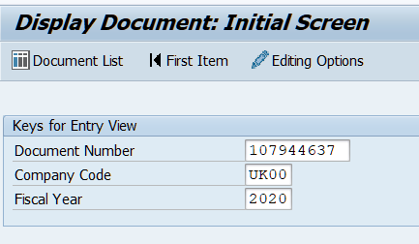  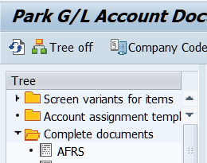  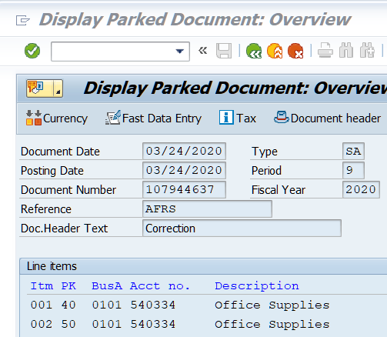
If the JV was accidently uploaded as a parked document, go to FB03 to save as complete before starting workflow. Use Document/Change, then Document/  Complete. | 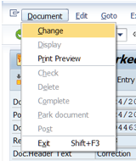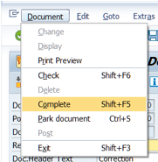
Click on the Generic Object Services (GOS) menu icon dropdown menu. | 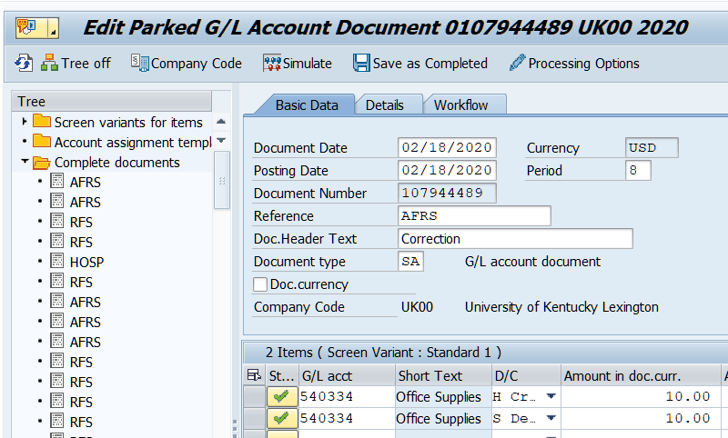
Choose Attachment list. | 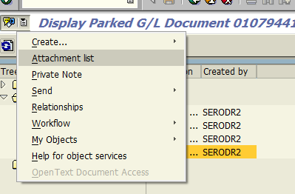
Choose New and Create Attachment in Open Text.  There are two ways to upload the support documentation. | 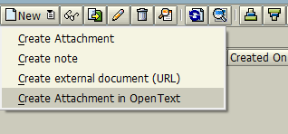
1. Select document type by double clicking to go to the file list to find the document.  Choose document and click open.  Either add description or leave blank and choose the green check. | 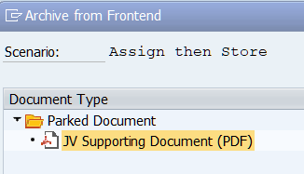  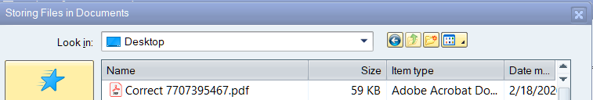  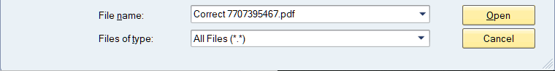  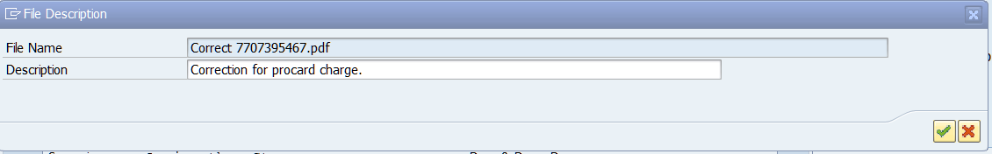
2. Select document type with single click and drag files into empty box.  Type description or leave blank and choose green check. | 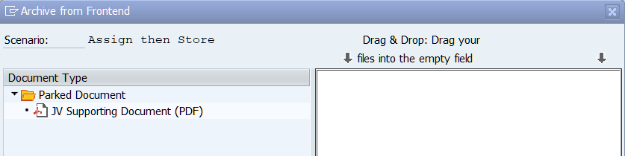
Using either method, the next step is to choose the green check at this screen.  The white box contains the information about the uploaded document. | 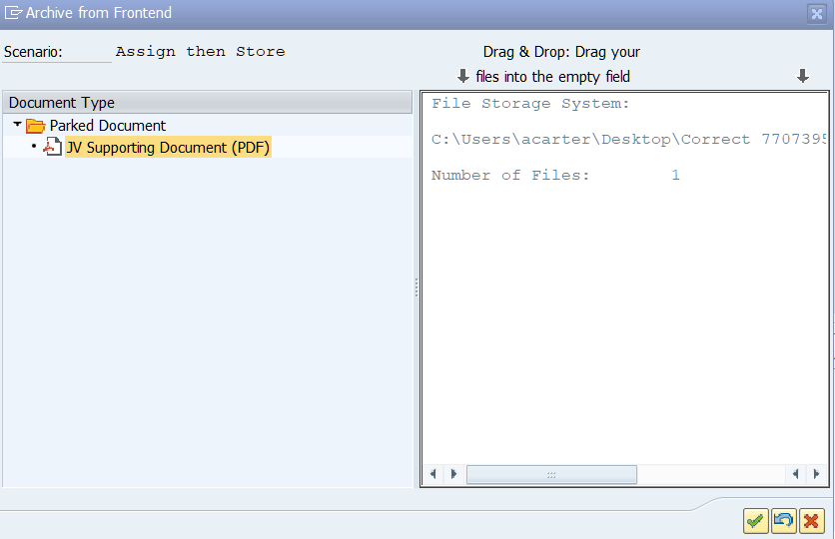

Document is ready to be attached.  Choose green check. | 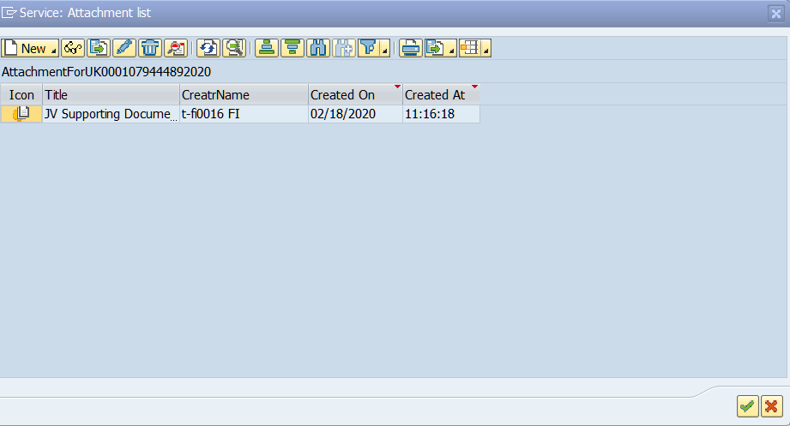
Start workflow by clicking on the Generic Object Services (GOS) menu icon dropdown menu. | 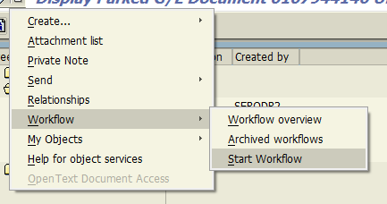
Select Start and then Business Workplace. | 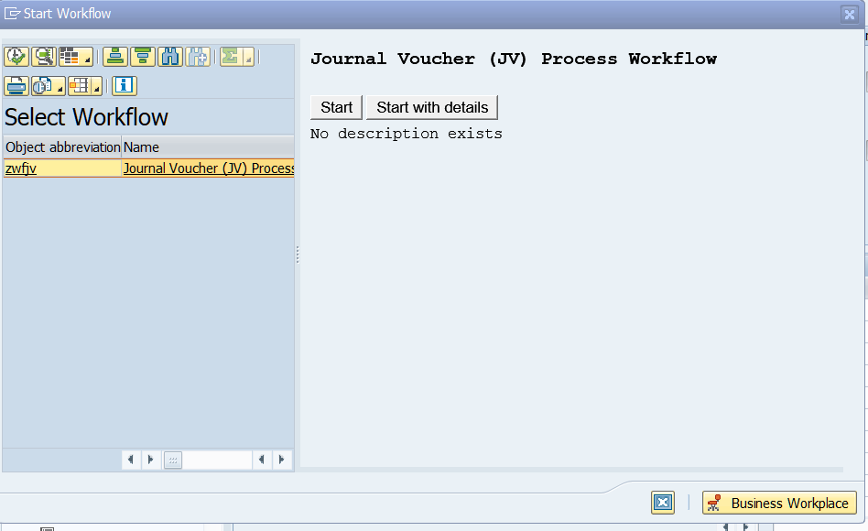
Select Inbox/Workflow to see the JV.  Double click on the JV. | 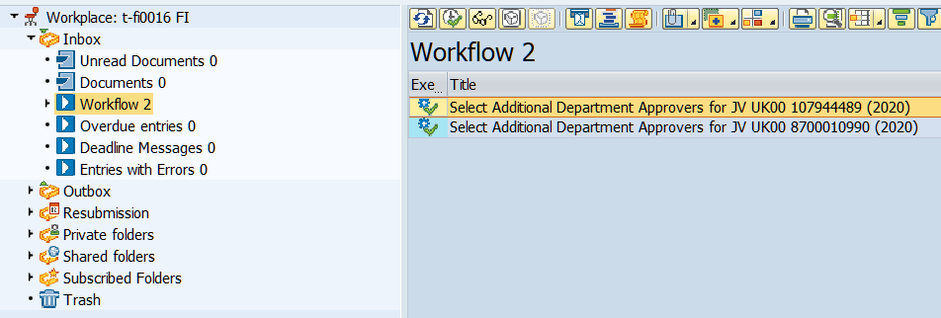

If Send to Department for Additional Approval is chosen, enter the SAP IDs of the approvers in the order that the approval is needed for the individual department and JV and choose the green check. | 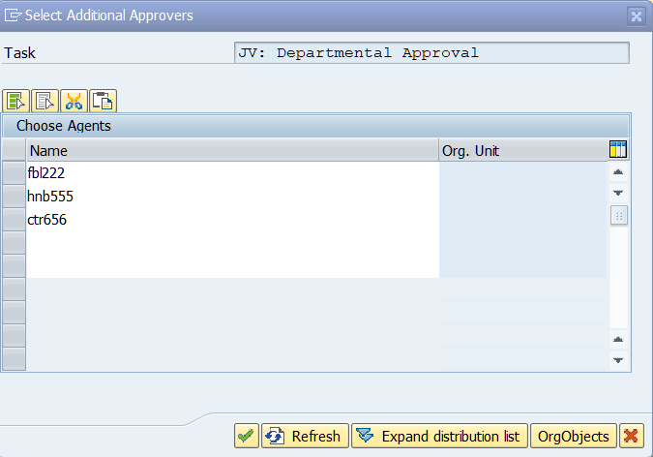
Departmental approvers will receive emails when the document is in their inbox for approval.  Access Business Workplace by clicking on the SAP Business Warehouse icon after logging into SAP.  The JV is located in Inbox/  Workflow.  Double click on JV and the following options appear.  Choosing cancel and keep work item in inbox will return to the workflow screen.  Note the descriptions provided for the different options. | 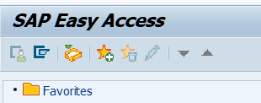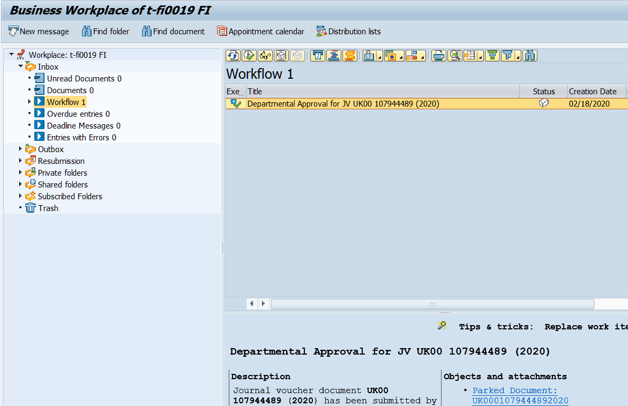  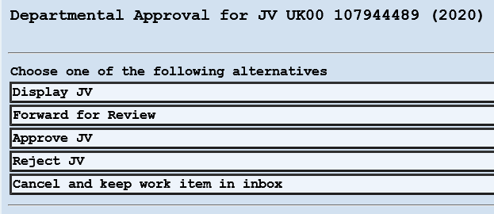  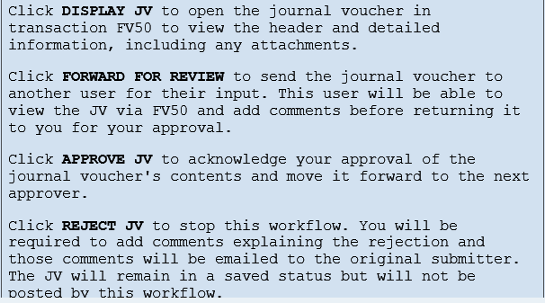
If Reject JV is chosen, enter the reason for the rejection at this screen, and choose the green check.  An email will be sent to the JV creator and they can read your comments in SAP. | 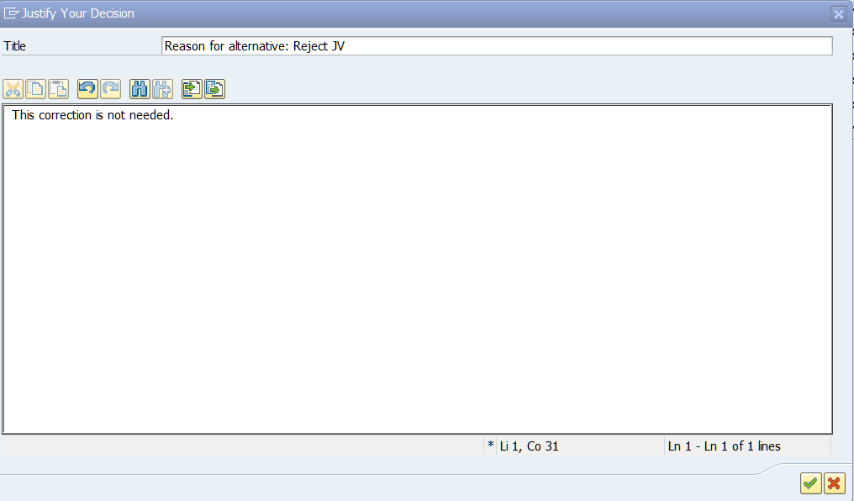
If Forward for Review is chosen, enter the SAP IDs of the reviewers and choose the green check.  A reviewer is chosen if they are not a department approver of the JV, but the department approver wants their input. | 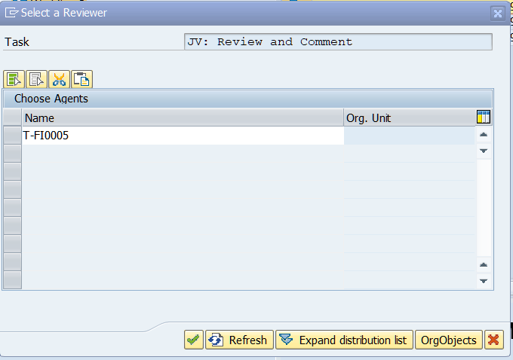
Reviewer will find JV in their inbox in workflow. | 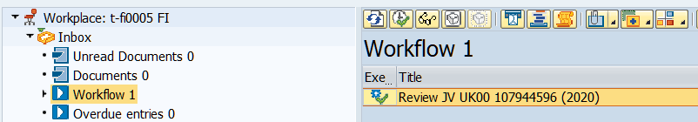
Double click on JV and the following options appear.  Note the descriptions provided for the different options.  Choosing cancel and keep work item in inbox will return to the workflow screen | 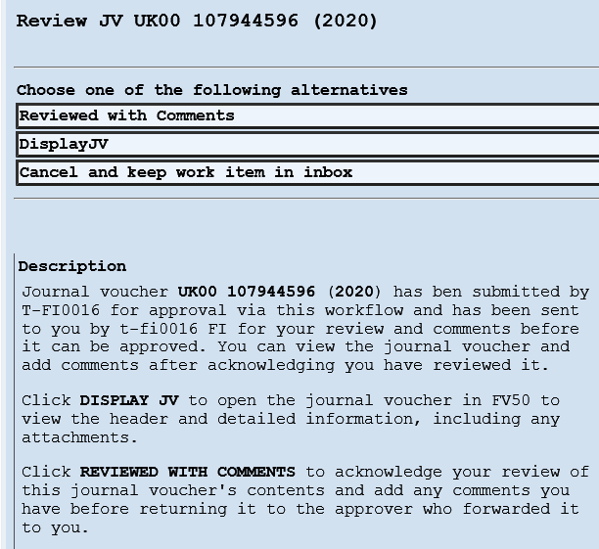
Choosing Reviewed with Comments will open a screen to use for comments.  Type a message and click on green check.  The message will be sent back to sender and the JV removed from the reviewer’s workflow. | 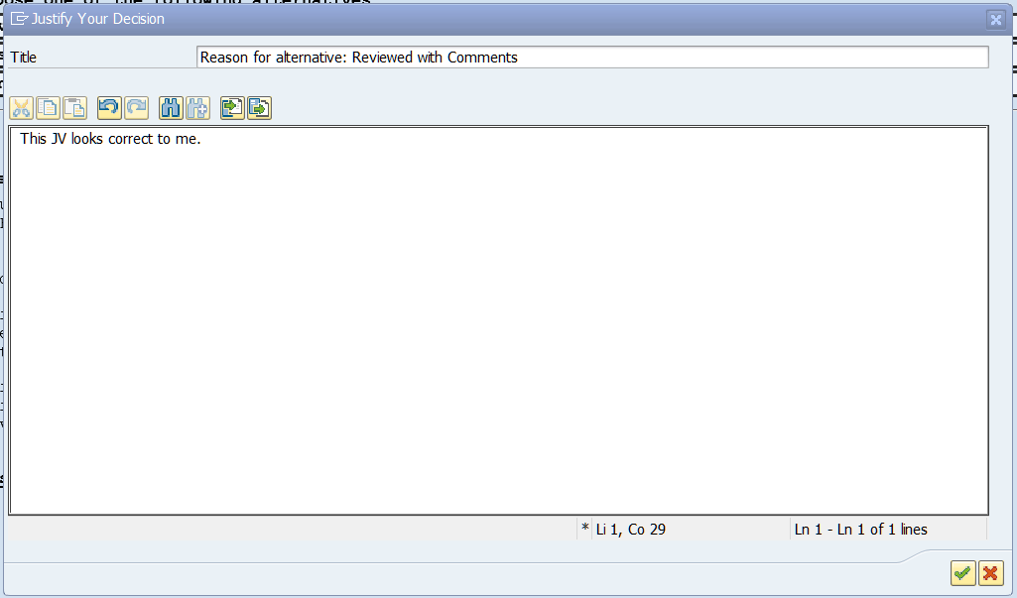
After the JV has been approved by all departmental approvers, including any reviewers they chose, it will route to Hospital, AFRS and/or RFS for final approval and posting, depending on what cost objects are on JV.  Once approval is final by the central offices, the JV will automatically post and the “Posted by” will be WF-Batch rather than the SAP ID of the individual who approved the JV. | 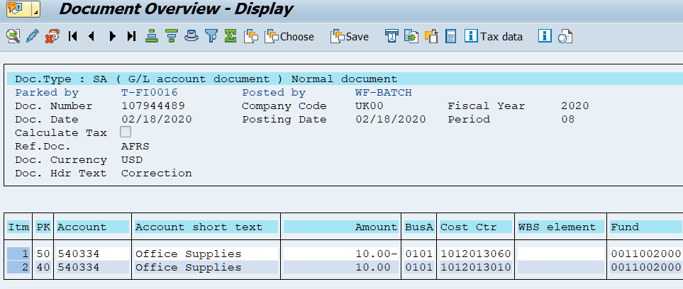
While the JV is in the system unposted, it is the JV creator’s responsibility to keep track of the JV and ensure that it posts using FV50, FB03 or Outbox/Started workflows in Business Warehouse to check on the workflow status of the JV. In this example, the JV is ready to be assigned to a final approver in AFRS. | 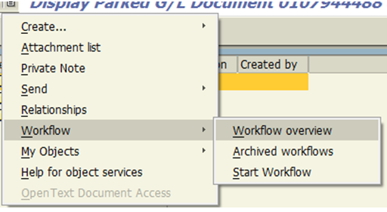  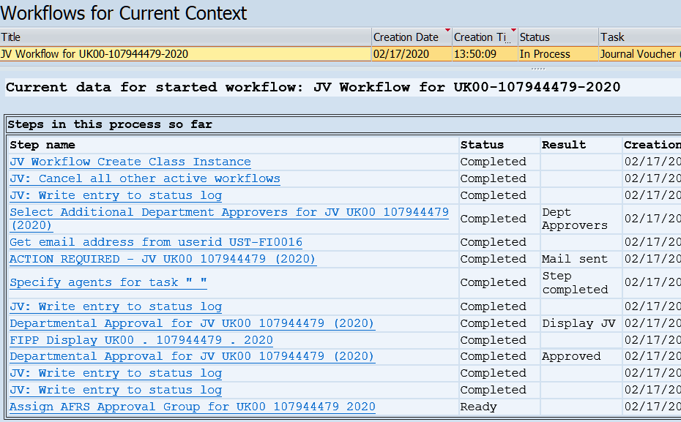
Questions? Please contact the following individuals with questions:
- 3* RFS grant SA and Z4 JVs
Sarah Rodrigues 859-257-1748 sarah.rodrigues@uky.edu
John Maddy 859-323-0687 john.maddy@uky.edu
Misty Atchison 859-257-1028 misty.atchison@uky.edu
- Hospital – JVs with Hospital business areas 0111, 0112, 0114, 0115
Mark Fedewa 859-323-5934 UKHCAccounting@uky.edu
Caroline Gann 859-323-5711 UKHCAccounting@uky.edu
Da Norm 859-218-5263 UKHCAccounting@uky.edu
- All other SA and Z4 JVs
Annetta Carter 859-257-6245 acarter@uky.edu
- JV Workflow questions and issues
Robbie Dials 859-257-6244 robbie.dials2@uky.edu
- General JV and Business Edit questions
Cindy Brown clbr294@uky.edu
- Business areas 0103 and 0500
Will Carpenter 859-257-6244 william.carpenter2@uky.edu
- Boone Center, GL accounts 5xxxxx (Operating Expense), 6xxxxx (Recharges)
Bill Coleman 859-257-1111 william.coleman@uky.edu
- Plant Fund WBS Elements (4xxxxxxxxx), GL accounts 56xxxx Capital
Lora Dials 859-257-6604 lora.dials@uky.edu
- G/L Accounts 1xxxxx (Other Assets) G/L Accounts 2xxxxx (Liabilities) G/L Accounts 4xxxxx (Revenue) Except UK Athletics, Boone Center, Housing and Dining
Derek Hitt 859-257-6290 djhitt3@uky.edu
- G/L Accounts 7xxxxx (Transfers)
Alex Lee 859-257-6022 alexander.lee@uky.edu
- G/L Accounts 51xxxx (Salaries) G/L Accounts 52xxxx (Benefits) G/L Accounts 5xxxxx (Operating Expense) G/L Accounts 6xxxxx (Recharges)
Laura Lenviel 859-257-5856 laura.lenviel@uky.edu
- G/L Accounts 51xxxx (Salaries) G/L Accounts 52xxxx (Benefits) G/L Accounts 5xxxxx (Operating Expense) G/L Accounts 6xxxxx (Recharges)
HaoXin Zhang 859-257-8638 hxzhan00@uky.edu
- G/L Accounts 55xxxx (Capital Equipment) G/L Accounts 5xxxxx (Operating Expense) G/L Accounts 6xxxxx (Recharges)

