Business Edits - WBS
Process: New edits are in place to assist users with the processing of JV documents. It is critical for the user to read the warning and error messages. Warning messages will provide users with reminders regarding backup documentation or other requirements. Hard errors prevent the document from being saved as complete. Formatting in the text and assignment fields are critical.

Procedures
Gather the documentation and scan in so it is ready to upload in workflow. | This should include:  - Labor Distributions  - Invoices or screen prints of goods receipt  - All travel related documentation of expenses for the full trip  - Rate Sheets (service centers and original billing)  - Emails to support transfer  - JV Explanation form fully completed with details of transfer and the  specific benefit to the project  - For travel and Graduate RA Tuition be sure to have 8-digit personnel number as the system will perform an effort check
How to Enter the JV = Transaction FV50 | Header Information:  - Document Date = today’s date  - Posting Date – Today’s date  - Reference = RFS for all JVs with at least one 3* WBS element.  Otherwise AFRS or HOSP based on cost objects used  - Doc Header Text = information helpful to the department  (i.e. Allocate printing expense)  - Document type = SA nonpayroll transfers or Z4 payroll documents (GLs 51 and 52)
Example: |  | 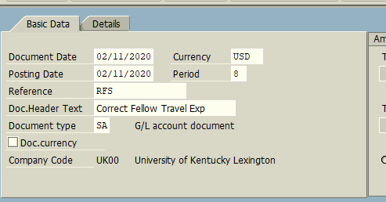
Line Entry: |  | Enter:  - GL Account  - Debit or Credit indicator (S= Debit and H= Credit)  - Amount associated with the GL  - Assignment (if applicable) = Valid 8-digit employee number  - Text = Must be the date of service in MM/DD/YY format  - Additional text is allowed in the assignment and text fields following the required information.  - Cost objects (WBS, cost centers, etc…)  - Enter information as usual on all remaining lines
Save As Complete |  | The Save as Complete function will run the edits on the document.  - Messages may pop up at the bottom of the transaction  - For warnings, please read carefully!  - Ensure all requirements are met and documentation is included with submission of JV.  - Be aware that if the document has more than one issue, the  system will only display one warning or error message at a time.  - DO NOT just enter through these messages.  Reference crosswalk for further explanation
Examples of messages |  | Hard error message – document will not save as complete  You will not be able to proceed until errors are resolved
Warning message – document will continue to save as complete

Be aware of warning messages. If items are not addressed the JV may be rejected upon review.

Document is successfully saved as complete
REMEMBER: |  | - A JV document MUST be saved as complete  - All documentation should be uploaded as attachment  - Please read any warning messages as JV may be rejected if proper attention was not given  - If these steps are followed, the new edits will drastically reduce the rejection of JVs through workflow and will allow for items to be reviewed and posted timely
Questions? |  | Please contact the following individuals with questions:  - 3* RFS grant Business Edits  Sarah Rodrigues 859-257-1748 sarah.rodrigues@uky.edu  Tina Reynolds 859-257-6267 tina.johnson@uky.edu  John Maddy 859-323-0687 john.maddy@uky.edu  Misty Atchison 859-257-1028 misty.atchison@uky.edu

