Title: Cost Share Funding – by Account and/or Individual
Process: Calculate cost share balances and create a journal voucher (JV) to fund cost share, either by account or individual.

Procedures
Determining cost share balance on an account level using BEX:  (BEX reports do not include Z4 documents)  Locate Grant Ledger under FI Financial Accounting/Grants Management in BW. |  | 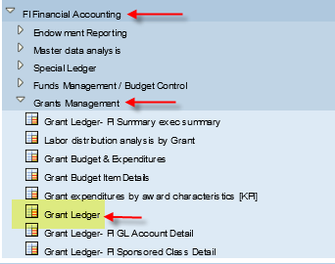
Variable screen:  - Enter fiscal period/year  - Enter grant #  - Delete E999999 from Sponsored Class  - Fund = 001189*  Click Execute  *Can also enter fund department #/range instead of grant |  | 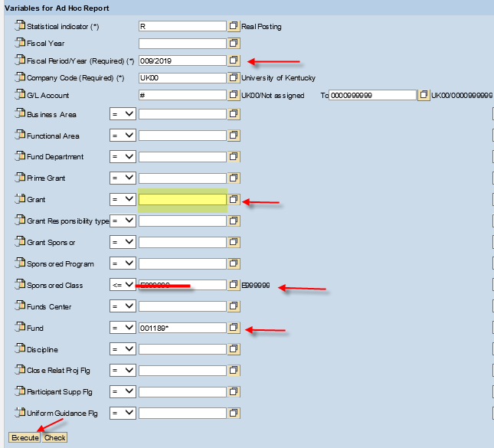
Scroll to the end of the report. If the final result row in the Cumulative PTD Expense column is a debit (positive) balance, funding is needed. If there is a credit (negative) balance, the account is overfunded. | 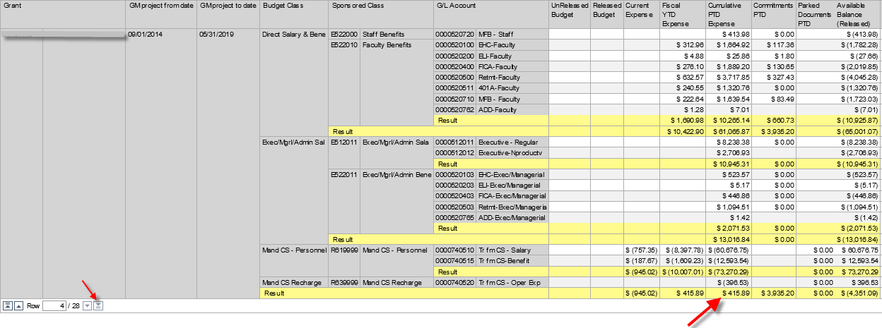
Determining cost share balance of an individual:  Locate Labor distribution analysis by Grant under HR Labor Distributions in BW. | 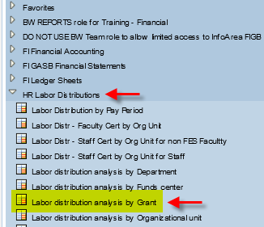
Variable screen:  - Enter grant #  - Fund = 001189*  - *Fiscal Period/Year optional*  Click Execute  *This report can be run one period at a time by entering the fiscal period/year or cumulative if left blank* | 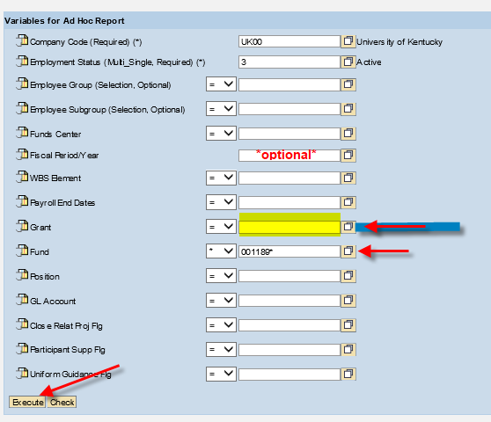
Filter for the individual you are cost sharing for by First Name, Last Name, Employee #, or Person # | 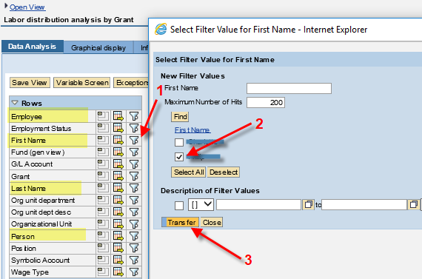
An example of one individual paid on the grant provided on the variable screen | 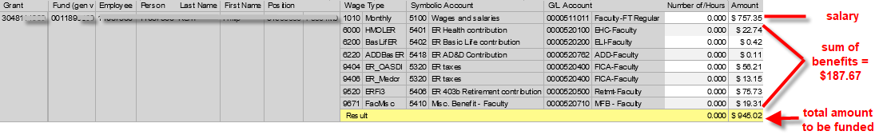  *The total balance does not include JV’s that have been processed*
Determine cost share account balance using SAP:  1. Open S_ALN_01000003  - Choose CS Balance Variant  - Enter grant  - Click execute | 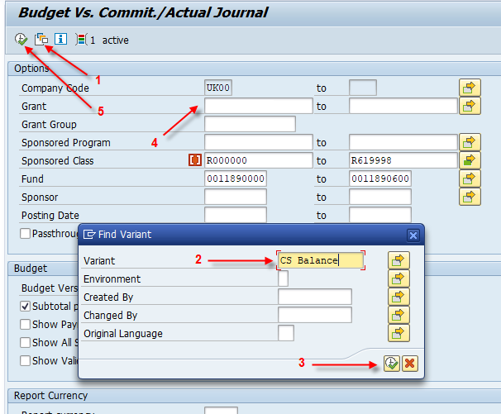
Invoice column shows funding balance.  - Positive balance = account needs funding.  - Negative balance = account is overfunded. | 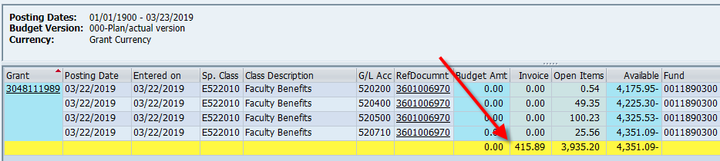
2. Open S_PLN_16000269  - Enter Grant #  - Fund: 001189*  - Execute | 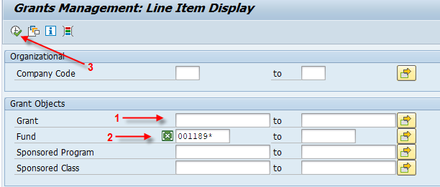
All transactions posted with 001189* fund will be visible.  Sum at the bottom shows funding balance:  - Positive balance = account needs funding.  - Negative balance = account is overfunded. | 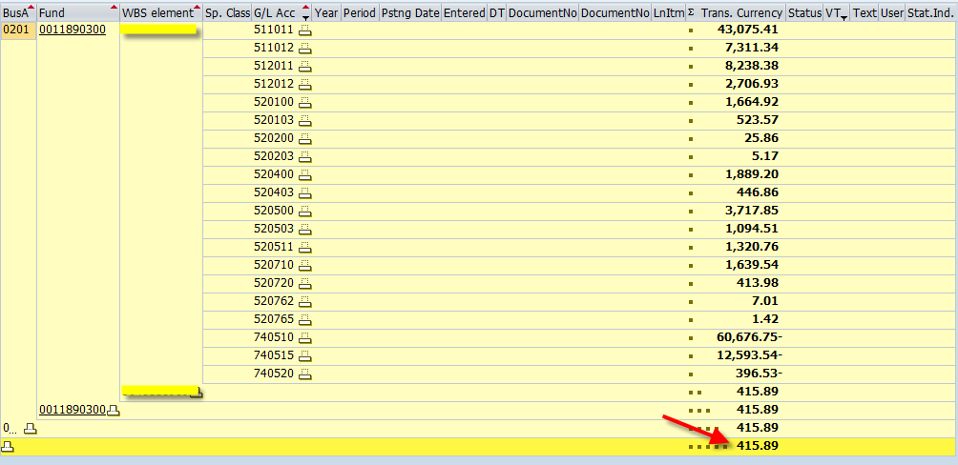
Creating a cost share JV:  General Ledger Accounts used to fund cost share via JV: | - 740510 Transfer from Cost Share – Salary Only  - 750510 Transfer to Cost Share – Salary Only  - 740515 Transfer from Cost Share – Benefits Only  - 750515 Transfer to Cost Share – Benefits Only  - 740520 Transfer from Cost Share – Operating Expenses  - 750520 Transfer to Cost Share – Operating Expenses
Debit entry will be to the cost center from which you are moving fund from (75* GL).  Credit entry will be to the WBS element that needs funding (74* GL).  Key in both the WBS element and cost share fund (001189*) to ensure accuracy.  Backup is only required if there is a need to explain an unusual circumstance.  Suggest keying the employee or person # in assignment field to easily identify all JVs related to the individual. | 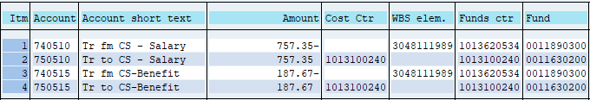
Automatic Cost Share Funding Program | Departments can elect to participate in monthly automatic cost share funding by providing a cost center to RFS. This program will fund all outstanding balances on each award with the department noted as the responsible unit that have cost share expenses posted for the month.  Any expenses charged to grants outside of the responsible unit will not be included in the automatic funding.  Reach out to the Research Financial Services Contact for more information.
Additional Information: | Cost Sharing BPM: https://www.uky.edu/ufs/sites/www.uky.edu.ufs/files/bpm/E-50-2.pdf  Research Financial Services Contact:  Jessica Milner 257-6282 jessica.milner@uky.edu

