How to upload a Z4 JV to edit payroll transactions
Process: The new document type Z4 provides consistent formatting and allows for greater accuracy of payroll information in SAP and for payroll confirmations. If you have a high number of employees and pay periods that must be corrected each month, an upload template can be used rather than typing the information into FV50. The template will be completed in Excel and saved as a Text Tab Delimited file. Using the ZFI_PARK_FROM_FILE in SAP, the file will be uploaded by the department to the ECRT system. As the file will only be parked, the department personnel will then save it as complete so the entries will undergo the edits. A central repository for reports in ECRT will assist departments to see both payroll system and SAP journal vouchers entries.

Procedures
Gather the documentation, such as the labor distribution. Pull the HR Labor Distributions using BW Web Reporting  Choose to run the report by Funds Center or by Grant | 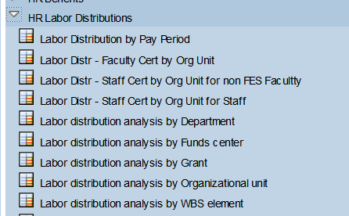
There is nothing to be input on this Variables page at this time. At the bottom of the page, click on Execute. Later in the process, the cost object will be added. | 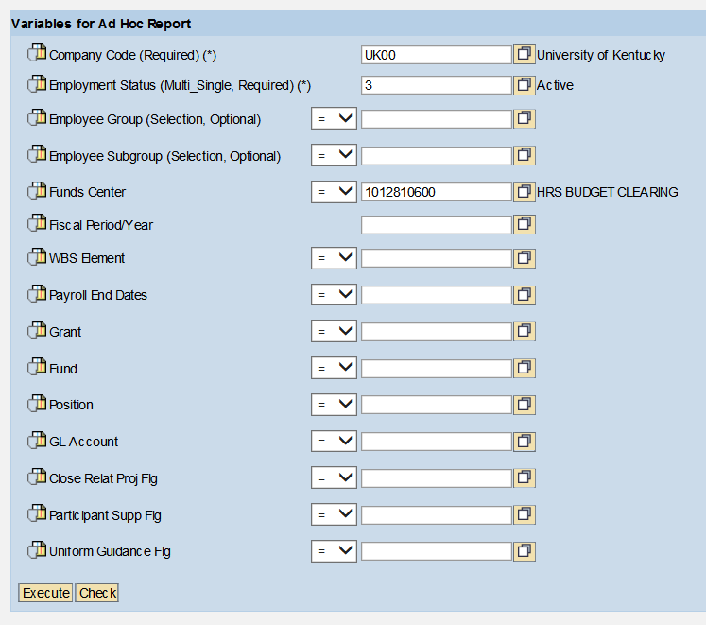
At the top left of the screen, click on Open View.  This will allow to choose a previously used view or add a view. Then choose Transfer to use.  Grant – ZKEBOYD00JVPAYROLL  Cost center – ZKEBOYD00JVCOSTCENTER | 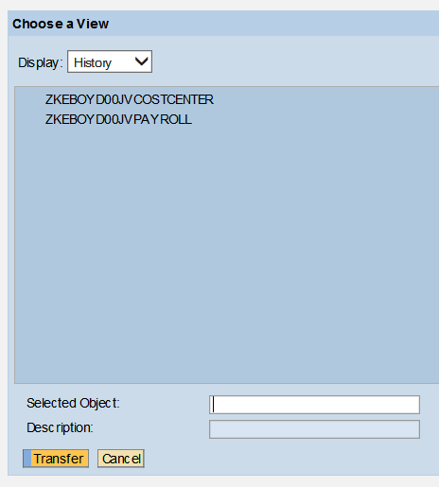  Previously used  Add new view
After confirming the view with Transfer, the screen will go back to the previous screen. Choose Variable Screen.
Input the cost object to be corrected. Then click on Execute. Note: If this step is not completed, the view information will be associated with the cost object that was used to create the view and not the cost object that needs to be used for the JV. | 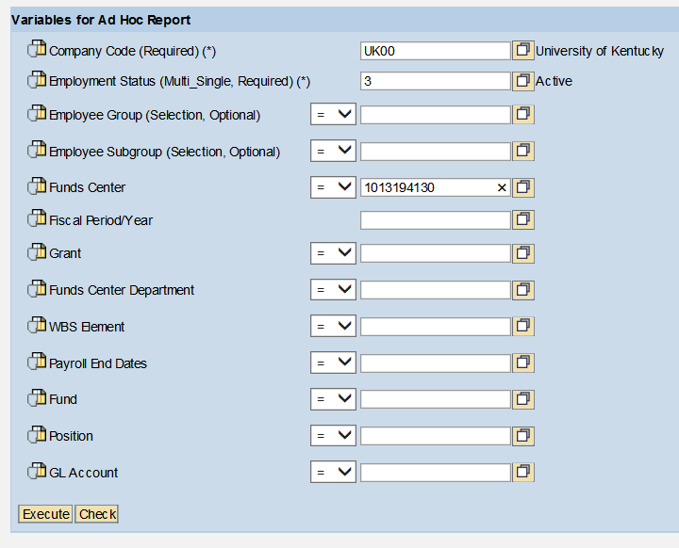
Filters should be used to only bring up the employee(s) whose payroll should be corrected and the appropriate payroll “for” period(s). | 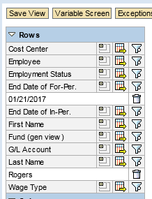
The labor distribution should include the wage type, “for” period, employee number and amount.  Each employee and each pay period will be entered separately on the JV. | 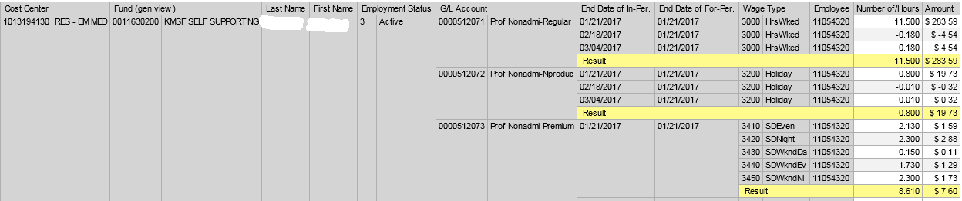  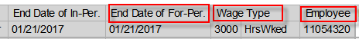
Using Excel, open a JV upload template. If one is not readily available, go to www.uky.edu/ufs/quick-reference-guides for the AFRS example JV upload template that can be used. | 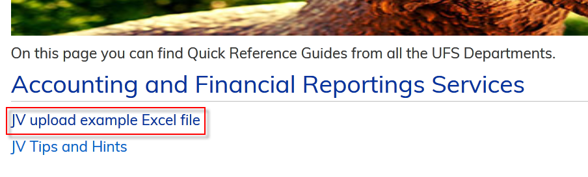
The first 6 columns of the JV upload template will be the same for all the rows. The columns after the 6th will be data that is normally used in a JV document. | 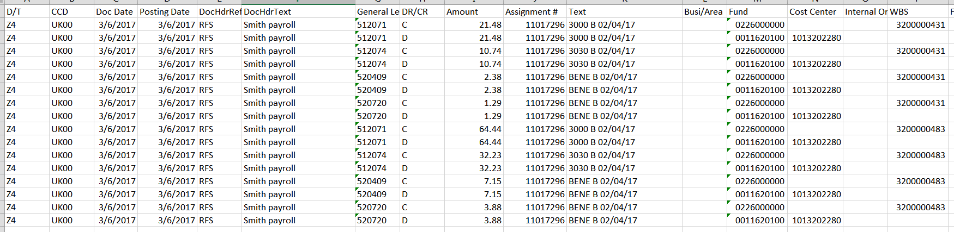
Fill in the D/T (document type) as Z4 and CCD (Company Code) as UK00. Enter both the Doc Date and Posting Date with today’s date. | 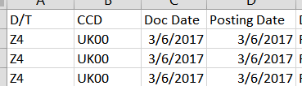
Fill in the Reference according to the cost objects on the JV. Use the following to determine the reference designation to be used.  “RFS” for all payroll JVs with at least one 3* WBS element.  “HOSP” for payroll JVs with only 105xxxxxxx to 107xxxxxxx cost centers.  “AFRS” for payroll JVs with a combination of 105xxxxxxx-107xxxxxxx cost centers with any other cost center or WBS elements other than those beginning with 3*.  Also fill in the Doc Header Text with information helpful to the department. | 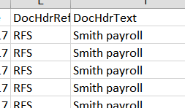
Use the labor distribution to input the GL account, DR/CR indicator (D=Debit and C=Credit), and amount associated with the GL. Fill in the Assignment with the employee number. It must be 8 digits, for example number 6274 would be 00006274. | Note: amounts should not include commas or negatives
Enter the information into the Text. Formatting in the text and assignment fields are critical.  WWWW Wage type (will be a number for 51* salary GL accounts and BENE for all 52* benefit GL accounts).  Enter M for monthly payroll or B for bi-weekly payroll.  Enter the ending date of the “for” payroll period as mm/dd/yy.  Additional text can be entered by adding a space after the “for” period and typing the text on the line. This is helpful if the JV covers multiple employees. | 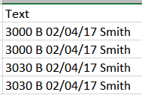  Wage Type  Bi-weekly or Monthly  Additional text  For Period
Enter the cost object for the first line.  Enter the remaining lines for the JV using the same formatting utilized on line 1. | 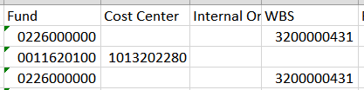
Save the file as a text tab delimited file. Close the file before attempting to upload to SAP. | 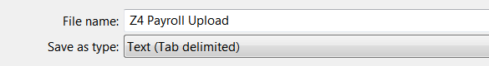
In SAP, go to transaction ZFI_PARK_FROM_FILE  Then enter the period. Browse for the file name and path to be uploaded. Click on the buttons for “Save as Complete” and “Background processing.” | 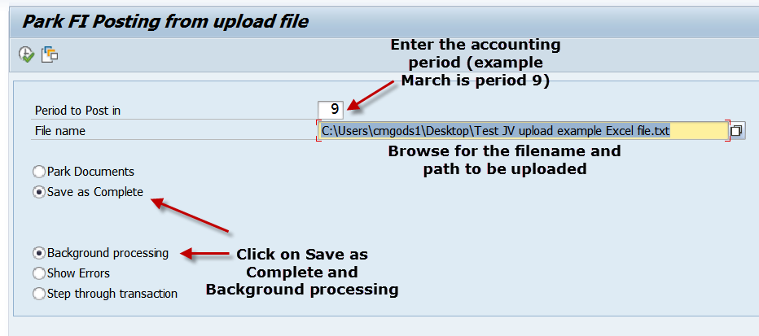
When the transaction is ready, click on execute.  SAP will now check the document for errors and will either save as correct by assigning a document number or report errors. | Execute  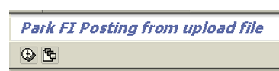
If any errors occur, look at the messages at the bottom of the transaction and correct the information on upload Excel file and resave the file to upload.  Try to save as complete again. Please be aware that if the document has more than one issue the system can only display one warning or error message at a time. | Check the bottom of the screen for errors  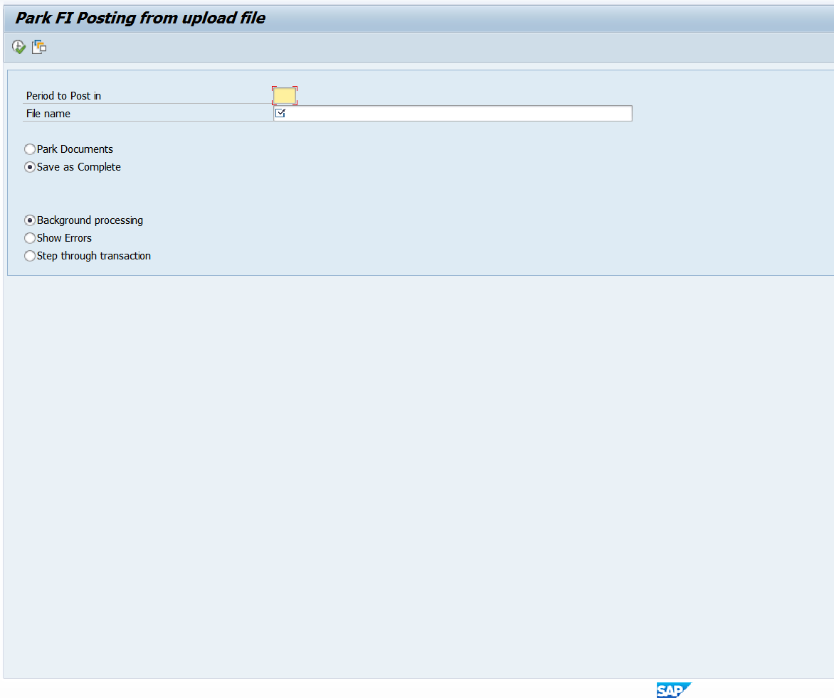
After the JV has been saved as complete
- Be aware that the Z4 JV document number will begin with 87*. Write down the number when it appears on screen.
- Follow the online JV process to attach backup documentation in OpenText and start the workflow (https://www.uky.edu/ufs/online-jv-process). JV workflow approval should include all of the appropriate signatures (JV approval in SAP), and attach the documentation needed to substantiate the JV such as labor distributions, emails, and payroll retro exception request.

Exemptions to the Edits
In rare cases, a payroll JV may need to be created that would go against one of the error edits on the Z4 document (for example, a payroll correction to only 51* salary GLs on a 3* WBS element). In these cases, park the document in SAP rather than saving it as complete and email the appropriate processing office to discuss the situation. If the edit exemption is approved, the processing office will save the JV as complete and will email the department to let them know that the JV has been saved as complete in SAP. Attach the email to the JV as backup for the exemption to the edits and route the document as usual to UFS for processing.
NOTE: Be aware that when the processing office saves the document as complete, they are not “approving” the JV at that time, they are only allowing the JV to move forward in the JV process. The JV will be approved or denied when it is formally submitted through JV workflow.
Helpful Hints
- The user needs to be sure to use the correct wage type for salary 51* GLs on the JV. The wage types vary for biweekly, monthly, and different employee classifications. Use the labor distribution views for BW given in this presentation to ensure the appropriate wage type is chosen.
- The user cannot have more than a few layers of folders for the system to look through. It is best for save the upload text files with a file path of less than five folders.
- Keep the formats consistent with the formats given on the original JV upload template.

Special Edits for ALL Payroll JVs
- Only salary 51* and benefit 52* GLs are allowed on Z4s, no other expense GLs.
- GLs cannot change between the debits and credits. For example, cannot input 512181 for salary debit line and 512041 for salary credit line. (If you have a situation where reclassification is necessary, see the exception section for instructions – should be rare exception.)
- The benefits must follow the same personnel grouping as the salary.
- If assignment or text fields are not in the correct format or are blank, the user will receive an error message.
- The system will check for valid payroll periods.
- Validity of personnel numbers will be checked.
- Funds starting with 04*, 05* and 07* are not allowed on the payroll JV (plant, loan, and endowment funds)
- The fund 0011000000 is not allowed on the payroll JV.
- Changes cannot be made to the assignment and text fields of the JV after posting ensuring internal control over payroll data.

Special Edits for Sponsored Project 3* WBS Elements
- Will not allow to post with only salary 51* GLs on the JV – the associated benefits must be moved as well.
- Payroll postings to or from projects with ROE dates, the user will receive an error message to contact the financial administrator.
- Payroll period will be checked against budget and pre-award dates by the system to be sure the payroll correction is within the time period of the project.

Questions? Please contact the following individuals with questions:
- 3* RFS grant Z4 JVs
Sarah Rodrigues 859-257-1748 sarah.rodrigues@uky.edu
- All other Z4 JVs
Laura Lenviel 859-257-5856 laura.lenviel@uky.edu
Averie Pritchard 859-257-6632 averie.pritchard@uky.edu

