***ecrt Users Guide***

**A Quick Guide for Department Effort Coordinators completing the Pre Review Process in a Backup Capacity**

**IMPORTANT: This guide is for users who will be performing functions in a backup capacity to the Primary Department Effort Coordinator. Both roles have the ability to perform the same functions, so communication is essential.**

**For best results do not use internet explorer to access the URL. Instead we recommend that you select Chrome or Firefox as your browser.**

1. Log in to the myUK portal page. At the top of the page select the Enterprise Services or Faculty Services tab. Next select the ecrt Payroll Confirmation subtab.

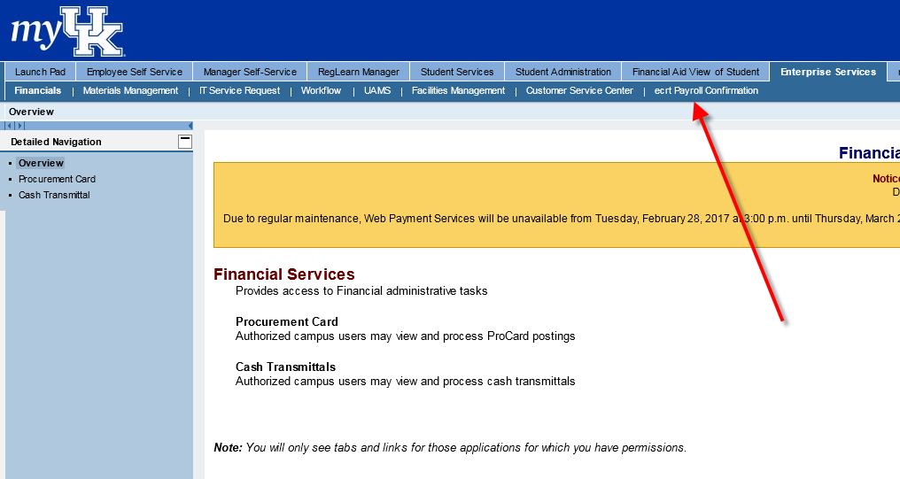

1. Click on ECRT Payroll Confirmation and the welcome screen will appear.

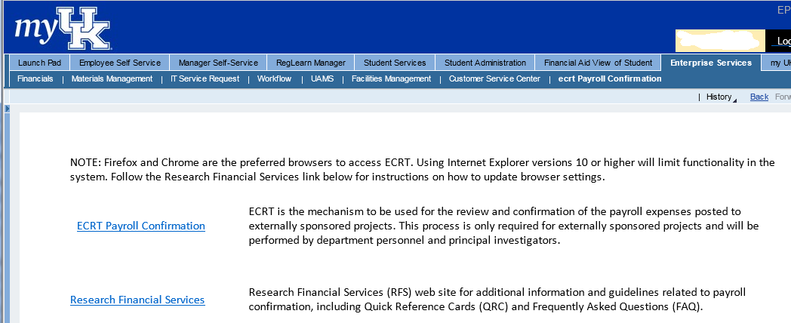

1. From the ECRT Welcome page, press the continue button to navigate into the system.

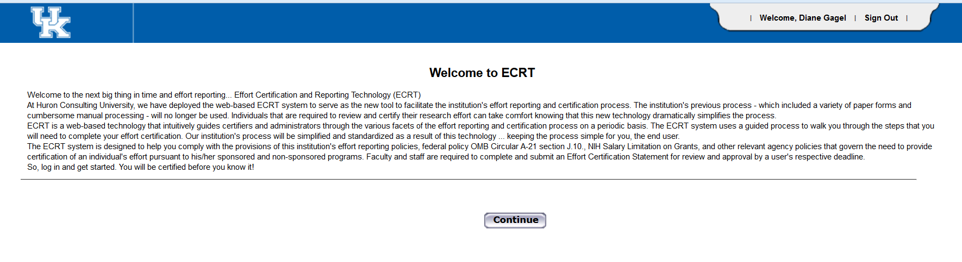

1. Once logged in, the screen will default to your homepage.

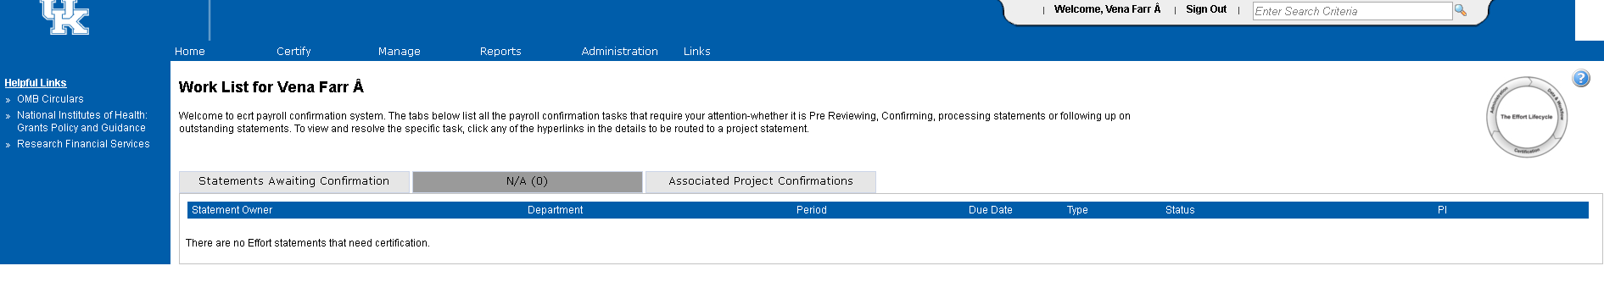

In order to route to project statements that are “Ready for Pre Review”, you will want to go to “Manage” and then select the Department Dashboard option. Then you will select the department that you want to work on, if you are related to more than one department.

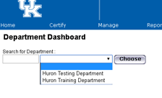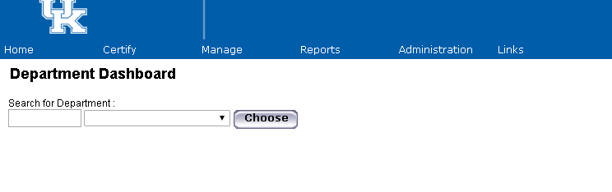

1. From the Department Dashboard, you will want to make sure that you are on the “Project Certifications” tab in order to view the project statements that you will need to Pre Review.

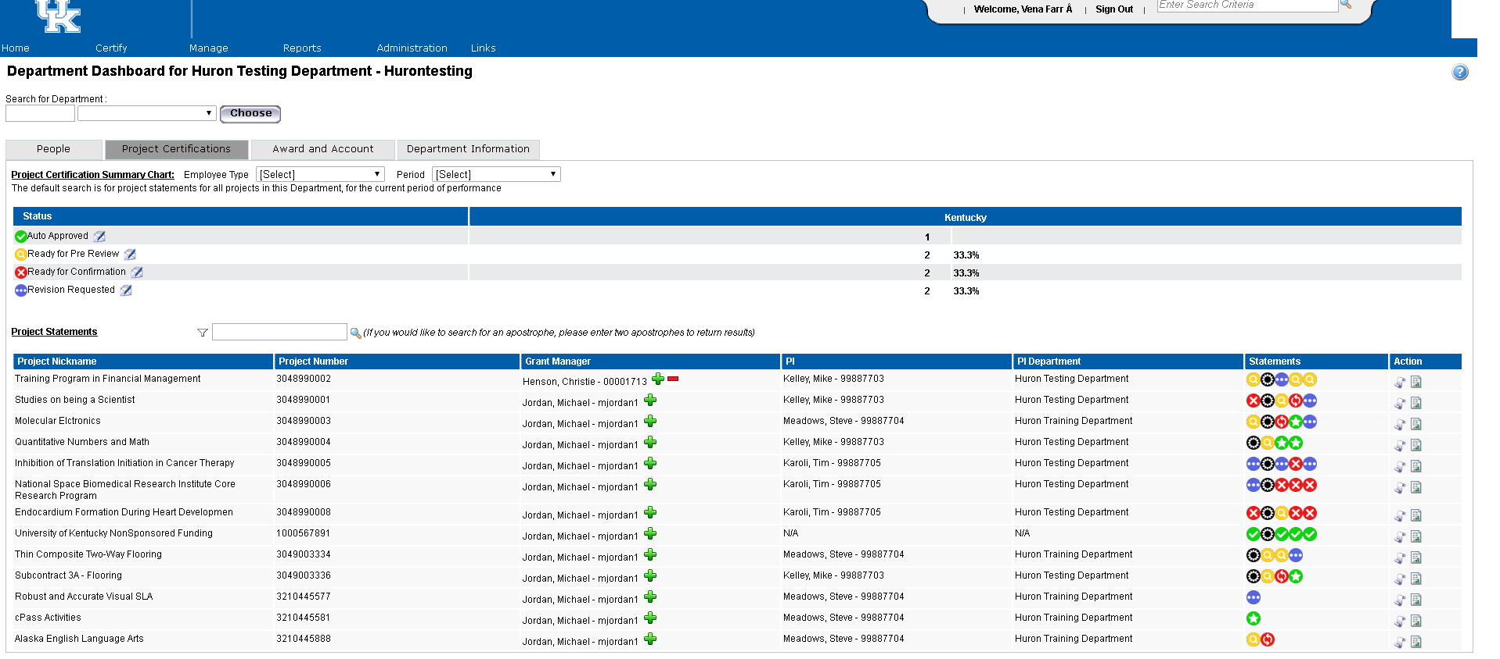

1. The projects that are ready for pre review (yellow icon with magnifying glass) are the ones you need to take action on at this time.
2. To select a specific project in pre review status, click the Ready for Pre Review icon on the associated line for that project.
3. After clicking the selected project, the project statement page will appear.

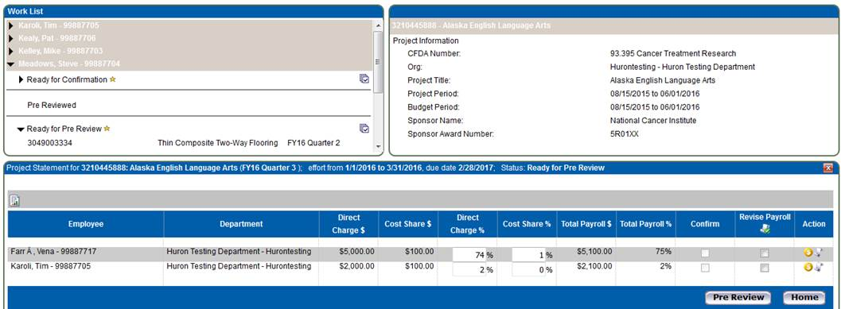

1. On the project statement page, you will find a variety of information about the project.
   1. The box in the upper left corner of the page is the work list. This contains a complete list of all projects and their associated Principal Investigators for which you (as the Primary Department Effort Coordinator) have the responsibility for completing a pre review of the payroll expenditures posted for the reporting quarter.
   2. The box in the upper right corner of the page contains information specific to the sponsored project, which can also be found on the GMGRANTD tab in SAP.
      1. For example, the CFDA number is an indication as to whether or not the project contains federal funds. If there are no federal funds associated with the project, this field will be populated as 99.999.
      2. Project Period indicates the entire length of the award period. For example, if your project is a 5 year award from NIH, the project period would reflect the entire 5 years, just as it does in SAP.
      3. Budget Period may be shorter than project period. Again, using the example of a 5 year award from NIH, if you have only received incremental funding through the second year of the award, the budget would only reflect the 2 years for which we are authorized to incur expenses.
   3. The main section of the page contains the detailed information associated with the specific project which needs to be pre reviewed. The blue ribbon on the project statement indicates the time period contained on the statement as well as the due date. **Note** – due date indicates when statement must be both pre reviewed and confirmed (if applicable).
2. During the Pre Review Process the Department Effort Coordinator should:
   1. Verify that all individuals that should be paid from the grant or cost shared on the grant appear on the project statement.
   2. Compare the dollars per individual on the project statement to the project budget.
      1. Do the amounts per individuals match what was requested to be entered by the payroll person?
      2. If there is a variance between the expected amount and actual amount charged. Why?
      3. Is an individual being cost shared when they should be direct charged or the reverse?
      4. Is there anyone being charged to the project that you did not anticipate?
      5. Is there anyone missing from the statement whose payroll should have been charged?
      6. Other variances?
   3. If a determination about the accuracy and completeness of the payroll expenditures cannot be made based on available information, the PDC may need to consult with others in the unit such as the Payroll Specialist, College Grants Officer, etc. so that any missing or erroneous information can be corrected timely and will reduce the need for repeating the process at a future time.
3. After completing the pre review, if you are confident that the information is accurate, click the Pre Review button at the bottom of the project statement.  This then updates the status to Pre Reviewed. Which means this step is complete and no further action is required at this time, unless any additional adjustments (via payroll retro) are posted to the project before it moves on to the ready for confirmation stage and is confirmed (federally funded) OR auto approved (non-federally funded). So, communication between the department effort coordinator and payroll specialist is the key to ensuring that any changes that have retroactive implications are shared in a timely manner.
4. If, after completing the pre review, you have determined that a correction to the payroll expenditures is needed, for one or more persons listed, click the revise payroll checkbox next to the name(s) of the individual(s) requiring an adjustment.

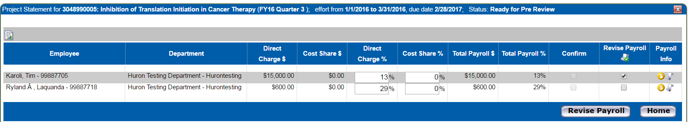

After selecting the checkbox, a new button  will appear. The status of the statement then updates to “revision requested”. The statement remains in revision requested status until the payroll adjustment is made. This statement remains on your work list, but moves from the “Associated Project Confirmations” tab to the “Pending Payroll Tasks” tab.

* **Please note that if there is a missing person on the project statement, you can select the revise payroll checkbox for any individual listed on the project statement and select the Revise Payroll button.**

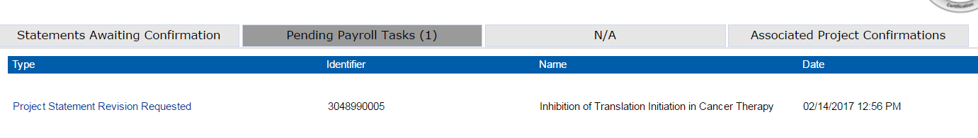

1. From the “Pending Payroll Tasks” tab, you will click on the link to go to the “Project Statement Revision Requested” task. The task will look identical to a project statement; however, different buttons will appear along the bottom allowing you to determine the appropriate next step.
   1. If you select the reject button, the statement will return to “Ready for Pre Review” status. Selecting the reject button means that you do not think that a revision is necessary after reviewing the payroll information.
   2. If you select the “Approve” button, the statement remains in “Revision Requested” status and will remain there until the correction to payroll is loaded into ecrt. This means that you do think that a revision is necessary to the project statement.

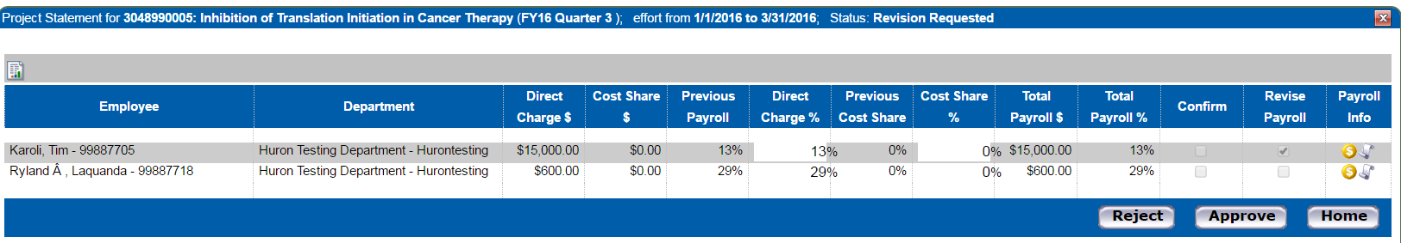

1. The Primary Department Effort Coordinator will receive a system generated email reminder when additional payroll associated with this task has been loaded to ecrt. (*Since the Department Effort Coordinator role is being used in a backup capacity, you will not receive the email notification but will be able to see the actions taken in the ecrt system.)* When the additional payroll is loaded, it will create a task on your homepage under the “Pending Payroll Tasks” tab. You will have two options for next steps.





1. Clicking the View Project Statement icon allows you to revisit the original payroll expenditure amount for the reporting quarter and verify if the amount of the revision that has now been loaded to ecrt is correct. If so, clicking the post icon will transfer the amount to the project statement and will then update to the new cumulative amount. This will update the status of the statement to “ready for pre review” and you can complete the process using steps 2 through 9 above.
2. If you believe that an additional adjustment to the payroll amount is needed, clicking the post and maintain icon will still transfer the amount to the project statement and reflect the new cumulative amount. However, the status updates to “revision requested” to maintain the “on hold” functionality while awaiting the additional adjustment processing in SAP and being loaded to ecrt. If you choose this option, please follow step 12 above to complete the process.

Once you have completed all of the pre review steps for each project (federally and non-federally funded) and the status for all has updated to “pre review**ed**”, you do not need to take further action. The projects will be removed from your work list and the next time you may be required to take action is when the “ready for confirmation” period opens to the Principal Investigators. During that period, should the PI feel that an adjustment is needed to an individual(s) on the statement, a revision requested task will appear for you on the Pending Payroll Tasks tab of your homepage. You will also receive a system generated email notification of this pending task.

**Note** – Until the project statement status has been updated to “confirmed” for federally funded OR “auto approved” for non-federally funded projects, the project is vulnerable to any additional payroll adjustments (via payroll retro). In order to keep the actual payroll results synchronized with the data in ecrt, it is necessary to continually load this information. So again, communication among all parties impacting the payroll expenditures is imperative to assure that all are aware of any changes.

1. To log out of ecrt, click the Sign Out link in top right corner of web page.



1. Once logged out, the following message will appear. Please just close or X out of this page.

