***ecrt Users Guide***

**A Quick Guide for Principal Investigators for Project Payroll Confirmation**

The Office of Management and Budget’s 2 CFR Part 200 *Uniform Administrative Requirements, Cost Principles and Audit Requirements for Federal Awards* (OMB’s Uniform Guidance), specifically, section “200.430 Compensation”, outlines required standards for documentation of personnel expenses. To comply with this requirement, we have chosen to implement project payroll confirmation using the ecrt software tool in place of our prior paper based annual effort certification document as the after-the-fact activity record. This revised approach and online tool provide the Principal Investigator more efficient and effective means to access information related to the payroll expenses posted to the project and assess the reasonableness of the payroll for each individual in relation to work performed.

A project statement is created for all sponsored projects, federally and non-federally funded. All statements are then routed to a business administrator in the department assigned responsibility for the project. In ecrt, the business administrator is assigned the “primary department effort coordinator” role. These individuals complete a “pre review” of the payroll expenses prior to the project statement moving to the “ready for confirmation” status.

While only federally funded projects will require formal confirmation by the Principal Investigator, you will have access to view all of your sponsored projects and are encouraged to review the non-federally funded projects periodically as well to ensure any errors are communicated to your business support staff for timely correction.

One key element to remember throughout this process is that we are confirming the reasonableness of the ***payroll expense*** in relation to the work performed. For interpretation, the payroll expense for each individual has a corresponding percentage.

This percentage is calculated based on the ***total compensation*** paid to the individual during the reporting quarter. In those instances where an individual may have received supplemental pay, such as a summer research payment, that pay will be considered in the denominator of the calculation of the percentage.

***Accessing the tool:***

**For best results do not use internet explorer to access the URL. Instead, we recommend that you select Chrome or Firefox as your browser. If you do not have one of these browsers available on your desktop, please contact your IT representative for assistance.**

1. Log in to the myUK portal page. At the top of the page select the Enterprise Services or Faculty Services tab. Next select the ecrt Payroll Confirmation subtab.

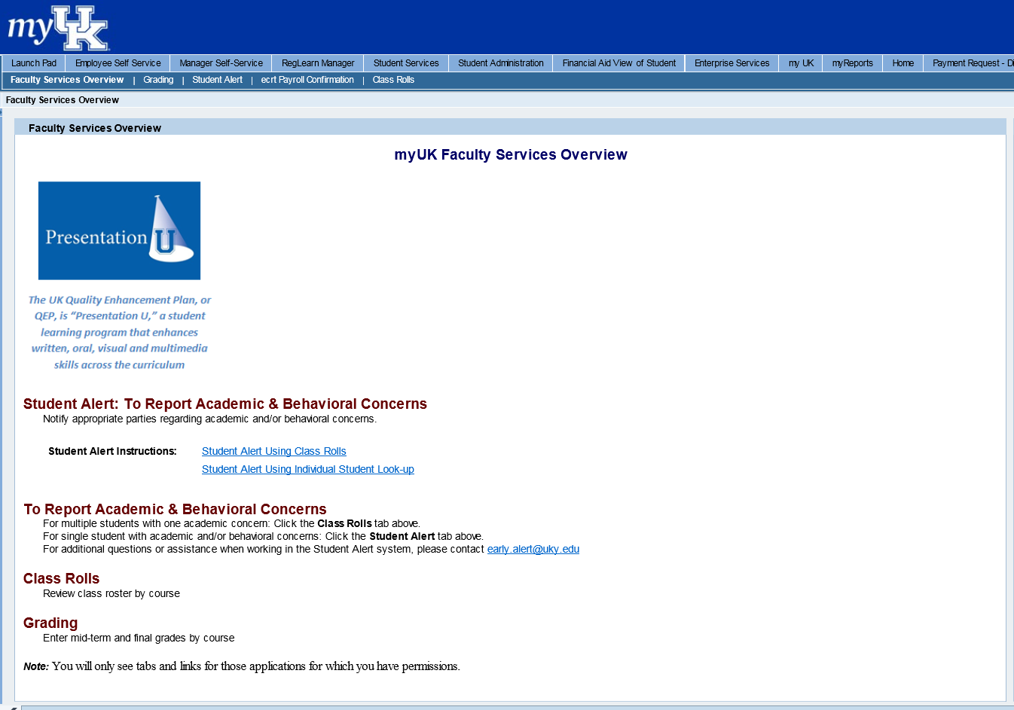

1. Click on ECRT Payroll Confirmation and the welcome screen will appear. Click on the ECRT Payroll Confirmation link to be routed to the software.

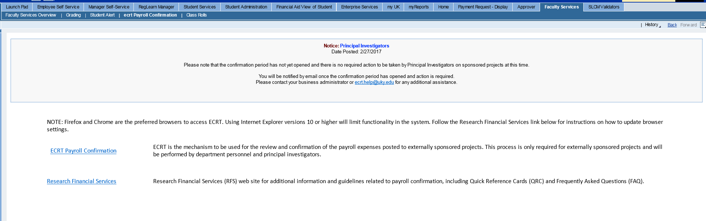

1. From the ECRT Welcome page, press the continue button to navigate into the system.

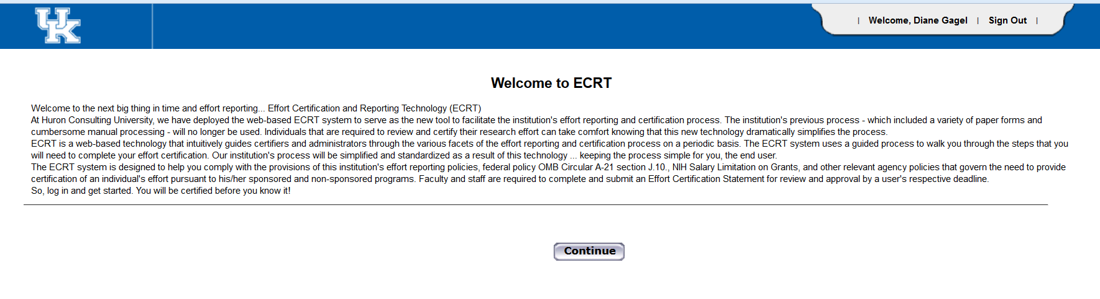

1. Once logged in, the screen will default to your homepage where your worklist is located:

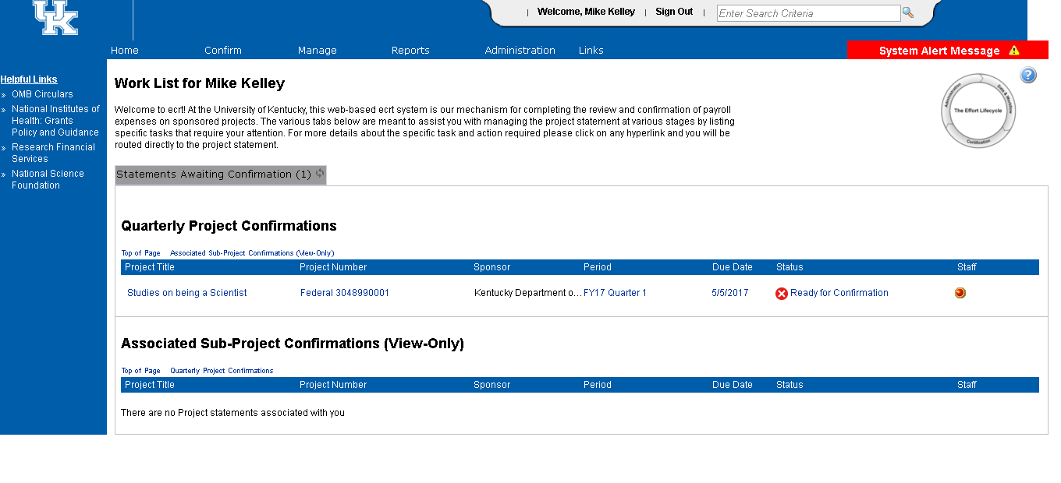

1. Statements that appear under the Quarterly Project Confirmations heading are statements requiring action. Statements that appear under Associated Sub-Project Confirmations (View Only) are statements for scope projects that are connected to your projects but have another PI assigned to them.
   1. No action is required to be taken on the scope project statements as the PI directly responsible for those accounts will have these tasks on their lists. However, you are being provided view access to these statements to assist in overall administrative and financial oversight of the total project.
   2. From the worklist, you will select the project statement that you would like to review and click on the appropriate hyperlink to be routed to a project statement:

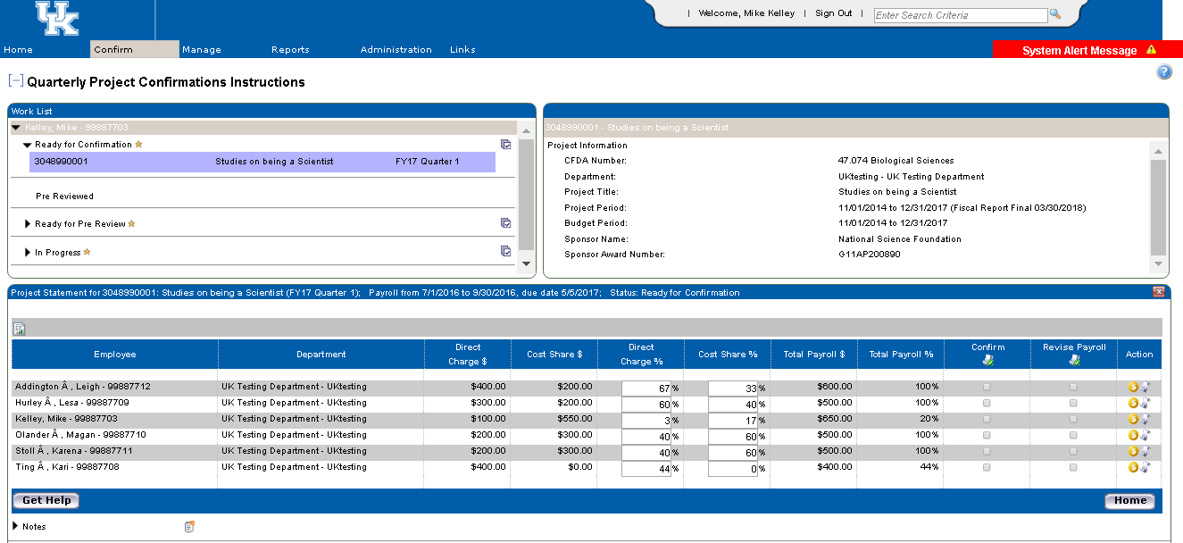

1. On the project statement page, you will find a variety of information about the project.
   1. The box in the upper left corner of the page is the work list. This contains a complete list of all projects and their associated statuses so that you can see where statements are in the workflow process. Click anywhere on the line and the project statement detail lines will appear for you to review. Continue this process with each statement listed as “Ready for Confirmation” until nothing remains in that status.
   2. If you prefer, you have the option to check the box indicated by the green circle next to the project statement to select all of the statements in “Ready for Confirmation” at once and will have the ability to scroll down on the page to see the detailed view of each project statement. However, each statement does require individual confirmation. The screenshot on the next page shows you what to expect when you have multiple projects selected at once.

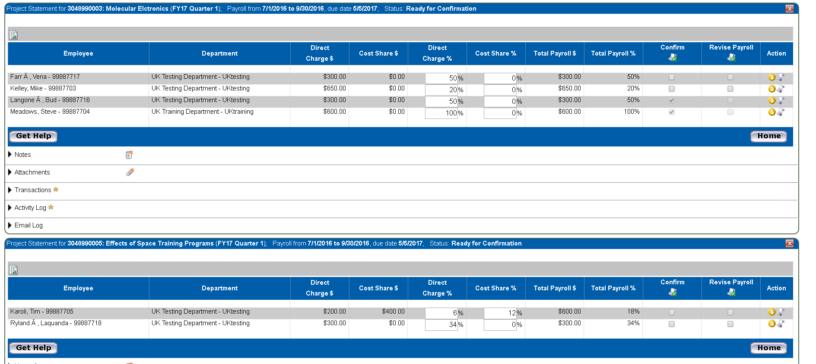

* 1. The box in the upper right corner of the page contains information specific to the sponsored project, which can also be found on the GMGRANTD tab in SAP.
     1. For example, the Sponsor Award Number equates to the External Reference Number you see listed on the monthly PI reports.
     2. Project Period indicates the entire length of the award period. For example, if your project is a 5 year award from NIH, the project period would reflect the entire 5 years, just as it does in SAP.
     3. Budget Period may be shorter than project period. Again, using the example of a 5 year award from NIH, if you have only received incremental funding through the second year of the award, the budget would only reflect the 2 years for which we are authorized to incur expenses.
  2. The main section of the page contains the detailed information associated with the project which needs to be reviewed and, if reasonable, confirmed. **PLEASE NOTE** – the percentage referenced next to the dollar amount represents the percent of total compensation the individual received during the reporting quarter. Supplemental pay, such as a summer research payment, will be included in the denominator of the percentage calculation. For a quick overview of all pay for the reporting quarter, click on the scroll icon in the Action column. This will show all of the cost objects that the individual was charged to and the respective percentage of total compensation.

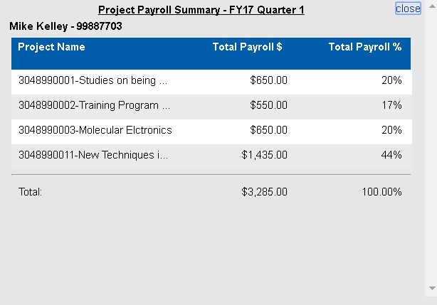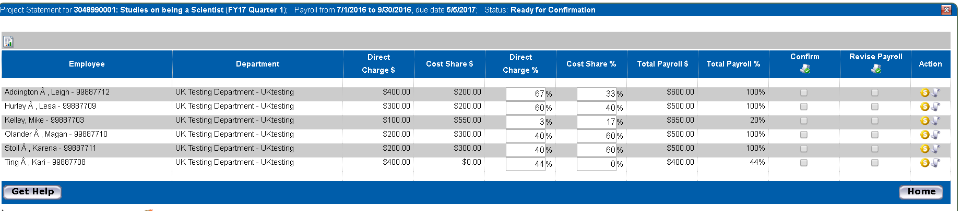

* 1. The blue ribbon on the project statement indicates the time period contained on the statement as well as the due date. Note – due date indicates when statement must confirmed.

1. Please review the information for the individuals paid and/or cost shared on your project to determine if the expenses are reasonable in relation to the work performed on the project by the individual, during the reporting period.

If all expenses for all the individuals listed on the project statement are reasonable, use the select all feature in the “Confirm” column (indicated by the green oval) and click the “Confirm” button at the bottom of the project statement.

An attestation statement, explaining what you are indicating will appear. If you agree, click the “I Agree” button. The status of the project statement will change from “Ready for Confirmation” to “Confirmed” status and will drop off of your worklist.

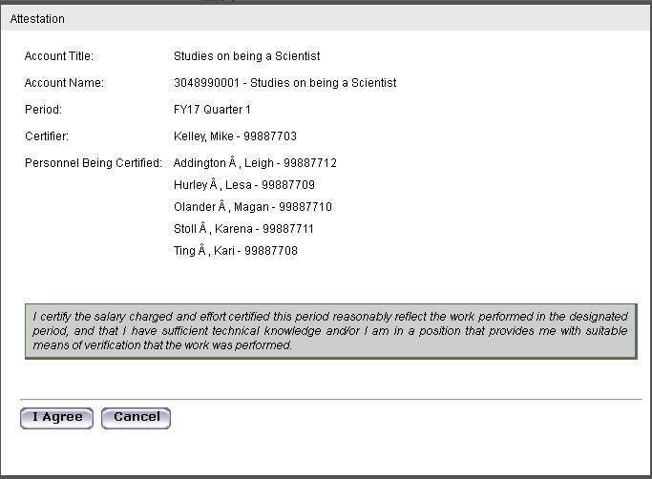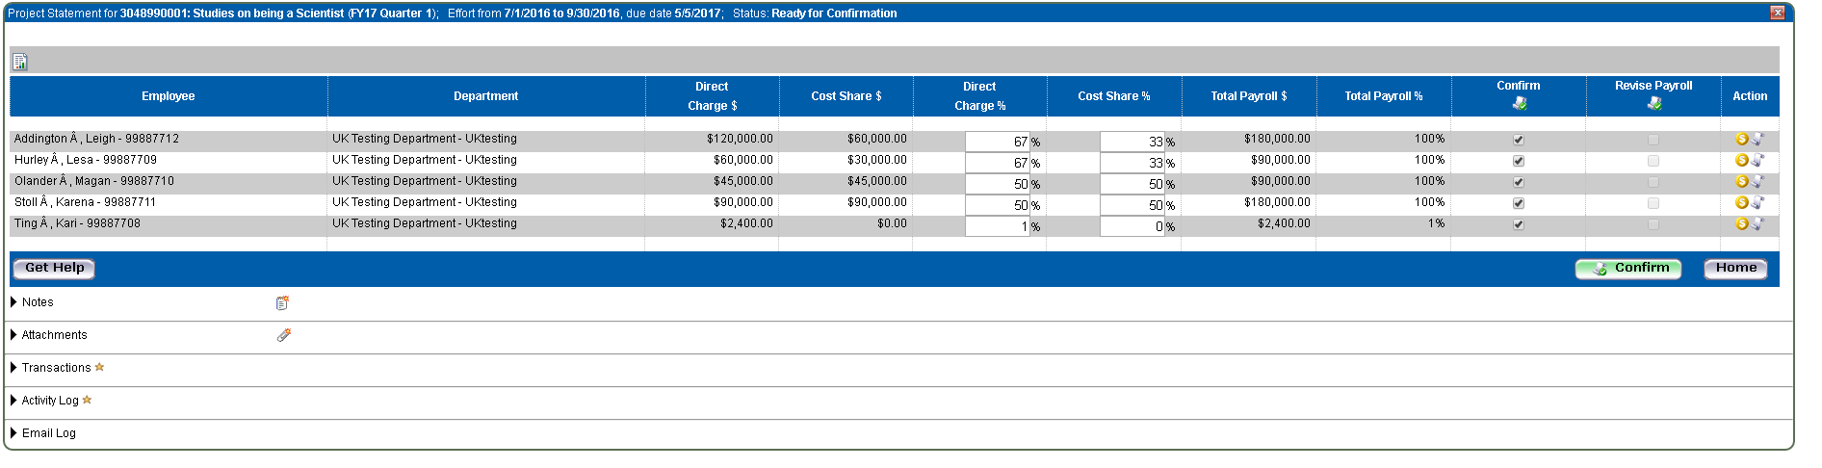

1. If you feel that the payroll expenses for some or all of the individuals listed do not reasonably reflect the work performed, you can choose to partially confirm; confirm and revise payroll; or revise payroll.
   1. 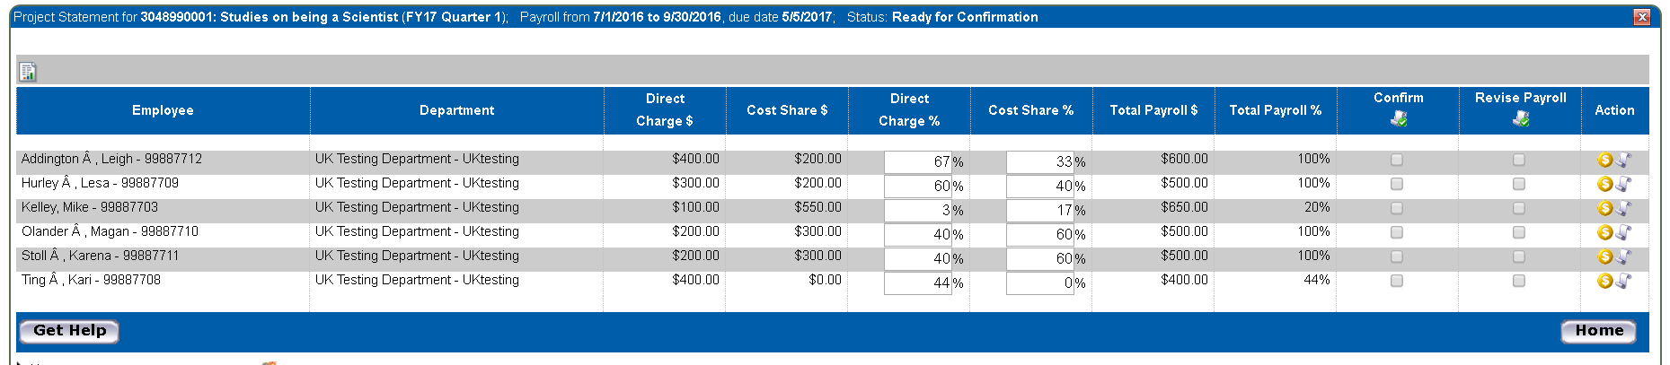*Partially Confirm*-select the “Confirm” checkboxes next to those individuals for whom you believe the payroll expense is reasonable in relation to work performed. Click the “Confirm” button, and agree to the attestation statement. The project statement remains on your worklist while you confer with others (such as the primary department effort coordinator) to determine if a payroll adjustment is needed.

If you have questions or concerns, click the Get Help button at the bottom left of the project statement. This will open an email application and automatically populate to direct the message to your Primary Department Effort Coordinator.

* 1. *Confirm and Revise*- select the “Confirm” checkbox next to those individuals for whom you believe the payroll expense is reasonable in relation to work performed and select the “Revise” checkbox next to those for whom you wish to request a payroll adjustment.

Selecting “Revise” allows you to edit the percentages to show what changes you believe are needed. Then click the “Confirm & Revise Payroll” button and agree to the attestation statement for those individuals you selected to confirm. The individuals that were selected to be revised, and the corresponding percentage you entered, will be routed as a task to the Primary Department Effort Coordinator to review and process the revision if necessary. The statement will fall off of your worklist until the revision is completed.

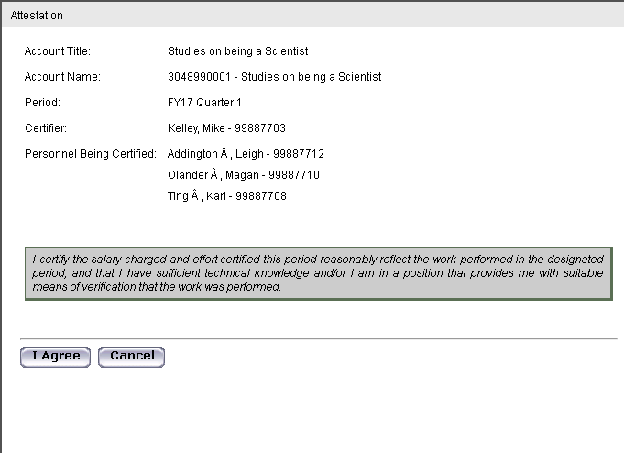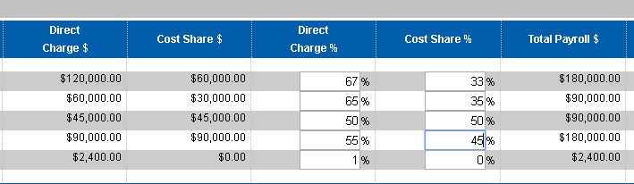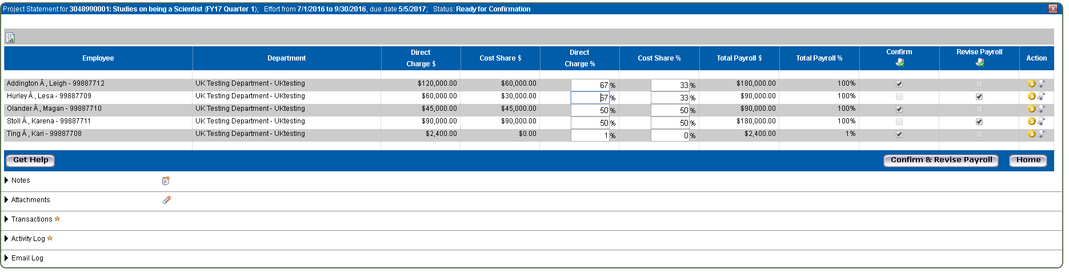

* 1. *Revise Payroll*- If none of the individuals on the project statement reasonably reflect the work performed on the project, you can use the select all feature in the “Revise Payroll” column to select all individuals, then edit the percentage columns to reflect your estimate, and click the “Revise Payroll” button to request the revision. As above, this information will be routed as a task to the Primary Department Effort Coordinator to review and process the revisions. The statement will fall off your worklist until the revisions have been processed. 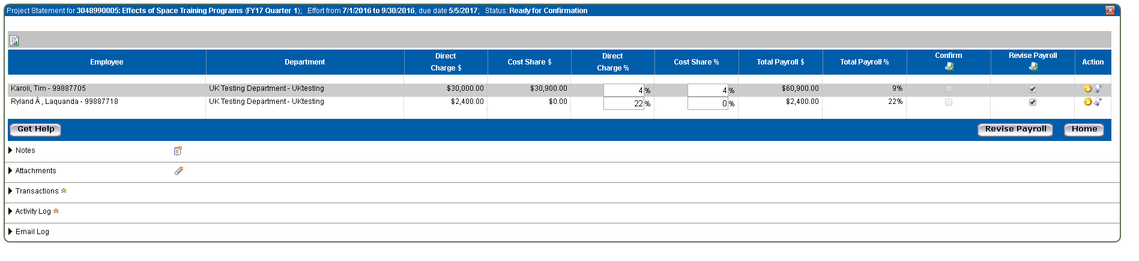

1. 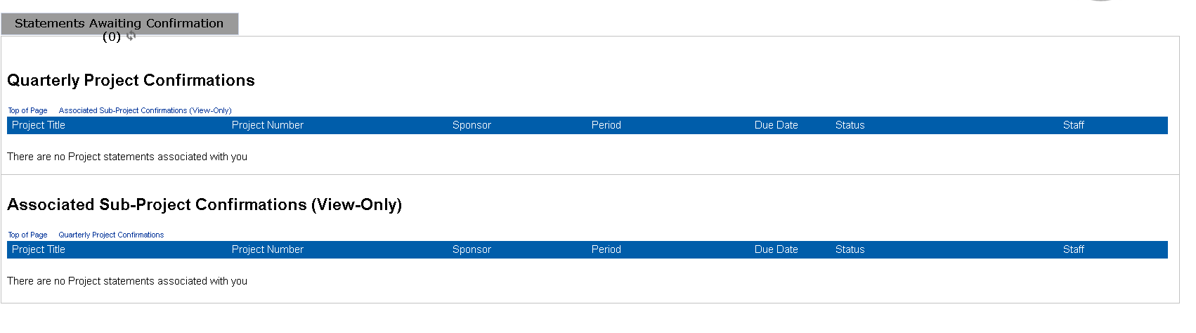Once you have completed reviewing and confirming and/or requesting revisions to all of the statements, you are done. You can click Home on the Menu to be routed to your homepage. The homepage should look like the following:
2. To log out of ecrt, click the Sign Out link in top right corner of web page.



1. Once logged out, the following message will appear. Please just close or X out of this page.

