Handout Packet

For Com 252

Introduction to
Interpersonal Communication

Spring 2008

Don Lowe

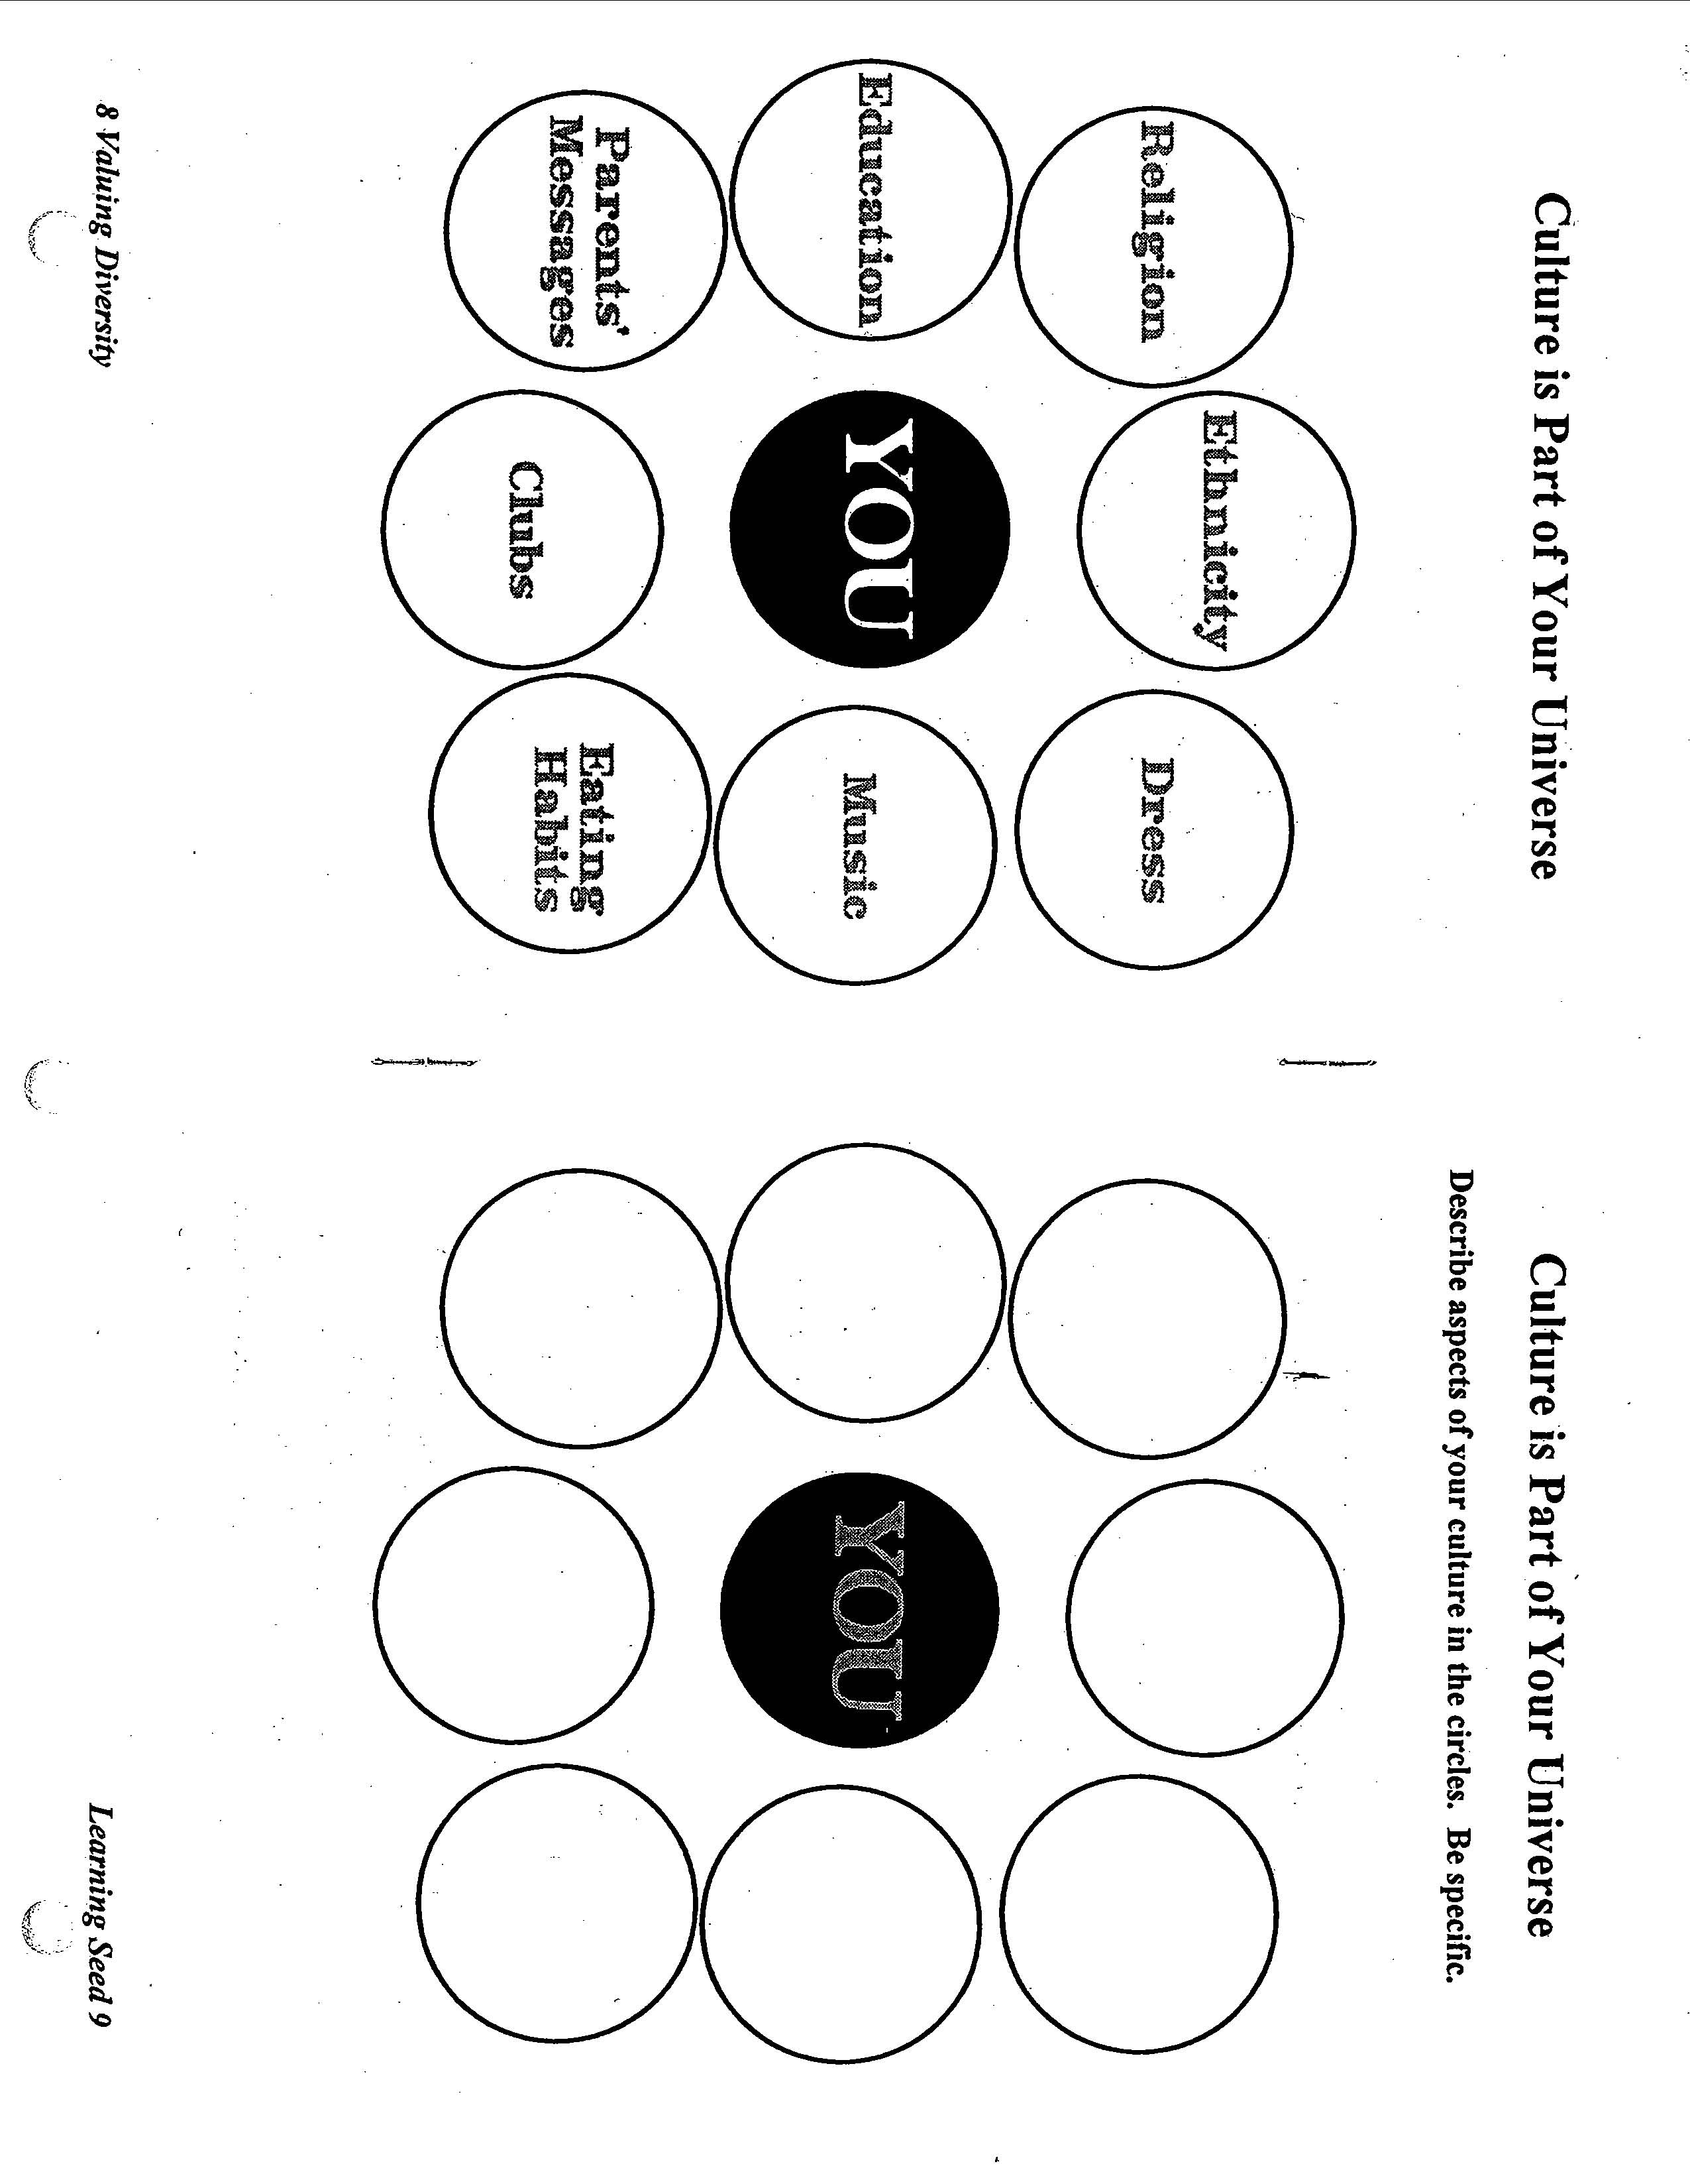

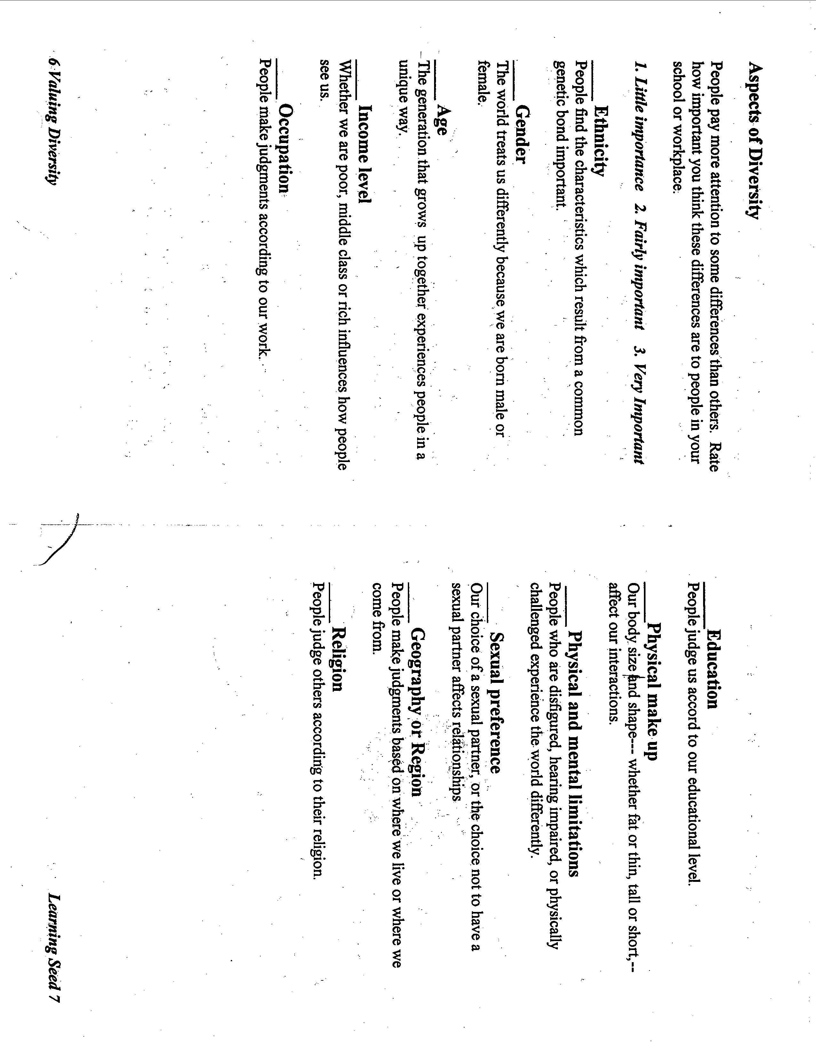

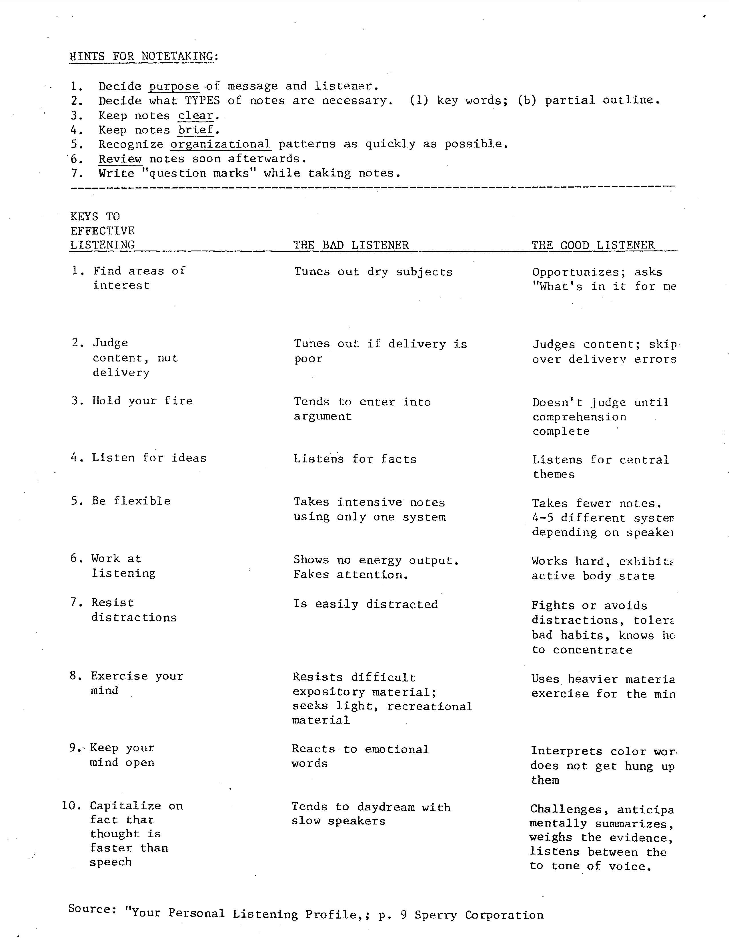

Com 252 Presentation Theories
2008

Cognitive Dissonance Theory of
(Leon Festinger)

“Cognitive dissonance is an aversion drive that causes people to (1) avoid opposing
viewpoints, (2) seek reassurance after making a tough decision, and (3) change private beliefs to match public behavior when there was minimal justification for the action. Self-consistency, a sense of personal responsibility, or self-affirmation can explain dissonance reduction ” (Griffin, p. A-15).

Dissonance: Discord between behavior and belief
Tension of dissonance motivates us to change a belief or our behavior in order to avoid a
distressed mental state

Interpersonal Deception Theory
(David Buller and Judee Burgoon)

Human beings are poor lie detectors in interactive situations. Although strategic
deception often results in cognitive overload that leaks out through a deceiver’s
communication, respondents usually miss these telltale signs due to a strong truth bias. When respondents appear doubtful, deceivers can adjust their presentation to allay suspicion” (Griffin (pp. A-13-14).

Strategies of deception –
falsification creates a fiction
concealment hides a secret
equivocation dodges the issue

Expectancy Violations Theory
(Judee Burgoon)

“Violating another person’s interpersonal expectations can be a superior strategy to
conformity. When the meaning of a violation is ambiguous, communicators with high
reward valence can enhance their attractiveness, credibility, and persuasiveness by
doing the unexpected. When the violation valence or their reward valence is negative,
they should act in a social appropriate way.” (Griffin, p. A-13).

Personal space expectations: Conform or deviate?
Personal space defined --
Related to Hall’s concept of proxemics –
An applied test of the original model --

Social Judgment Theory
(Muzafer Sherif)

“The larger the discrepancy between a speaker’s position and a listener’s point of view, the greater the change in attitude – as long as the message is within the listener’s latitude of acceptance. High ego-involvement usually indicates a wide latitude of rejection. Messages that fall there may have a boomerang effect” (Griffin, p. A-15)

Three Attitude Zones: Acceptance, rejection, and noncommitment
At the instant of perception, people compare messages to their present point of view
Individuals differ in their tolerance around a given point.
Three zones of attitudes describe a personal attitude structure –
Latitude of Acceptance – any position considered as acceptable
Latitude of Rejection – any position considered objectionable
Latitude of Noncommitment – any position neither acceptable or objectionable

Social Penetration Theory
(Irwin Altman and Dalmas Taylor)

“Interpersonal closeness proceeds in a gradual and orderly fashion from superficial to
intimate levels of exchange as a function of anticipated present and future outcomes.
Lasting intimacy requires continual mutual vulnerability through breadth and depth of selfdisclosure”
(Griffin, p. A-14)

Personality structure: A multilayered onion
Outer layer –
Inner core –

Closeness through self-disclosure
The depth and breadth of self-disclosure
Peripheral items exchanged more frequently and sooner than private information
Self-disclosure is reciprocal, especially in early stages of development
Penetration is rapid at the start but slows down quickly as the tightly wrapped inner layers
are reached
Depenetration is a gradual process of layer-by-layer withdrawal.

Symbolic Interactionism Theory of
(George Herbert Mead)

Humans act toward people, things, and events on the basis of the meanings they assign to
them. Once people define a situation as real, it’s very real in its consequences. Without
language there would be no thought, no sense of self, or no socializing presence of society within the individual.” (Griffin, p.A-13)

Mind, Self, and Society emphasizes core principles of meaning, language, and thought

Meaning: The construction of social reality
Humans act toward others or things based on meanings they assign to them.
Once people define a situation as real, it’s very real in its consequences.

Language: The source of meaning
Meanings arise out of social interaction people have with each other.
Meaning is not inherent in objects.
Meaning is negotiated through the use of language.
Symbolic naming is the basis for society
Symbolic interactionism is the way we learn to interpret the world

Uncertainty Reduction Theory (URT)
(Charles Berger)

“When people meet, their primary concern is to reduce uncertainty about each other and their relationship. As verbal output, nonverbal warmth, self-disclosure, similarity, and shared communication networks increases, uncertainty decreases – and vice versa. Information-seeking and reciprocity are positively correlated with uncertainty” (Griffin, p.A-14).

Uncertainty reduction: To predict and explain
Two types of uncertainty -- behavioral questions and cognitive questions

Social Information Processing Theory
(Joseph Walther)
“Based solely on the linguistic content of computer-mediated communication (CMC), parties who meet online can develop relationships just as close as those formed face-to-face – though it takes longer. Because online senders select, receivers magnify, channels promote, and feedback enhances favorable impressions, CMC may create hyperpersonal relationships.”
(Griffin, p.A-2).
.
CMC vs. Face-to-Face: a SIP instead of a gulp
Relationships grow IF participants gain information about each other and use that
information to form impressions.
Two unique features of CMC –
Verbal cues – impressions based on verbal cues only
Extended time – takes long to develop relationship but
Sip/gulp comparison

Chapter 11: Relational Dialectics Theory (Leslie Baxter and Barbara Montgomery )
“Social life is a dynamic knot of contradictions, a ceaseless interplay between contradictory or opposing tendencies such as integration-separation, stability-change, and expressionnonexpression. Quality relationships are constituted through dialogue, which is an aesthetic accomplishment that produces fleeting moments of unity through a profound respect for the disparate voices.” (Griffin, p.A-2).
Relationships (friend, romantic, and family) are all by complex contradictions that make the relationship constantly in flex.
The Tug-of-War Dialectics of Close Relationships
Contradiction is a core concept – simultaneous and conflicting tensions
No final synthesis or equilibrium – ongoing ‘tug-of-war’ or a “relational rope under tension “
Contradictions are “produced and reproduced through the parties’ joint communicative activity”(p162)

Three Dialectics That Affect Relationships
Relationships not developed in straight line path or based on either/or kinds of decisions
Three overarching dialectics (but no finite list of relational dialectics):
Integration-Separation
Stability-Change
Expression-Nonexpression
Internal Dialectics – within a relationship
External Dialectics – between a couple and their community
Dialectical moments are opportunities for dialogue between the partners

Notes for Com 252 Oral Presentations

ORAL PRESENTATIONS

Each pair/dyad will choose one of the following Interpersonal Communication theories. One speaker will present and define the theory while the other will present practical applications of the theory to class members’ everyday lives.
Each oral presentation will be 6 minutes in length and will include a minimum of 2 academic sources/journal articles.
Each pair will be part of a 6 member group that will speak on similar topics but they WILL NOT work together, other than deciding who goes first, etc.

WRITTEN COMPONENT
Include:

1)Outline—see attached

2)Handout/Brochure

A)Synopsis—a brief paragraph describing each speaker’s presentation

B)Glossary—a list of key terms from each speaker’s research

Format for Brochure:

1)one single page (fold and layout your choice)

2)creativity a plus BUT not a necessity

3)bring at least one copy per group in class

ACTUAL SYMPOSIUM

Include:

1)introduction of speakers

2)citation of all sources used

3)visual aids when necessary

4)de-briefing of exercises, video clips, handouts

5)each speaker’s clearly stated PDR
preview/development/review

CONSIDER:
1)how you dress

2)being informal in tone and language

3)eye contact

4)movement

5)volume

6)vocal fillers Uhm/like

7)reading notes

8)hand movement

9)energy/ZING

10)while other is speaking

11)time frame with Q & A

12)time frame met by each speaker

13)time allotted for questions

14)actually get together and time it

15)someone to operate the equipment

16)all slides on one data file for fluency

17)transitions to show flow; connect it; make sense of order

18)say all your sources when & where you use them (not just on slides

19)don't just write outline on power point and read it

PREPARATION OUTLINE
THE INFORMATIVE SPEECH WITH PRESENTATIONAL AIDS

NAME: ______________________________________________ SECTION: _____________

TITLE OF SPEECH: __________________________________________________________

Introduction
I. Attention Catcher:
II. Listener Relevance Link:
III. Speaker Credibility:
IV. Thesis Statement:
V. Preview:
Transition (optional):

Body
I. First Main Point:
Listener Relevance Link:
A. Subpoint:
a. Sub-Subpoint:
b. Sub-Subpoint:
B. Subpoint:
a. Sub-Subpoint:
b. Sub-Subpoint:
Transition:

II. Second Main Point:
Listener Relevance Link:
A. Subpoint:
a. Sub-Subpoint:
b. Sub-Subpoint:
B. Subpoint:
a. Sub-Subpoint:
b. Sub-Subpoint:
Transition:
III. Third Main Point:
Listener Relevance Link:
A. Subpoint:
a. Sub-Subpoint:
b. Sub-Subpoint:
B. Subpoint:
a. Sub-Subpoint:
b. Sub-Subpoint:
Transition:

Conclusion
I. Restatement of Thesis:
II. Summary of Main Points:
III. Clincher:

References
List the references you used in the speech. Format them according to APA style.

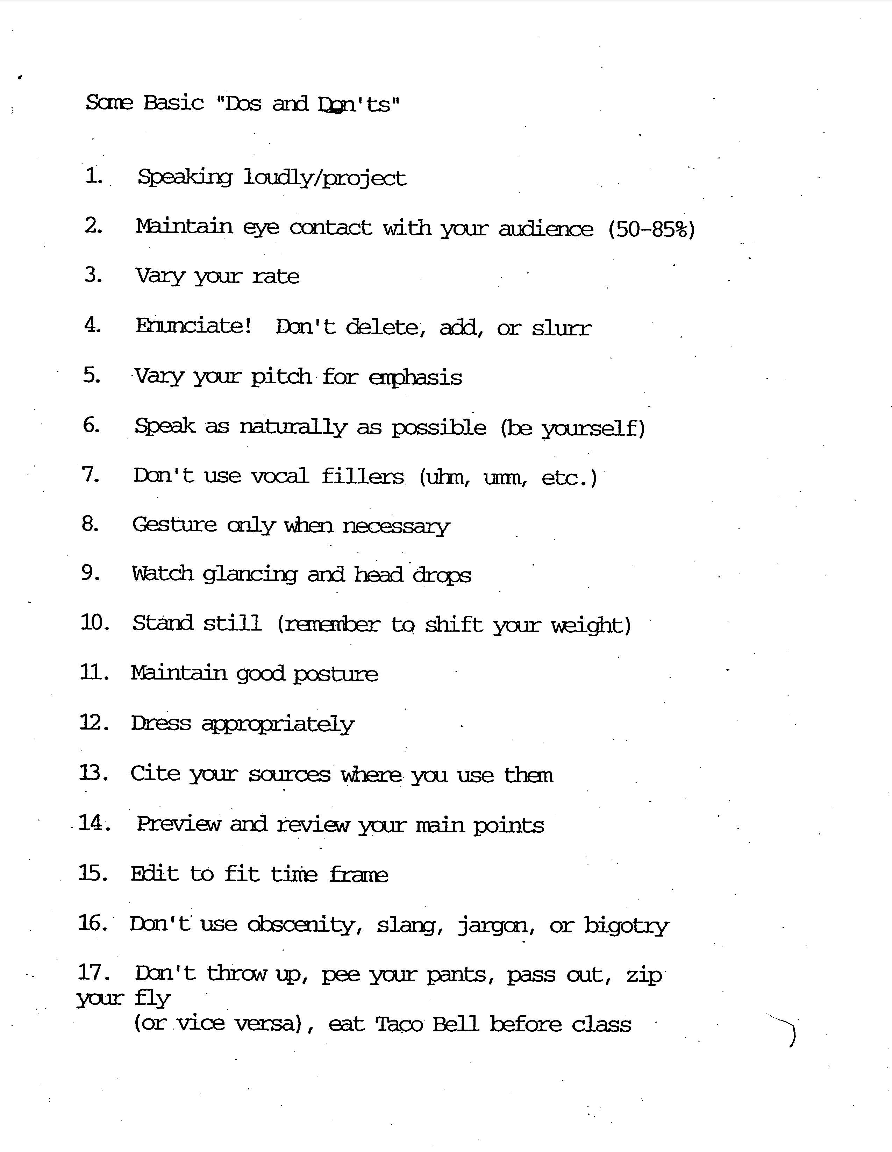

COM 252
Test One
Review Sheet

CHAPTER ONE

Communication Process and Elements
Encoding
Messages
Channels
Decoding
Feedback
Noise
Contexts
Types of Human Communication
Intrapersonal
Interpersonal
Small Group
Public Speaking
Mass
Mediated

Axioms
Irreversible
Interdependant
Content/Relational
Continuous
One cannot NOT communicate
Intentional and Unintentional

CHAPTER TW0

Culture
Enculturation
Acculturation
Ethnocentrism
High Context/Low Context
Power Distances
Individual vs Collectivist

CHAPTER THREE

Self
Concept Factors/How it Develops
Esteem

Awareness

Disclosure
Johari Window Open, Blind, Hidden, Unknown
Factors
Age, Gender, Topic, Relational, Valence (risks), Culture
Reflected Appraisal

Social Comparison

Characteristics of High and Low Self Esteem

Impression Management and Why

High and Low Self-Monitors

Self-Fulfilling Prophecy

CHAPTER FOUR

Perception

Process Select, Organize, Infer

Factors Age, Gender, Race, Education, Religion, Past
Experiences, Attitudes, Values, Beliefs

Stereotype

Ethnocentrism

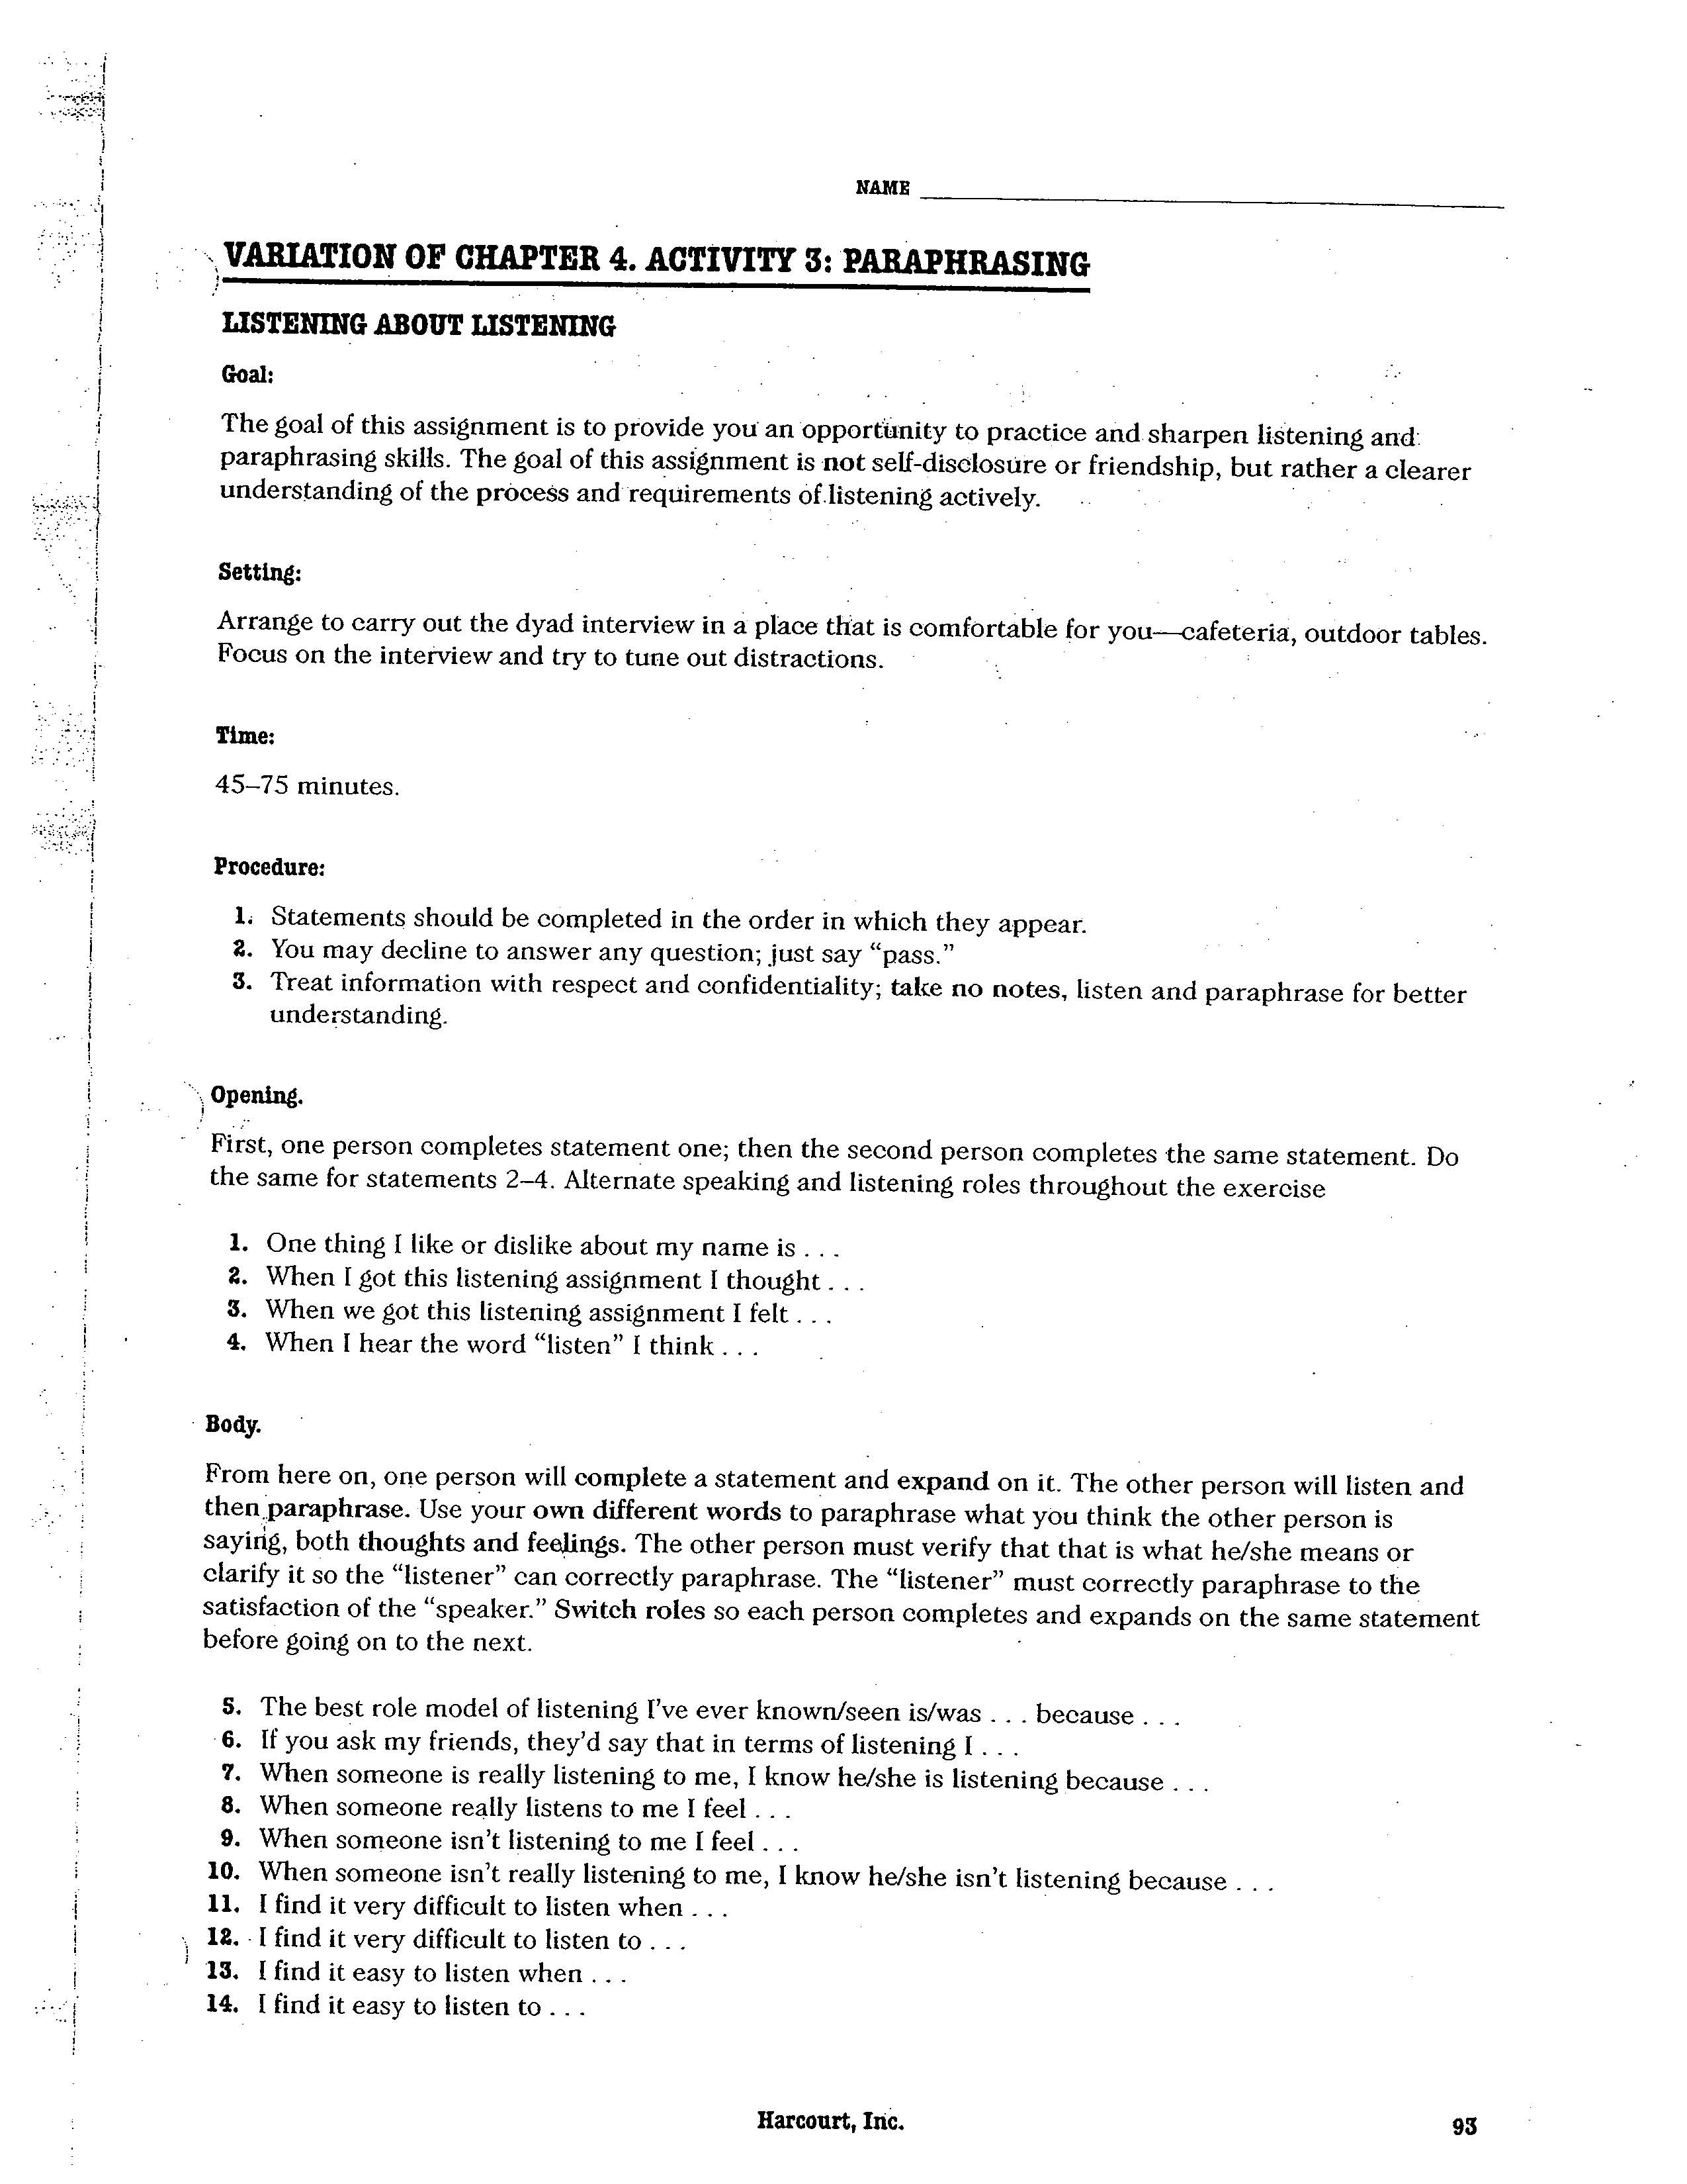

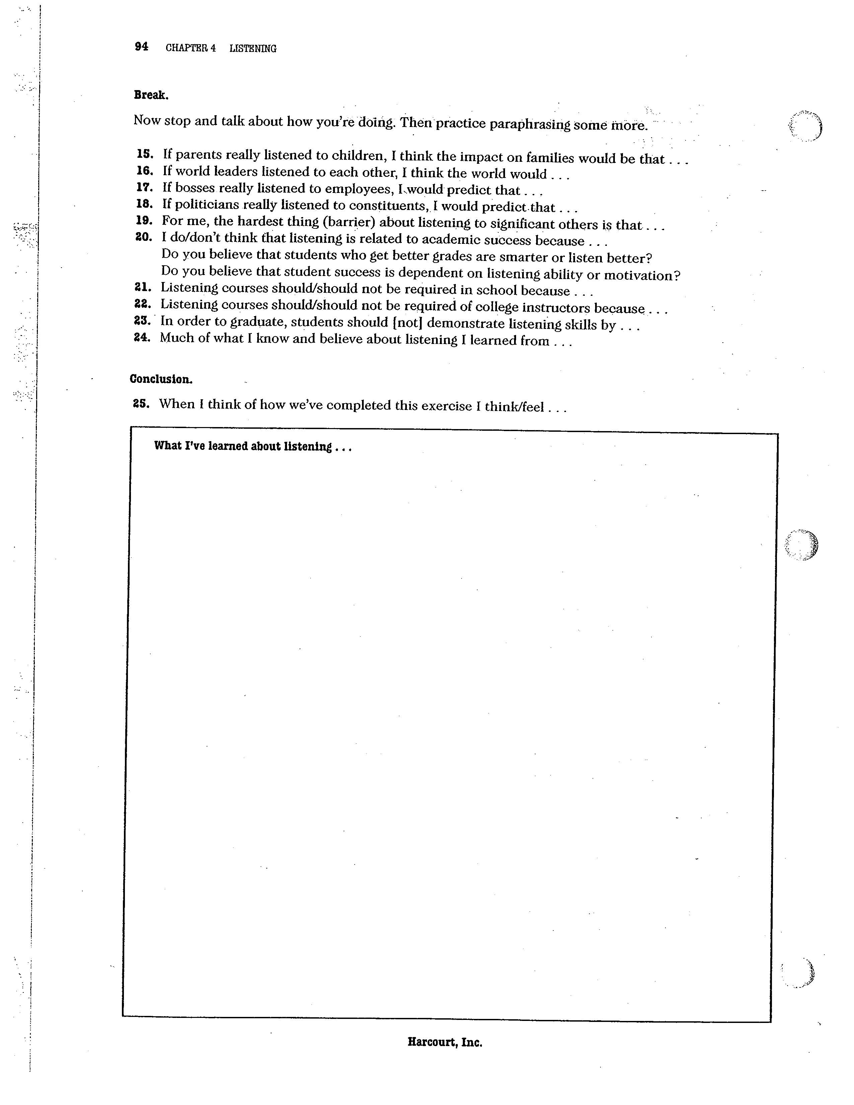
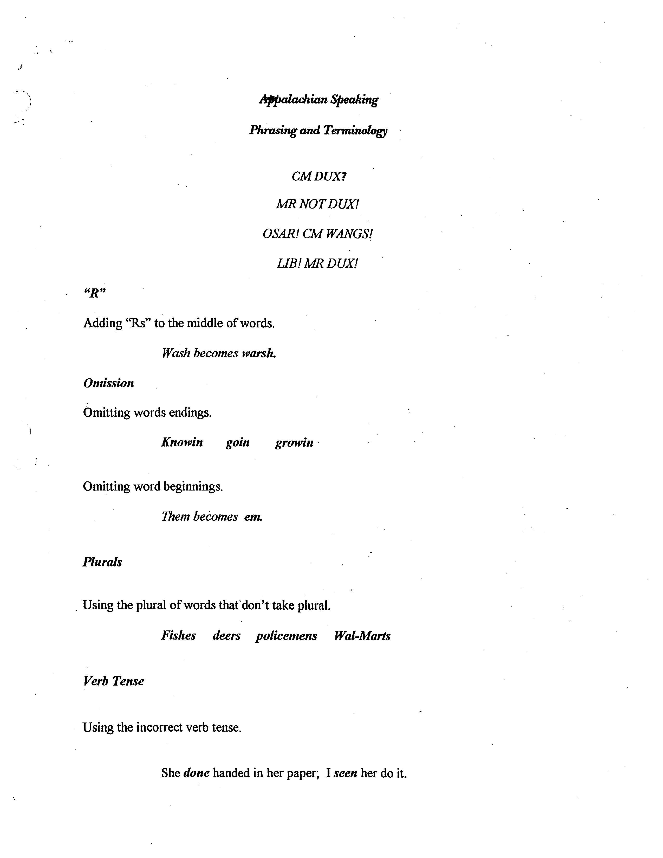

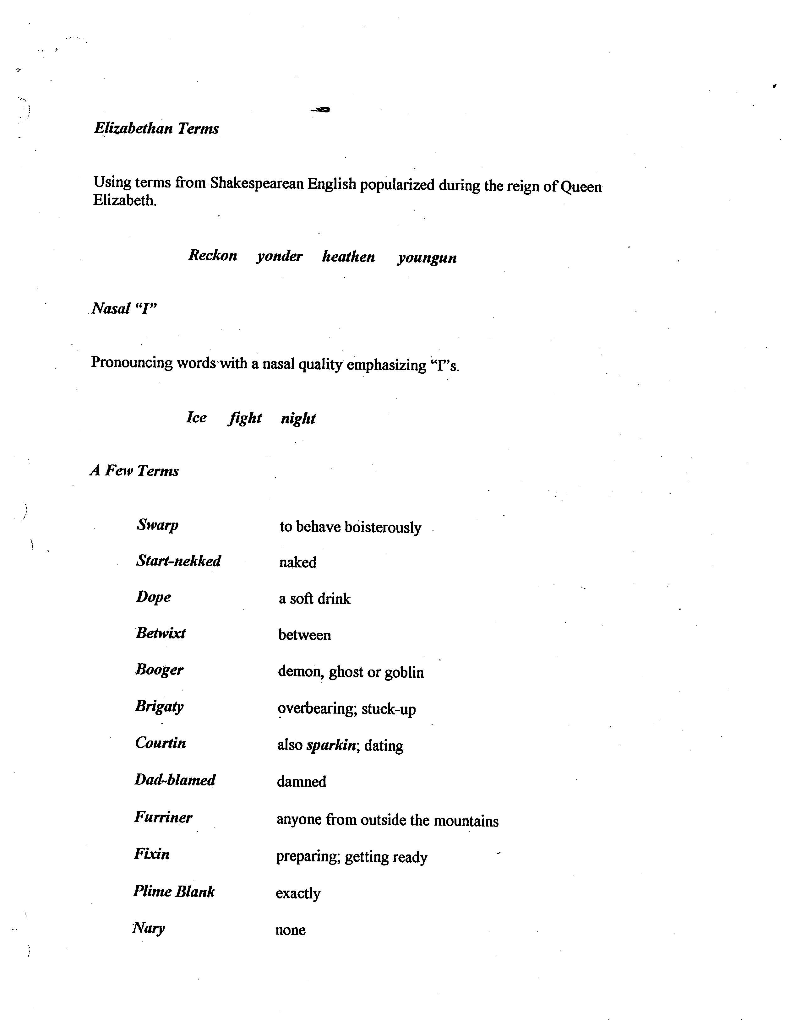

Language Characteristics
Of American English

DENOTATION The dictionary definition of a word.
Its literal meaning.
Cool—lukewarm; tepid in temperature
Bad—evil; wicked

CONNOTATION The meaning assigned to a word by an
Individual or group.
Its figurative meaning.
Cool/bad

SIMILE Stated comparison using like or as.
Like A Virgin/Like A Prayer

PERSONIFICATION Giving humanlike qualities to inanimate
Objects.
Money talks; bullshit walks

HYPERBOLE Exaggeration.
The fisherman’s story.

EUPHEMISM An inoffensive expression substituted for one that would be considered offensive.
Pound the posturepedic; spank the monkey

IDIOM Word meanings particular to a user that
Can’t be literally translated; jargon, regionalism.
Keep tabs on; rock the house

JARGON Word meaning specific to a profession.
Byte; head; gutter

REGIONALISM Specific word meaning according to a
Geographic region’s usage.
Soda; bubbler; gum band

SLANG Street language from subcultures that has
Been adopted by mainstream population.
Roll like thatlblowin up my phone

INITIALISM Using the initials of a group, organization,
Etc. instead of the name.
VCR/CSI/DVD/CNN

ACRONYM Using the initials of a group, organization,
Etc. to spell a new name instead of the
Original, longer name.
SCUBA/RADAR/AIDS

EPONYM A name, as of a people, country, product,
Or the like, derived from an individual.
Kleenex/Jell-O/Coke/Jeep/Ping-Pong

HOMONYMS Words that sound alike but have different
Meanings and sometimes different spellings.
Bass/Desert/Close/Tear/

PREJUDICIAL Racist/sexist/homophobic
Blackballed/throw like a girl/that’s so gay

ABSTRACT Levels of abstraction
Ball/love

EMOTIVE Words that evoke emotions
Louisville (Cardinals that is) sucks

SYNTAX Architecture of sentences, paragraphs,
Essays, etc.

SEMANTICS The study of word meanings.

American English (like all languages) is in a constant state of evolution.

It is impacted strongly by:

a)the media
songs Get Jiggy With It
TV SNL
movies I’ll Be Back
cable news shorter; WMD

b)technology
medical MRI
computers mouse
WWW web; hits

c)other languages
French perfume, fiancée, Jacuzzi
German Volkswagen
Spanish burrito; San Antonio
Japanese Toyota
Etc

Nonverbal Scavenger Hunt

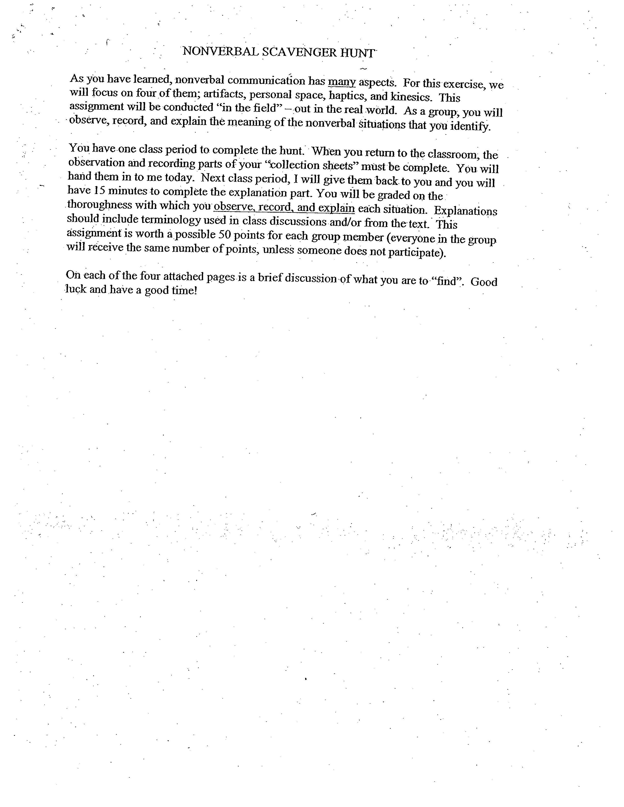







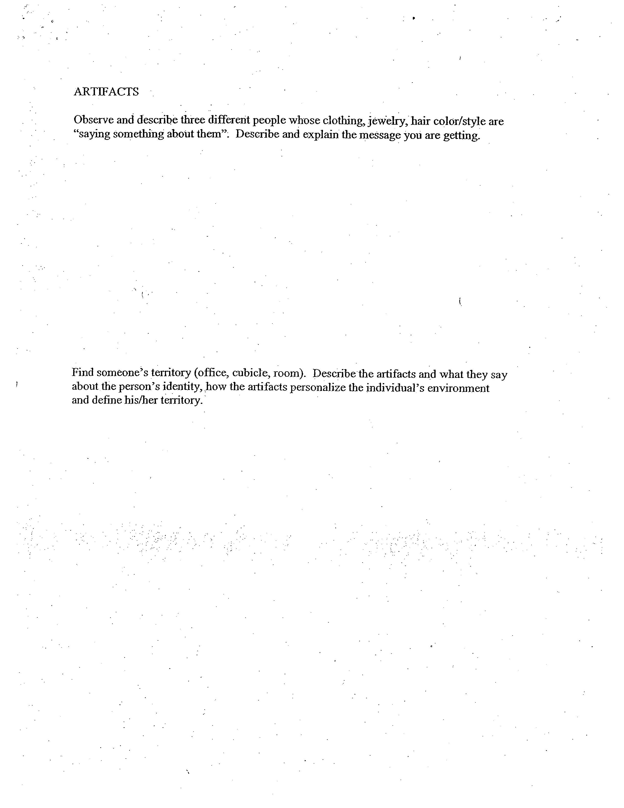

COM 252
Test Two
Review Sheet
Ch 5, 6, 7

CHAPTER FIVE

Verbal
Connotation/Denotation
Syntax rule governed
Semantics
Symbolism
Meanings are in People
Powerless/emotive
Abstraction
Racist, sexist, heterosexist
Handout
Jargon, acronym, etc

CHAPTER SIX

Nonverbal
Kinesics
Emblems, Illustrators, Regulators, Adaptors (self, alter, objects), Affect Displays
Proxemics
Distances Intimate, Personal, Social, Public
Territory
Chronemics
Formal/Informal
Haptics
Gender/Cultural
Eye Contact
Gender/Cultural
Artifacts
Color
Clothing, Body Adornment, Jewelry
Paralanguage

Page two of two

CHAPTER SEVEN

Listening

7 Laws from Video
Ratio to Speaking
Ratio other communication events
Listening not synonymous with hearing
Listen with all 5 senses
Listen for enjoyment/entertainment or information
Gender and listening
Styles of
Active, Empathic, Critical, Passive
Describe active listener

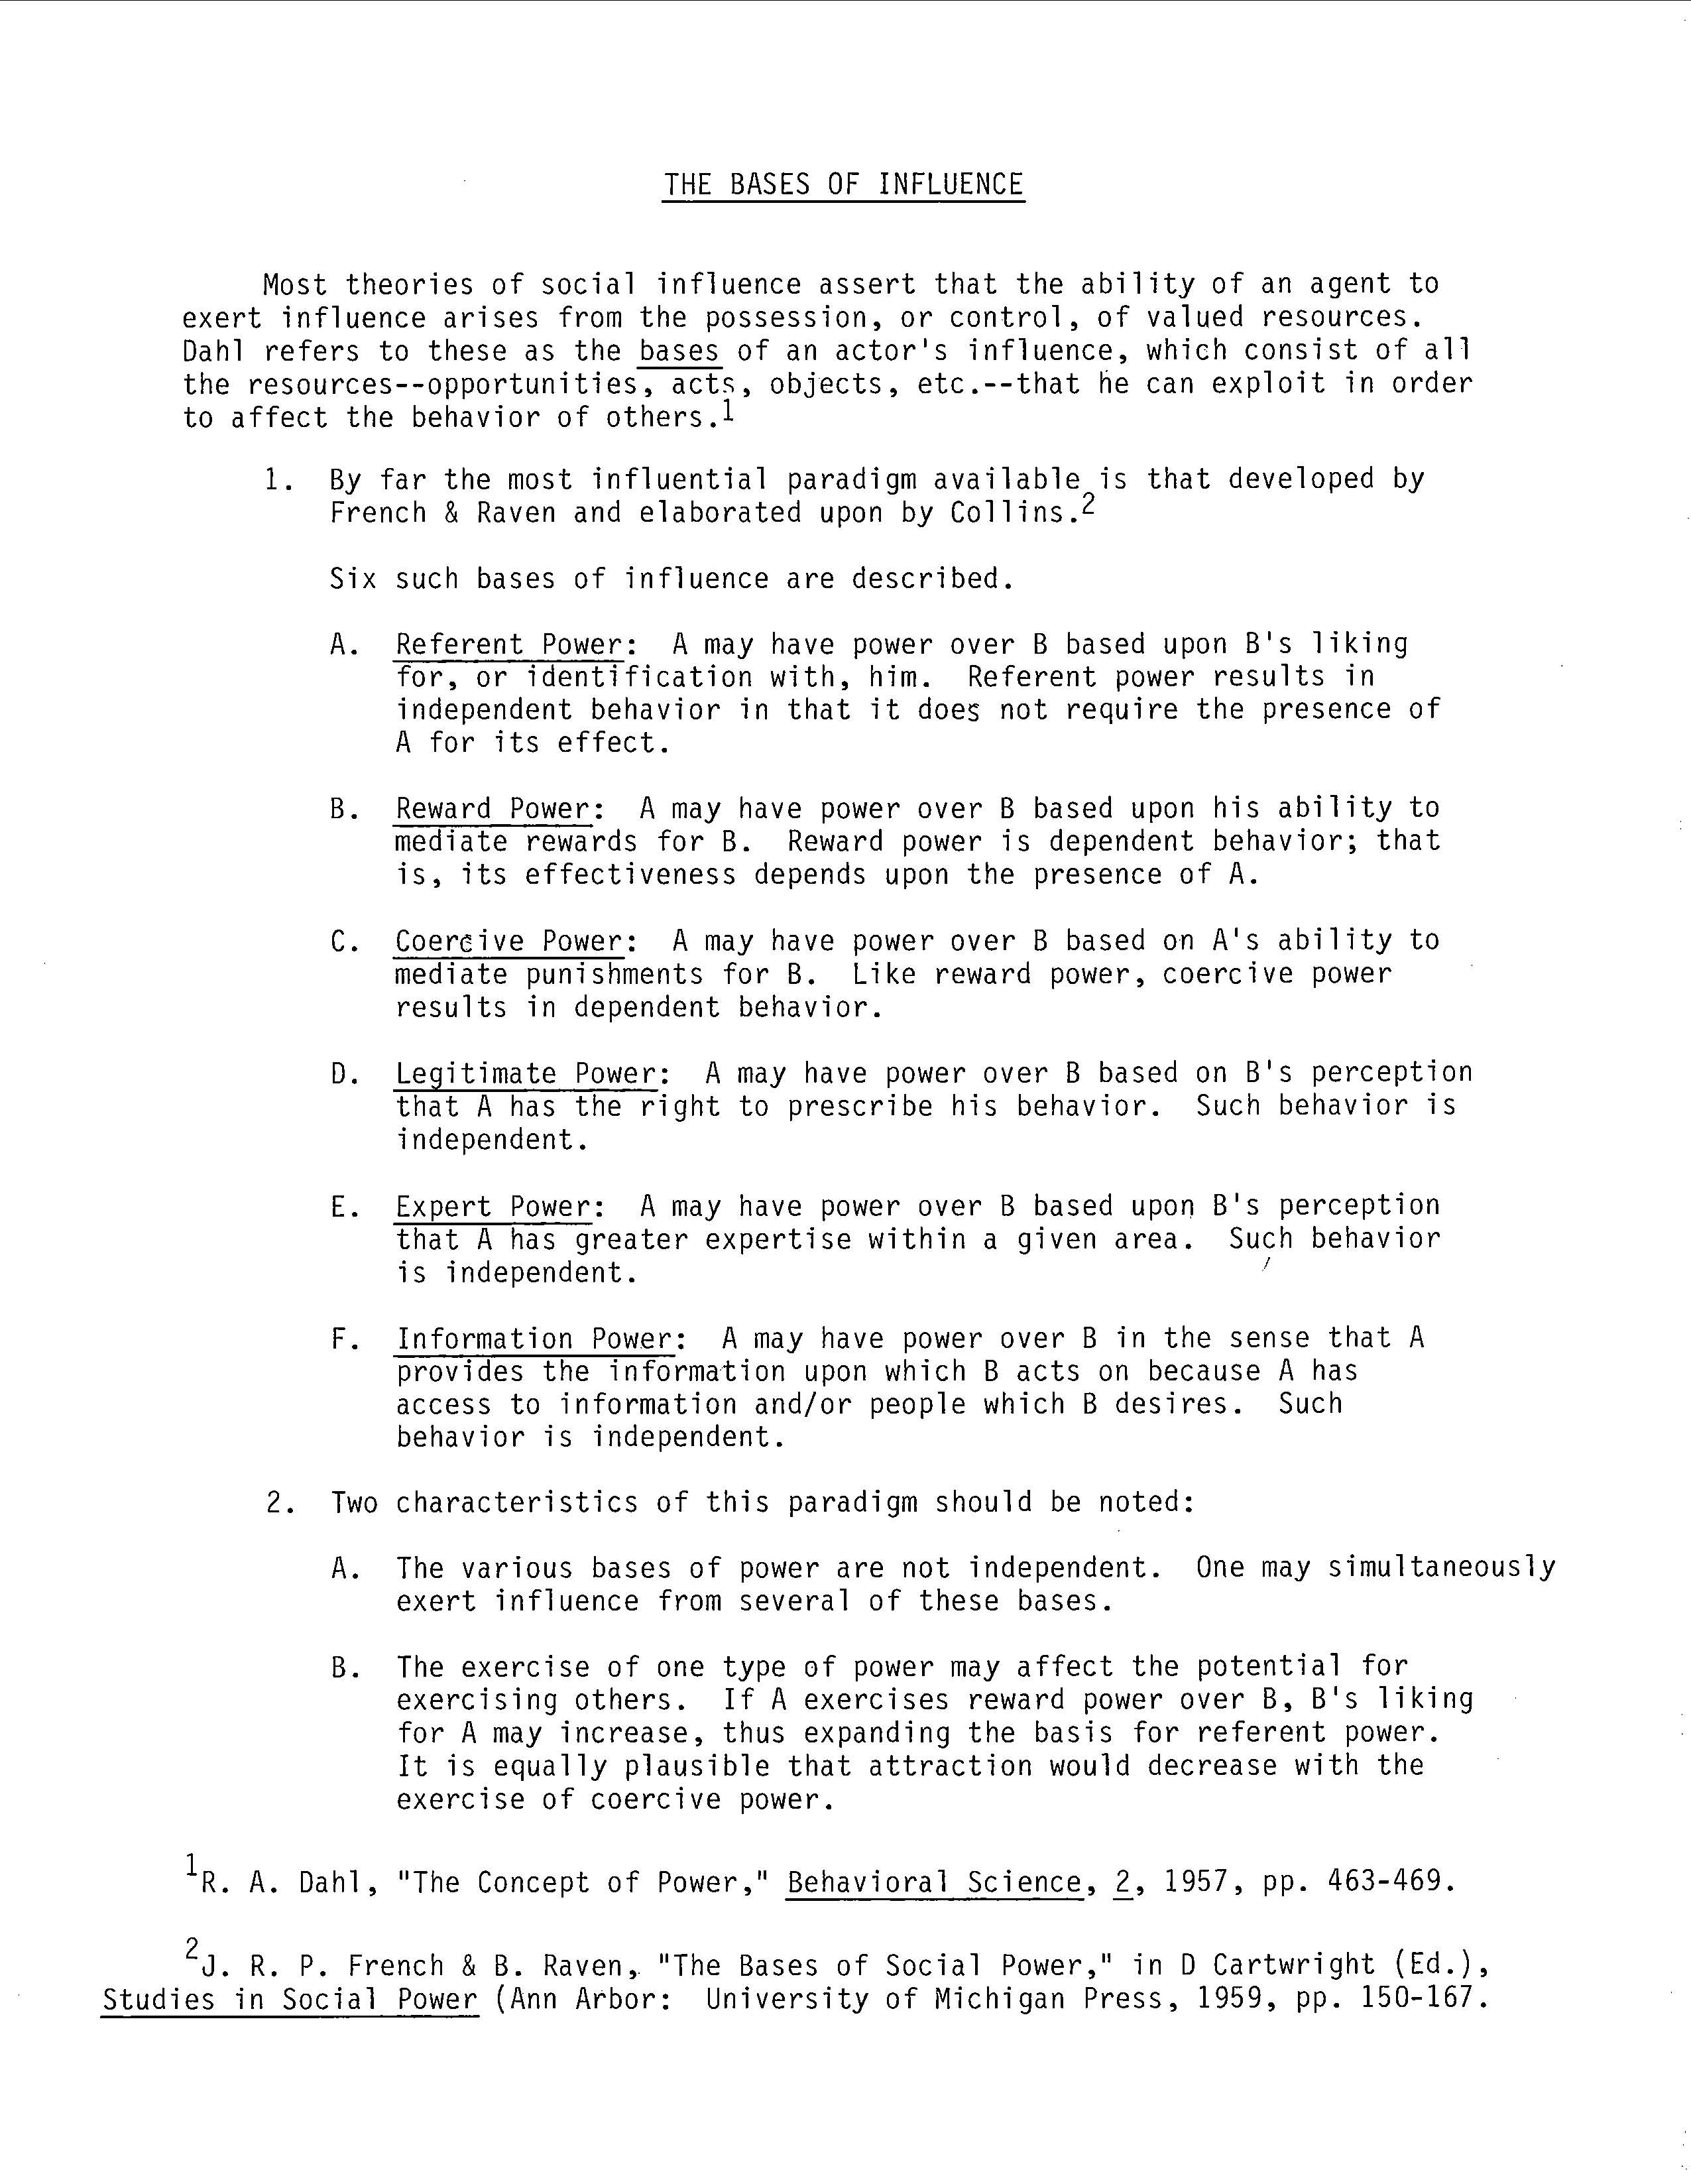

Com 252
Interpersonal Communications
Facebook Paper

Materials Needed: A Facebook account.

This paper will be 2-3 typed double spaced pages (not including the survey)

In this paper you will complete the following:

1)a survey about your Facebook usage (attach to the back of your paper)

2)an exercise that breaks normative behavior expectations on Facebook

3)a description of the events—which option you chose, when you conducted the test, etc

4)a description of the results/reactions—who responded and how

5)an analysis of the results—what this exercise taught you about computer mediated communication as part of interpersonal communication

In order to complete this exercise, choose one of the following options:

1)remove all photographs of yourself from your account

2)stop using your account for at least a 24 hour period

3)post something really out of character for yourself

4)poke a total stranger

5)excessively contact someone throughout a 24 hour period

6)change your relationship status

Directions: Students, in order to refine the following survey, please write any ideas you may have about wording of questions or choices, the choices themselves or even entirely new questions adjacent to those questions.

Complete the following

Describe your Facebook usage:

1)I established my account:

0-1 month ago ___ 1-3 months ago ___ 3-6 months ago ___ 6 months-1 year ago ___

More than 1 year ago ___

2)I established the account because:

I was curious ___ My friend asked me to ___ I wanted to contact someone I already

knew but had lost touch with ___ I wanted to make new friends ___ I was bored and

wanted something new to do ___

3)I use the account:

Once a month ___ once a week ___ once a day ___ 1-3 times a day ___

more than 3 times a day __

4)I have __________ number of people listed as friends

0-50 ___ 50-100 ___ 100-150 ___ 150-200 ___ 200 or more ___

5) I have __________ number of photos posted of myself.

0-5 ___ 5-10 ___ 10-15 ___ 15-20 ___ 20 or more ___

Page two

6)I use the account to/for: (check all that apply)

Homework help ___ socialization ___ dating ___ casual sex ___ partying ___

7)I choose who to add to my account based on (check all that apply):

Similar interests ___ Photos ___ In person requests ___ Physical attraction ___ No

particular reason ___

8)I worry about how I am portrayed on this site:

Never ___ Rarely ___ Sometimes ___ Often ___ Always ___

9)If I had to suddenly stop using this site, I would be/feel:

Fine ___ disappointed ___ sad ___ upset ___ very upset ___

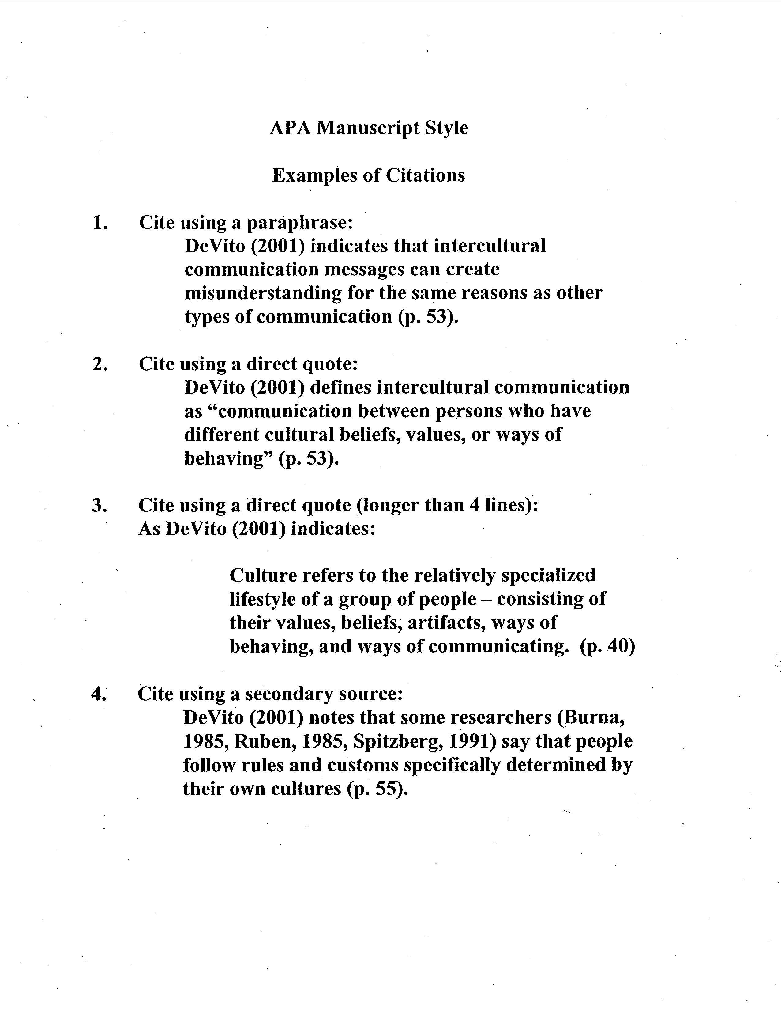

COM 252
Test 3 Review

Chapter 9

Theories of Attraction

Attraction Theory
Proximity
Similarity
Complementarity
Matching Hypothesis
Social Exchange Theory
Equity Theory
Rules Theory

Stages of Relational Development

Initiating
Experimenting
Intensifying
Integrating
Bonding

Stages of Relational Dissolution

Differentiating
Circumscribing
Stagnating
Avoiding
Terminating

Chapter 11

Levels of Aggression

Nonassertive

Assertive Upholding one's own rights without infringing upon the rights of others.

Aggressive

Passive Aggressive
Chapter 12

Conflict

Types of Conflict

Content
Relational
Value
Ego

Nonproductive Conflict Strategies

Blame
Minimizing
Redefinition
Non-negotiation
Manipulation
Gunnysacking
Silencer
Beltlining
Avoidance
Force

Productive Conflict Strategies

Become an Active Participant
Use talk rather than force
Enhance the self-esteem of the person you are arguing with
Be supportive of the other person
Focus as objectively as possible on the points of the disagreement; don't attack
The other person

Bases of Influence (see Handout)

Critic (your name): ____________________________________ Section: __________________

Speaker (person you critiqued): ____________________________________________________
Instructions: For each section, identify something the speaker did well and something the speaker could improve on. Your critique will be graded on the following criteria:
1. Use of "I" language (I liked how you…)
2. Use of specific examples (…you mentioned that millions of people are affected…)
3. Suggestions for improvement (Maybe it would help if you…)

CLASSMATE CRITIQUE FORM
THE INFORMATION SPEECH WITH PRESENTATIONAL AIDS

Delivery | CRITIQUE (Identify something the speaker did well and why. Identify something the speaker could do to improve, why, and how.)
Use of Voice: Intelligibility (rate, volume, pitch, quality, enunciation, pronunciation)? Conversational style? Fluency? Emotional expression (vocal variety)?
Use of Body: Attire? Poise (no distracting cues)? Eye contact? Facial expression? Gestures?
Structure
Macrostructure: Attention catcher Listener Relevance? Speaker Credibility? Thesis statement? Preview? Transitions? Thesis restatement? Summary of main points? Clincher?
Microstructure: Language (clear, accurate, vivid, inclusive)? Style (novelty, connectives, phrasing)? Technical jargon defined? No slang? No vocalized pauses (verbal garbage-- "uh," "um," "like," "ya' know")?
Content
Analysis: Supporting points (appropriate, thematic, breadth, depth, listener relevance)? Appropriate focus? Learning styles?
Supporting Material: Relevant? Recent? Varied? Credible? Clear? Distributed throughout? Properly credited?
Presentational Aids: Construction (large, neat, colorful, clear, symbol system)? Integration (concealed/ disclosed, referenced, smoothly demonstrated)?

Critic (your name): ____________________________________ Section: __________________

Speaker (person you critiqued): ____________________________________________________
Instructions: For each section, identify something the speaker did well and something the speaker could improve on. Your critique will be graded on the following criteria:
1. Use of "I" language (I liked how you…)
2. Use of specific examples (…you mentioned that millions of people are affected…)
3. Suggestions for improvement (Maybe it would help if you…)

CLASSMATE CRITIQUE FORM
THE INFORMATION SPEECH WITH PRESENTATIONAL AIDS

Delivery | CRITIQUE (Identify something the speaker did well and why. Identify something the speaker could do to improve, why, and how.)
Use of Voice: Intelligibility (rate, volume, pitch, quality, enunciation, pronunciation)? Conversational style? Fluency? Emotional expression (vocal variety)?
Use of Body: Attire? Poise (no distracting cues)? Eye contact? Facial expression? Gestures?
Structure
Macrostructure: Attention catcher Listener Relevance? Speaker Credibility? Thesis statement? Preview? Transitions? Thesis restatement? Summary of main points? Clincher?
Microstructure: Language (clear, accurate, vivid, inclusive)? Style (novelty, connectives, phrasing)? Technical jargon defined? No slang? No vocalized pauses (verbal garbage-- "uh," "um," "like," "ya' know")?
Content
Analysis: Supporting points (appropriate, thematic, breadth, depth, listener relevance)? Appropriate focus? Learning styles?
Supporting Material: Relevant? Recent? Varied? Credible? Clear? Distributed throughout? Properly credited?
Presentational Aids: Construction (large, neat, colorful, clear, symbol system)? Integration (concealed/ disclosed, referenced, smoothly demonstrated)?

Critic (your name): ____________________________________ Section: __________________

Speaker (person you critiqued): ____________________________________________________
Instructions: For each section, identify something the speaker did well and something the speaker could improve on. Your critique will be graded on the following criteria:
1. Use of "I" language (I liked how you…)
2. Use of specific examples (…you mentioned that millions of people are affected…)
3. Suggestions for improvement (Maybe it would help if you…)

CLASSMATE CRITIQUE FORM
THE INFORMATION SPEECH WITH PRESENTATIONAL AIDS

Delivery | CRITIQUE (Identify something the speaker did well and why. Identify something the speaker could do to improve, why, and how.)
Use of Voice: Intelligibility (rate, volume, pitch, quality, enunciation, pronunciation)? Conversational style? Fluency? Emotional expression (vocal variety)?
Use of Body: Attire? Poise (no distracting cues)? Eye contact? Facial expression? Gestures?
Structure
Macrostructure: Attention catcher Listener Relevance? Speaker Credibility? Thesis statement? Preview? Transitions? Thesis restatement? Summary of main points? Clincher?
Microstructure: Language (clear, accurate, vivid, inclusive)? Style (novelty, connectives, phrasing)? Technical jargon defined? No slang? No vocalized pauses (verbal garbage-- "uh," "um," "like," "ya' know")?
Content
Analysis: Supporting points (appropriate, thematic, breadth, depth, listener relevance)? Appropriate focus? Learning styles?
Supporting Material: Relevant? Recent? Varied? Credible? Clear? Distributed throughout? Properly credited?
Presentational Aids: Construction (large, neat, colorful, clear, symbol system)? Integration (concealed/ disclosed, referenced, smoothly demonstrated)?

Critic (your name): ____________________________________ Section: __________________

Speaker (person you critiqued): ____________________________________________________
Instructions: For each section, identify something the speaker did well and something the speaker could improve on. Your critique will be graded on the following criteria:
1. Use of "I" language (I liked how you…)
2. Use of specific examples (…you mentioned that millions of people are affected…)
3. Suggestions for improvement (Maybe it would help if you…)

CLASSMATE CRITIQUE FORM
THE INFORMATION SPEECH WITH PRESENTATIONAL AIDS

Delivery | CRITIQUE (Identify something the speaker did well and why. Identify something the speaker could do to improve, why, and how.)
Use of Voice: Intelligibility (rate, volume, pitch, quality, enunciation, pronunciation)? Conversational style? Fluency? Emotional expression (vocal variety)?
Use of Body: Attire? Poise (no distracting cues)? Eye contact? Facial expression? Gestures?
Structure
Macrostructure: Attention catcher Listener Relevance? Speaker Credibility? Thesis statement? Preview? Transitions? Thesis restatement? Summary of main points? Clincher?
Microstructure: Language (clear, accurate, vivid, inclusive)? Style (novelty, connectives, phrasing)? Technical jargon defined? No slang? No vocalized pauses (verbal garbage-- "uh," "um," "like," "ya' know")?
Content
Analysis: Supporting points (appropriate, thematic, breadth, depth, listener relevance)? Appropriate focus? Learning styles?
Supporting Material: Relevant? Recent? Varied? Credible? Clear? Distributed throughout? Properly credited?
Presentational Aids: Construction (large, neat, colorful, clear, symbol system)? Integration (concealed/ disclosed, referenced, smoothly demonstrated)?

COM 252
FINAL Exam
Review Sheet

CHAPTER ONE

Communication Process and Elements
Encoding
Messages
Channels
Decoding
Feedback
Noise
Contexts
Types of Human Communication
Intrapersonal
Interpersonal
Small Group
Public Speaking
Mass
Mediated

Axioms
Irreversible
Interdependant
Content/Relational
Continuous

CHAPTER TWO

Culture
Enculturation
Acculturation
Ethnocentrism
Power Distance
Low/High Context
Individualist/Collectivist

CHAPTER THREE

Self
Concept
Esteem
Awareness
Disclosure
Factors that influence Self-Disclosure/Johari Window

CHAPTER FOUR

Perception
Process Select, Organize, Infer
Factors Age, Gender, Race, Education, Religion, Past
Experiences, Attitudes, Values, Beliefs
Stereotype

CHAPTER SEVEN

Listening
Video 7 Laws
Ratio to speaking
Ratio to other communication events
Listen not synonymous with hearing
Listen with all 5 senses
Listen for entertainment/enjoyment or information
Backchanneling
Gender and listening
Styles/Types
Passive
Empathic
Critical
Active
Characteristics of Active Listening

CHAPTER FIVE

Verbal
Connotation/Denotation
Meanings are in People
Handout
Jargon, Acronym, Initialism, Regionalism, Slang, etc

CHAPTER SIX

Nonverbal
Kinesics
Emblems, Illustrators, Regulators, Adaptors (self, alter,
Object), Affect Displays
Silence
Paralanguage
Haptics
Gender/Cultural
Eye Contact
Proxemics
Distances Intimate, Personal, Social, Public
Territoriality
Artifacts
Color
Clothing, Body Adornment, Jewelry
Chronemics

CHAPTER ELEVEN

Communication Apprehension
Trait
State
Assertive
Nonassertive
Aggressive

CHAPTER NINE
Stages of Relational Development
Initiating
Experimenting
Intensifying
Integrating
Bonding

Stages of Relational Dissolution
Differentiating
Circumscribing
Stagnating
Avoiding
Terminating
Relational Development Theories
Attraction
Similarity, Proximity, Matching Hypothesis, Complementarity
Social Exchange
Equity
Rules

Interpersonal Power/Handout

Bases of Influence
Referent, Reward, Coercive, Legitimate/Position,
Information, Expert, Persuasive

CHAPTER TWELVE

Interpersonal Conflict

Types
Content, Relational, Ego, Value

Non-productive Strategies
Blame, Force, Non-negotiation, Gunnysacking, Beltlining, Redefinition, Avoidance, Silencer, Manipulation

