Sample Design Justification: The following sample is an amalgam of parts from various articles on my CaseMate project. Yours does not have to be this extensive, I just wanted to give you lot’s of examples.

When used at scale in schools, information technology is much more commonly employed to automate current practice. We see evidence of automation in the use of web pages for content acquisition, instead of books; in the electronic management of attendance, where formerly there was paper; in teachers’ use of PowerPoint instead of the whiteboard; and in server-based content management as a replacement for filing cabinets. All of these applications are purposeful, yet none actually addresses how teaching and learning is transacted using the research-based practices of the field (Bain, 2007, p.195).

Introduction
In his book The Self-Organizing School, Bain (2007) describes the need for classroom technologies to have design features that reflect instructional goals. Tools that do this are referred to as pointy end tools. A pointy end tool does not merely automate tasks, but drives the user towards more effective practice. Automation in the context of this paper refers to any sort of time saving benefit or clerical relief afforded to a user. For example, an online spreadsheet-style grade book may be a time saver for an instructor as it calculates averages and distributes scores to students, but does not necessarily encourage effective grading. Likewise, the automation and information management capabilities available through the Internet hold great potential for supporting instruction, but are insufficient without thoughtful and purposeful application. Take, for example, blogs, wikis and other web 2.0 applications that are being used in educational settings. While they can be employed in learning settings, instruction was not the primary purpose for these tools. The allure of such applications is evidenced as they are being folded into commercial learning management systems, such as BlackBoard. Blackboard itself is designed to support any type of instructional environment and while it is targeted to the purpose of managing a classroom, it is fairly agnostic about what is happening pedagogically in the classroom. There is not an explicit connection with the design of these tools and the research-based practices of the field that have been shown to impact learning.
When the term web 2.0 was coined, it was in reference to “the business revolution” (O’Reilly, 2006) that occurred with the initial use of the Internet as an application environment rather than networking environment. While there are transferrable lessons from business and social applications, the educational community must examine for itself how to leverage the Internet as an application environment, i.e. how do we best use Internet based environments to accomplish the task of helping people learn. For teacher education, web 2.0 could mean seizing the opportunity to build utilities that will help support and shape the way that teacher candidates learn and implement instruction. The opportunity of the Internet as an application environment coupled with the proliferation of open source projects such as Moodle, Drupal and WordPress means the ability and feasibility to create custom applications is greater than ever. Even proprietary systems such as BlackBoard can be “sharpened” through custom modules. This paper presents an example of a web tool that was redesigned to shift it to the pointy end of the application continuum.

Refining Cognitive Tools to a Pedagogical Point
The idea of pointy tools extends the idea of computers as cognitive tools. Cognitive technologies allow a user to go beyond the limitations of their own cognitive abilities by transcending limitations imposed by factors such as working memory and cognitive load (Pea, 1985; Lajoe, 1993). Spreadsheets, for example, allowed users in the business world to become hypothesis testers by removing the clerical task of calculation from the end user (Jonassen & Reeves, 1996). In this example, the cognitive tools were not just about making a task easier, but having the user engage in tasks that were more meaningful. Cognitive tools, and by extension pointy tools, allow the user to “think harder about the subject matter domain being studied or the task being undertaken and to generate thoughts that would be impossible without these tools” (p. 697). In addition to spreadsheets, cognitive tools can encompass databases, expert systems and programming languages, which are a significant part of the web 2.0 infrastructure. All of the aforementioned tools are blunt in nature and can be used in a myriad of ways, including basic automation. A spreadsheet may be used as a way to explore relationships and trends within data sets, but it is also used to simply add numbers. It is this point that differentiates cognitive tools and pointy tools. Cognitive tools are blunt and “unintelligent” in nature, while pointy tools are “sharpened” with scaffolding that can share the cognitive load in ways that enable knowledge construction and meaningful reflection and analysis of the classroom environment. An example of this sharpening is provided by researchers from Vanderbilt University who developed a software application called STAR.Legacy (Schwartz, Biswas, Bransford, Bhuva, Balac & Brophy, 2000) that served as a scaffolded authoring environment. The environment provided a more limited set of authoring options and an inquiry framework that is embedded in the interface and navigation. While there was flexibility in the tool, there was an explicit theory of assessment and instruction that shaped how a user interacts with the tool. It is this scaffolding that defines a pointy tool.
To this end, I describe a project, CaseMate, an online environment for creating media rich instructional cases, as an example of a pointy end tool that seeks to provide instructors with a cognitive scaffold by facilitating formative assessment. Scaffolding has been long recognized as a critical element in facilitating inquiry based instruction and understanding of complex relationships (Brush & Saye, 2000; Hannafin, Land, & Oliver, 1999). Hard scaffolds are support mechanisms that can be anticipated and planned in advance based upon student difficulties with a task (Brush & Saye, 2002). Graphic organizers, partially solved problems and reading prompts are all examples of hard scaffolds that an instructor might employ. Soft scaffolds are rooted in social interactions, whether they be student-to-student or student-to-teacher (Vygotsky, 1978). An example of soft scaffolding is when a teacher provides prompts that are generated just-in-time according to specific student needs. Additionally, when facilitating class discussions, a teacher’s role as facilitator requires her to use soft scaffolding to redirect, clarify and moderate the experience. Researchers have examined the uses of embedded scaffolding in a multimedia environment called Decision Point!, a hypermedia database program designed to examine the African-American civil rights movement (Saye & Brush, 1999; Brush & Saye, 2000). In one of their findings, the researchers noted the difficulty with a teacher’s soft scaffolding even after multiple implementations of an instructional module. The authors suggest that, “Some hard scaffolds may serve as intermediate structures that support teachers in the task of soft scaffolding by creating time for reflection before their response is required” (Brush & Saye, 2002 p. 10). Although the discussion of scaffolding is usually in reference to helping students engage in open-ended learning assignments, the same principles may be applied to helping teachers provide better soft scaffolding. In addition to describing scaffolds as hard or soft, one can describe scaffolds as being conceptual, metacognitive, procedural or strategic (Hannafin, Land, & Oliver, 1999). Strategic scaffolds, in particular, are targeted in facilitating interpretation of data. The information that was most useful for the teacher in the Brush and Saye study (2002) were packaged and presented information and suggesting that strategic scaffolds are of benefit to supporting soft scaffolding. Similarly, the summarizing interface of CaseMate presented in this paper is a tool for developing strategic, hard scaffolds that can be used to bolster soft scaffolding in synchronous or asynchronous instructional environments. The CaseMate interface is intended to present the assessment results in a manner that allows the instructor to focus students on key ideas in a reading but also to make efficient decisions using the collected assessment data.
The first step in using formative assessment is to have an assessment that targets the crucial concepts, procedures and skills that are taught. Once the formative assessment has been administered, the next step is to analyze the results to determine what corrective actions are most appropriate. A person by item matrix is one way to organize results (see Figure 3) from an assessment. The person-by-item technique has been used in the educational measurement community for decades (See Harnisch and Linn (1981) as an example). The driving rationale behind the person-by-item display of data is that looking at aggregate scores is a blunt method of interpreting assessment results and a closer look at the patters embedded in the responses can “yield important information about student preparation” (p. 5). The version presented here is based on Dr. Edward Kifer’s use of this technique. Dr. Kifer studied under Benjamin Bloom and has been involved in leading assessment efforts for over 30 years. His use of the person-by-item matrix feflects an approach that testing is not just a tool to “bash schools, teachers, or students” but rather a mechanism to “inferences about the efficacy of a curriculum” (Kifer, 1997, p. 627). In the matrix, the items (questions) are arranged across the top according to cognitive complexity while the students are ordered by ascending overall performance. This provides an efficient way to determine where the gaps in student learning are and what types of interventions are most prudent.

 | Items
Student | 1 | 2 | 3 | 4 | 5 | 6 | 7 | 8 |  | Score | Percent
 | Knowledge |  | Translation |  | Application
May | 0 | 0 | 0 | 0 | 0 | 0 | 0 | 0 |  | 0 | 0
Joe | 1 | 0 | 0 | 0 | 0 | 0 | 0 | 0 |  | 1 | 11
June | 1 | 1 | 1 | 0 | 0 | 0 | 0 | 0 |  | 3 | 33
John | 1 | 1 | 1 | 0 | 1 | 0 | 0 | 0 |  | 4 | 44
Jo | 1 | 1 | 0 | 1 | 0 | 0 | 1 | 1 |  | 5 | 56
Sandy | 1 | 1 | 1 | 1 | 0 | 1 | 0 | 0 |  | 5 | 56
Sally | 1 | 1 | 1 | 1 | 0 | 0 | 1 | 1 |  | 6 | 67
Fred | 1 | 1 | 1 | 1 | 0 | 0 | 1 | 1 |  | 7 | 78
Oscar | 1 | 1 | 0 | 1 | 0 | 1 | 1 | 1 |  | 7 | 78
Gene | 1 | 1 | 1 | 1 | 1 | 1 | 0 | 1 |  | 8 | 88
Average by Item | .9 | .8 | .6 | .6 | .2 | .3 | .4 | .5
Figure 3: Person-By-Item Matrix for Analyzing Results of an Assessment

An instructor teaching this course might react to the data in Figure 1 with the following interventions. Items 5 and 6 are topics that clearly need to be revisited by the instructor—only 2 of the 10 students successfully answered item 5 and only 3 of the 10 students correctly answered item 6. Items 1 and 2 appear to be well learned as illustrated by high degree of success on those items. The students that missed those items also performed poorly on the majority of the assessment and need more intensive interventions, such as tutoring or regular attendance to office hours. Items 3, 4 and 8 could be remediated by using peer-tutoring techniques, such as think-pair-share, so that half the students could clear up the misconceptions of their peers (Mazur, 2008).
The use of concept inventories and force response items have been used successfully in STEM instruction such as physics and engineering statics. Steif and Hanson (2006) report that concept inventories in statics were found to have significant correlations with final examinations. This finding is useful in that it points out that forced response items can be used to gauge mastery of complex material in engineering courses. It should be noted that if assessment is being used in a formative manner, the correlations between assessments should be minimal because the corrective activities that are included.
Seymor Papert (1980) describes gears as a mechanism that he uses to ‘think’ with. He used the interaction of gears as a way to represent the “chains of cause and effect”. Borrowing from Papert we use the metaphor of gears to illustrate the role of visual informatics in in facilitating complex cognitive tasks. The first frame of figure one illustrates a scenario where no tools are present to scaffold the task. As the complexity of the task increases (i.e. the rotational speed increases) the cognitive load and strains on working memory increases. Once a critical limit is reached the task is too complex to execute. Introducing tools we can scaffold the task so the amount of cognitive resources needed to execute decrease it. The larger the radius of the tool gear (i.e. a more robust tool) means that the rotational speed for the cognitive load gear can remain low even if there is a high rotational sped for the task (i.e. a very complex task).
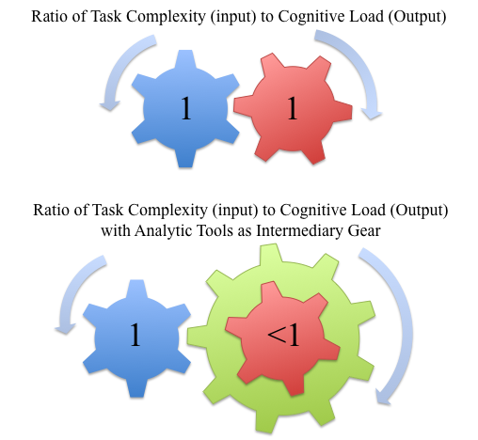
Figure 5: Metaphor for the role of Technology and Visualization in Assessment

By adding conditional formatting to color code the person-by-item results matrix, the internal patters of the data immediately become more recognizable. Additionally, the actual responses can be entered for each student so that another layer of data can be integrated, furthering the inferences that can be made by the instructor. For example did the students who missed the item all choose the same distractor or were the choices evenly distributed among the distractors?
In reviewing the course management software and gradebooks, the displays of data were driven by an approach to grading that is driven by calculating a summative semester grade. One could generate a person-by-item matrix from an assessment delivered via blackboard, but would be required to export the data to another program, such as Excel, where they would have to have fluency with pivot tables, formulas and conditional formatting, not to mention the time to transform the data. This lack of features drove the repurposing of an open-source tool to better support the analytical tasks associated with formative assessment.

 | Items
Student | 1 | 2 | 3 | 4 | 5 | 6 | 7 | 8 |  | Score | Percent
 | Knowledge |  | Translation |  | Application
May | F | T | B | 0 | 0 | 0 | 0 | 0 |  | 0 | 0
Joe | T | T | B | 0 | 0 | 0 | 0 | 0 |  | 1 | 11
June | T | F | D | 0 | 0 | 0 | 0 | 0 |  | 3 | 33
John | T | F | D | 0 | 1 | 0 | 0 | 0 |  | 4 | 44
Jo | T | F | B | 1 | 0 | 0 | 1 | 1 |  | 5 | 56
Sandy | T | F | D | 1 | 0 | 1 | 0 | 0 |  | 5 | 56
Sally | T | F | D | 1 | 0 | 0 | 1 | 1 |  | 6 | 67
Fred | T | F | B | 1 | 0 | 0 | 1 | 1 |  | 7 | 78
Oscar | T | F | C | 1 | 0 | 1 | 1 | 1 |  | 7 | 78
Gene | 1 | 1 | 1 | 1 | 1 | 1 | 0 | 1 |  | 8 | 88
Average by Item | .9 | .8 | .6 | .6 | .2 | .3 | .4 | .5
Figure 6: Color Coded Person-By-Item Matrix for Analyzing Results of an Assessment

CaseMate is an online environment for creating media rich instructional cases while reducing the overhead associated with assembling and publishing web-based materials (website address). The current framework uses a module development metaphor of categories and elements. Categories are used to organize the module according to an instructional framework. The learning cycle is a well-accepted format for designing inquiry-based instruction. It breaks up instruction into four stages: engage, explore, explain and elaborate. If an instructor wanted to set up an inquiry activity in CaseMate he or she could use these four stages as the categories. The elements associated with each category would be comprised of various media and assessments. Figure 7 shows a sample screen shot of an element where an instructor has embedded an interactive simulation along with some accompanying assessment items. This type of presentation can be created with any number of platforms or authoring environments. What makes the CaseMate environment unique is that the results from the assessment are presented in a color-coded person-by-item matrix (see Figure 6).

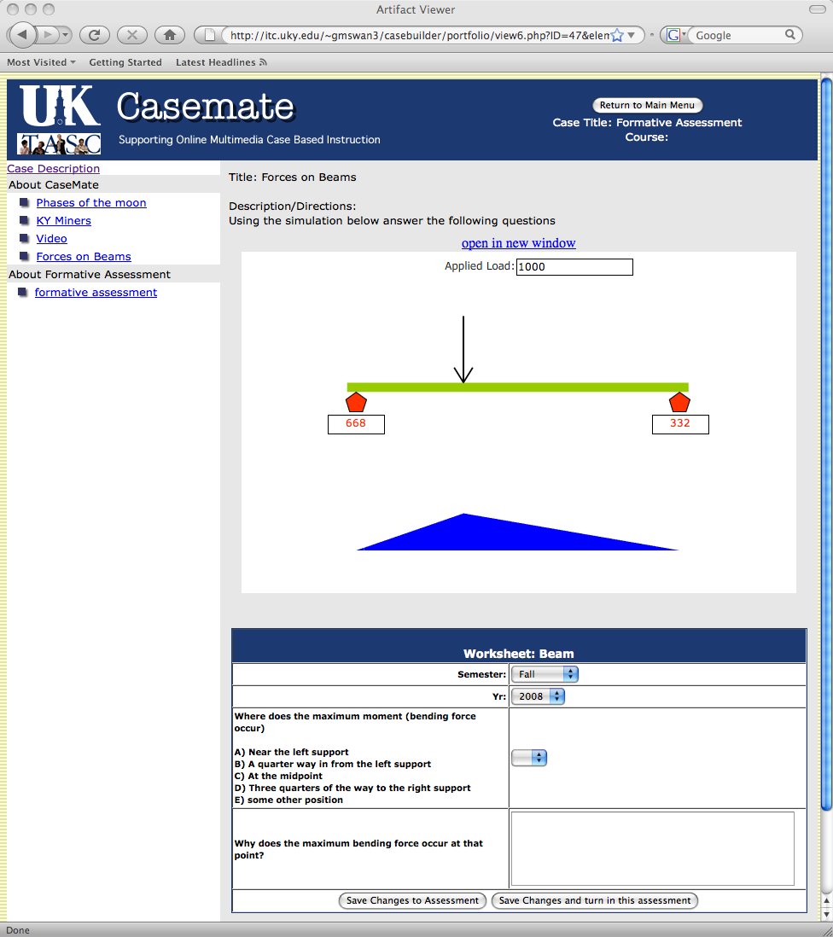
Figure 5: Person-by-Item Matrix for Trial 3
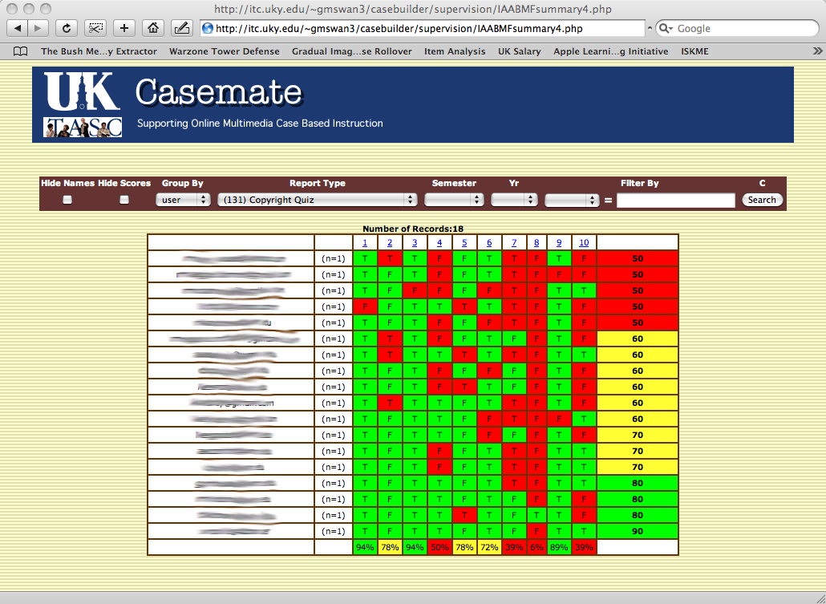
Figure 6: Person-by-Item Matrix from implementation trial

