The Curious Case of Clickers in UKY Engineering Education

Gerry Swan
University of Kentucky

Introduction
Molenda (2009) called for instructional technology to contribute to learning productivity. He provides several definitions of productivity: “1) doing much more with a little more, 2) doing more with the same, 3) doing less with less, and 4) doing more with less” (p. 85). Thus, the productivity equation balances efficiency and effectiveness. Given the push to maximize enrollment (a tactic) through the creation online programs (technology) , there is little doubt that administration in higher education has the efficiency side of the productivity equation in their sight. However, there seems to be much less discussion about the effectiveness side – a balance that begins with instructional effectiveness (a foundational strategy) as well as appropriate tactics and technologies.
It is not that we do not know how to make instruction more effective, quite the contrary. According to Hasselbring (2001), our understanding of technology and learning have evolved at an accelerated pace in recent decades although “too often, our use of technology in schools and other learning environments has ignored what we know about how people learn” (p.5). Moreover, technology is a tool that can be used to execute a tactic, but without an effective strategy, tools and tactics result in nothing but expenditures of money and personnel.
This paper looks at the results of a survey conducted with undergraduate engineering students about the in-class practices students encountered in the classes they perceived to be their best and worst learning experiences. In addition to general techniques such as lecture or project work, we included the use of audience response systems, commonly referred to as clickers, as one of the instructional practices students could select from. The reason clickers were selected for inclusion had to do with recent IT push at the university to support the use of clickers in larger university classes (to enhance individual participation in classes) and visits several faculty members in the College of Engineering had made to other programs where the use of clickers featured prominently in their programs.

Conceptual Framework

Formative Assessment
Formative assessment, a term coined by Michael Scriven in 1967 and repurposed by Bloom for instructional purposes, is basically a failure analysis of student learning. Formative assessment can have many interpretations, some of which are contrary. For this paper, formative assessment assumes three characteristics. First, formative assessment should be marked but the score is not counted towards a student’s grade. If students perceive an assessment as a competitive endeavor (e.g. “I have to get as many points as possible”), rather than a developmental one (e.g. “I need to figure out how well I know this material”), the classroom context is counter-productive to learning. The second characteristic of formative assessment is that it should change subsequent instruction. For example, if a quiz is given to students and the instruction that follows is the same regardless of how students perform on the formative assessment, it is not formative assessment. The assessment, whether it be paper and pencil or project-based creates a moment of contingency (Wiliam, 2006), where the instruction can tack based on how students perform the assigned task. Guskey (2008) points out, “Formative assessments alone do little to improve student learning or teaching quality. What really counts is what happens after the assessments” (p. 1). The process of providing feedback and correctives are paramount in the formative assessment process. Black and Wiliam (1998) concluded, “the provision of challenging assignments and extensive feedback lead to greater student engagement and higher achievement” (p. 13).
Blooms’ work in developing Mastery Learning has been shown to significantly decrease the variation in student achievement (Bloom, 1968; Guskey, 2005) . Other instructional innovations such as Personalized System of Instruction (Keller, 1968) also have been shown to have positive impact on student learning. A common thread between these programs is a corrective feedback process and instructional alignment that occur intermittently throughout the learning process. The purpose of formative assessment is to protect students from “falling further and further behind if they missed a key point” (Keller, 1968, p. 90). In reviewing the research on both Mastery Learning and Personalized System of Instruction, Kulik, Kulik, and Bangert-Drowns (1990) reported that for studies showing strong effects, one of the contributing factors was that “control students receive less quiz feedback than experimental students do. Equating the amount of quiz feedback for experimental and control students reduces the size of the mastery effect” (p.286).
Lastly, formative assessment should occur frequently. A midterm exam, while able to be used in a more formative nature than the final exam, occurs too late for students or teachers to employ corrective actions. Formative assessments should tie directly to what is being taught from unit to unit and the classroom instructor should be fully engaged in the process of selecting assessments and evaluating student responses (Stiggins, 2004).

Audience Response Systems (ARS)
Technological tools are a necessary part of addressing administrative issues related to formative assessment, after all if you cannot manage or interpret the data then you will not be able to effectively do formative assessment. Stiggins (2004) argues that to make formative assessment a powerful tool we must, “provide teachers the tools they need to build classroom environments that promote learning through continuous student-involved assessment, record keeping and communication” (p. 26). The ability to efficiently collect data from hundreds of students is one of the reasons that Audience Response Systems (ARS) have gained popularity.
ARS are devices that allow polling of groups of people, the responses from which are aggregated and displayed for instructor to utilize. These systems have evolved from direct wire systems to infrared to radio frequency devices. The explosion of Internet enabled smart phones allows has also emerged as another mechanism to deploy ARS software.

METHOD
In order to explore the instructional experiences of this sample of engineering undergraduates, a survey was conducted at a research-intensive university framed by the question, “what should we be doing with instructional technology in engineering education?” The presented results are meant to be instrumental (Stake, 2003), in that its purpose is “to provide insight into an issue" (p. 137) and enrich understanding of a larger issue.

Instrumentation and Survey Design
In the ten item survey, students were asked to think of their most and least effective classes. For each of these scenarios, they were asked to indicate which instructional techniques were used during class as well as provide information about their attendance, final grade and persistence of knowledge. The last factor, persistence of knowledge, asked students to rate their mastery of the content from “Not at all – 1” to “Could teach it – 5”.
The instructional techniques were generated from two one hour interview sessions with a focus group of five engineering students (four seniors and a junior). The list of techniques generated included: taking notes, working problems, responding to questions, listening to lecture, group work, peer discussion, demonstrations and clickers. As stated previously, the clickers option was added to the list because the use of them was suggested to engineering faculty who visited other universities.
The core ideas of Knowledge Management (KM) are rooted in the transition within and between tacit and explicit forms of knowledge. Explicit knowledge encapsulates all knowledge that can be documented, codified and stored. For KM applications in an educational setting one way of thinking about explicit data is using the ideas of proximal and distal data (Bain & Parkes, 2006). Distal data, while related to learning and teaching, are more removed from specific classroom transactions and work patterns that are taking place. Distal data, while critical to making evidenced-based decisions, it “is not sufficiently focused on the critical work processes and patterns of schooling to deliver the benefits expected from KM”. Student demographics, attendance, behavioral incidents, suspensions, and even grades are examples of distal data. While they do provide indicators of success, their ability to inform organizational improvement is limited without connecting them to the context of the classroom. In addition to distal data, schools also need to include in their data pools sources that emerge directly from the activity of students and teachers in classrooms. Looking at the various sources of data available at the college the researchers found none that specifically referenced the use of instructional techniques. That absence of information was the driver to the design of the survey instrument used in this study.

Participants
The survey of instructional experiences was sent to all undergraduate students in the College of Engineering, across all fields except . Approximately 15% of the college of engineering student undergraduate population responded to the survey (n = 276). The number of responses from each department are shown in table 1.
Table 1
Number of survey participants by department
Department | Number of participants
Agricultural Engineering | 14
Civil Engineering | 37
Chemical and Materials Engineering | 30
Electrical Engineering & Computer Science | 66
Mechanical Engineering | 98
Mining Engineering | 31

Procedures
A ten question electronic survey was sent to all undergraduate students in the college of engineering asking about their instructional experiences. The survey link was sent out to the undergraduate students by the department chair of each area (e.g. Mechanical, Electrical, Materials, etc.) via listservs. Even thought the data collected for this study was primarily quantitative the design and analytical approach was analytic induction, which is normally associated with qualitative studies. The resulting data was analyzed to create frequency tables comparing the distributions of responses for various pairings of the categorical data collected in the survey (experience type vs. course grade, course grade vs. material retention, etc.). The analysis was done in an inductive, exploratory fashion in which the findings were generated in an emergent, rather than apriori fashion. Following the guidelines of analytic induction, the findings generated by this method employs select data and instances of phenomena within interpretive commentary. This approach serves several purposes beyond giving the reader a sense of being present. First, they serve didactic and rhetorical functions by conveying everyday meanings to the reader to “ground the more abstract concepts of the study” and providing “adequate evidence that the author has made a valid analysis” (Worthen, Sanders, & Fitzpatrick, 1997, p. 149-150).

FINDINGS

Clickers - What went wrong?
When we compare the distribution across the material retention confidence scale with that of the course grade, we see that the positive and negative course distributions are almost the inverse of each other in terms of distribution, with the bulk of scores occurring at 4 and 2 (See Table 2).

Table 2
Comparison of Assigned Grade and Self Report Material Mastery/Confidence
 | Level | # positive responses | # negative responses
Grade | A | 227 | 42
 | B | 41 | 85
 | C | 3 | 85
 | D | 2 | 44
 | E | 0 | 15
Material Retention | 5 | 54 | 4
 | 4 | 130 | 25
 | 3 | 73 | 43
 | 2 | 14 | 133
 | 1 | 2 | 67

Next, we examined the various techniques used and their most effective to least effective ratios. Not surprisingly lecture and note-taking occurred most frequently, with the ratio of negative to positive experiences was almost 1:1 in both cases (See Table 3). Given that every class involves some transmission of information, these results were not unexpected. In-class questions, problem solving, peer discussion, demonstrations and group work were all associated with positive instructional experiences. Of all the instructional techniques listed, only the use of clickers were significantly weighted in the negatively perceived courses. The distribution of positive and negative course experiences was compared to a 1:1 baseline using a chi squared test to determine statistical significane. Except for lecture and note taking, all the other distributions differences were statistically significant at the 0.05 level.

Table 3
Occurrence of Instructional Technique in Most and Least Effective Courses
Instructional Technique | No. of times indicated for the Most Effective Course | No. of times indicated for the Least Effective Course | Ratio of Most to Least Occurrences | Chi-Squared Value
Lecture | 211 | 218 | 0.97 | 0.114
Note taking | 195 | 183 | 1.07 | 0.381
Questions | 133 | 36 | 3.69 | 55.68*
Problems | 183 | 87 | 2.10 | 34.13*
Demonstrations | 70 | 18 | 3.89 | 30.73*
Peer Discussion | 51 | 22 | 2.31 | 11.52*
Group Work | 41 | 27 | 1.52 | 2.88*
Clickers | 8 | 40 | 0.20 | 21.33*
* indicates significance at p < 0.05
So, what went wrong with clickers? At the very least, one might expect a ratio similar to lecture or note taking. To try and contextualize this finding, the open response field for comments was examined. This was an optional part of the survey, so not all students chose to leave comments, but many did. Each comment was reviewed for a reference to clickers. Several students offered comments that provide insight to this trend, most indicating the use of clickers for attendance or ‘high stakes’ assessment and attendance. Several of the comments are provided below:
Student Response 1: As a side note, it's my opinion that clickers are a very ineffective way of teaching a course. They encourage attendance, yes, but attendance might not be fully necessary for some students to truly excel in a course. Clickers have, however, been used effectively in at least one of my classes, where the grades from clickers were basically not counted and were used more for class polling and assessment on whether or not more work in a particular topic area was necessary.

Student Response 2: Clickers may be an effective way for professors to receive immediate feedback from students during a lecture, but typically most professors who use clickers only use them at the beginning of class for attendance purposes only (or if they are used during the lecture, a grade is assigned to the student based on the response). Clickers should be used as a tool for professors to judge the students awareness of the material; assigning grades to clicker responses may actually lower a student's grade if they do not immediately grasp the material.

Student Response 3: I have always disliked the way in which clickers were used in my classes as a lazy way for professors to take attendance and force students to respond to questions without actually interacting with us.

Tools are often reinvented to fit existing notions of practice (Rogers, 2003) and the examples shown above are driven by an accountability-based strategy to increase class attendance. While these uses of clickers can certainly coax students to come to class, it does not change the nature of the in-class instruction. Hattie and Timperly (2007) refer to this too often used type of assessment as a mechanism that is used to get students to “do more” or “do better.” The go on to point out that “Students receive little feedback information in these instances” and “rarely does such feed- back enhance the processes and metacognitive attributes of the task” (p. 101).

What went well – A roadmap for technology use
Clickers did not resonate with the students who participated in this survey, but that still leaves the question, “what did?” If we look at the distribution of activities across the persistence of knowledge scale (tables 4 and 5), it sends a strong message that having students interact and actively apply knowledge while they are in-class is beneficial. The distributions are not normal but skewed, which makes this argument more compelling. The distribution for lecture and note taking are more normal. The distribution for clickers is skewed, but not in the direction one would hope to see. Table 4 presents the data nemrically while Table 5 shows the data for each row in bar chart format. The maximum values for each row is relative to the data in that row. The minimum value for each row is zero. This was done to illustrate the overall trends at each level.
Table 4
Comparison of instructional technique and its distribution on the mastery scale
Instructional Technique | Persistence of Knowledge Scale
 | L=1 | L=2 | L=3 | L=4 | L=5
Lecture | 49 | 120 | 91 | 125 | 43
Note Taking | 40 | 110 | 80 | 102 | 45
Group Work | 3 | 8 | 19 | 23 | 14
Peer Discussion | 2 | 7 | 18 | 25 | 21
Demonstrations | 6 | 7 | 18 | 39 | 18
Questions | 4 | 22 | 43 | 62 | 38
Clickers | 15 | 12 | 9 | 9 | 3

Table 5
Graphical comparison of instructional technique and its distribution on the mastery scale (maximum value relative to inline values)
Instructional Technique | Distribution across ‘Persistence of Knowledge’ scale
Lecture | 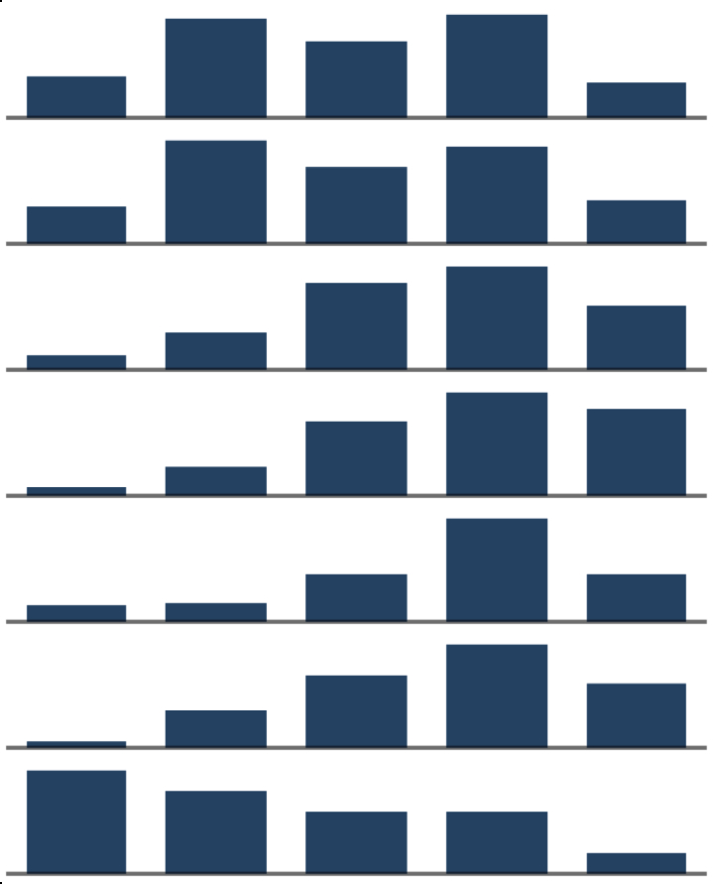
Note Taking
Group Work
Peer Discussion
Demonstrations
Questions
Clickers

Next, we take the total number of techniques employed by an instructor (excluding lecture, note taking and clickers) and look at the distribution across the knowledge scale (see Tables 5 and 6). The distributions become more heavily skewed as the number of techniques employed increases. In the Handbook of Formative Assessment (2010) Guskey notes “to attain better results and reduce variation in student achievement, Bloom reasoned that teachers would have to increase variation in their teaching” (p. 109). The results of this survey dovetail with Bloom’s suggestion in that we see that mixing in a variety of well-executed techniques resulted in a more robust learning experience. Executed well these practices give students opportunities to ferret out misconceptions and correct them. Without meaningful interaction between students and instructors, there is limited opportunity to engage in error correction. As with Tables 4 and 5, the Table 6 presents the data numerically while Table 7 shows the data for each row in bar chart format. The maximum values for each row is relative to the data in that row. The minimum value for each row is zero. This was done to illustrate the overall trends at each level.

Table 6
Comparison of the number of instructional techniques used and distribution on the mastery scale
 | Persistence of Knowledge Scale
# of Techniques Used | L=1 | L=2 | L=3 | L=4 | L=5
n=0 | 45 | 87 | 20 | 33 | 2
n=1 | 17 | 42 | 43 | 48 | 20
n=2 | 5 | 13 | 41 | 46 | 13
n=3 | 1 | 5 | 8 | 22 | 14
n=4 | 0 | 2 | 3 | 5 | 4
n=5 | 0 | 1 | 2 | 3 | 5

Table 7
Graphical comparison of the number of instructional techniques used and distribution on the mastery scale (maximum value relative to inline values)
# of Techniques Used | Distribution across ‘Persistence of Knowledge’ scale
n=0 | 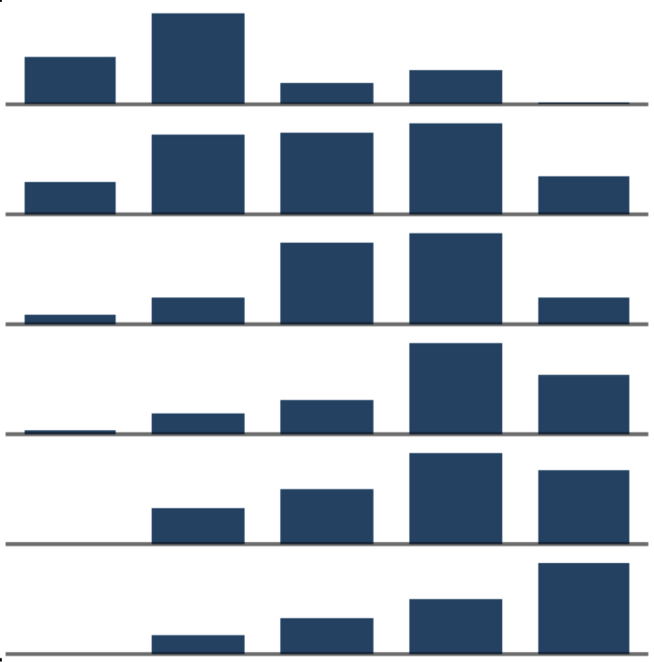
n=1
n=2
n=3
n=4
n=5

Peer tutoring, cooperative teams and re-teaching are techniques Guskey (2008) gives as examples of corrective activities that can be used to address misconceptions identified during formative assessment. We feel that it is no surprise that techniques that are aligned with suggested corrective activities correlated with the courses students rated the highest. Even demonstrations could be considered a form of re-teaching, in which an instructor “explains difficult concepts again using a different approach or different examples” (p. 3). Again, it is important to point out all of these techniques were used during class time--so not just group work, but group work in the presence of the instructor. Of course, clickers could be used to help facilitate any of these techniques. In fact, any number of instructional technologies could be used with any of the mentioned tactics. While certain technologies may fit one implementation better than others, most are relatively blunt in nature so that they can be repurposed for many different uses.

Conclusion
Technology tools like clickers are on campuses and probably not going anywhere and if they do, they will most likely be replaced by something else. For example, just before submitting this paper for review, we received an email about a new course capture platform that was recently purchased by the University administration and would be implemented in the coming months. One of the first statements in the announcement was, “While course capture might not fundamentally alter a faculty member’s underlying pedagogy, its adoption can promote student learning.” Without addressing the pedagogy underpinning the use of technology in some systemic fashion, how can any tool lead to greater productivity?

Any technology-based interventions should be accompanied with a robust implementation plan that is rooted in research about teaching and learning. While clickers, learning management systems and Smartboards can be used to enhance existing practices, if those practices are not rooted in research on effective learning and teaching, there may be no value added to the process. Worse, they may actually further cement or empower practices that are detrimental to learning and student development. Relying on the affordances of a particular technology and individual instructors to have an organizational impact on student achievement is probably wishful thinking at best.

References

Bain, A. (2007). The self-organizing school. Rowman & Littlefield Education.
Bain, A., & Parkes, R.J. (2006), Can schools realize the learning potential of knowledge management?, Canadian Journal of Learning and Technology, 32(2). Retrieved from http://www.cjlt.ca/index.php/cjlt/article/view/49/46
Black, P. & Wiliam, D. (1998). Inside the black box: Raising standards through classroom assessment. Phi Delta Kappan, 80(1), 139-148.
Bloom, B. (1968). A taxonomy of educational objectives..
Crouch, C. H., & Mazur, E. (2001). Peer instruction: Ten years of experience and results. American Journal of Physics, 69(9), 970-977.
Clark, R. (1983). Reconsidering research on learning from media. Review of Educational Research, 53(4), 445-449.
Clark, R. (1994). Media will never influence learning. Educational Technology, Research and Development, 42(2), 21-29.
Guskey, T. (2005). Formative Classroom Assessment and Benjamin S. Bloom: Theory, research, and implications. Paper presented at the Annual Meeting of the American Educational Research Association (AERA). Montreal, CA.

Guskey, T. (2008). The rest of the story. Educational Leadership, 65(4), 28-35.
Guskey, T. R. (2010). Formative assessment: The contribution of Benjamin S. Bloom
(pp. 106-124). In H. L. Andrade & G. J. Cizek (Eds.), Handbook of formative assessment. New York: Routledge.
Gladwell, M. (2002). The tipping point. Boston: Back Bay Books.
Hasselbring, T. S. (2001). A possible future of special education technology. Journal of Special Education Technology, 16(4), 19-26.
Hattie, J., & Timperley, H. (2007). The power of feedback. Review of Educational Research, 77(1), 81–112.
Keller, F. S. (1968). Goodbye teacher. Journal of Applied Behavior Analysis, 1, 79-87.
Kozma, R. (1991). Learning with media. Review of Educational Research, 61(2), 179-211.
Kozma, R. (1994). Will media influence learning? Reframing the debate. Educational Technology, Research and Development, 42(2), 7-19.
Kulik, C., Kulik, J., & Bangert-Drowns, R. (1990). Effectiveness of mastery learning programs: A meta-analysis. Review of Educational Research, 60(2), 265-306.
Lasry, N. (2008). Clickers or flashcards: Is there really a difference? The Physics Teacher, 46(4), 242-244.
Lasry, N., Mazur, E., & Watkins, J. (2008). Peer instruction: From Harvard to the two-year college. American Journal of Physics, 76(11), 1066-1069.
Martyn, M. (2007). Clickers in the classroom: An active learning approach. EDUCAUSE Quarterly, 30(2), 71-74.
Mayer, R. E., Stull, A., DeLeeuw, K., Almeroth, K., Bimber, B., Chun, D., et al. (2009). Clickers in college classrooms: Fostering learning with questioning methods in large lecture classes. Contemporary Educational Psychology, 34(1), 51-57.
Molenda, M. (2009). Instructional technology must contribute to productivity. Journal of Computing in Higher Education, 21(1), 80-94.
Oppenheimer, T. (1997). The computer delusion. The Atlantic Monthly, 280, 45-62.
Petroski, H. (2008). Success through failure: The paradox of design. Princeton, N.J: Princeton University Press.
Rogers, E., M. (2003). Diffusion of innovations (5th ed.). New York: The Free Press
Stake, R. (2003). Case studies. In Norman. K. Denzin & Yvonna. S. Lincoln (Eds.), Strategies of qualitative inquiry (2nd Ed.) (pp. 134 - 164). Thousand Oaks, CA: Sage.
Stiggins, R. (2004). New assessment beliefs for a new school mission. Phi Delta Kappan, 86(1), 22-27.
Wiliam, D. (2006). Formative assessment: Getting the focus right. Educational Assessment, 11(3–4), 283–289.
Worthen, B.R.; Sanders, J.R.; and Fitzpatrick, J.L. (1997). Program evaluation: alternative approaches and practical guidelines. 2nd ed. New York: Longman.

