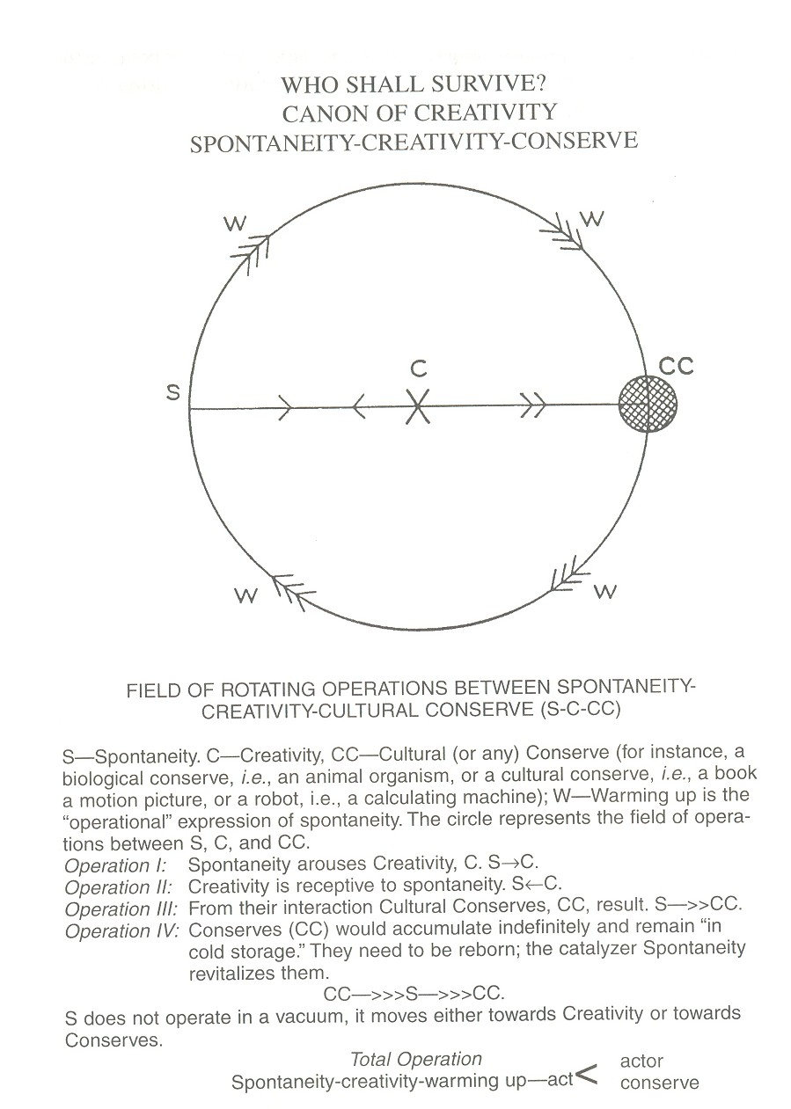

Figure 3. The canon of creativity (Moreno, 1953/1993)
Reproduced by permission, American Society of Group Psychotherapy and Psychodrama.

