Running head: PSYCHODRAMATIC TECHNIQUES IN MULTI-CULTURAL INTERACTIONS

The Use of Psychodramatic Interventions and Techniques to Enhance Multi-Cultural Interactions

Rory Remer, Ph.D.
Pam Remer, Ph.D.
Department of Educational and Counseling Psychology
University of Kentucky

March 2, 2005
Abstract

Values are central to mutli-cutural understanding. In this chapter we propose to describe a series of exercises and interventions that we have used to address the impact of overt values (e.g., social locations) and covert values (e.g., cultural conserves and values orientations) on cross- and sub-cultural interactions with audiences of students, business personnel, and professional counselor/therapists. The rationales for the development and implementations are offered from Chaos theory (dynamical system), Kluckhohn’s Values Orientations structure (covert values), and Psychodramatic (cultural conserves) perspectives—specifically role theory, spontaneity/encounter theory, and enactment theory. Specific examples from workshops are provided and examined.

The Use of Psychodramatic Interventions and Techniques to Enhance Multi-Cultural Interactions

“Isn’t it warm and stuffy in here?”
“I’m warm and finding breathing hard. I’m going to open a window.”

“I’ll get the check. It’s my treat.”
“Thank you for the wonderful dinner out.”

“It’s a pleasure being able to hear about your children’s accomplishments. Tell me more. How is
your spouse?”
“Well, enough small talk. Let’s get down to business.”

Typical exchanges among people? No. Different approaches to communication in the same situation between people from different cultures.
From taking off shoes when entering someone’s home, to accepting and opening gifts, to being a guest or host, to arranging and keeping appointments, to answering questions in classes or meetings, to greeting people with or taking leave with a hug, to being in someone of the opposite gender’s room alone, to making eye contact, to myriad other responses to typical social interactions and situations, the ways we approach them are influenced, if not dictated, by unwritten and often unconscious rules. These rules, and even more the assumptions on which they are based, constitute cultures. When they are violated, whether intentionally and consciously or not, problems often occur (Remer, 2004a).
Of course an important step, typically the initial one, in dealing with cross-cultural interactions is to raise awareness of these differences (Sue & Sue, 1990, Worell & Remer, 1992, 2003). However, simple awareness is not usually sufficient, even if increasing it is possible. The innate, often visceral reaction, to having one’s expectations violated engenders barriers to understanding and acceptance. So what are we to do to ameliorate these frictions, especially in this age of ever increasing and demanding global, multi-cultural contact? Some possible approaches lie in the realm of psychodramatic enactment and the use of other psychodramatic action techniques (e.g., role reversal) to go beyond cognitive exposure and reach individuals at the deeper emotional levels where true understanding and appreciation, if not acceptance, is experienced first hand.
In this chapter we not only present and describe some of these approaches and techniques, but also go beyond to provide more extensive foundations for their adaptation and use. We will recount situations in which they have been employed. Even more importantly we will offer some theoretical structures from which to view these interventions, attempting not only to answer who, what, where, when, and how, but also why. Specifically, besides conveying some of the essence of psychodramatic enactment and spontaneity theories, we will look at culture from perspective of Kluckhohn’s Values Orientations model and change from a Chaos Theory (Dynamical Systems) standpoint.
What is Culture
By definition culture is “the sum total of ways of living built up by a group of human beings and transmitted from one generation to another” (Stein, 1973, p. 353). However, the definition hardly conveys the complexities and depth of the processes involved in such accumulation and transmission of the patterns of thought, behavior, interaction and even emotion.
Culture, like many amorphous phenomena, is difficult to define specifically or operationally. Yet, we not only recognize its impacts, but also “know it when we see it.” However, delineating its boundaries or making distinctions from societal, racial, familial, and even personal patterns is impossible. Fortunately for our purposes those distinctions are not necessary, and similarities of cultural patterns and their influence to these other levels of patterns are, in fact, helpful in adapting psychodramatic interventions to cultural contexts, if that is the level by which the patterns are viewed.
What We Do
Although we have used many different interventions and variations on interventions to address assorted aspects of multi-cultural interactions, they might readily be categorized as warm-ups or enactments. The former tend to be less directly challenging, even playful, while the latter have more specificity, depth, and intensity. However, the distinction is not necessarily clear, nor can the impact be counted on to be as predictable as the labeling suggests.
We offer three examples, two from the first category and one from the second. We will also suggest some variations, more to give permission to adapt them spontaneously to the demands of the situation than to give specific rules. From that base we will provide some theoretical rationales—underpinnings—so that you can better decide for yourself whether a modification is appropriate or not. And that is the point of the theoretical structure.

Warm-up Exercise: The World Map Locogram
In the world map locogram exercise the world is represented by the space in the room. Participants then go to places in the world where they have experienced the most impact of a particular culture or society—usually the birth country or where they spent their formative years but not necessarily—in relation to a particular criterion chosen to be explored. For example, they can distribute themselves according to where they developed their senses of responsibility or where they learned what it meant to be a particular gender. The stories behind their choices are shared with the group.
Since everyone is involved at once, no one is forced to stand out from the group, although they do have to stand up in the group. They must talk to each other not only to share stories, but also to figure out the world map. We leaders also participate and do not “structure” the world anymore or less than anyone else. Interacting provides opportunities to chat with others one to one and in small groups, promoting a sense of joining, comfort, and trust. The processing leads to awareness of differences and similarities of cultural messages and often to personal insights. Frequently, for example, as participants hear stories they are reminded of similar experiences they have had, though perhaps contrasting ones or, as they struggle to locate themselves in the world space, they realize they are torn between locations, sometimes almost literally as they try to span oceans or continents. One woman landed in the middle of the ocean as she recognized she felt at sea.
Warm-up Exercise: Experiencing the Kluckhohn Values Orientations (Another Type of Locogram)
In a similar vein, though somewhat more in the gray area between the playfulness of the first warm-up described and the enactments to be discussed shortly, is a second locogram warm-up, exploring the Kluckhohn Values Orientations (Kluckhohn & Stordtbeck, 1961). This one is often more intense because it focuses on awareness of values usually below the level of consciousness.
As in the world map, participants are invited to stand, this time on their values. First the Kluckhohn values structure is introduced so that the various dimensions and the values within them are briefly described and the purpose of the exercise explained (See Table 1). The actual definition of the values as they relate to and are experienced by participants personally are left to their interaction with each other—both the participants and the values. One dimension is chosen for exploration at a time. As many as desired can be explored, the choices being left to the participants, within time constraints and the intent of the workshop.
For instance, the Time sphere is often chosen first as one both easy to understand and not too threatening (human nature tends to be the most threatening). Participants are asked to identify what time orientation they believe to be most important. Then to get at their orderings (e.g., future > present > past) and interactions among these values to discuss when, where, with whom, and how they tend to be future, present, or past oriented—and what impact these proclivities have on their attitudes, thoughts, feelings, and actions. An example might be what being late for an appointment means and who wears or does not wear a watch.
In exploring others’ responses in this and other values dimensions, the variations of patterns come to light, often heightening the sense of complexity of human interactions. The interaction of dimensions (e.g., time and activity spheres) becomes apparent, as do the shifts and hierarchical nature of values implied by the orderings. Participants begin to realize how they make assumptions about others and themselves based on deeply ingrained patterns of thoughts and feelings. This recognition provides an explicit basis and a tool to be employed in more in-depth work.
As the group cohesion increases the foundation is laid for more intense and perhaps personally involving interactions. At this point moving into specific enactments is possible, though not required.
Enactments: Sociodramas and Psychodramas
Generally, we try to stay at the level of sociodrama—enactments designed to deal with group issues rather than those of individuals (psychodrama). Again, the line between the two is often blurred, though less so theoretically than practically. In reality the group issues have personal correlates and personal issues are shared among group members to some degree. Where the line is potentially and particularly gray in our case is the use of doubles—a supporter who stands behind a person speaking the inner voices for him or her--to exemplify, emphasize, and even exaggerate the cultural values messages.
Unlike the warm-ups, enactments are more varied and dictated by many aspects of the group interactions such as trust level, past interactions of group members with each other, role relationships, and numerous other factors. However, the pattern is generally warm-up (engagement), role-played interactions (enactment proper), discussion, and closure, although role-play and discussion may cycle as the situation demands and time constraints allow. Perhaps a specific description will prove enlightening.
As part of the warm-up the group picks a particular topic or issue to explore. It can be from personal experience, a newspaper, movie, book, or other media story, a problem that has been suggested by business circumstances, or any other source. To convey what can occur we will take a “low level” issue, giving and accepting a gift, a common enough situation in most guest/host relationships both within and across cultures.
To generate ideas and possibilities to explore we engage the participants in a short discussion surrounding the situation, asking them to think of and recount when, where, with whom, and how they have found themselves giving or receiving gifts. A specific scene is then chosen to role-play (the choice can be made in a number of ways, for example using a locogram, but for simplicity sake, let’s just say someone expresses a desire to explore a particular scene and the group agrees). Two people volunteer or are encouraged/prodded to take part, one as the giver and the other as the receiver. The scene is set up and the role play continues until the point where the pattern of interaction is apparent or ends. For example, the giver presents the gift, it is received, opened and acknowledged. The interaction is processed examining the reactions—feelings and thoughts—of the interactors and of the “audience.” People sharing their perceptions agree or disagree with various aspects of the way the interaction has eventuated. Perhaps someone says the gift should not be immediately opened, but rather saved for later and opened privately; perhaps someone says that what would happened would depend on the relationship of the giver and the recipient, who was the guest and who was the host; perhaps someone says what would happen would depend on whether others were present and who they were; perhaps someone says “I wouldn’t have done it that way.”. All these alternate scenarios offer possibilities for the explorations of factors coming into play—often from influences related to Kluckhohn’s spheres. Any or all can be role played and processed, leading to further possibilities.
Specifically to emphasize the cultural messages involved, doubles can be used to heighten the unconscious messages ingrained by culture. To accomplish this end, a person is used to speak the inner thoughts and feelings of the role-players that they might not be willing to express—“I don’t know why he gave me clothing, I am embarrassed to receive such an intimate gift.” “She doesn’t like the scarf I gave her, I can see it on her face.” Or deeper—One (I) must be not shame my family by accepting such an intimate gift.” “One (I) must reciprocate a gift with one at least as nice.”
Once these different scenarios have been enacted, the difficulties—misunderstandings, frictions, discomforts—can be discussed. Specifically, the underlying cultural norms, rules, and expectations can be identified and compared. The “whys” and “wherefores” can be looked at. Then possible alternate courses can be enacted to see where they might lead. In the case mentioned one person might adapt to the guest/host situation as defined by the other’s culture; both might try to switch; they might ask guidance of others more knowledgeable and/or present; or they might anticipate a problem and openly negotiate how to exchange gifts, even inventing their own ritual (cultural pattern) incorporating what is essential to each—“I humbly accept your gift with the understanding I will reciprocate in the near future with one of my own.” “I will look forward to accepting your gift to me.” Both bowing.
Such processing often leads to exploring the concept of “face,” how to preserve one’s sense of self, honor, and efficacy in the view of self and others (while doing the same for the other in the interaction if so dictated). This construct seems virtually universal and can be related to cultural values and the Kluckhohn spheres, a complex proposition to say the least. These discussions are not used to reengage in role-plays, but instead are aimed at closure—putting people “back in their heads” and at a less emotionally intense level. However, strong personal reactions are not unusual. We make ourselves available to talk more personally with those who need to do so. We also mention that such reactions are likely, even on a delayed basis, so participants should seek support if they find themselves unsettled and disconcerted.
For exactly this last reason, in workshops we tend to shy away from psychodramas—enactments specifically designed to engage both the focus person (the protagonist), the auxiliaries (those actively participating in the enactment), and the audience at a personal level. We will do psychodramas if the participants understand (as much as possible) how they may react and are willing to involve themselves to that degree and if the resources—time, trust, support-system—are available to address strong responses.
Why We Do It
Three theoretical perspectives buttress our interventions: Cultural Values Orientation Theory (Kluckhohn & Stodtbeck, 1961), Psychodrama Enactment Theory (Moreno, 1953/1993), and Dynamical Systems (Chaos) Theory (e.g., Remer, 2005a, 2005b, 2005c). The first supplies the content focus and a means for discussing cultural differences. The second provides the techniques for working actively on cultural patterns and their interactions. Chaos theory, which deals with patterns and changes in them, imparts direction for altering patterns and further conveys the difficulties and possibilities for doing so.
To understand the whys behind what we have described we will now briefly offer the theoretical underpinnings. The two most obvious are Psychodramatic Enactment Theory (one part of the larger interrelated network of sub-theories that constitute Morenean Theory, or what he termed Sociatry or Sociometric theory) and Kluckhohn’s Values Orientation Theory. However, we will also suggest that Chaos theory, a more general theory of change in patterns, provides a more general context from which to operate. To further connect Chaos theory to the other two structures its links through Morenean Spontaneity/Encounter theory are also given. First a brief explanation of each and then their application to the examples offered.
One View of Culture: The Kluckhohn’s Theory
The recognition that cultural values have a significant impact on interaction, particularly between people from different cultures, is nothing new (Remer, 1998, 1999; Sue & Sue, 1990; Worell & Remer, 1992, 2003). At the unconscious and seemingly most trivial of such instances may lay the biggest problems, and the most potential danger.
By and large, the challenge of acknowledging and incorporating different cultural values in multicultural interactions has been recognized and confronted (e.g., Pedersen, 1995; Remer & Remer, 2000; Sue & Sue, 1990). The circumstances discussed generally deal with more or less overt values and the methods employed all incorporate some awareness/consciousness-raising (Worell & Remer, 1992, 2003). A direct examination of overt values has been demonstrated effective (e.g., Pope-Davis et al., 2002). But what of the times the cultural values and the assumptions about patterns of thought, feeling, behavior and/or interaction that stem from them are far less obvious and even unconscious or covert? What about when they are so deeply embedded, so second nature that they and their influences are far more difficult to identify? Most influences, if not all, operate on multiple levels, both the more obvious and the more unconscious. Sometimes the “obvious” actually gets in the way of seeing the patterns and the conflicts at deeper levels. At these times the dynamical (non-linear, non-independent/chaotic) aspect of these patterns presents the biggest, potentially most insidious, trouble, but can be the key to addressing these multicultural challenges—both cross- and sub-cultural.
The purpose of the present interventions was to teach workshop participants—business people, teachers, diplomats, students, and various other groups who regularly have cross-cultural contact—to deal with hidden values in cross-cultural interactions, perhaps preventing significant frictions from proliferating. The focus was on cultural nuances (as represented by the Kluckhohn Values Orientations) that reflect cultural values and subsequent assumptions at the unconscious, “second-nature” level.
Although anthropologists differ in their approaches and views to dealing with cultures, one useful perspective was developed by Kluckhohn and Stodtbeck (1961), Values Orientations. They identified the differences in cultures as the preferred “views” taken toward the realities of life. They called these patterns of thought, feelings, actions, and interactions values orientations. They delineated five spheres—time, human nature, relational, person-nature, and activity—that could be used to characterize the cultural patterns. (See Table 1 for more details.)
Rather than values Kluckhohn and Stodtbeck (1961) chose the term values orientations because they viewed the patterns more as tendencies that might vary from situation to situation to some degree than absolutes, and because the orientations influenced responses to stimuli at a more subliminal than conscious level—in other words, people respond in certain ways without thinking about why they do. For example, we do not usually think about why we use time-pieces to stay on schedules as a future time orientation. Precisely for this reason, conflicts between different cultural orientations are hard to recognize and difficult to address.
In the work we do we deal with both conscious and unconscious levels of influences. Values Orientations provide a tool for addressing the more challenging, unconscious level. They also interface well with both Chaos theory and spontaneity theory.
Chaos Theory: The Dynamical Characteristics of Cultural Interactions
In psychology, as in other disciplines, we try to simplify the view of reality to make it more manageable. To do so our approaches are linear and reductionistic. Multi-cultural interactions are far too complex for this approach. Chaos theory (ChT) offers a much better structure from which to view—albeit on more difficult to comprehend because we may not be used to this way of thinking.
Cultural systems are in perpetual chaos. Only the degree and how the patterns of interaction manifest themselves are at issue. The chaotic characteristics of these dynamical systems should not be considered problematic; they are absolutely essential to the systems’ functioning. The implications for both clinicians’ and researchers’ knowledge of and skills for addressing these types of systems cannot be understated.
Cultural systems, and all other dynamical systems human or otherwise, are recursive—adjust via feedback loops. Cultures establish and adapt their patterns of behaviors, thoughts, feelings, and interactions in complex, chaotic manners. The interactions of cultures are even more obviously chaotic.
Human interaction patterns, both within and across cultures, are examples of the strange attractors (focal points of changing valence) and basins of attraction (boundary sets containing chaotic patterns) of dynamical (i.e., chaotic) systems (Butz, 1997; Remer, 1998, 1999, 2003a, 2003b). They are usually unpredictable, especially in the long term; they are irreversible, in that once a pattern has been influenced that influence becomes part of the dynamics/patterns of the system; and they are subject to the sensitivity to minor differences (the “butterfly effect”)
To understand better the challenges and possibilities some background in Chaos theory is necessary. Here is a brief overview related to cultural patters.

The Mathematical Basis of Chaos Theory (ChT)
x_{n+1} = k x_{n} (1-x_{n})
This equation, or model, is called a logistical map. It feeds values back into itself (i.e., it is recursive). While seemingly simple looking enough, its behavior—the patterns it generates—evidence all the essential characteristics of a chaotic, dynamical system, such as a cultural system. If k, called the tuning constant, is small the patterns produced are stable and predictable. Once reached, they do not change under further iteration. For large values of k, patterns are chaotic. They are sensitive to initial conditions and are both short-term predictable and long-term unpredictable. Chaos is highly sensitive disorderly orderliness.
Application to Cultures
Chaos is not only indicative of, but also provides necessary energy for, adaptation of dissipative, dynamical systems patterns. Without it they would stagnate and cease to exist. As chaotic systems, these remarks apply to cultures.
From various perspectives (phase spaces), cultural systems (strange attractors) evidence short-term predictability and long-term unpredictability in patterns of feelings, thoughts, behaviors, and interactions—fluctuating within boundaries (basins of attraction). For example, looking at the Kluckhohn time sphere, all cultural interactions evidence future, present, and past proclivities, though emphasized and interacting differently depending on situational demands. However, enough “commonality” exists to be able to infer a tendency to a particular ordering.
Cultural patterns are both similar (self-affine) across situations, levels, and/or processes and are more or less different and complex (fractal). Peoples’ patterns across cultures are similar in either how or what is manifest to be able to be labeled human, yet different enough to be distinguishable from each other to a greater or lesser degree. The same is true of peoples’ patterns within a culture.
Due to “linking” of sub-systems reciprocally (resonance) and their non-linearity/non-independence, systems can increase in complexity and energy (bifurcation), sometimes so quickly that the chaos level can be disconcerting (cascade). As cultural patterns interact and adjust to each other, they generate choices in courses of action. For instance, when various people within a culture react choosing different actions, their patterns start to become more diverse until, perhaps, the original pattern is difficult if not impossible to discern. However, these same characteristics lead to new coherence (self-organization), that is, a new overall cultural pattern will be evident. The change of the US culture from primarily agrarian/rural to information/service/urban is an example that might support the point.
Depending on chaos level (system state/sensitivity), patterns shift, sometimes dramatically and permanently (sensitivity to initial conditions), but never reversibly or controllably. Cultural patterns can change drastically, like the proliferation and impact of internet use, or be virtually resistant to change. In either case, they can only be influenced, not controlled. Thus, dynamical systems must be in a ready state (far from equilibrium), for significant, permanent change cannot occur without it. So, if we want to produce alterations in cultural values orientations, we must be willing and able to disrupt those patterns.
For much more detailed explanations the reader is referred to the articles and books listed in the references (e.g., Butz, 1997; Butz, Chamberlain, & McCown, 1997; Crutchfield, Farmer, Packard, & Shaw, 1995; Remer, 1996, 2002, 2005a, 2005b, 2005c; Wildman & Russell, 1995).

Psychodramatic Theory: Spontaneit/Encounter and Enactment
While Chaos theory supplies more insight into the dynamics of multicultural interactions, the question of how to intervene—how to induce, recognize, and adapt chaotic patterns—is still not answered. Psychodramatic theory comes to the fore here. In particular, spontaneity theory, role theory, and especially enactment theory, provide the links and the tools required. Spontaneity/encounter theory demonstrates the parallels and compatibilities of viewing cultural patterns as strange attractors, emphasizing the characteristics that make them chaotic so they can be addressed effectively. Enactment theory suggests the “how to,” the praxis to which this book is addressed.
For the reader’s sake, synopses of these aspects are now presented here. For the full expositions see Remer (1996, 1998, 2004a, 2004b) from which these sections are borrowed.
Spontaneity/Encounter Theory
Spontaneity/Encounter Theory is central to the Morenean system. It primarily addresses the phenomena that are essential to all the others sub-theories—bonding, trust, and interactive energy. In particular it focuses on adaptability to interpersonal, and other, life situations.
Overview. Spontaneity is the ability to respond to new circumstances adequately or to react in “old” situations creatively, energetically, and appropriately (Moreno, 1953/1993). What this definition requires is meeting the criteria to judge whether one is acting spontaneously as indicated by the acronym PANIC—the action must be:
- within the parameters of the situation
- adequate to the demands of the situation
- novel, in order to generate energy to have an impact
- immediate, in the present moment, and
- creative, modifying the established pattern from which the action arises in order to increase future adaptability. (Hollander, personal communication, January 28, 1985, acronym mine)
As indicated by the last criterion, spontaneity is grounded in a structure that has developed from previous experience, either personal experience or that of others—what Moreno termed the “cultural conserve.”
In particular, when others are involved being spontaneous requires adjusting to demands injected by others’ needs, perceptions, and so forth as well as one’s own (e.g., acting assertively). Assessing what these requirements might be (i.e., meeting criteria a and b) necessitates encounter—connecting with others in a congruent, honest, open manner. To engage in a productive encounter one must be able to recognize the basic structure of the interaction and adapt accordingly (i.e., respond spontaneously). To have functional encounter one must be clear about ones own needs and perceptions and must be willing and able to see the situation from another’s perspective, at times others’ perspectives (i.e., role reverse with the other being encountered and able to convey an understanding of and respect for the other’s view, Hale, 1981; Remer & de Mesquita, 1990).
Whether promoting a functional enactment, exploring and attending to role structures, examining and repairing social atom relationships, or dealing with the sociometry of a group both encounter and spontaneity come into play. Spontaneity and Encounter theories supply the terms and understandings to do so.
Constructs. The following five constructs are involved in understanding Spontaneity theory:
- Spontaneity is a quality or characteristic possessed by people that allows them to act in accord with the PANIC criteria to meet the goals of adaptability already mentioned in the definition.
- A conserve (or cultural conserve) is a structure based on past experience that provides direction for acting effectively in a given situation.
- Warm-up is a multidimensional process (e.g., cognitive, emotional, physical, chemical, social, etc.) that engages energy for addressing situational demands and promotes both the selection of an appropriate conserve and the ability of interactively modifying that conserve to meet the demands.
- Creativity is the ability to establish a modified conserve, link it to other relevant conserves, and convey those connections to others.
- Act-hunger describes the constellation of reactions (i.e., thoughts and emotions) of individuals when an action does not satisfy the PANIC criteria, thus leaving a lack of closure.
The primary construct of Encounter theory is tele. On a basic level, tele is the ability to “see” and “be seen,” that is to recognize the patterns of other individuals as they really are and the ability to allow the others recognize one’s own patterns accurately (as epitomized by Moreno’s classic and graphic description, Hale, 1981, p.93). Tele is in contrast to transference, which is projecting one’s unwarranted perceptions of others on them (e.g., seeing them as you need to see them not as they really are). As a result of the encounter process, tele between individuals can be influenced, though not primarily consciously, so that bonding, trust, comfort, connection, and communication is affected. In instances of strong tele, the resonance quality of patterns and connections is clearly evident between and even among those interacting.
The Canon of Creativity (Moreno, 1953/1993) portraying the central process of Spontaneity theory and its constructs are offered in Figure 1.

Insert Figure 1 here

Enactment Theory
Enactment theory deals with what most people believe is psychodrama, the portrayal of scenes from life experience to work through problems. Of course, psychodramatic enactment has broader, more flexible goals than just resolving problems. In any case, enactment theory provides the terminology to talk about and implement all enactments.
Overview. Hollander (1969) provided one of the most informative, classic descriptions of Enactment Theory (or Psychodramatic Theory) via the Hollander Curve. He integrates various other aspects of Morenean theory in explaining how the enactment emerges from group interaction during the warm-up phase moving to the enactment proper and culminates into reentry to group dynamics in the closure. As the protagonist is chosen, representing the group theme, scenes are selected and portrayed on the stage using the protagonist’s conserves but incorporating the energy and connected issues of the other group members and the director/leader as they serve as auxiliaries and audience. The act-hunger—potential energy—is transformed to kinetic energy and channeled into examining and disrupting the conserves reaching a peak at the catharsis of abreaction. New, more functional conserves are tried out and assimilated as the energy is focused through the use of surplus reality during the catharsis of integration. The enactment ends and those engaged in the enactment return to group mode where sharing, and possibly processing, occurs.
Constructs. The constructs essential to discussing Enactment theory are presented in Figure 1. Some further explanation or definitions may make their connection clearer.
- The warm-up is the phase where group members are helped to focus their energies on the psychodrama enactment process and engage their spontaneity. Through different types of activities the group members choose a common theme and a person to provide a structure for the action.
- The scene provides a matrix around which the action occurs on the stage.
- The stage contains the action and allows a structure to help differentiate space for different purposes—interviewing, enactment, or group interaction.
- The action is the interplay of the protagonist and auxiliaries in the roles designated in the scene setting. It may be comprised of a number of scenes.
- The protagonist is the person selected by the group representing the chosen theme and providing the structure by which the theme is worked.
- The auxiliaries (auxiliary egos) are the active parts of the structure provided, representing significant features of the conserved situation, the scene. They may be significant others or important aspects that are necessary for the release of blocked energy. A special type of auxiliary—the double—stands for the internal processes of the protagonist, specifically feelings and thoughts. In a sense the audience are also auxiliaries providing a complementary perspective to that of the double, an external, removed view that can be incorporated into the action either directly by becoming active auxiliaries or indirectly through the director or other auxiliaries.
- Act-hunger conveys the idea of the blocked or misdirected energy that can be used more functionally to address the issue/problem/theme being explored.
- When the energies attendant on and indicated by act-hunger(s) of those involved in the action are released the catharsis of abreaction results. Here that energy is focused but is not in a useful form.
- The catharsis of integration brings that energy together in a different, potentially more functional way, an integration of the components present in or added to the action.
- The surplus reality is the organization of these components in new ways not previously available.
- Closure is reached in the final phase of the enactment where those present return to group interaction sharing their personal reactions and reconnecting with each other, the protagonist, and the director. Processing, the analysis of the drama more technically, may occur later as another aspect of closure. It is a distinct, though similar, pattern of interaction with a different goal, one best kept separate.
- The director facilitates, promotes, provokes, coordinates, and choreographs the flow of energy both within and between the various components and phases of enactment.
The enactment process and the relationship of its constructs are portrayed in Figure 2.

Insert Figure 2 here

Application of the Theories
In examining the two warm-up exercises and the enactment conveyed we will bring together the theoretical structures presented above. Some of the connections—the relationship of Chaos theory and Morenean sub-theories—have already been made and elsewhere (e.g., Remer, 2005a, 2005b). They will not be belabored. Interested readers can go to the sources referenced for more detailed explication. Here, the interplay of the three structures will be emphasized.
The Locogram Warm-ups
Patterns will not change unless the system producing them is sufficiently sensitive to any influences (interventions). The purposes of the warm-ups are to sensitize the system and to bring together the cultural strange attractors represented by the values orientations in a way that promotes sufficient perturbations to move the system far (enough) from equilibrium. At the same time pattern aspects intended to be included in any new pattern generated are introduced. Encounter and spontaneous adaptation are the essence of the approach. The participants are brought together so that they must encounter each other through the demands the exercise places on their one-to-one and group interactions. The cultural conserves, their values orientations present by virtue of both conscious and unconscious enculturation, influence how the participants encounter (who speaks first, who approaches whom, etc.). The interactions engender disruptions in conserved patterns, particularly the more fractal the patterns interacting are. For example, as participants from different cultures interact their relational sphere differences (perhaps “individual > collateral > lineal” may conflict with “lineal > collateral > individual”) may influence how participants defer to each other during the sharing process. The sharing further promotes both chaos, as differences (fractalness) are explored, and self-organization at the individual and group level, as new patterns are established at all levels—cognitive, affective, behavioral, and interactive. In a way, a new culture/cultural patterns common to the group as a whole are produced. These new patterns, though not predictable, are self-affine and fractal to and inclusive of the patterns brought by the participants. For example, the new pattern might be “lineal = individual > collateral” where both older participants and more aggressive ones may be accorded primacy.
Further processing, aimed at examining and learning from the encounter process itself, recursively feeds the self-organization. As participants realize their tendencies to be “individual” or “collateral,” for instance, they may experiment with a different pattern. Since one of the hallmarks of psychodramatic interaction is the use of space to represent other dimensions (e.g., using physical distance between people to represent emotional attachment) the processing through a different perspective can bifurcate the experience—a shift from cognitive to affective--increasing the complexity and chaos. Once the group has experienced this phenomenon to the point of accepting the disorienting and re-orientating ebb and flow, they can then trust themselves, others, and the process sufficiently to delve still deeper through risking the chaos of enactment.
To summarize, disruption of present patterns and self-organization to new patterns at all levels are to be achieved through the encounter of individuals’ cultural values patterns. The caution that must be offered is that predictability is not to be counted on. Sometimes very little happens; sometimes much more drastic disruption occurs than intended. In the warm-up instances, this latter outcome is less likely to occur because of the boundedness of the exercise both in time—allowing for short term higher predictability—and because well defined basin of attraction induced by structuring and choosing a limited phase space (e.g., restricting exploration to the time sphere). Still the key to productive adjustment to any eventuality is spontaneity in the moment.

The Enactment
Although certainly similar in both purpose (i.e., to foster chaos so patterns can be altered and then to engender self-organization into new, hopefully more functional ones) and procedures to the warm-ups, the gift-giving (or any other issue focused) enactment described is further meant to intensify the chaotic change process. The chaotic impact of encounter is heightened in a number of ways: (a) through focusing on a particular source of disruption (choosing a topic and scene that engage specific values orientations), (b) by stressing fractalness through the use of doubles to make the implicit values orientations differences manifest, (c) via concretizing to make cognitive level chaos both behavioral and affective, (d) by inviting bifurcation by the juxtaposing perspectives (both convergent and divergent as becomes apparent as tele increases) as contributed by the various group members from different positions (e.g., audience, auxiliary, double, director) and roles (e.g., protagonist, antagonist, significant other), and (e) counting on resonance to feed and magnify the disruptions of patterns that occur. For example, having a bicultural participant’s cultural conflict between future/individual orientation (e.g., the need to wait to open the gift where it can be reacted to alone) versus the present/collateral orientation (e.g., the need to share one’s appreciation of the gift with the giver and those others present) represented by competing doubles pulling the person vigorously toward the discrepant stances. Or exploring the “same” issue at the interpersonal level with interactors from two different cultures, examining the self-affine and fractal aspects of the patterns of interaction at the different levels—internal/intrapsychic and external/interpersonal. The sensitivity of the system (the group of participants in this case) might be further impacted by the issue being addressed in vivo, that is in the here and now of the moment, rather than representing an external pattern, say, if a group member has brought a gift for the facilitators. The specifics of the self-organization are again more specifically addressed through spontaneous “solution” exploration in surplus reality (e.g., combining individual and collateral values) with all participants contributing their cultural influences/perspectives to the production of new patterns. This phase is followed by sharing/processing much like that done in the locograms.
The summary is similar (self-affine) to that offered previously. Whether through the use of more generic locograms or a more intense enactment like the gift-giving sociodrama, the aim is the disruption of present patterns and self-organization to new patterns at all levels are to be achieved through the encounter of individuals’ cultural values patterns. However, in the spirit of fractalness, the cautions must be emphasized more because the intensity is likely higher and, concomitantly, the basin of attraction less well defined when doing sociodramas, since they are based on group chosen and personally relevant issues. Thus, particular attention should be paid to residual act-hunger (discomfort due to lack of sufficient self-organization) from all pattern levels—that is, pay more attention to both individual and group problematic responses immediate and longer-term.
Conclusion
We hope we have effectively conveyed the potential psychodramatic interventions hold for enhancing multi-cultural understanding and interactions. We hope we have not only offered some direction but also “food for thought” if not for action. Action methods go far beyond “simply” talking to engendering impact a multiple levels. We invite you to employ your own spontaneity and creativity in using, adapting, and inventing your own techniques and methods. If they are both self-affine and fractal and if they are guided in their production and effectiveness by the theoretical structures and examples (i.e., the conserves) we have shared, we will have been successful…and so will you.

References
Butz, M. R. (1997). Chaos and complexity: Implications for psychological theory and practice. Washington, DC: Taylor & Francis.
Butz, M. R., Chamberlain, L. L., & McCown, W. G. (1997). Strange attractors: Chaos, complexity, and the art of family therapy. New York: John Wiley & Sons.
Crutchfield, J. P., Farmer, J. D., Packard, N. H., & Shaw, R. S. (1995). Chaos. In R. J. Russell, N. Murphy, & A. Peacocke (Eds.), Chaos and complexity: Scientific perspectives on divine action (pp. 35-49). Vatican City State: Vatican Observatory Publications and The Center for Theology and the Natural Sciences, Berkeley, CA.
Hale, A. E. (1981). Conducting clinical sociometric explorations: A manual for psychodramatists and sociometrists. Roanoke, VA: Royal.
Hollander, C. E. (1969). A process for psychodrama training: The Hollander psychodrama curve. Denver, CO: Snow Lion Press.
Kluckhohn, F. R., & Strodtbeck, F. L. (1961). Variations in values orientations. Evanston, IL: Row, Peterson, & Co.
Moreno, J.L. (1953/1993). Who shall survive? Foundations of sociometry, group psychotherapy and sociodrama. (Student edition). Roanoke, VA: Royal.
Pedersen, P. B. (1995). Culture-centered ethical guidelines for counselors. In J. G. Ponterotto, J. M. Casas, L. A. Suzuki, & C. M. Alexander (eds.). Handbook of multicultural counseling. (pp. 34-49). Thousand Oaks, CA: Sage.
Pope-Davis, et al. (2002). Client perspectives of multicultural counseling competence: A qualitative examination. The Counseling Psychologist, 30, 355-393.
Remer, R. (1996) Chaos theory and the canon of creativity. Journal of Group Psychotherapy, Psychodrama and Sociometry, 48, 145-155.
Remer, R. (1998). Chaos theory and the Hollander psychodrama curve: Trusting the process. The International Journal of Action Methods: Psychodrama, Skill Training and Role-Playing, 50, 51-70.
Remer, R. (1999). Multicultural therapy/psychology and chaos theory. Unpublished Manuscript. Lexington, KY: University of Kentucky.
Remer, R. (2002). Blinded by the light. Unpublished Manuscript. Lexington, KY: University of Kentucky.
Remer, R. (2003a). Chaos theory and its implications for counseling psychology. Unpublished Manuscript. Lexington, KY: University of Kentucky.
Remer, R. (2003b). Experiments in chaos: Patterns and partners. Unpublished Manuscript. Lexington, KY: Author.
Remer, R. (2004a). Cultural nuances, assumptions, and the butterfly effect. Unpublished Manuscript. Lexington, KY: University of Kentucky.
Remer, R. (2004b). When a partner is traumatized: Learning to cope with chaos. In D. R. Catherall (Ed.), The handbook of trauma and the family (pp. 51-68). New York: Brunner-Routledge.
Remer, R. (2005a). An introduction to chaos theory for psychodramatists. Journal of Group Psychotherapy, Psychodrama and Sociometry. (In press).
Remer, R. (2005b). Chaos Theory Links to Morenean Theory: A Synergistic Relationship. Journal of Group Psychotherapy, Psychodrama and Sociometry. (In press).
Remer, R. (2005c). Family disruption: Chaos vs. havoc. In V. L. Bengston, A. C. Adcock, K. R. Allen, P. Dilworth-Anderson, & D. M. Klein (Eds.), Sourcebook on family theory and research. (pp. 123-124). Thousand Oaks, CA: Sage.
Remer, R., & de Mesquita, P. J. (1990). Teaching and learning the skills of interpersonal confrontations. In D. D. Cahn (Ed.), Intimates in conflict (pp. 225-252). Hillsdale, NJ: Lawrence Erlbaum Associates, Inc.
Remer, P., & Remer, R. (2000). The alien invasion exercise: An experience of diversity. International Journal of Action Methods: Psychodrama, Skill Training, and Role-Playing, 52, 147-154.
Remer, R., & Remer, P. (1982). A study of the discrepancies among the values of twelve counseling theories: The quantification of values differences. Counseling and Values, 27, 2-17.
Stein, J. (Ed.) (1973). The random house dictionary of the English language. New York: Random House.

Sue, D. W., & Sue, D. (1990). Counseling the culturally different: Theory and practice (Second Edition). New York, NY: John Wiley & Sons.

Wildman, W. J., & Russell, R. J. (1995) Chaos: A mathematical introduction with philosophical reflections. In R. J. Russell, N. Murphy, & A. Peacocke (Eds.), Chaos and complexity: Scientific perspectives on divine action (pp. 49-93). Vatican City State: Vatican Observatory Publications and The Center for Theology and the Natural Sciences, Berkeley, CA.
Worell, J., & Remer, P. (1992). Feminist perspectives in therapy: An empowerment model for women. Chichester, England: John Wiley & Sons.

Worell, J., & Remer, P. (2003). Feminist perspectives in therapy: An empowerment model for women (2nd ed.). Hoboken, NJ: John Wiley & Sons.
Figure Captions

Figure 1. The canon of creativity (Moreno, 1953/1993)

Figure 2. The Hollander psychodrama curve
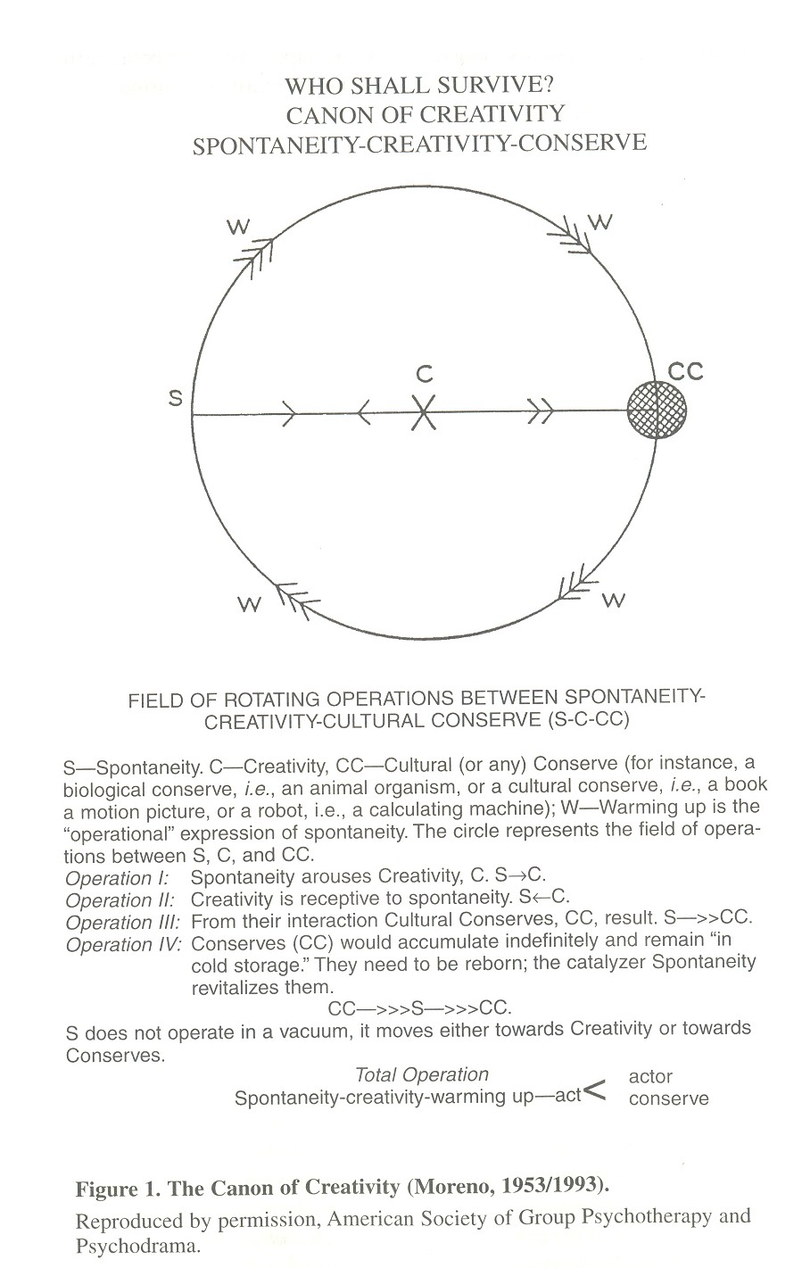
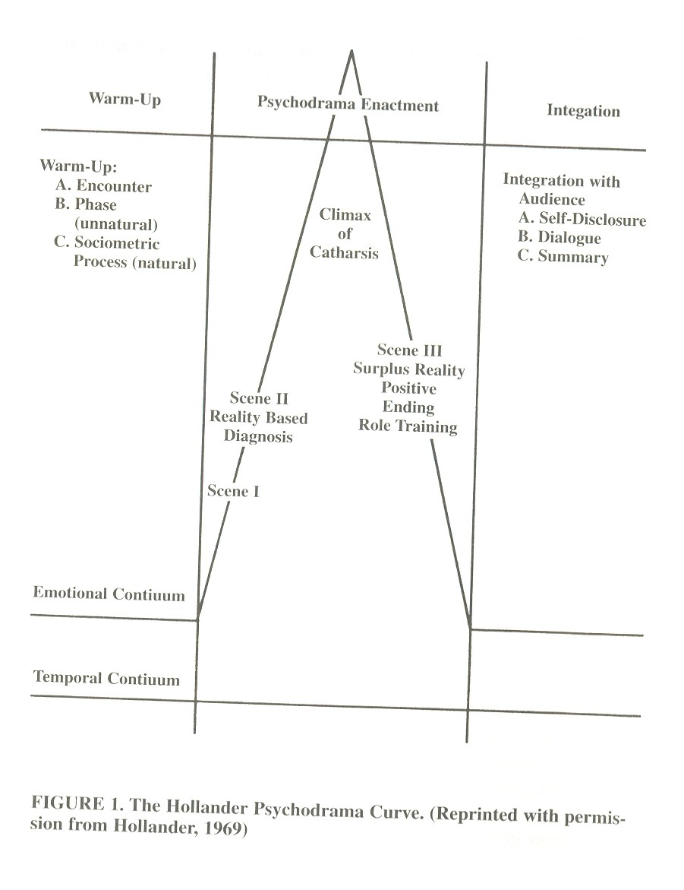

Table 1

Values Orientations by Sphere of Influence

Sphere

Time Human Nature Relational Activity Person-Nature
Past Bad Individual Being Subjugation
Emphasis on events Human nature is evil Individual goals have primacy Spontaneous expression Domination of by natural
of yesterday autonomy of choice of human personality and/or supernatural forces

Present Mixed Collateral Becoming Harmony
Emphasis on events Human nature is both Emphasis on laterally Emphasis on growing into Living compatibly with natural
occurring today good and bad extended relationships an integrated whole and supernatural forces

Future Good Lineal Doing Control
Emphasis on Human nature is good Continuity of the group through Activity resulting in external Exerting rule over natural and
tomorrow--better than time--ordered succession external, measurable supernatural forces
today accomplishment
Neutral
Human nature is not
inherently good, bad,
or mixed

Adapted from R. Remer and P. Remer (1982)

