Posted on Thu, May. 29, 2008
reprint or license print email
Digg it del.icio.us AIM

Lexington tops list of enemies to environment

'Carbon footprint' is largest in nation

By Andy Mead

AMEAD@HERALD-LEADER.COM

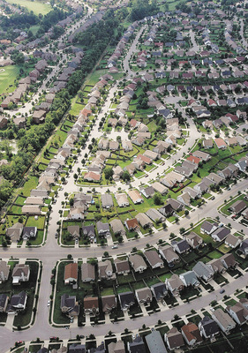 | Lexington, which touts itself as the Horse Capital of the World, now has a less appealing nickname:  Bigfoot.  A first-of-its-kind study of the carbon footprints of the nation's 100 largest metropolitan areas being released by the Brookings Institution on Thursday puts Lexington at No. 100 -- the worst of them all.

Lexington: 91st-largest metro area, #1 per capita CO2 polluter
This study: "a partial footprint" considers only residential buildings and transportation.

Drivers:
- Traffic. Metropolitan sprawl + little use of public transportation
  - Single-family homes in a Lexington subdivision use more energy than, say, Baltimore rowhouses that have shared walls.
  - Truck and other traffic on the interstate highways intersect here.
- High consumption of dirty energy.
  - Lexington's hot summers and cold winters mean residents use furnaces or air conditioners almost year-round.
  - energy comes from burning coal, a high-carbon fuel.
- Inefficient homes.
  - building standards in Kentucky (and Southeast US) place minimal importance on energy efficiency.
  - Lack "a conservation ethic". Oregon, Washington and Idaho have relatively cheap energy, but waste less

Los Angeles ranked well:
concentrated area,
strict building standards
mass-transit rail system.

Study recommends federal and local policy changes:
- Federal
  - promoting transportation choices,
  - rewarding local and state governments for reducing driving
  - requiring that homes for sale include the costs of heating and cooling.

- state and local governments:
  - tightening building codes to produce more efficient homes
  - strengthening planning and zoning regulations so less forest and farmland is converted into subdivisions.
  - encourage Infill

- City voters approved a tax to increase LexTran bus service in 2004,
- more emphasis on bike lanes

