Global Environmental Issues:
Global Warming & Biodiversity Conservation

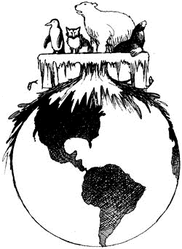

Causes of Global Warming

- Earth has a natural greenhouse effect – the trapping of incoming and outgoing solar radiation by moisture and natural greenhouse gases

- Last 130 years: Industrial Revolution
Has changed the amount of these natural greenhouse gases

1. Carbon Dioxide – from the burning of coal, petroleum, gasoline

1860: 280 parts per million
2000: 370 parts per million
2010: 380+
2050: 400-600 parts per million (estimated)
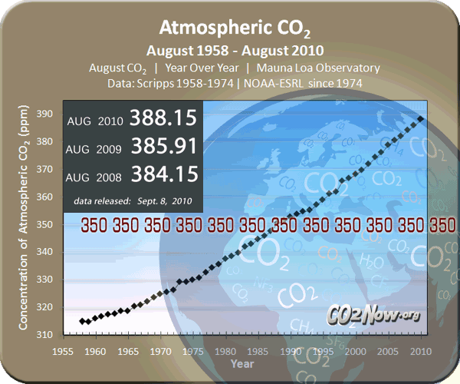

CO2 emissions components

2. Chlorofluorocarbons (CFCs) – from aerosol sprays, refrigeration, air conditioning

Increasing at a rate of 4% per year
Absorbs a thousand times more infrared radiation from Earth than a
molecule of carbon dioxide

3. Methane – from vegetation burning (rainforest clearing), leakage of pipelines and refineries associated with natural gas production, and ‘natural’ leakage from cattle and sheep

The atmospheric concentration of methane has increased by 151% since 1750 and is its highest in 420,000 years.

4. Nitrous Oxide – from use of chemical fertilizers

5% of human-caused greenhouse gases

5. Water Vapor – largest greenhouse gas and naturally occurring

generally considered to increase with increased temperatures
Unanswered questions:
can water vapor lead to a feedback effect causing a 'runaway' greenhouse effect?
can areas become more arid? allowing greater reflectance back into space?
how will it vary across regions? some hotter, more humid, wetter...others more arid, dryer?

- About three quarters of our greenhouse emissions are from burning fossil fuels and most of the rest is from deforestation.

    - How will greenhouse emissions alter over time?
    - What will happen to natural sinks?
      - Soil? huge reservoirs of CO2 are held in surface deposits such as soils, peats, etc.

What is the Present Effect of this Buildup of Greenhouse Gases?
Iconic Images…

- Keeling Curve
  - Totals: increase in overall atmospheric content
  - Annual amplitude (a bit hard to see on this graph): ‘greening’ of North America and Siberia with Global Warming

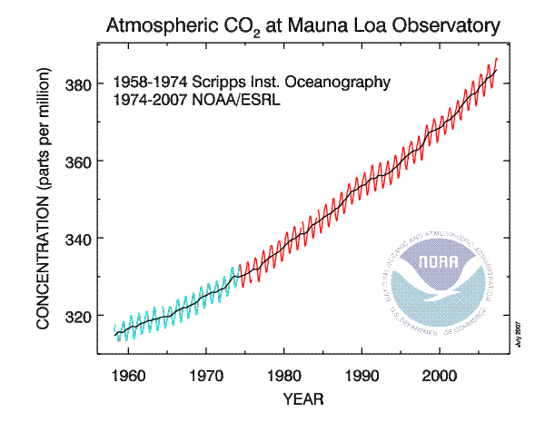
- CO2 and Temperature Change from Ice Cores
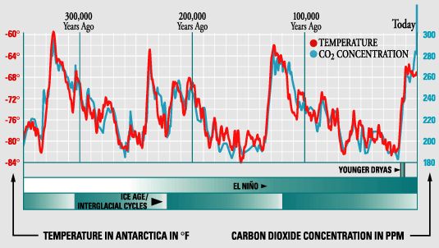

Big difference between CO2 and temperature today. Far greater than at any time in the last 300,000 years. Temperatures have not shown the same correlation thus far, however. We hope they will not I suppose…

- Anthropogenic versus ‘natural’ forcings

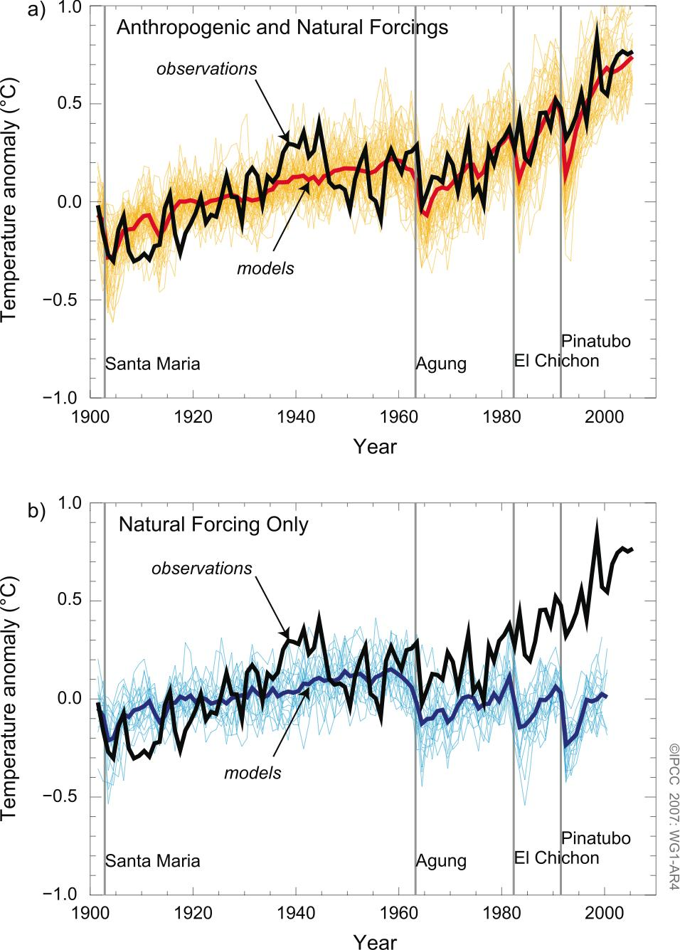

Slide: Future scenarios
Slides: Sources and Sinks

What are Potential Effects of this Buildup of Greenhouse Gases on Biodiversity?
Some Impacts… Habitat Destruction

- Changes in Temperature affect glaciers and oceans
  - Increase in Sea Level due to Thermal Expansion of the Ocean and Melting of Ice Sheets:
Continental (Greenland, Antarctica), Mountain (Rockies, Kilimanjaro, Andean)
Millions of species will be displaced.

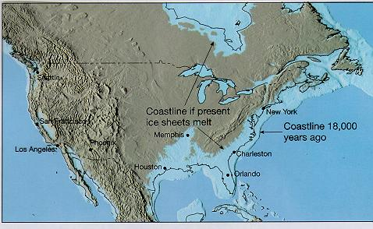

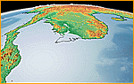 | Southeast Asia  if West sheet melted (17-foot/5m rise)
 | Southeast Asia  if East sheet melted (170-foot/50m rise)

  - Loss of Ice Sheets and associated ecosystems
    - Polar Bears,
    - Vast under-ice ecosystem of Krill and the related ecosystem (sea lions, penguins)
    - Mountain Ecosystems: many pockets of biodiversity are dependent upon snowmelt.
- Global Warming alters terrestrial Ecosystems
  - Change in Animal / Plant Cycles
Earlier Migration and Breeding of Birds, Animals, and Plants
Change in CO2 concentrations may increase crop yields
Change in weather patterns may harm crop yields
Loss of fish populations in part due to global warming and ocean acidification (see below)

- Extra CO2 has effects as well
  - Acidification of the Ocean and Coral Bleaching (Die-Offs):
warming AND difficulty of building shells of calcium
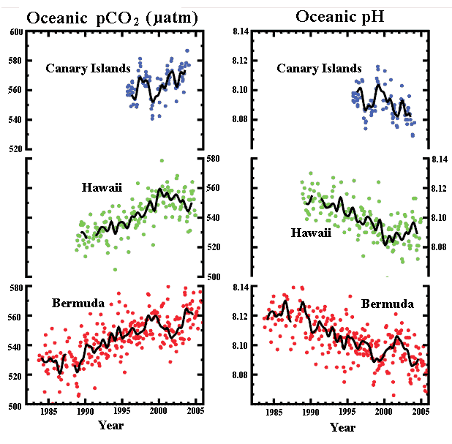
Coral Reef bleaching: loss of related fish populations (added to direct destruction)

Basically: Massive Ecological Changes with Massive Impacts on Society

Slides: Social Aspects of Greenhouse Gas Production

The Politics of Global Warming
The Problem of Assigning Responsibility
a. Who is Responsible for Global Warming in the first place?
b. Who should be Responsible for 'Cleaning Up the Mess'?

- 1992 Rio de Janiero Earth Summit
Those who signed – bound by international law to reduce their greenhouse gas emissions…but those countries emitting the most greenhouse gases
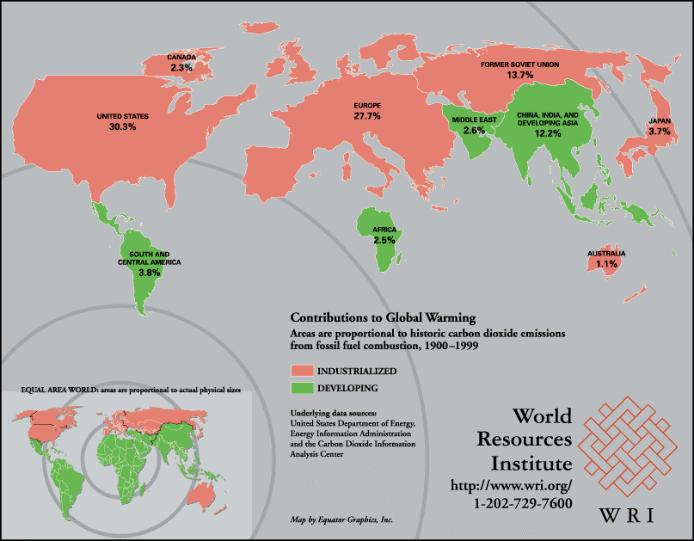
did not come close…

- 1997 Kyoto, Japan
-Again, another treaty aimed at cutting emissions.
-But the details as to how this would happen were not decided on…
-A deal was finally hammered out in Marrakech in 2001, although the United States, the #1 producer of greenhouse gases, pulled out in 2000

Why did it take so long for…
countries to start talking and an agreement be reached?

1. Debate over Global Warming in the US
- Some see a need to control emissions
- Others worry controls will
a. harm business
b. increase the cost of living for Americans

2. In Contrast to the European Union
  - More energy efficient than the US and can meet the requirements with greater ease.
Nonetheless, many debates with respect to how to meet the challenges of global warming:
      - Nuclear power generation versus Renewables and Conservation
      - 20% reduction in Germany versus increases in Portugal, Greece, Spain

3. Tensions between Industrialized and Industrializing Nations
- Industrialized World (the ‘West’), created the global warming problem and today contributes more than half of greenhouse gases.
- Therefore, some feel industrialized nations should…
a. Drastically curb their emissions
b. Finance emission controls in developing countries

- Industrializing countries are Reluctant to Sign because…
a. Emission controls will restrict their economic future
Example: China’s huge supply of soft coal – wants to use this coal to fuel industrialization
b. They feel the responsibility does not lie with them
Economic Argument from Vandana Shiva: director of the Research Foundation for Science and Ecology, India
She opens with Two General Statements:
1. “the threat to the atmospheric commons has been building over centuries, mainly because of industrial activity in the North…[yet] the North refuses to assume extra responsibility for cleaning up the atmosphere. No wonder the Third World cries foul when it is asked to share the costs.”
2. The Third World calls for an "ecological democracy" - the worst polluters should pay the highest price for cleaning the environment
Her Main Argument:
The North is not only Responsible for Polluting… The North is the driving force behind industrialization in the Third World
- Western 'experts' and organizations (ex - World Bank) have pushed the Third World into using oil, gas, and 'modern' agriculture (herbicides, pesticides, fertilizer, etc.)
How has the North done this?
- Through regulations and funding
Examples:
- World Bank's "barometer of 'development'" = Energy Consumption
- Economies based on Renewable Sources of Energy were assumed to be Unproductive
"‘Most agriculture is unproductive; human or animal manure may be used, but chemical fertilizers and pesticides are unknown.’"
- The World Bank does not want to fund governments that are "unproductive."
- If Third World governments switched to an agriculture based on fossil fuels (tractors, insecticides, fertilizers), they would continue to receive aid
- World Bank funds power projects in the Third World
The National Thermal Power Corporation (coal based power plants) = the largest beneficiary of World Bank assistance
- Also: Corruption in Third World governments
What else is involved in this Push towards Fossil Fuels?
- Aid for fertilizer, tractors, etc: benefits Western corporations.
"For every dollar of aid given, three dollars worth of business is generated in the industrialized countries."
The Core Problem
- Debt Burden: prevents the Third World from spending on the environment
- Undemocratic regimes: Wealthy rulers profit from environmental degradation
Conclusion:
"If the North is really serious about coming to grips with global warming - whether caused by higher levels of fossil-fuel use or faster rates of deforestation - then debt and unequal trade must be tackled first. Both are reflections of the deep rift between rich and poor which frustrates our search for environmentally sustainable development."

Global Warming: A complex environmental, social, and economic issue that ties the world together…

